Appendix A1. Focus Group Discussion Guide
Introduction
- Shortly introduce yourself (e.g., where do you work, how you are involved in the project).
- Thank stakeholders for participation.
- Explain the research project.
- Explain the aim of the interview.
- Interested in exploring participants’ understanding of front-of-pack labels, the label’s perceived effect on purchasing habits, visibility and credibility.
- Explore formats perceived as attention grabbing, effective format to use as a warning against unhealthy foods and drinks, and formats likely to influence purchase behaviour.
- Explain informed consent and ask stakeholder to sign.
- Make sure that the stakeholder has your contact details if any additional questions would come up later.
- Explain that the audio recorder can be paused at any time during the interview.
- Explain that the stakeholder can request for any parts of the audio recordings to be removed after the interview, up to [date].
- Explain that the results will only be described and reported at an aggregated level.
- Before proceeding, ask if there are any questions about the research project, the interview or the confidentiality.
Ask permission to turn on the recorder.
Opening questions
Hello, my name is ___________, I will be conducting the session today, and this is __________, who will assist me by taking notes and helping in the conduct of the research. Thank you for participating in this study today. We’re interested in people’s reactions to proposed labels for the front of food and drink packages. I will show you a label that is being proposed. I will ask you for your reactions to it. Now, I am going to show you an image of some products and then we will discuss what you see. First, I want to make sure that you can see the image clearly, so I will show you a trial image and once you confirm that you can see it clearly, we will proceed to the main image.
[Image 1–3]
Image 1- Red and Green Symbol
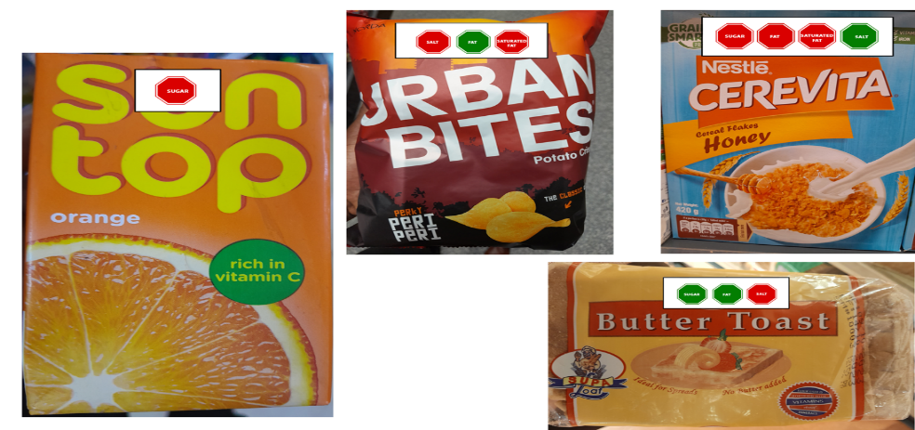
Image 2: Red and Green symbol with icons
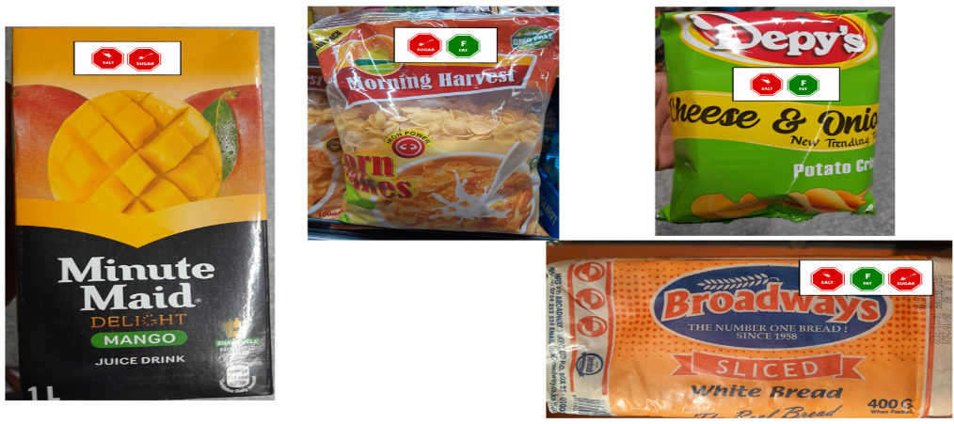

Image 3: Warning Symbol
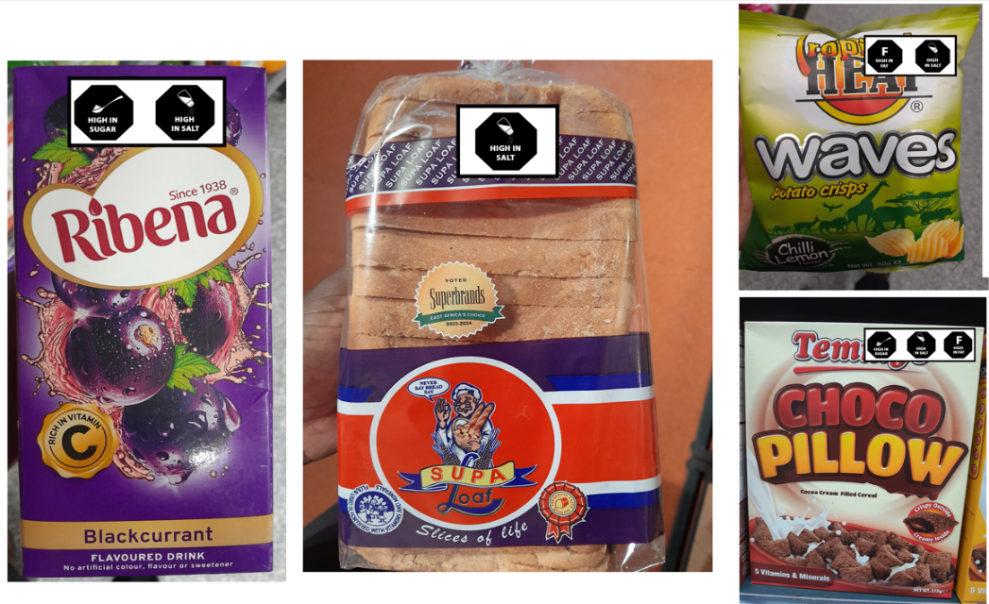
Did you notice any labels on the packages?
Now I am going to show you the image again and this time I want you to focus closely on a set of labels you will see on the front of the food and drink packages.
Study this set of labels closely and l will ask you some questions about it.
[VISIBILITY/MEMORABILITY]
How visible was the label?
Describe how eye-catching you found it to be (Probe: shape, color, text, message)
How memorable is the label?
Kindly recall and describe the label to me. (Probe on shape, color, text, message)
[COMPREHENSIBILITY]
What do you think is the purpose of these labels?
What did you understand from the labels?
What does the label tell you about the healthiness of the food?
Was it easy to understand? Why?
What did you not understand or find confusing?
To whom do you think this label is directed to?
How believable did you find the label?
What about this label may be culturally inappropriate?
What about this label may be difficult to understand/interpret in Kenya?
[POTENTIAL EFFECTIVENESS]
Did this label change your attitude towards the food/drink that you just saw? How?
Would your decision to buy a product in the shop be affected if you saw this label on a product? How?
Would this label affect your purchase of a product that you regularly buy if it was on it? Probe: How, increase or decrease the purchase of it?
In your opinion, what is the benefit of placing a label like this on healthy/unhealthy foods?
How would this label be harmful?
What effect does a label like this have on people in Kenya? Probe—how will it help in addressing obesity or high blood pressure?
[IMPROVEMENTS TO THE LABEL’S MEMORABILITY]
What aspect of the label had the most impact on you and why?
Was there anything that was offensive or inappropriate in the labels?
[COMPARATIVE RATING]
Now, thinking of all the labels you’ve seen today, what was the most memorable in these labels? Probe—what image do you remember most – color, shape, text? What words do you remember?
Thinking of all the labels you’ve seen today, does any one label stand out for you? Which one would that be? Why?

