AFRICAN POPULATION AND HEALTH RESEARCH CENTER
RIGHT TO FOOD PROJECT-(ENDLINE
ARCHIVAL NUMBER: 181017_0913, 181017_1402
CONTACT TYPE & DESCRIPTION: PHOTOVOICE–(ADULTS)
DATE: 17/10/2018
START TIME: 2:00PM
END TIME: 4:45PM

M: thank you again for coming and for your time here at X Centre. As I have explained to you we will have a discussion from now about right to food and about food security and any other topic relevant to our discussion for the day. So we will start with the picture on the extreme left, at the top. So please the owner of the picture the stage is yours. Picture number one, group one. Welcome.
PHOTO ONE, GROUP ONE.
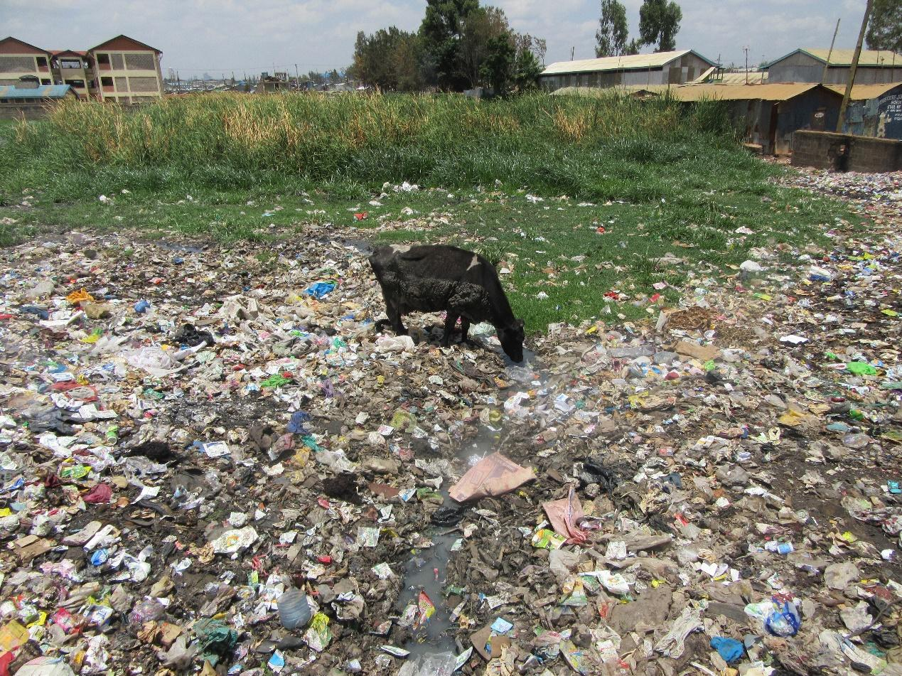

R3: Hallo everyone, I am R3 from group one discussing photo number one. In this picture I captured at this dumping site there is a terrace there and there is a cow drinking water from it and on the side there are greens, grass and vegetation. This picture shows you the way this cow is feeding badly. It is drinking water from terrace and it is usually milked at night. It must have some illnesses that can affect people. Another message from this picture is this area taken up by the damping site takes up a lot of space that can be reclaimed and be done for beautification. Groups can came together the way we are here today. Come up with an idea of a farm to reclaim. It can help solve hungry problems. Like for the group that I come we had a space we took a picture of before and after it was a damping site but we changed it and now we get vegetables from it. I think that was the information that I wanted to convey in this picture number one.

M: Okay. Thank you R3. I would like us to speak in an audible tone and R3 explained to us what he wanted to capture with his picture but before I open up the discussion to the group. R3, you have told us greats themes. Now I would like to know. These things that he has said how do they relate to food security and right to food?

R3: When it comes to food security this area can be reclaimed, be done for beautification and what I mean by beautification is making it into a farm. So that when people do urban farming because these days Nairobi is already full and people are even farming with plants going up in containers. You find this small space can become a very big farm and that can help with food security.

M: Okay, thank you very much. I would like to open up the discussion to the rest of the group. He has talked about reclaiming land. Do we all understand what he means? If we all understand what can we say yes?

All R: Yes!

M: Okay. Now he has said we can reclaim this land and do urban farming. I would like to ask this picture that he has shown of the damping site do we have many more like that here?

All R: Yes!

M: when we speak about the possibility of reclaiming the land is there reclaiming of land that we have seen here in Mukuru? Reclaiming of land to do things like urban farming? Is it something that has happened, land reclamation for urban farming?

All R: Yes.

M: So it is happening?

All R: Yes.

M: In the reclaiming that you have all see. What is present? What is used?

R2: what is mainly not available in the farming is soil, because that area as you can see doesn’t have a lot of soil. If good soil can be found then the farming can happen.

M: thank you. Let me ask my question again. In the reclaimed land that we have seen what do we usually seen planted? What is produced on that land? Who has seen this project? R2.

R2: I am the one who manages that reclaimed land that we have. On that space you will find vegetables of all kind.
M: Like which vegetables?

R2: Sukuma (Kale), Spinach, Kunde (cowpeas leaves), Malenge (pumpkin).

M: Okay, thank you. So the vegetables when they have been planted where do they end up? Who uses them?

R2: at the moment it is mainly the members that benefit from them. Our members mainly don’t have trouble accessing vegetables.

M: Okay. So it helps the members? Do the members buy them?

R2: the members have a small amount that they contribute so that we can buy water because water is also a problem.

M: Okay. I would like to ask. When there is an initiative like that of urban farming where we can produce vegetables like he has said. Those who benefit from the initiative, how are they different from the rest of us who have to get vegetables in other way? Is there a difference and if there is what is it? R8.

R8: Firstly, there is a big difference because if you see that farm it is big and you can put many different vegetables and then at the same time you can keep chicken. Again if you look at the farm those who get vegetables from the farm can vegetables that are clean. Vegetable that if they use compost they will use the natural one as opposed to the one bought at the store that have chemicals. It will be better than those who buy vegetables from vendors and they don’t know where the vegetables come from. Because this is Nairobi and most of the vegetables are sprayed with chemicals and also the process of how the vegetables are handled before they get to the market may not always be the safest. So you find that you buy dirty vegetables, that have been washed badly and then cut badly and its general handling is just bad. How it was transported you can’t tell. When they are being packet in the bags they might even be stepped on so you find they will have vegetables that are cleaner than what the rest have access to.

M: Thank you. Let me ask a follow up question. He has said that vegetable sometimes is poorly handled. If you pay attention to his description does it have any effects to us? If it has what are they?

R2: What I can say is that you may find that the vegetables are planned next to a sewage and the water used come from there because it’s where it’s grown near so you find that the vegetables you are buying is already contaminated because the water they are using is not safe. So there is high risk.

M: Thank you. May be my last or second follow up question would be. Because we are discussing urban farming here and you yourselves have explained to me the difference between vegetables gotten from urban farming and those found in the market. My question is here in Mukuru are there people doing urban farming apart from the mentioned group? R6.

R6: there are people doing urban farming. There are two or three schools doing urban farming here around. Some have a greenhouse and they also help by selling vegetables to the students or parents of the school. Like there is a school down there, last month they were selling tomatoes and they were selling it at a very low price because the greenhouse is not dependent on the weather.

M: Okay, thank you very much. Let me ask. Still as we discuss urban farming in the urban area. Those of us who are here why do we not practice urban farming personally? Those of us who are here. Why don’t we practice urban farming? Especially because we know about it and have even spoken about its benefits? R8.

R8: You know here we are in town. And many of us have jobs that require a lot of time. You will find someone leaves their house in the morning and they come home late to the point at which if you do urban farming you can fail to find time to attend to that farm. You will come to find that the pot or sack being used are also hard to come by and if you find them they can be a bit expensive and also another reason people can do it is because of the houses we live in. We usually rent them and the landlords can refuse to allow us to farm of the plot. For example the ones for hanging on the wall and the house we leave in are made of iron sheets and you can put the hangings on the wall and then the houses fall.

M: Thank you. Why else don’t we practice urban farming? I would other people to talk. R10.

R10: I would say this. Planting in Nairobi is very tricky. Finding a place to plant is very hard. You can find that maybe you will find that land in a group and maybe it was land that was available because I know even finding it was not easy. In Nairobi many of us have come from the village so I would say somewhere to farm is the problem.

M: Any other contribution? R12.

R12: In my opinion, there is no space. For example that greenhouse we may also not have the skills to maintain it.

M: Thank you. I would like to take a last burning answer. R3.

R3: What I would like to say, is what makes urban farming hard is lack of knowledge. Like those of us in the group Lima Lima. The damping site was just there but because we had that knowledge we became more interested with farming. Yes you see the land is small but you know that it can help the community and those who come and visit that space can go and practice the same and do more.

M: Thank you. We have spoken about one or two things to do with the reason why we do not practice urban farming but before some of us had said that urban farming is a good thing. We even mentioned the benefits. Let me ask, what can be done so that we can start urban farming? What can be done about the limitations that we mentioned? So that an enabling environment can be provided so that we can do the urban farming and we can have access to the fresh vegetables we were talking about? R4.

R4: In my opinion we are told that knowledge is power. If the landlord as R8 had spoken about, that landlords say that we are spoiling their houses. If they can be trained and explained to why we are going the urban farming and they can also be given a chance to do it on their plot it would be very good.

M: Okay. R4 before we move from you. This question may also go to all of us. She has given us some good insight on what can be done. So when you give a recommendation of what can be done, it would also be good to tell us who you think should do it and is best placed to do it. Is that Okay? So give us the recommendations and who we think has responsibility to do it? So R4 you can add.

R4: the person who I think can give us or pass this information properly is the chief because usually when people have problems they go to the chief. And when the landlord will come and find containers and other things used for farming he will most likely immediately go to the chief and to the chief I will also be taken. I will be asked to explain why I have done that and so the chief himself is the one who should call the landlords together and explain to them that there is benefits to the urban farming to happen in his area.

M: Okay, thank you very much. Another recommendation? What can we do? R2.

R2: First, I can help with the landlord situation. You see when it comes to the landlords who are bring up issues with the hanging of the pots you can put up wood on the iron sheets. When you put up that wood it will not affect the iron sheets and also the pots used are not heavy enough to affect the iron sheets. another recommendation I would give is for us as a group we have that space maybe we can plant seedlings that we can give the community because there are people who come to us for seedlings so we can give them because they have already shown interest, for me what I see they can do is if people can get soil and they find where they can get the seedling even if it’s from a group and then get supply of the containers and the seedlings have already been planted all they are going to do is fix them. It may be easier for more people to be willing to take part.

M: Thank you R2. When you talk about groups. Maybe you are talking about Groups. Where are these groups

R2: Us our group is from [Name of place].

M: So you are talking about a group from the community?

R2: Yes.

M: Okay, thank you very much. Let me take the last recommendation. If you have another recommendation you can share with the group? Is there? Okay let me ask this. My last question in regards to urban farming. We have talked about the benefits of urban farming. We also talked about the benefit in regards to contamination and also about money. Is there another benefit to urban farming apart from those two? How else can the urban farming help the community? How else can urban farming help in regards to food security? Is there another one that we know? Okay, R3 so that I can conclude with you, when you were you were taking that picture to show us the various things we have discussed. Could there have been another picture you would have wanted to take to show us the same situation but you did not get a chance?

R3: Yes

M: tell us what the picture was.

R3: That picture the distance was the main problem. I wanted to take a photo of a farm that is just in my mind.

M: Alright, thank you very much.

R???Check tape 17:30) I wanted to clarify something on the land that you had talked about that has been reclaimed. The damp site you are doing vertical farming or what are you doing?

R3: we are doing vertical farming (pallets) and container gardening. Plastics containers, metal dishes.

M: Okay, thank you very much R3. We can release you. Please because of the noise we can’t clap but I want us to still appreciate everyone. It’s important to appreciate people. Isn’t it? So today we will us flowers. So we will be lifting our hands and then we drop for the person. Okay? Let’s give him flowers.... a little more life. Then drop. Ok thank you very much R3. Let us go to the second picture. We will go in a certain way. Photo number one group two.

PHOTO ONE, GROUP TWO.
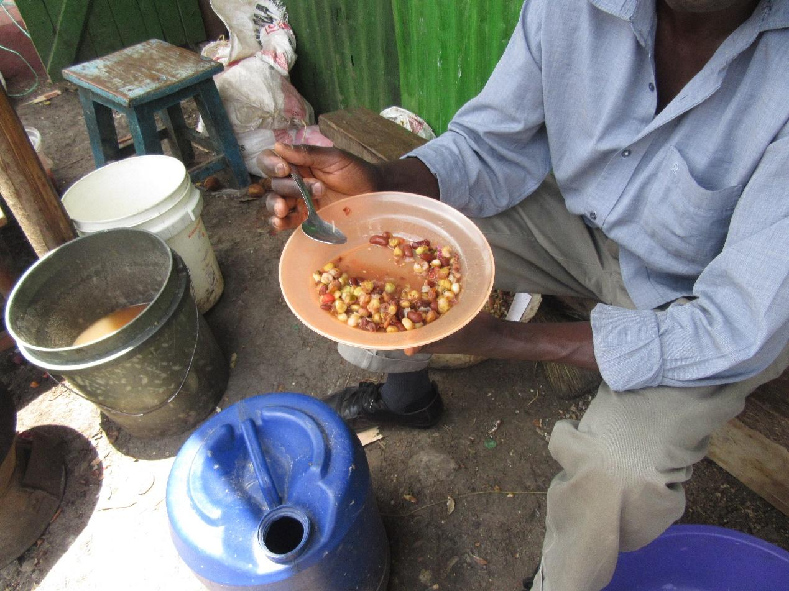

R6: Hallo everyone. I am R6. In my picture I wanted to capture the way the environment is not safe. If you look at this picture the man is eating but this environment is not clean and according to food even if it’s in your house there needs to be cleanliness. If you just put food in a dirty place the hygiene becomes poor and that make the food not safe. If you look closely at the picture there is a bucket that has dirty water and it’s not safe where that food is.

M: Okay. Thank you very much. Maybe before we open up the discussion to everyone please link for us the story of your picture and food security and right to food.

R6: This man according to this picture has a right to food and that was the cheapest food he can find because we asked him and he said that it was the cheapest. We asked also because we needed to ask him whether we can take his picture but not a picture of his face. He said yes. So we asked him why he choose that food. He said it was the available food I can access.

M: Okay, thank you very much R6. R6 has mentioned two things. R6 firstly what food did you say that is?

R6: Githeri.

M: It’s githeri. He has said that this githeri is the cheapest food that that man could afford. He has also said that the food is accessible. We have all heard that. I would like us to discuss those two topics. First let me ask, here in Mukuru is it true that this type of food is what is cheapest or among the cheapest and it’s also accessible? Is it true as he has said?

All R: Yes.

M: Someone has said sometimes please explain.

R9: there is a food called “Choma”. You are given chapati with some stew called “airways”. That one is also said to be good easily and is cheap.

M: So that chapati with surwa is also among the cheapest? But also this Githeri is among the cheapest? Before we continue can someone explain to those of us who don’t know what surwa is?

R: soup of beans.

M: Okay, do we have said that this githeri is among the cheapest food. I would like to ask. How cheap? From how much can you buy it at?

R: Ten shillings

M: So starting from Ten shillings going up? Okay and also we have said that it is accessible? It can be found easily? Why? R11. Why is this the food that is easily found? Why are the others not as accessible? And you can mention those other foods. Try and compare that githeri with something else that you would said is not easily accessible. R11 is still thinking. R2.

R2: I can say the reason it is easily accessible is because of what someone earns. Because even the person cooking the githeri if they cook other food not many people will be able to afford it. So he has to cook something that people can afford because of people’s earnings.

M: Thank you. He has talked about money again.

R9: Let me try. What I would say is that food does not require a lot of things. Just water and fire to boil it. It doesn’t require a lot of things like oil. So that is why it’s in plenty.

M: Okay, thank you. R4.

R4: Also it depends where you are cooking that githeri. Because you can cook for people pilau in a certain area and in their life time they have not seen pilau or they can’t afford it so when someone is cooking this githeri they know that the customers in that area or many people in that area will buy it.

M: Let me start from there. R10. We have said that this food that we find here they are used to it. Is it true that this food has been eaten here for long? Till people are used it? So I would like to ask this. This githeri in your opinion is it healthy? Your experience of eating this githeri. How is it? To our health and body. What would you say about this githeri?

R6: I would say that this githeri depends on how it is cooked. It has benefits and also lacks benefits. If you look at the nutrients going into the body. If you look at beans it’s protein, maize is starch, tomatoes and other things. In my opinion it’s at least balanced. Not much but somehow. Its problems are many. There are those who cook it with “Magadi “ and this magadi is said to affect the leg joints, it gives someone a stomach ache, there are some people who also when they boil it, they don’t pour out the initial soup and that one affects people with ulcers and your stomach will constantly be painful. It is also food that makes one strong and it’s cheap so you can find that it will sustain someone for a long time. Especially those going for building work.

M: Thank you. Does anyone want to add on to that? Let me ask this then. He has said it has benefits, like construction workers have been eating it. I would like us to start at the benefits. What are the benefits of githeri? To our health? Let me expand a little. Let us not only look at githeri, let us also look at the other foods that we had mentioned that we had said we can access at a low cost. Let’s look at that range of food what are their benefits?

R2: for githeri many people say it holds the stomach. Like if you eat githeri in the morning and you are going to work, especially if it’s manual work. You will be able to work and not feel hungry quickly. It stay in the stomach for long and provides energy.

M: Okay, thank you. Anyone else? Does githeri have nutrients? These foods that we are eating that we find at this price, do they have health benefits? Or they don’t? That is my question. Those of you that have been eating this food that are found at Ten shillings, do you feel that they have health benefits or they don’t? R10.

R10: They have benefits.

M: Please mention the benefits to our health. R10 is thinking. R4.

R4: In my opinion this cheap food people are eating it may be food but it’s not necessarily healthy food. Because that person simply wants to get full. But it has no health benefits because when you look at that food if you only have the maize and we will speak about balanced diet then there are things that it lacks. Most people would rather just food but it doesn’t have to be balanced.

M; Thank you for that good insight. Someone else? Are there other benefits? Is there someone who agrees or disagrees in a good way? R6?

R6: I would add. I want to oppose R4. There are some foods that. One of the problems we have here is that we look at people living in places like Runda are the ones eating a healthy diet. These food we have hear have health benefits. For example I said like githeri, has proteins, which is also found on meat so when we see someone in Runda eating meat we think he is ok but also beans has proteins. When it comes to starch, maize has starch. We look down on sukuma (kale) and yet it is very good for us. It gives us our vitamins from vegetables. And they say you must eat a balanced diet that has vegetables, starch, and proteins so that we get vitamins A, B, C. We also look down on oranges saying I can’t eat because I don’t have money but they have benefits to our health.

M: Okay

R4: I want you to remember that we are talking about the githeri in the photo. He has not told us that that githeri has sukuma or tomatoes. This is the cheap food that is available and what does it help us with?

M: Okay. You are all right. I want us to expand the conversation a bit. There are those saying there are benefits and there are those saying it has no benefits. If we continue I. That category, those foods that we had mentioned that are accessible with little money do you feel like they have benefits? Because you have been using them or do you feel that they have no health benefits? R8.

R8: Githeri in general if it is cooked well has health benefits. You will find that the beans give proteins and add blood to the body. Maize give starch, carbohydrates and some vitamins. But if we discuss the githeri in the picture. That githeri the soup has been removed severally to cool mandazi (fritters) so it remains almost plain water. Though we know now in Kenya githeri can make you a millionaire but that githeri you will find most of it nutrients have gone to those who ate the fritters and the person eating the githeri is eating so that they can eat full but it has little benefits to the body.

M: Thank you very much. Let me ask then. Here in Mukuru because we are discussing food that is available at little cost is there food that we would like to eat but because of not having money we are not able to eat? Is there food like that? That we would wish to eat but we usually don’t eat it because of not having money? If there is such food o want to hear yes. Is there such food?

All R: Yes.

M: I would like you to tell me what food it is that you would very much like to eat but because of money you don’t usually eat it or you don’t eat it often. Who can tell us? R1.

R1: Okay, even that githeri it can also be good depending on how it is cooked. You will find that that githeri is only maize and beans but you can vegetables. The githeri can be properly fried and potatoes added at least it becomes better.

M: Okay, thank you. R5. Is there a try of food that you would very much like to eat or that you feel that if I was able to eat this food it can be helpful to my body? Or I like the food in a way but you don’t eat it much because of money? The money makes it I accessible. That is what I want to hear. What food is it? R8.

R8: There are many foods one would want to eat.

M: Mention one as we go.

R8: Like chicken, meat, there are fruits like beetroot that also should be eaten in plenty but it’s not easily available but also it’s expensive. So someone simply buys what is available because you just want to be full. There are many kinds of fruits, like apples, pineapples, things like that.

M: Okay, thank you. Is there anyone who wants to add? R5 are you ready now?

R5: If you go to the shop and find that fish is sold at 300 shillings and you only have 100 shillings then you can’t afford.

M: Thank you. Does someone else want to share? It can be you or people living in the community because we are representing people in this community. So it doesn’t have to be personal. R3.

R3: I would say that we don’t have a variety of fruits. We mostly have access to like water melon.

M: Okay, oranges are not easily found?

R3: We don’t have variety.

M: Okay, let me ask a follow up question. Those fruits that are available like melon and those that are not found do they have a difference in regards to the health benefits? If you find these fruits do they have more benefits then what we have readily available.

R: Yes.

M: Like which ones?

R7: Like apples.

M: Okay, tell us the health benefits. What health benefits does an apple have that water melon does not have?

R7: I don’t know what I would say are the health benefits buy what I know is that it’s expensive to buy.

M: Okay, I can see R8 wants to help.

R8: Yes. Let me help. The work of the Apple is to add blood to the body, it also has vitamins. Apples also help to reduce fat in the body.

M: Thank you. R2.

R2: What I would say is this fruits found in our community I feel like they all have similar health benefits. Because maybe all of them contain vitamins so even if you eat those that are said to be affordable and you fail to eat the expensive ones you are all the same. Also long as in your bracket you have a balanced diet.

M: Okay, thank you. I want us to move a bit faster. I want to ask my second last question in regards to this picture. We have talked about money, we have also talked about food that we would like to eat but we can’t eat them because of money. I would like to ask: what can be done so that we can have access to that food that we are talking about? To improve accessibility so that we enjoy those benefits that we are talking about. What can be done and by who? Recommendations. R2.

R2: I would say that people still need to look into urban farming, because for example if it’s chicken. You can keep them in the small property so you can have access to the chicken. Another thing that can be done is maybe the government or Non -governmental organizations can train people on urban farming. Because there are many things people can grow where they are but because of lack of know and lack of resources they don’t.

M: Thank you very much. Anyone else? R9?

R9: I can try. If you look at our community here we don’t have a market. If we find somewhere to put up a market those who can supply those vegetables can bring them here in plenty so that we can all be able to access them. You will find that the people selling fruits here are just hawkers and they are also very few.

M: Okay, thank you. Those are some good insights. Can I get a last one? R12

R12: I think if the community is educated on the importance of the right to food , through seminars, and the benefits of different foods are explained, at least even if you are behind it benefits you to know these things.

M: Okay, thank you. My last question. In this picture, R6 said that this githeri. There is something he mentioned there that is used to cook called “Magadi”. It not only me who heard that. We all heard him mention Magadi and that it is used. Is it something that really happens here?

All R: Yes.

M: He said Magadi has medicines that affect the joints and other effects. I would like to ask. Apart from Magadi alone foods in this environment are there cases where people add things to food. Things that are dangerous to us? Are there those cases?

All R: Yes.

M: Can we mention the food and what is added? Quickly as we go. R6.

R6: I can start. Like we know we live near factories and these companies process bread and cake. There is that sugar used. I am sure some of us have encountered it. The sugar is so small but the amount of flour it’s used to back is a lot. So you find there are those people who are working I the factory that steal this sugar and come and sell it to the people who own the hotels because can buying the one in the shop they are sold for one kilogram at one hundred shillings and the other one is sold at twenty shillings and they don’t even know the amount they are meant to measure. And you know that other sugar one tea spoon mixes in flour of several kilograms but them they use it to put in the chapatis and fritters and it has an effect.

M: What effect?
R6: It can affect people with high blood pressure.

M: Thank you very much R6. Another example quickly? Something that is made around and you know that they add something? Please let us not be fearful. R1.

R1: There is a way some people inject chickens with medicines and you will find that in one week or two to three weeks the chickens are big and its meat you are being sold for. And you can’t be sure what medicine they have been given to make them grow that fast. We are sold for that meat.

M: Okay. Thank you R1. Someone else. Please let’s talk, why are we quiet? R8.

R8: There are those who ripen bananas. There is a chemical that they object in the bananas to make them ripen faster and the bananas can be ready in twenty minutes. You can also find that someone cooks soup of legs. That soup is meant to be cooked with certain time but you find that it is ready with forty five minutes. They add things like Magadi and so it has harmful effects.

M: Okay, thank you. I want to finish with R6. When you were capturing this photo. Is there another picture you could have wanted to capture and you did not manage? To show the same message?

R6: It is only that one.

M: Alright. Thank you so much. M1.

M1: There are two things I wanted to ask. R6 is the one who spoke about issues of sanitation. Is that what you wanted to talk about?

R6: yes that is what I wanted to talk about.

M1: Maybe we can talk about that. There is also something I wanted to ask R9, you said that here there is no market and you said that maybe effort can be made to bring a market here. Do you think there is a place where this market can be put?

R9: there was a place that was set aside for a market but people grabbed it. So I think we can say if the chief is spoke to or our MCA they can rectify the situation.

M: Alright thank you. R6 the way my colleague M1 has said tell me on or two things about sanitation around this area.

R6: When I started I said. There is not clean and the person is being served food there. If you look around next to him there is a bucket with dirty water and there are also flies. It was not a good environment to eat that food.

M: Okay. Then let me ask all of you. The environment in this picture is it a common thing here? Food is cooked in an area which is as he has described?

All R: Yes.

M: Because it is something you say is present, have there been any effects that you have experienced in relation to that environment?

All R: Yes.

M: Okay, R8.

R8: If you look at that picture you will see that that man is eating. He is holding his plate in his hand. There is a bottle, I am not sure whether it is for water. There is bucket and I assume that bucket is for washing dishes. That plate when he finishes will be placed there in the bucket and food will be put for someone else and it may not be washed. It’s just dipped in the water and then someone else is given the same plate. The food drops there as you can see the place does not look like it is swept and in the same room he is eating is also the kitchen. Where they are also seating looks cramped but people will still come and seat there. If you look at the water that may be the water for drinking it may not have been treated with any water. If you look at the water you will l ow where it comes from. Another effect that would come out of a place like that is cholera because those are the things that have made people to get illnesses such as cholera, typhoid,. These illness is brought about by situation such as this.

M: thank you very much. Is there anyone else who has something to add? R8 has represented us well?

All R: Yes.

M: I will ask this. He has mentioned some illnesses. I want us to look at this issue of illness in another way. We say there are environments like this that cause contamination and people end up getting sicknesses such as typhoid and cholera. Let’s look at it this way when we as a community get such illnesses how does it affect us and especially how does it contribute to food security in your house and the lives of your family? R8.

M1: How does it affect us in terms of food security or also nutrition?

M: When you are sick the situation of food availability at home and food security how does it get affected? And for you yourself when you are not well, your nutrition, your health, your body- how is it affected?

R8: For example if I get unwell and I am the breadwinner of the family it means that my children will lack food because I will not be able to get up and out of the house to go and look for food. When I am also unwell l will need the help and this help it has to be given to me by someone who is next to me. Like my wife or my children of which the children can’t help me because there is not to do. They are waiting for me instructions from me. Either to go and call someone to help from the neighbourhood or anyone else that is close enough to help. If you look at this situation if I will be unwell and will not be able to provide anything to my family it means my children will struggle and if they struggle it will also affect their education and life as well.

M: Thank you. R8 has given us a very good perspective. Is there anyone who would like to add? I would like us to look at things in a larger perspective. R12 looks like they want to add something

R12: I would like to say. We as a community should take up that initiative of the right to food before it move along because if it leave our hands it causes other things.

M: Thank you very much. I will expand this discussion. When we talk about sanitation I want us to talk about until it’s exhausted so that even if it comes up again later we won’t have to dwell on it. I would like to ask. This situation, because you have told me that this is an eating area and it’s a place where food is sold. You have also said other place where food is sold there is a similar situation of dirt like in the photo. I would ask, is there somewhere where clean food is found in this community or is this the situation in all the places?

All R: There are places.

M: R7 is there? Many of you are saying that there is. So there are places where the area is clean. So my question is this why would someone go to the place that is not clean if there is a clean place. What are the factors?

R1: To be able to go to the place that is clean, with clean surroundings depends on someone ability. For some people they can’t afford that place. If you go to the clean hotels it can be costly but here you can just go with the little money you have then pay and eat. That is what makes people eat in a dirty place.

M: Thank you very much. Another reason? R10

R10: I would say I have a friend in pipeline estate. I once visited him and that friend took me to a certain hotel and asked me to order what I wanted. I was brought for a menu. But when I looked at the menu I did not know what I would order. Because I have never used so much money and it was for breakfast. I was cooked for eggs, two chapatis and tea. It cost almost six hundred Kenya shillings but when I am here. If I use a lot of money for breakfast maybe it’s just one hundred shillings and that is enough for me to spend.

M: So you are trying to say that it is still money that is the reason.

R10: Yes. The issue is money.

M: Thank you very much. Apart from money any other issue? Another factor? R6.

R6: What I would say is that they are very few.

M: which ones are few?

R6: The clean ones. They are very few in this community and now for example someone has come home late from work. You have maybe reached at about 10pm and if he looks around that is the shop that is opened. The clean ones maybe they are fat so it will mean he just eats what is available.

M: Thank you very much. The last comment. R2.

R2: What I would say contributes to people eating in such a place is feeling like no matter what they cannot get unwell. So he has convinced himself he can eat anything,

M: Thank you. I can see R7 has a burning issue.

R7: I would say that for the person eating there they feel lo it saves time. If they go home and cook it will take longer her and the food there is cheap. The decide let me eat what is cheap and then I go and sleep. Instead of going home to cook for myself which will take longer.

M: Okay, thank you. R5.

R5: I think also if you are walking around and you see your friend is out there selling the food you would much rather promote them even if the environment is not the best.

M: Ok thank you very much. We have talked about many things in this picture. Starting from availability. Means through which we can access this food money being a limitation and also we have talked about sanitation and cleanliness. All those issues what can be done about them so that the situation can become better? Let me take two or three comments. What can be done and who would be able to do it? R6.

R6: You know during President Moi’s time he would say we would remember him when he was gone. During Moi’s time there were people who moved checking the cleanliness of the hotels. These days the health guys are seated in the office and not bothered about these things. That initiate did not continue. People used to say if you work for a hotel, you should be clean and dressed well but these days you find people in vests cooking chapatis.

M: Another recommendation?

R8: Educating the community. Everyone should know their rights and also things to do with cleanliness and the like. Also everyone should know how they will access clean water, clean food. But a problem that is there in areas like this we don’t have people who are meant to follow that up why lead by our leaders. So the leaders have the knowledge and ideas but the feedback given there is that the community is fine, we have taught them but the truth is they have not come to the community. They just take us people in the community as just common.

M: Thank you. I would like us to move forward. Other recommendations will come as we move along. So please let us give R6 flowers. Thank you. Let us go to this picture that is here. Photo number 5 from group two. The owner of the picture. Please come. Okay he has left the room. Let us move to photo 1, group 3.

PHOTO ONE, GROUP 3.
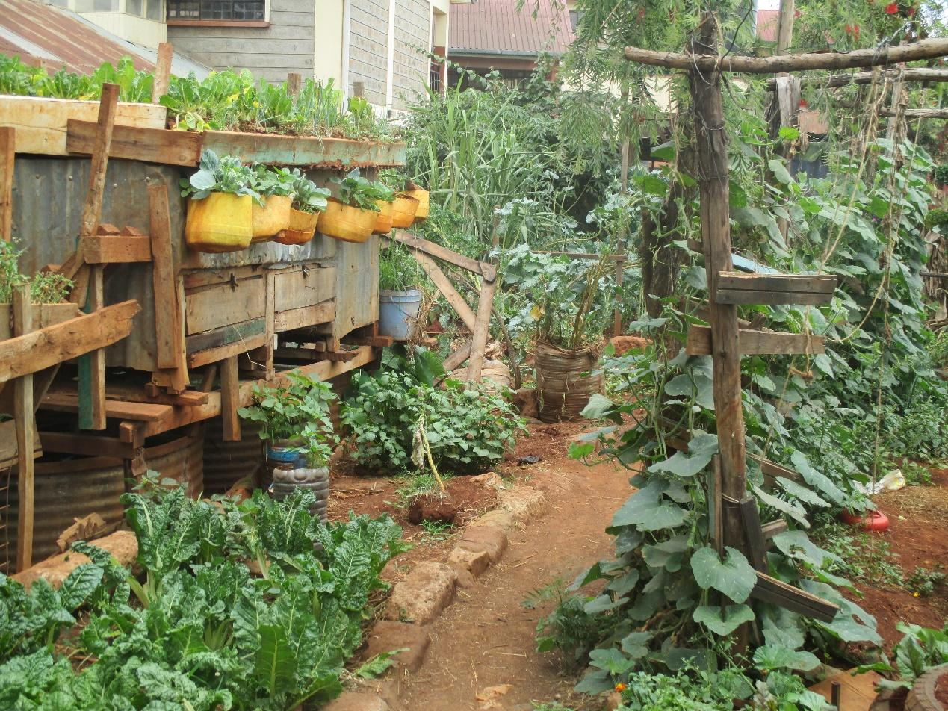

R11: Me as R11, I would like to take about picture one of group three. This picture as we looked at it does not have many stories. It is mainly touching on the environment and food that is clean and if you look at it we don’t use it in the community much. This area looks like only a selected few use it because for us in the community we is vegetables that come from the sewage and we don’t know where they come from. That is why these vegetables have been put in a clean environment, they look healthy, and they are watered with clean water not from the neighbourhood. That is why it just looks good.

M: Thank you very much R11. You have said that these vegetables you don’t use them? I would like to know why?

R11: it’s not easy for them to be brought to the local shops to be used so you find that only special people are the ones who can use the.

M: who are these special people you are talking about?

R11: Like the rich. You will find that vegetables like this will go to the super market and the people in the community cannot go to the supermarket to buy them. We just like to be cut for the local ones.

M: Thank you. What she has said. This Vegetables are found in the supermarket? And we in the community do not like to have to go to the supermarket? Is it true? I am asking that because I want to know if it a situation that is true to this community or if that is not the true situation. Do you support what has said? Is that the true situation? R6.

R6: Firstly, where was the photo taken?

M: Good question.

R11: The photo I took right here in the compound.

M: Just in the compound so the picture is from this neighbourhood? Before we go ahead this picture you have said you too it here in the neighbourhood is at someone’s place or what project is it from?

R11: The project is from this school in this compound right here. I have not taken it from outside.

M: Alright. Thank you. R8.

R8: That picture has made me happy. If I look at it properly the vegetables are healthy and I can talk about it because I have seen many such projects. That uses the methods of urban farming. If I look on the side I see something that looks like house for chickens and hares. And then below it there looks like a fish pond. So in that picture is little space that has been used to be able to farm many things of which I would say is that we are back where we started when we talked about us people from the community being lazy. That is little space that can do a lot. The way the person in the photo has used it. There is Sukuma, Spinach, pumpkin and the other things so you see those vegetables are clean and the environment is also clean, the water used there is probably clean and it is also found here in Mukuru just the same as the rest of these pictures and the person doing the farming is just from here so what I would say is that we are just lazy.

M: Thank you very much R8. We have gone back to the topic of urban farming. And he has added that among the reason we don’t farm. When we had discussed urban farming we had said that we don’t farm for many reasons. He has added that to some extent we are also lazy. There is an angle I would like us to look at. At least urban farming is something that we have discussed but there is another angle he has brought about that fresh food or food that has better quality is found somewhere. Maybe in the supermarkets or other places and we are the ones who don’t go to buy them usually. I would like to know why? Why is it that food that we know is of good quality is found in a super market we don’t go to buy it there? Though we know it is there why don’t we go for it? R7.

R7: Now there at the supermarket it’s hard to get there. Here in the neighbourhood there is only one supermarket and they do not sell vegetables or greens. They only sell other things so if we can go to the kiosks that is where we will. There is no super market close. I won’t leave here and pay bus fare to go to the supermarket to buy vegetables. It’s better for me to buy this one which is close and then go and wash it well and cook it well and it will be of benefit to me.

M: R7 you have said it doesn’t make sense to go to the supermarkets. Why?

R7: Because fare and vegetables we have to eat almost daily.

M: So you are saying the main factor is money? So R7 has spoken about money. That money can make it hard to get to the food that we would say is good so we settle for this other one. Apart from money what is another thing? R10.

R10: I would say distance. Maybe you don’t have money in the morning and then you hustle and hustle to get that money and you finally get it at like lunch time. As you have work maybe you start to feel hungry. You can’t leave the neighbourhood till town to buy vegetables and you are already hungry so it will be easier to get what is already there and use it and the other one you will go for it in the evening. Then maybe by the time it’s evening again you won’t go for it.

M: Thank you. So we have two issues there. There is an issue of distance and then also money. I want us to follow it up a little. Another one so that we don’t repeat ourselves? R8.

R8: We look at the cost because you will have used bus fare to get there. Maybe from here to town is thirty shillings. That thirty shillings you can just buy vegetables here. Vegetables for twenty shillings and tomatoes for ten shillings. Instead of going to buy vegetables at the supermarket that may be more expensive. Another thing I would look at is that when we go to the supermarket. Here in [Place] we are used to metal shacks. We go to those supermarkets and they are in tall buildings and you can fail to see those vegetables because it’s not what you are looking for. For me I have seen vegetables in Nakumatt, Tuskys supermarkets and it’s just because when I go to those supermarkets the things that are welcoming me there in the supermarket are snacks and other things. I will forget to go to the greens.

M: Thank you. M2 has something to say.

M2: I feel like another point that is coming out is the fact that we don’t go to the supermarket because those things are available here in the neighbourhood so they don’t necessarily have to only be at the supermarket. They are available here.

M: Thank you Faith.

M1: For me what I have not understood. M2 says that these things that are in the supermarket are also available here. Is that to say that if you had money you would go and buy it at the supermarket? So I want to know what is the difference between what is I. The supermarket and what is found here at the kiosks. What is the difference?
1:00:18
M: That's a good question. R10.
R10: What I would say is that you see that photo number one and there's a photo over there photo number 4 the one at the bottom. Let me speak concerning photo number 4.
M: Photo number 4 group 3 we're not speaking about that yet. We will get to it. If you have a question concerning that photo we will get to it.
R10: But as in what I'm saying is this here's what I would say. Those vegetables are fresh everyday they're watered with clean water. So those vegetables are at least. You can eat those vegetables and gain some benefit. So you're saying that because the rest of the vegetables that are brought here every day in the morning in sacks we don't know what has been done to them they're simply packed in sacks. You don't know what type of water has been poured over them or how they have been watered. You see the owner is simply in business. This one who has planted has planted for consumption by people around them. You understand?
R?: Now the vegetable that is in the supermarket what is the source? Does it come from a garden like this one? That one that you said comes in sacks where does it come from? I just want to understand that so that I can know this one the way I'm seeing it the one that's in the supermarket I have not really understood the difference.
M: Okay let us move to R12.
R12: In my opinion I don't see the difference. Because even if you go to the supermarket these vegetables you won't find any that have Kenya Bureau of Standards certification. Some of the things you will find have passed through the bureau but vegetables I have never seen that have been certified. So the vegetables in the supermarket and these ones the only difference is that in the supermarket you find them stocked in a proper shelf and they haven't been too exposed as the ones in the neighborhood are.
M: Thank you very much. Anyone want to add to that? R2.
R2: They would say that those in the supermarket and these others there's really no difference. Because some of these supermarket people maybe they buy their vegetables from Marikiti while those in the neighborhood most of the time is the person who sells you vegetables you probably know where they source their vegetables from. You can't be buying vegetables from someone and you don't know where they get their vegetables from. Most of the vegetables in the neighborhood come from Marikiti. Even those in the supermarket you find most of the times they probably bought them from Marikiti and took them to the shelf. They probably cleaned them up and they look different from the ones we’re getting the neighborhood but at the same time they’re the same vegetables. The only challenge is that you don't know the source of the vegetables you don't know where this person bought their vegetables from. That's what the people in the neighborhoods don't do checking the source, they simply go and buy vegetables from any vendor.
M: Thank you very much. I don't know whether R(?) you have gotten your response?
R(?): It's all right.
M: Okay thank you very much I would like to move us along. Following that story this angle has come for a second time. As we were speaking earlier the angle came up concerning fruits. We perceive that fruits are very good for us but they're not available in the neighborhoods. Then the vegetables contribution has come up showing one thing that there are certain foods which in our own perspective we believe they are helpful and valuable to us more than what is available in the neighborhood. It is the same type of food as what is around but there is another type that we perceive as better. For example speaking of vegetables we have vegetables in the neighborhood but the vegetables that are somewhere else we think are much better. So I see we have that same trend. So my question is this are there other foods that we think of in that perspective? Yes we are here but we think that those foods at another place are better? R10.
R10: What I would say is that nowadays even kales are not as delicious. If you go to the village and compare you tell the difference. Isn't it? If you're given kales here to eat on a plate and you're given in the village to eat you'll be able to tell that there's a big difference. So for me I prefer cabbages. If you pick this one and you pick the one from the vegetable vendor you will realize when you eat that there's a difference.
M: Okay thank you. Apart from vegetables and fruits what other foods do we feel have a difference? A difference between what we get here in the neighborhood which is not better than the supply in a different place? Are there other foods or is it simply vegetables and fruits? Is there another type of food? R12.
1:04:59
R12: I would say meat.
M: Okay.
R12: Mostly what you will find here in the neighborhood you can actually be sold for something you're not sure of. But for example in the village you will find that there is an abattoir. You would know that this meat is from this animal and so on. But here in the slum provided you find some meat in the butchery you don't even know what it is they are selling to you they can even sell you dog meat.
M: Okay thank you. Can I hear about one last type of food? Is there another food that someone can think of? R10.
R10: Fish as well. Fish nowadays is not the same quality as a long time ago. For example I don't know (Inaudible) that contained plastic fish. Fish which when you put it in water it swells up.
M: Thank you very much. Now this is what I would ask we have confirmed that there are foods that we see in other places and believe they're better quality than what we have here much as it's the same type of food. And we have given some examples and we have given the reasons for example distance was mentioned, cost was mentioned as well as other reasons. My question is what is it that can be done to make it possible for us to find the quality we believe is ideal for us? What can be done? And by whom? In order for you to find the vegetables that you desire the fish that you know this is the fish I need that you find the fruits that you need what can be done? And by whom? Recommendations we said that we look for recommendations here, isn't it? We are not just complaining. R2.
R2: What I would say is that people need to address something called urban farming. And organic farming more so for example the vegetables that have been planted organically are better even the taste. If the vegetables we grow are organic you can tell the difference from the other vegetables.
M: Thank you R2, organic farming. Another recommendation other than organic farming? What else can be done? Or should we just settle for things as they are? Is there something we can do for there to be a change? What is it? R12.
R12: (Inaudible) we need to be taught the knowledge and skills.
M: By who?
R12: For example there are organizations that you guys can connect us with that can help us.
M: Thank you very much. A final contribution?
M?: Skills about what?
R12: About this right to food and what we're supposed to eat.
M: Thank you very much. Any last recommendations? We are okay? Alright let's prepare our flowers these are for R11. Let's give them flowers. Thank you so much. I would like us to move on to the next image. We're here photo number 5 from group 3.
PHOTO 5, GROUP 3.
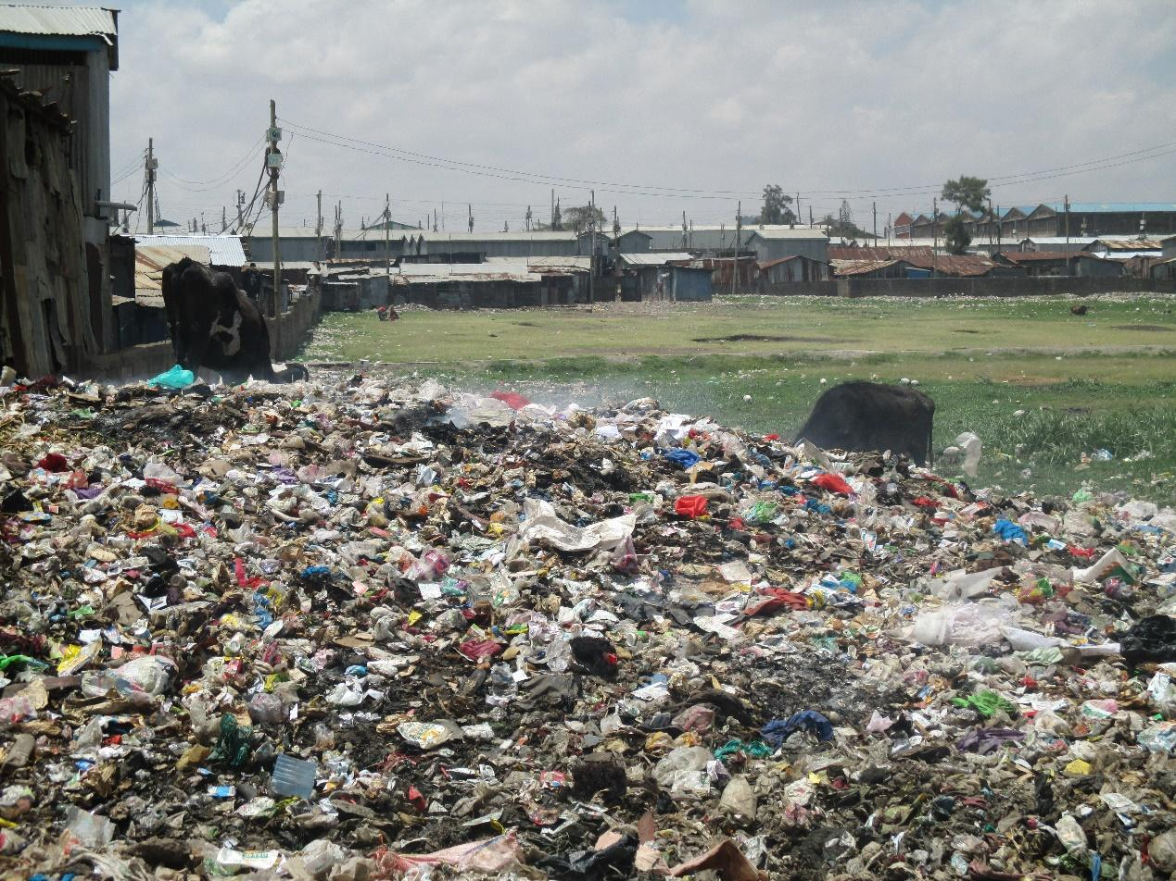
R?: As you can see here this is a cow here. Right next to it is rubbish. If you look at the other side you can see that there are people who live here. What is means is that even the milk we drink hear in the community, here in our neighborhood, the cow eats lots of that whatever is there in the rubbish, everything. Once the cow has eaten and then we drink the milk from the cow (inaudible). This is not good. Of course you can also see that people live here and as you can see there's a toilet there which must be where people go. All this means that this place is not good.
M: Okay thank you very much. Here's what I would like to ask she has explained to us about a dirty environment. That the cow is obtaining food from the dirty environment and then we consume something that has come from that cow for example milk. Let me ask first is this situation what happens here? Is it what happens here?
All R: Yes.
M: Okay. Once the cow eats food from this rubbish and then we probably consume milk from that cow does that cause us any harm? Does that milk cause us any harm?
All R: Yes.
M: What harm does it cause us? R7.
R7: Because milk if you don't boil it properly, you might consume it and it causes you to get sick even diseases such as TB. Cow milk can transmit disease to people. Or it might cause stomach upsets and pain.
M: Thank you very much. Anyone else? R8.
1:09 57
R8: I will support R7 because as you can see where that cow is feeding much of the food in that place is not grass but simply rubbish that has been disposed of there. Perhaps those are leftovers that are being thrown out. As you can see that is a dump site which you have all kinds of rubbish. So once the cow consumes that rubbish it comes into the body. The owner will come and milk the cow and probably sell that milk to people. What that means is that they also get that rubbish indirectly through the milk that they consume. Alternatively the cow will get sick. For example how the cow is standing on dirty water it might contract from the water foot and mouth disease. The cow might also contract other physical illnesses such as anthrax. Once that cow is sick I am sure that if it dies it won't be thrown away or buried. They will likely slaughter the cow and sell the meat in a butchery. At that point they will have spread the diseases to the inhabitants of the community.
M: Okay thank you very much. R11 you can also participate as we proceed with the discussion. Now this situation of having a cow and the milk is not healthy and also perhaps my meat will not be healthy the question I would like to ask is this are there such foods in the market? Are there such foods being sold here? Are they being sold here?
All R: Yes.
M: So here's the question we ourselves what can we do to make sure that we have not bought that milk or that neat coming from this kind of a cow? What is it that we can do ourselves to make sure we get the right food so we don't get this kind of food that is contaminated and can cause us harm? What can we do? R7.
R7: Animals or livestock like this maybe if we were brought for livestock specialist who come from time to time to come and inspect whether the livestock are still healthy. If they used to come and inspect the animals while dispensing the necessary medication because you might find that the livestock don't even get the medication they need and so on. Even like pigs here in our neighborhood you might find that one has died and you don't know the cause and you find it has been slaughtered and people have bought the meat. People don't call those veterinarians to come and inspect the meat. So if those veterinarians would come regularly just to come and inspect the livestock it would help.
M: Okay thank you very much. Is there something else that we can do? So that we don't go and eat food of substandard quality? R2.
R2: In my opinion something else we can do is people need to know how to manage their surroundings. So for example where the rubbish is being disposed of if it was being disposed of appropriately where it’s to be collected this kind of dirt would not be here. So my contribution would be that what we ought to do is to maintain cleanliness where we live.
M: Thank you very much. I would like us to move forward. Perhaps there is a question?
M1: I would also like to ask we have spoken of making that place clean. How do we do that where would we dispose of that waste?
R2: For us like how we reclaimed that dumping site that we reclaimed we relocated the rubbish. We coordinated with the ward admin and people from the county and they came and we moved the rubbish to where we take it because there's a place where rubbish from this neighborhood ought to be collected and they came and collected it from there. So to reclaim this area for example there are places where people dump their neighborhood rubbish for it to be collected by the county if they dump where the county will collect that place will be clean.
M1: So what you're saying is that there are garbage collection services here? Are they there? Is it a government service?
R2: There are groups that offer the service. They manage waste in the neighborhoods.
M1: So those groups collect rubbish within the neighborhoods and then dump in the dump site? So then the city council ought to come and collect from the dump site?
R2: We have agreed with the County Council that we will dump at a specific point. They've been coming and they collect with their trucks each month. So that becomes clean. So you will find that these many dump sites within the neighborhoods are being gotten rid of.
M1: Why is it that now we have that waste disposed of there if you have these groups that collect the rubbish?
1:14:48
R(?): Let me add to that. You see each neighborhood has youths who collect garbage and deliver it to a specific place. As in you find that there are people who may be past Sunday the youths came and cleaned. So maybe they clean every Sunday because you can't say I will give you a sack in which to collect rubbish and you stay with it for a whole month because you will be smelly (Inaudible). As in you will find that someone has given you a sack they bought for example you will find the place where we stay we came together as about 26 young people we went to [name of place] and picked certificates for that. So we collect rubbish every Sunday. In order to start that service we had to have sacks, papers and so on. Each one of us contributed a certain amount for us to buy the sacks. And as you know things are difficult right now so we can't give you a sack and just leave it with you like that. Because that would mean that we would also go at a loss. So what we did we said per plot it's possible for each plot to contribute 20 shillings. Because each plot has 6 rows. So this Sunday so and so contributes next Sunday someone different and so on.
M1: So 20 Shillings per week?
R?: Yes, Every Sunday 20 Shillings. When we come to collect rubbish 20 Shillings. What you find is that there are difficult people. And no matter how much you try to explain you can't convince them they will still give you trouble. So for such people what you do you ask them for 20 Shillings for rubbish collection and they say I don't collect my garbage through that service. That’s when you find such an unplanned dump site. You could even find that if you start collecting that garbage where that cow is you just go and collect it you send yourself there and you say I want to collect people will say that you want to grab that piece of land. It will result in problems you can even find yourself getting arrested. So something like this if they wanted to start afresh you see people in the neighborhood going to talk to the chief for this rubbish to be collected and that is a process.
M1: So now such groups how can they be assisted in order for them to carry on with their work?
R?: What I would prefer because as you know many things there is someone who supports. You might have a supporter, something like this project can move on well if you have someone who is supporting you because it's not every plot that has someone to pay that 20 Shillings bill. You can go and find that on Sunday you go to someone's home you find that they have gone to church. And you will still collect the rubbish and that is something you will find that every Sunday people have gone to church. You will collect the rubbish and the more you collect the more you get tired. You will come in even pick that sack that you have and (Inaudible).
M1: So that support where would it come from?
R?: That is the same question we are asking ourselves.
R?: What I would even emphasize more on is that you may find assistance from government or even on NGO. This kind of rubbish how we had said we can manage it in the neighborhood we had said that we won't be collecting rubbish from people's doorsteps. We would be collecting monthly. So we would also collect payments monthly. The thing that was a challenge was the drums in which to store the rubbish in different positions which would need to be secured with chains or metals and so on. We found that that was becoming costly to buy those things because if those things are available even if someone is walking and they have some rubbish they can simply dispose of it in that bin. So that would mean that we won't be coming to collect garbage, we would only come for the garbage at the end of the month and will simply be coming to collect the payments for garbage collection at someone's doorstep. But you would find what other people are very problematic. So you'd find that we would have lots of conflict with the residents. You would find that it would be annoying and difficult to clean that kind of place. You find that you even clean today and tomorrow it has been dumped at again. So if maybe such things were done (Inaudible) maybe find a piece of land that has been set apart for dumping.
M: Thank you very much for the good insights. I would like us to move forward and then we will take a break. After this take a break to freshen up and then continue. I would like us to go to photo number 4 group 3.
1:19: 51
PHOTO 4, GROUP 3.
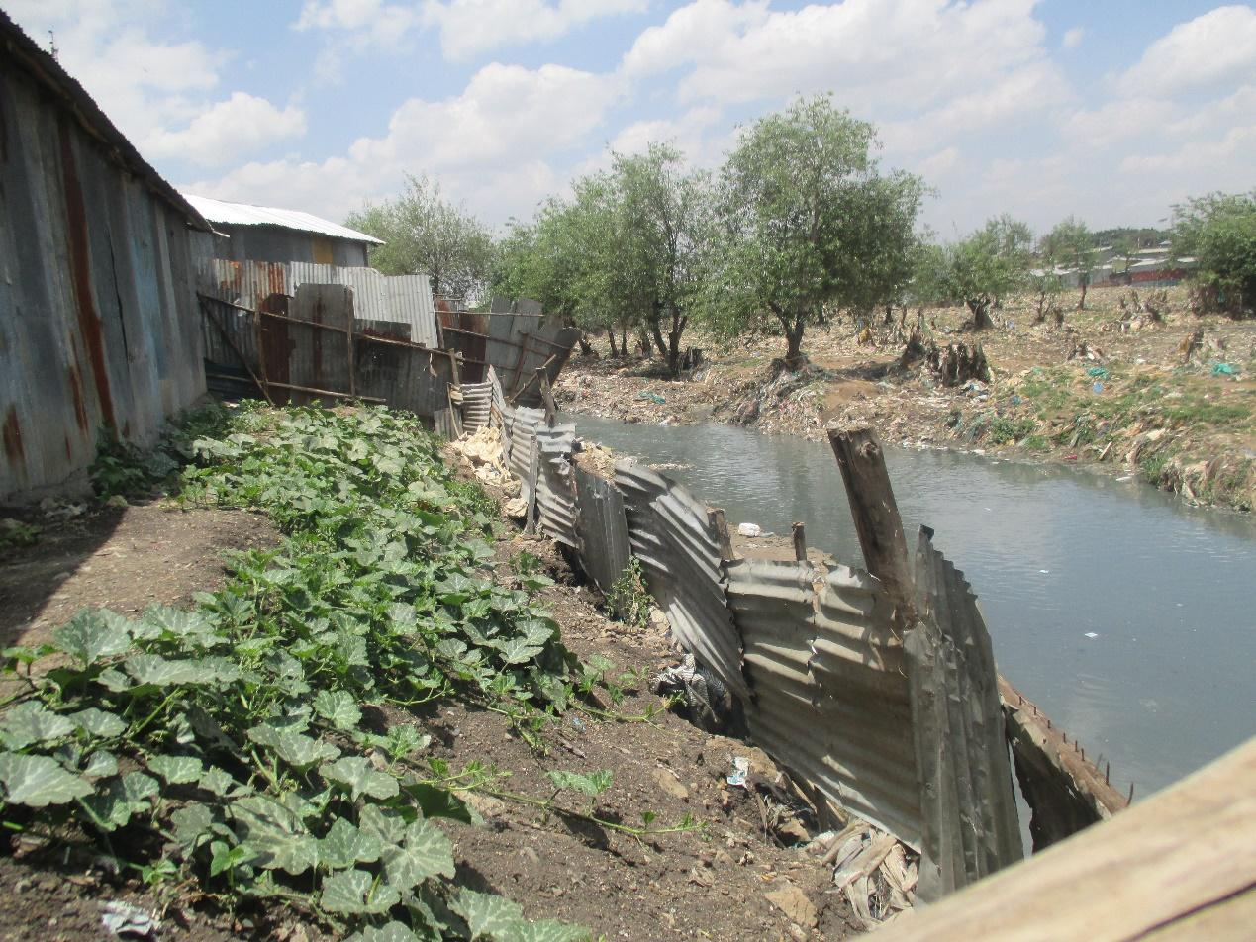

R9: My name is R9 and I'm in group 3. We are looking at photo number 11 which looks like this. I don't know if you can see it clearly. If you look at it what you can see this is a sewer this is a river this is a river that is carrying all the sewage from here. If you look at it clearly you'll see that there's a borehole. On the other side there is a house that is very close to the river. So what this image is showing is that this vegetables that have been planted here people are using this water and this water is dirty. So there is contamination. This river there are those who live close to it. So that is also a risk. In this entire photo there is nothing that is safe. From the houses themselves to the vegetable themselves. So that's how it is.
M: Alright thank you very much. My first question is this those of us who are here is this situation something that happens here? The people plant vegetables close to sewer lines? Is this something that happens? It happens?
All R: Yes.
M: Okay this is what I will ask why is it that people do that? What is the reason? Those who are doing this why are they planting vegetables at such a place? R2 says it's due to water availability. Tell us a little more.
R2: You find people like these they do this due to water you'll even find that some use generators to pump the water to water their plants. So you find that those crops grow well there because the water that place there you find that all latrines from this neighborhood are pumped to that river. So when vegetables come from that garden (Inaudible).
M: Okay. These vegetables when we consume them, do they cause any harm to us as compared to others that have been planted in other places? Is there harm? Yes R9.
R9: The main challenge that I see is that you see this water is being used to water these vegetables and then it is taken to a kiosk and sold to us. Vegetables from a kiosk are usually not washed. They simply place it there and then they remove it they don't necessarily wash them well. They simply dip it in the water and give it to you and you go with it to the house and sometimes we don't cook vegetables until they are properly cooked. So you find that people fall sick.
M: Okay thank you very much. We had spoken about the effects of diseases- when we fall sick how it negatively affects us in terms of food security- so we're not going to dwell on that because it is an issue that we had already discussed earlier. So let's please give them flowers drop thank you very much. Next we look at photo number 8 from group 3 and then we move on.
PHOTO 8, GROUP 3.
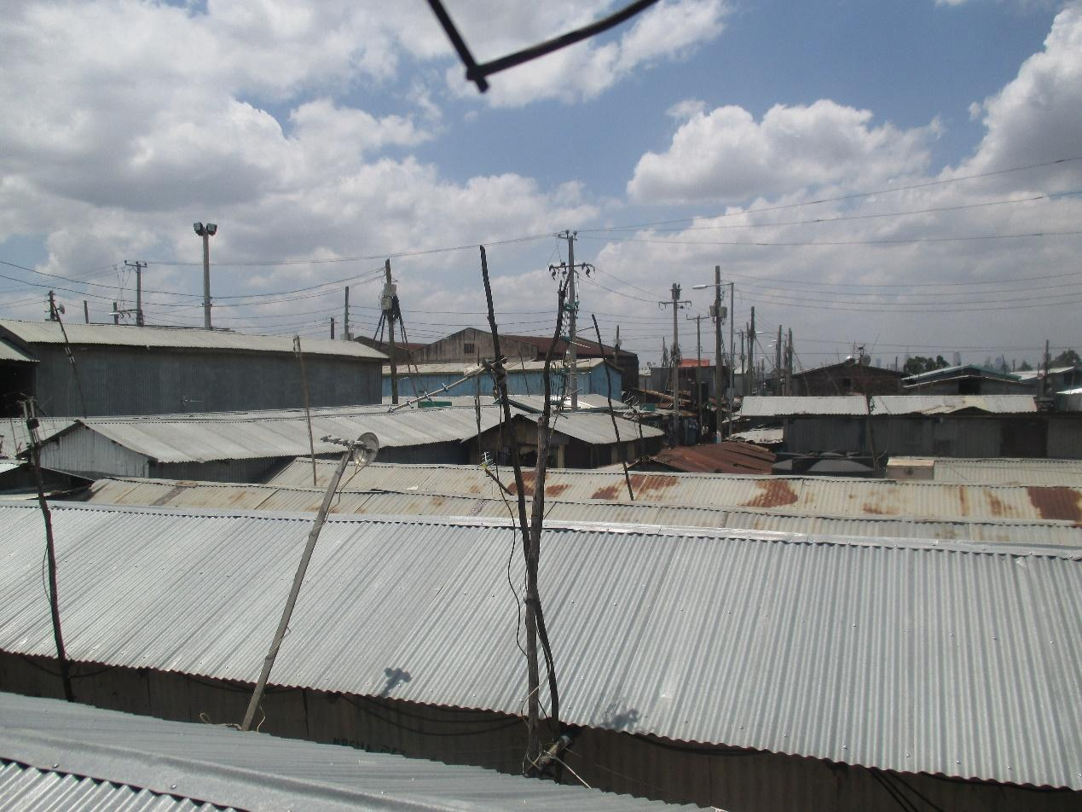
R?: This is my photo when you look at it you'll see that is a photo I took of how our communities look. How buildings have been built in the neighborhood. When you look you can see that there aren't any roads or pathways. People and vehicles can’t pass through unobstructed say for example if there's a fire you find that fire trucks cannot reach our neighborhood. The houses simply burn down. And people lose their property. So this is a place that has a high population and then it is very congested. So our neighborhood is not good.
M: Okay thank you very much. My first question is do we all agree that our population here is very high? Is this an issue that is there?
All R: Yes.
M: The question now is due to this high population here in our neighborhood of [Name of place] how does this negatively affect issues of food security? How does it impact health issues and nutrition issues? How does it impact our issue of food? I have opened the field R3.
R3: I would say that when the population is this high it affects food security because demand is very high. You find that like in photo 4 when people find that opportunity to plant next to a river that is unclean but when they sell their produce there is still high demand.
M: Okay. Thank you very much. Someone else how does high population affect or impact the issue of food security? R2.
1:24:50
R2: Many people have relocated and are running away from rural areas coming to Nairobi in search of work. Meanwhile when we left the rural areas we left farms that we are no longer farming. So we all come to compete for space in the ghettos. It really contributes because you find that the number of farmers now has reduced significantly because people are still migrating from the rural areas to the city.
M: Thank you very much I would like to ask when the number of people in the rural areas reduces how does it affect the issue of food?
R2: It affects the issue of food because you would find that when the farmers reduce and maybe they were supplying 10 people with vegetables, it will mean that these 10 people have to search for a new supply. While they're searching it results in (Inaudible).
M: Okay thank you very much. Another effect of high population? Let's not just look at people in the community you can also consider the number of people in the house. When a house has many people I don't know how many is many but if we can see that many people in one place how does it impact their food in that household? R8.
R8: When there are many people in the area it means that the food that is available is not enough even if you have money you can fail to find foods to buy at the market. Because those who came early might have found and those who come later find out the food is finished and they will lack food. What this means is that even those who are supplying this food are few. So many will lack food.
M: Thank you very much R8. Let's move to the community level. Now I want to know at the household level if in the house there are many people how does this affect the issue of food? And how does it affect it? R7.
R7: If you’re many in the house if you were to eat a balanced diet you might then be forced to reduce it you won't have the balanced meal. If I was to cook kales and ugali and fruits I will be forced to use the money for fruits on something else. You'll find that a larger amount of money will have been spent than what fewer people would have spent.
M: Thank you very much. Is there someone else? Before we move on? Okay we have seen that we have discussed that when the population is high it affects the issue of food Security in many ways, is that true? The question now is what ought to be done in regards to this population issue? What can be done how can it be contained? What can be the solution and who is supposed to solve this problem? Our final issue before we take a break. R12.
R12: What I would say is that employment is what causes the population to be high in some places. Because many people are hustling. Maybe there's a house you find that for you to live here and go to a different house I bet the house you find that maybe that house cost 4500 Shillings to rent. You see you find that it may cost 10000 Shillings and yet your own income is much lower than that. So what you find is that here in the neighborhood for me maybe a house costs me 2000 Shillings so even if I don't hustle you might be able to get some money from a friend or from your mother and they assist you to pay rent.
M: Thank you very much. What can be done about the issue of overpopulation or high population? What can be done in order for the population to not be so high that effects the issues of food? What can be done? R2.
R2: What I would say is that what can be done for the population to reduce the first thing is family planning to happen in the community on all sides. Because you’ll find that some people have too many kids you can find someone with seven children and it's not that they have good money. You'll find someone has five children and yet his salary is very low. So you see these kinds of people need to be assisted by government and other people here for family planning to happen. The other thing is that like the counties, work needs to happen for people to stop migrating too much towards the city. Because you find what happens in Nairobi there are too many people because every day there are new people coming in and those who are leaving are few.
M: Okay thank you very much for that. Is there someone else?
1:29:54
R?: What I would suggest is about reducing the urban population is that we need to remove this mentality that work can only be found in Nairobi. The Government can advise especially now that there are counties to have factories in other places. There are places where there are open spaces for instance if you go to places like Kajiado there are places where there's lots of space. Those are places where things like factories can be taken and the population issue it will be assisted.
M: Thank you very much R6. Someone else?
M2: That issue of unemployment that he has started to say for example companies can be taken two other places to reduce the population here in Nairobi is there another thing that can be done or is there something that you guys can do in order to resolve the unemployment issue for it to be sorted?
M: Okay we ourselves what are we doing to address unemployment? R8.
R8: People believe too much in being employed. And that is why you find that when children complete school all they can think about is going to Nairobi or to urban centers. People forgot that there are opportunities in the rural areas. We can go back to the rural areas and do something important for example improved agriculture you can employ yourself such things you understand? It would be much better than coming to Nairobi where you would get a job which is very unlikely and you find issues like overpopulation which will give you many problems. So when we go if we go back to the rural areas we could find things to do and things will be much better.
M: Thank you. Is there someone else?
M1: Let me do a follow-up and ask do you think people from here would go back to the rural areas?
R8: In my opinion it is possible as it is better than staying in Nairobi but where you are, you are jobless and yet in the rural areas there is something you can do. That would be better.
M: As the people who are here what do you think can be done to make it possible for many people to go back to the rural areas?
R?: Someone has come to Nairobi and has found there is no work and then they have come to a training such as this one in our thinking let me go back to that farm of mine. If you want something like that if you are that lucky and found that someone has taught you something like that that is beneficial whereby maybe you have a small farm at home because what gets us to move from home is maybe that we don't have enough family and farm land. So you find that something like that can be done on a small farm and yet you would be able to earn a lot. Someone will then go back home and practice what they have been taught. So what I would say perhaps to the government or to the involved bodies is people such as these can be called to a seminar like this one and when you get this training you tell someone you don't have to stay here and in order to earn money even at home you can. You encourage them and then maybe if there's a little bit of assistance you go in someone can go and start with that a new life and to build up their lives. I think that would be better.
M: R2.
R2: What I would add to what R8 has said is what causes many people to quit farming is lack of water. So what I think the government can do to make people start moving back to their rural homes is perhaps to make water available to all farmers. Because right now even if I go back to the village you will go and plant maize and some of it will dry. You'd end up with a small harvest and be frustrated with farming. But if the government made available water for everyone go back to the rural homes to farm.
M: Okay thank you very much. One last contribution.
R?: What I would add is Madame has asked how we can reduce unemployment and R8 has said that we shouldn't be over dependent on employment. So like these guys who have formed groups that do that, how can we empower them to continue with that thing until (Inaudible). You will find that the government says there is a youth fund but when you go to that you find the process you have to go through you end up not going through the hassle. These NGOs tell you that they can fund a group but the business proposal they tell you to do and many people dropped out of school due to issues of school fees and so on maybe someone looked and realized we have six younger siblings and so they decided to drop out of school and become self-reliant if you tell this person to write a business proposal properly it will just be like you're singing a song. It needs to be easier to access these opportunities such as loans and so on.
M: Thank you very much. I would like for us to take a break after which we will come back and continue. [Name] will inform us how long we need for the break.
M?: In order that we are not too late I would propose five minutes. Is that long enough?
M: As we take them break let's not go far. It's just a short break for us to stretch okay? As you take a break there are some sweets here you can pick one so that it can give you more energy. 5 minutes who is the timekeeper? R8 thank you.
1:35:34
Audio paused.
M: As we continue I would like us to go back here and start with photo number 3 from Group 1. Photo number 3 Group 1. Welcome R4.

PHOTO 3, GROUP 1.
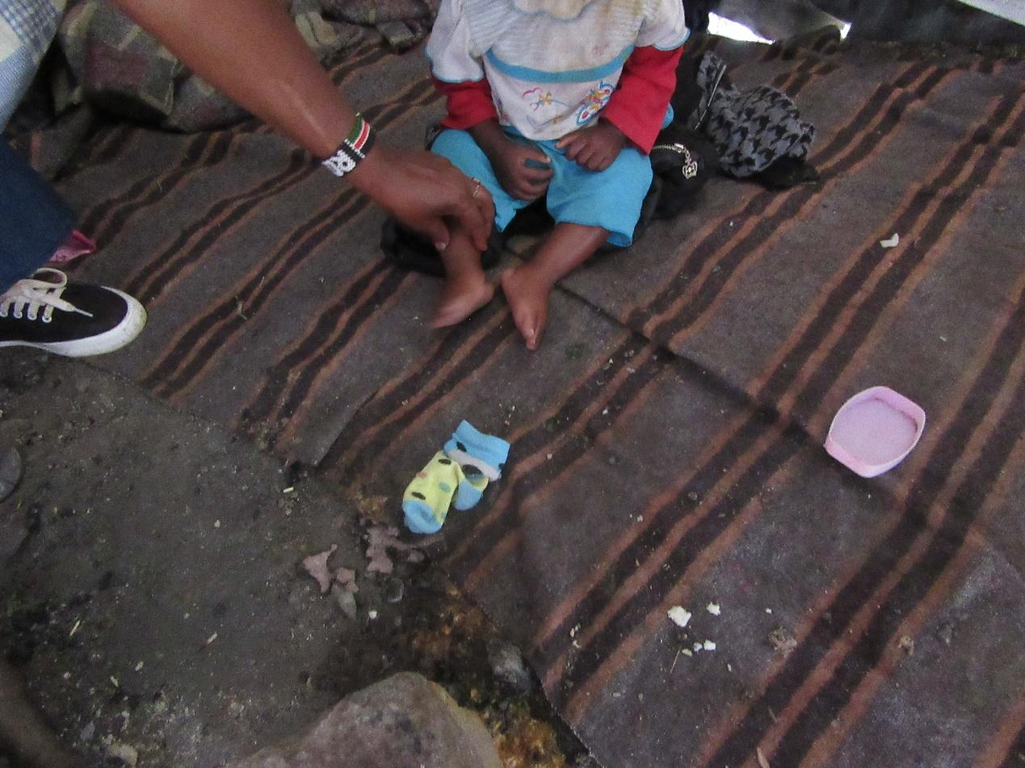
R4: My name is R4 Group 1 picture number 3. Picture number 3 means (?) In other words nutrition. For that child. This child in order for them to get nutrition there are many things that have contributed to that. This child their mother is giving them any food not necessarily quality food. You find that they are given porridge that doesn't have milk or anything else and that porridge is used from morning to night. That same porridge in the morning when the mother is leaving if they give the baby when it's warm but throughout the rest of the day when it's cold. It will cause them stomach issues and that stomach would be swollen. Also because the child is in this state if this child is 2 years old they need to be eating a balanced diet but it is not available it is only porridge. One, poverty contributes to that. Two, that mother's ignorance because that mother doesn't want to be told even if they are they think that it is a normal thing. Number three the mother thinks that this child as they are, they are fat but the reality is that the child is not well. So this mother still lacks knowledge. They need to be informed what a balanced diet is. A balanced diet they can find it from the things that are available in the area where they live. Because that child when the mother goes to the kiosk near where they are they can find amaranth for five Shillings they can find tomatoes for one shilling or two Shillings or five Shillings. They can find beans that do not have soda for 10 Shillings and they can feed the baby and the baby will have had a balanced diet. This child is malnourished. They have drunk impure water and that is water that passed through pipes within the neighborhood the plastic ones and they pass through ditches they get leaks and you find out that child finds that water at the tap when it is already impure. That mother for one because they do not have that knowledge they don't know how to treat water so they will simply give the baby that water as impure as it is. The child will be malnourished and will start to diarrhea and when the child diarrhea's they can die because no matter what they eat it will simply be passed out because their health has been affected. Therefore this mother the first thing is that they need to be educated that the right of the child to food ought to be there. Cleanliness is also an important lesson because where that child is whatever is close to them they will pick and put in their mouth even if there is food they will eat with dirty hands. Hallelujah!
M: Thank you very much R4. R4 has explained to us many things concerning the issue of malnutrition and as I recap a little bit she has explained to us the causes of malnutrition. She has mentioned a few. To remind us she has spoken concerning the types of foods that children are fed she mentioned the issue of ignorance among parents at home about what they should do she talked about contamination of water there which goes and causes disease. My first question is this, number one is this issue of malnutrition is it an issue that is there among us in this society? Is it there?
All R: Yes.
M: Thank you very much I would like to know this R4 has given us some causes of malnutrition in our community. Are there other causes that she may not have mentioned? What other causes are there that can result in malnutrition in this community apart from the type of food and apart from ignorance in the parents and apart from water contamination? What are the other reasons? What else causes this malnutrition issue? R12.
1:40:12
R12: Poverty. You will find that maybe the parent is a single mother she's not working even if she's hassling she only gets a little money and maybe she has many children so even if they hustle what the children need she may not be able to afford it.
140 32
M: Thank you very much. Another contribution? R10.
R10: You could also find that the person who has that child is not their mother maybe it's someone who the baby has been left with. And you know as long as the child is not yours you know how these people are and what they do. Not all of them but there are some people who are careless. They don't care. They'll give the child porridge in the morning porridge in the evening until when the mother will get back.
M: Thank you very much what he has spoken about the caregiver who is minding the child. Another issue that might contribute to this malnutrition? Other than the ways in which you haven't mentioned.
R1: You might have a child like that one but you have your own problems and you don't want to be open to other people so you can't take good care of the child.
M: When you say you have your problems what do you mean what types of problems? R1.
R1: It could be that you do not have work and so you do not have a good income and your child is becoming malnourished and you don't want to be open or maybe you lock the child away so people don't even know that there is such a problem. By the time it becomes known the situation will be much worse.
M: Okay let me get one final contribution. If it's there. My next question is this R4 has mentioned that this man nutrition is also contributed to by foods that we eat. Or the foods that we give to children. Isn't it? What are the foods we normally give children all the foods that we eat which in our opinion might cause this problem of malnutrition? Which foods are we eating? That we see might contribute to this issue of malnutrition? R12.
R12: You might find that among workers when someone leaves their child somewhere due to the time they wake up in the morning even if it's boiling beans that early in the morning they simply make some rice and maybe put some or ugali with soup. And the child will survive like that the whole week.
M: Thank you very much. Someone else? R4.
R4: Food the children in this neighborhood are given is potatoes and rice. Even without a tomato. That is the food for children everyday rice and potatoes. Rice and potatoes. Rice and potatoes. And white porridge, which the flour comes processed. We used to use less processed flour and that used to be better than this one that is already fully processed.
M: Why is it that many times people feed to the children those potatoes?
R12: They say that is what is easy to cook and can be cooked quickly. They also say that is what is cheap.
M: Thank you very much. What other foods are often given to children that might also cause this malnutrition? Is there another example? R2.
R2: You find that some children the parents don't even cook food at home. For example a hand cart guy may just eat two chapatis and some soup. Maybe another one will go and eat rice with chicken or beans with chicken. So you might find that some people don't have the time to cook for children (Inaudible). They eat food in the hotels.
M: Okay thank you. What type of foods do we see in our opinion that if these children are fed will help prevent this issue of malnutrition? What types of food would ensure that we don't see malnutrition here in our community? R7.
R7: The first thing that I would say is these mothers are ignorant. They have been educated they go to clinic and are educated on how to feed their children. But then even if you go and find them in the house and explain to them they will still feed the children the foods they are used to. And if you ask them they will say that that is what they are accustomed to cook for them. So ignorance is the fast main challenge. Also even if you don't have money if you cook for this child even if it is that rice and you mix it with some greens even if you just buy for ten shillings or even five Shillings you will find that child has had a good meal and a balanced diet. And the fruit for five Shillings. You probably won't even have spent 50 Shillings or a hundred.
M: Okay thank you very much R7. R7 has told us has brought out some issues for all of us. First she has brought up the issue of ignorance again and I would like to know: what is the main contributor to women having these high levels of ignorance? That at even after being taught as she has mentioned they still go home and do what they're used to? Why? R1.
1:45:26
R1: The issue is simple ignorance. They're unaware of the importance of feeding children well. So even if they're placed say in seminars where they are taught the importance of feeding children balanced diet it will be helpful.
M: Okay thank you very much. You have you given us a recommendation thank you. Would you like to add to that issue of ignorance R4?
R4: (Inaudible) because I have worked with these women and I understand them these women say that because they're in the neighbourhood and they think they ought to simply live as they do in the neighborhood. When you go and tell a woman they say provided my child is growing it's all right all I need is for my child to be growing. So you can find that yes this child is growing but they are weak and they are constantly needing to go to hospital. And even if you try and educate them ignorance is the main sickness here.
M: Okay I want to follow up on that issue that you have educated these women but they are still not implementing what they have been taught. Why? What is the problem?
R4: They say that this poverty is the contributor. Because most of the times when you give them flour for this child or (Inaudible) for this child you will find that that woman in the morning wakes up and uses (unclear). If you tell them for one this is medication and not just food you find that when the child is brought for clinic rather than growing and moving forward they are regressing. This illness I don't know where the medication will come from.
M: Thank you very much. R6 you have a contribution?
R6: The other thing they say is time. If you give them flour for porridge they say and that by the time they have cooked the porridge they'll be late for work or something like that. They don't have time for their child. They're just in a hurry and they say that this will take time.
M: Okay thank you. Anyone else with a contribution? Alright this is my question.
M1: (Inaudible) when you say that the mothers don't have time why don't they have time? For their children.
R?: Some of them have jobs they are employed in these companies. (Inaudible) you'll find that they're not able to breastfeed. So maybe before they go to work they need to leave (inaudible) because breast milk has the nutrients that they need. So I would say these companies deny them the time to invest in their children. You see that someone leaves here at 6 and comes back at 6. They come in find out that baby has slept they don't even need to know how the day has been.
M: Thank you. R10.
R10: There is someone I saw who had a child recently it hasn't even been five or six months what their situation has meant is that she has to hustle. Because of where her life is at. This child still wants to breastfeed it is a small child, still very small. But this woman has been forced to put the baby on milk you see. Because her ability does not allow her. So for some people it is not their desire they are simply forced they don't like it but they have been forced. (Inaudible)
M: Okay. R8.
1:49:47
R8: I think it will be beneficial that all women are educated. Because when you have that baby your life is in that baby. You have to care for them well and make sure they have grown not just physically but also mentally because this child will become in future generations a good person who can help you in the future. The first thing is that breast milk is very important. So no matter how busy you are you can't be too busy to mind your child. If you are forced to work for long hours there are things that you can do these women are taught and they know and every woman who has ever gone for a seminar or takes their children to clinic these are things that they know. So I would say that yes there's an issue of ignorance but it is also important for someone to take care of their child. They need to do that knowing that this child is their future.
M: Okay, R12.
R12: I don't know whether mine is a question or an answer. The responsibility of minding the child is it the mother's responsibility or is it shared between the two of us? Because women are being accused as the ones who ought to bear this burden of taking care and feeding the children. In case of the absence of the mother and the man is not educated on how to take care of the child, the child would die. So what I have is a recommendation that once someone is pregnant the man should be involved even the clinics before the birth and so on we should both attend. If it is education we ought to be educated both of us. That way at least we can improve.
M: Thank you very much. I want to ask my final question in this section. Before we move from there. As we speak about the issue of malnutrition we have spoken a lot about children. My question is this are adults in this community of [Name of place] are there those who are affected by the issue of malnutrition? Or does malnutrition occur among children only? Are there adults?
All R: Yes.
M: Who can explain to us? Malnutrition among adults here R4.
R4: There are adults here in Ruben. There is a neighborhood somewhere there those people in that neighborhood when they wake up in the morning all they do is drink illicit brews they don't have time to eat. So you find that person coming here to Rueben Center to the clinic and they are panting. If you inspect them and look at them you can find that even their blood level is low. But the stomach is big. This is because this person does not eat and their friends are the same type of people. So even among adults and especially men there are many who have malnutrition. If you are, because for us women those who are malnourished, we visit them, sit them down and tell them that they are not going to embarrass us. But there is no kamukunji for men. The kamukunji for men is that one where they go and drink but the one for women, and those women will be sober, the women will come in sit down this woman and say to her “you have children and these children depend on you. And there is no one nowhere else where they can find care except from you. So you have to step up. You need to do this and that and the other.”
M: Thank you very much. I would like us to move forward okay I would like us to continue. That image has given us a very good conversation let's give them flowers drop. Thank you let us move to photo number 4 group 1.
M1: We didn't find a solution for (Inaudible).
M: Okay. There is only one recommendation that came concerning this issue of malnutrition in our community here in [Name of place]. I think I have heard 2 recommendations so far. First that we should all go for education. The other one was given there. Does anyone have a different recommendation? What can be done in order for this community to stop struggling with the issue of malnutrition among children? Among the men we've had the recommendation about when men gather together. Especially among children what can be done? You know that for this issue of malnutrition do not exist here? R4.
R4: I think this needs the intervention of every member of the community. Because this child is a child of the community. Because when you see such a child who is living in that kind of state I have to follow up to find out who their parent is and what they are doing every day and why the child is the way they are. So when everyone becomes an interested party this issue will come to an end.
M: Another recommendation? A quick one? Even afterwards if it comes to your mind you can still mention it.
M1: Allow me to continue to ask. We said that often times the women the reason many times they don't feed the children and they don't breastfeed well is because they are going to work. I would ask: what would be the intervention there? Or what can people do?
M: R10.
1:55:12
R10: And that is a problem because to assist someone like that would be difficult. You see maybe they’re a single mother you can't provide her with everything and chances are you yourself are living in poverty. So that question is extremely difficult.
M: Okay R10 says that this is a very difficult problem to solve. Another contribution? Here is what [Name] is asking this is the situation. Here's a woman, she should be breastfeeding or has a small child she should be taken care of but she is still working. Where she's working maybe she's not given time well so it's affecting her and she's not taking good care of her child as she ought. In this entire situation is there something that can be done to assist with this situation? For this woman to be assisted? Is there a solution?
R2: What I would say is that the government ought to put in place procedures in these companies because many companies still don't follow employment laws. You will find that expectant women ought to get leave to be able to breastfeed say for 6 months. Such laws need to be actualized in the companies in the industrial area as well. Because many of these companies you will find they don't give that time.
R?: You will also find that that work to which that woman is going you find that that salary is probably also very low. So she's at work and the child is suffering but if she was earning at least a bit better it would be easier for her to better take care of her child.
M: Thank you. Another issue? Okay thank you very much so as we move forward I would like us to discuss photo number four from group one the one at the bottom. Photo number 4 Group 1 taken by R1 welcome.
PHOTO 4, GROUP 1.
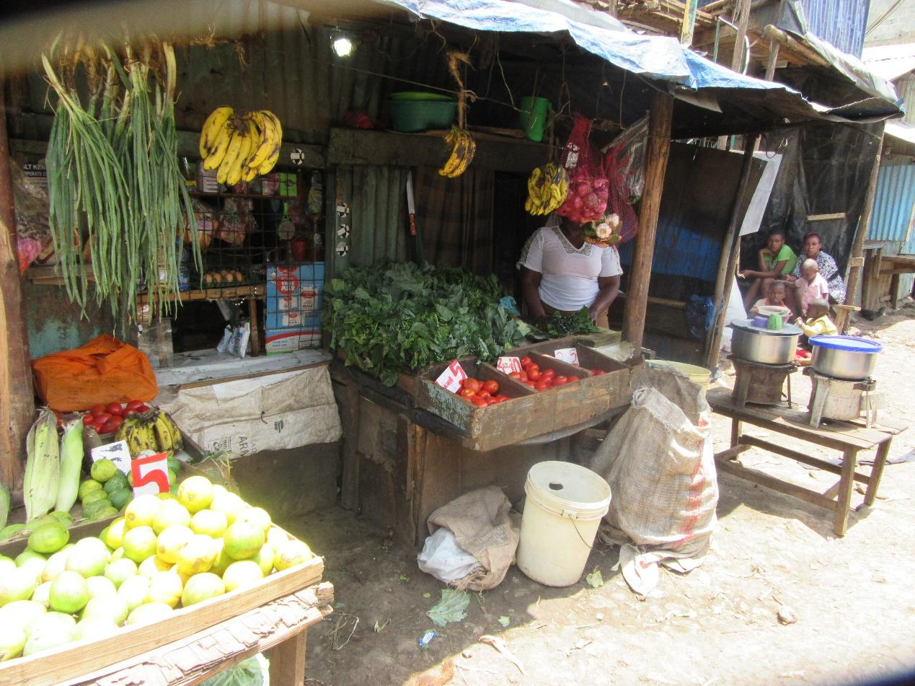
R1: My name is R1. I am speaking concerning photo number 4 from Group 1. As you can see in the image that is a photo that has a vegetable kiosk and also a shop and also food is cooked there. This shows us that there is a balanced diet there so that if you go to that kiosk you can find vegetables of the type that you wish to get, you can find from the shop flour if that's what you need you also find food such as beans and green grams are ready. There are also fruits so that is a balanced diet.
M: Thank you very much R1. She has spoken at length concerning balanced diet. She has said that all the foods that form a balanced diet are available. Is this true? Is it true that these foods are available?
All R: Yes.
M: Thank you very much. My second question is this people from this community we ourselves do we eat a balanced diet or we don't? Is it our norm to eat a balanced diet? Do we think that we eat a balanced diet or not? Who can contribute? R6.
R6: Some of us do some of us don't know whether we eat a balanced diet. But it is not complete usually. So if you look at the table of a balanced diet you'll realize you can't access all those things at the same time.
M: So it is not complete? Normally what is it supposed to be?
R6: They say that you should consume a little starch and vegetables and proteins. You can find that someone goes there for vegetables and starch and that's it they haven't picked an orange. So the meal is not balanced.
M: Thank you very much. You have said that sometimes it is difficult to find all the foods that form a balanced diet together. Why is it difficult?
R6: Capital.
M: Capital? Okay speaking about money and I feel like some people want to support him. R4.
R4: I would like to support you 100% because that kiosk belonging to so and so has everything there. Everything is there but money. You will go there with a hundred Shillings or maybe 50 Shillings. You will pick tomatoes you will pick some greens and the ones at the bottom go for 20 Shillings. There are some oranges there if you add to that beans that 50 Shillings is finished and yet you still want but lack the means to get. So the foods are available but the purchasing power is what is lacking.
2:00:13
M: Okay, we have said that money is a problem. Money is problematic. So what we are being told here is that food is there but we are not eating them because of lack of money. Is that the truth? Is that the situation here? Let me ask my question this way. If you look at these food that are said to be a balanced diet in order to eat a meal that you will say is balanced diet, if you use the foods we have here, what are we meant to eat and then we will do the math and see how much it comes to. What from the picture of you eat will you say is a balanced diet? Who can start for us? R8 do you want to try?

R8: There is some Kale, bananas as fruits, there are oranges, onions. You can also buy things like flour. There is garlic, tomatoes and other supplies in the store.

M: Thank you. So we have agreed that for there you can get a meal that is a balanced diet? So my other question is to get a balanced diet from there. How much does someone need? Let us start with a budget for one person. How much money does one need? R3.

R3: I think you need just about a hundred shillings.

M: What will one hundred shillings buy?

R3: In that some place they are selling githeri. You can buy githeri for thirty shillings, tomatoes for ten shillings, you can buy some vegetables, oranges and bananas.

M: Thank you. What about if you have a family. Like an average size family? How much do you need to be able to put a balanced meal on the table?

R6: You need about eight hundred shillings a day.

M: R6 says eight hundred shillings. Does anyone else have an amount? R8

R8: For me in a day I need about six hundred to six hundred and fifty.

M: Thank you. I would like to know. This balanced diet we have highlighted money as being a barrier to accessibility. What can be done so that we will be able to have access to this food that constitutes a balanced diet at a cheaper cost? So that money is not the reason why we can’t access this food? What can be done? In this setting. Because we are saying that the foods are available but we are not eating them and we have said the reasons. What can be done? R12.

R12: For example if we have farms in the rural areas that are idle we can think of maybe farming things like cereals and keeping them because they do not get spoilt quickly.

M: Thank you very much. We have been told we can farm in the rural areas and bring to Nairobi. R8.

R8: You know not everyone can access farming land in the rural area cause we come from far. We have talked about urban farming. If we can find space. But if you cannot find space the first thing is there are foods that have the same nutrients that are cheaper and are similar to the expensive ones, for example if you take beans and meat , beans have a lot more benefits to our body then meat. And meat is more expensive then beans. So you can avoid this meat and just eat beans. Other things are like Kale or spinach will give you nutrients, more than using foods that are more expensive and have the same value.

M: Thank you. Let me ask this. We have talked a lot about money as something that keeps us from accessing a balanced diet. Apart from money what else in our setting can keep us from a balanced diet? Apart from money. R1.

R1: Ignorance. We will eat certain things and avoid things like fruits and say as long as we are full yet we do not see the value of fruits. So I would say ignorance.

M: Thank you. Another one?

R6: Unemployment.

M: How R6?

R6: if I don’t have a job I can’t access all those things.

M: So you she gone back to the money issues?

R6: Yes.

M: Is there anything apart from money and ignorance? Ok thank you very much. Let us give R1 flowers. Thank you very much. Let us move to photo number 3 group 2.
PHOTO 3, GROUP 2.
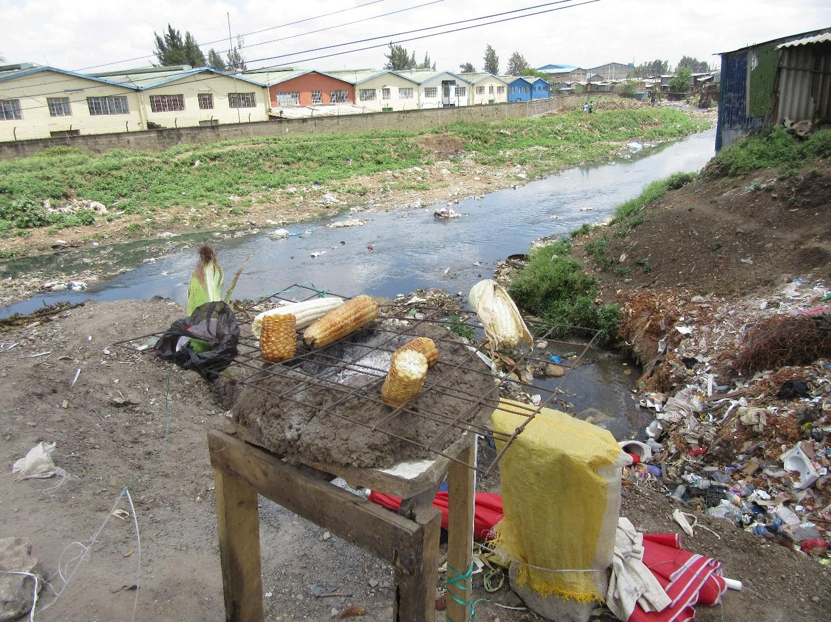

R5: I am from group two and in the photo (inaudible)

M: Thank you very much. So in this picture we can see an issue of drainage, we can see maize close by. First I would like to say. If you look at that picture we see maize and then we can see an open drain. Is that something that is common here? Is it common?

All R: Yes.

M: Ok, I would like R5 to explain to us. Relate for us the maize being there near and open drainage. How are the linked?

R5: You see this drainage (inaudible)

M: Is this something that is happening? R8 wants to add something.

R8: That photo has a number of messages but I will talk about the drainage. Where the maize is, just below it leave the drainage there is a sewage that has bust from a company or for city council that is pouring into that drain. Just down behind the maize, there are houses that are built there. Those structures that are there they have connected their toilets to that drain and that is food that is being prepared there. If that was not enough that road has a lot of dust. Cars are passing there and the dust is just settling on the maize as the cars pass.

M: Thank you. What I am hearing is that this sewage and the drainage that is there is taking us back to the issue of contamination. Isn’t it?

All R: Yes.

M: That issue we had discussed conclusively. So we won’t discuss it again since we have already talked about it. Let us give him Flowers, flowers. Thank you. I would like us to move forward. Let us go to photo number eight of group two.
PHOTO 8, GROUP 2.
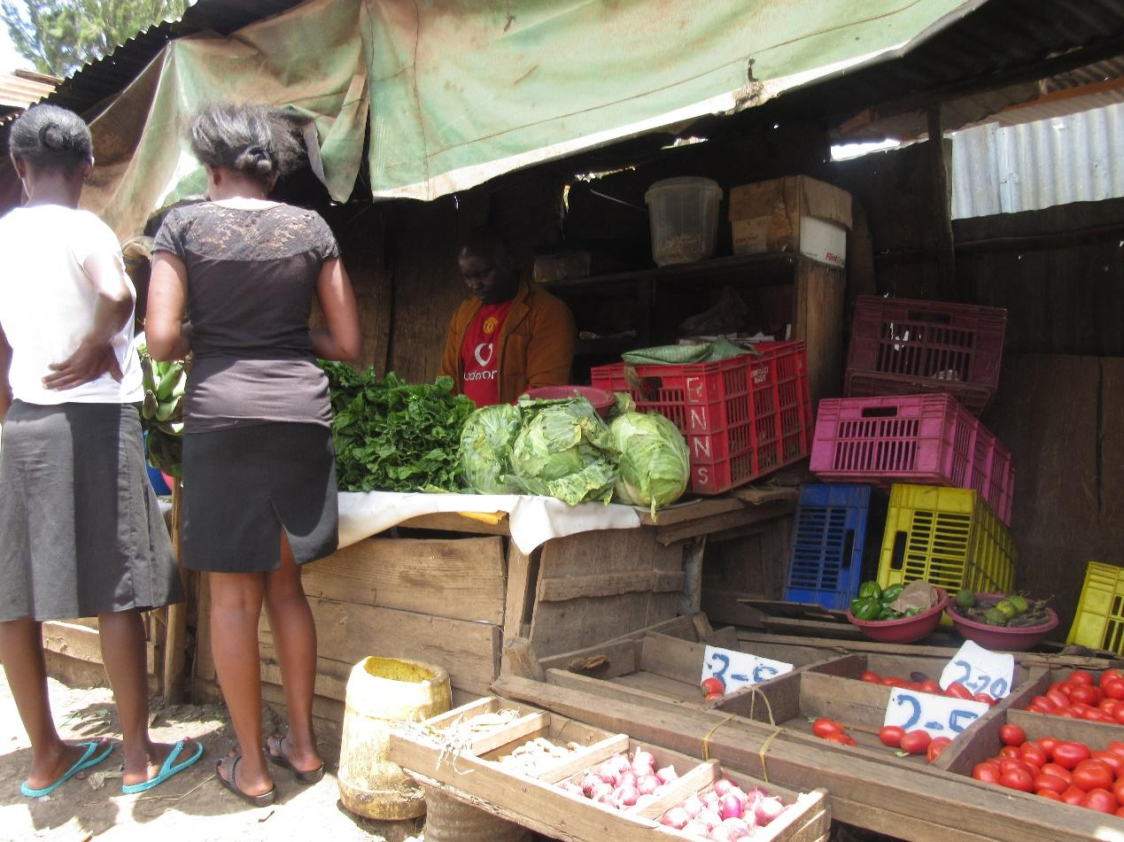

R8: I am R8. From group two talking about photo 8. In this picture we can see there is a kiosk, there is a customer there and in this kiosk there are supplies. If you look at the supplies closely they have not been arranged well. There are crates of things that are finished that have been put on the side. There are onions and tomatoes. Then there is vegetables each put on top of the other and that vegetable there is someone who is trying to serve her customer. And if you look there, there is some water that has turned brown. And that water is what used to wash the vegetables and then give her customers. And as if that is not enough in this house there is some food cooking where you can see the smoke. And the smoke shows that this is not a clean place. So if you look closely when she is selling her supplies she has not paid attention to the cleanliness that is required.
M: Thank you.
2:10:18
M: Okay thank you very much. We’re saying that in this image this person has not paid attention to cleanliness. The issue of cleanliness we have already considered but there is another angle that he has brought up that I want us to consider. It looks like that caption is speaking about storage of food. I would like to ask here in our community how do we store food normally? Starting from the person who is selling to those of us who are buying what is the situation when it comes to storage? Here in our community? You can give a contribution about the home or you can contribute about the seller. Food storage, R6.
R6: For many of us storage is poor. We live in a single room that is 10 by 10 feet so there is no space. So even when you cook food whatever is left over you probably keep it under the bed. Because there is no space.
M: Okay thank you very much. Anyone else would like to comment about storage? Whether in our homes or for the person who is selling what is the normal situation? Let's explore the situation. R3 what is the situation?
R3: When it comes to the issue of storage what I would say is that it's poor. You would find that some use for example in hotels you could find a bucket and maybe find flour in it. Sometimes that same bucket is used to wash clothes. So storage is poor.
M: Thank you very much. So we see that storage is poor both in the home and with the person who is selling. What I would like to ask is this, this situation of poor storage how does it affect food? How does it affect food? The fact that we have poor storage. How does it affect food?
R1: It will affect food in that for example if it is stored under the bed in the house we have rats in this neighborhood. A rat will simply pass and then in the morning you wake up and pick your food and eat it.
M: Okay thank you very much R1. I would like to ask this: what is the problem if a rat passes over your food?
R1: It will not just pass over your food it would get into the food it will eat and then it will get out. So the problem is that maybe the rat has been walking in the sewage it comes from the sewage and gets into the house once it has eaten it then goes back to the sewage. So when the child wakes up they simply continue to eat from where they had left off.
M: Thank you very much. She has explained to ask concerning contamination of the food with that. What is another problem that comes from leaving food poorly stored? R8.
R8: You see like that those vegetables have been placed on a table. As the vegetables are stacked together in that way heat accumulates among them. What that means is that the leaves that are in the middle start to turn and once that happens they start to go bad. When they start to go bad they attract flies and when the flies come and land on those vegetables that will also bring dirt. If I can also assist on the first issue as my colleague has said rats are small animals that walk and they might have come from eating something dirty before they come to eat the food in the house. So you simply come and you haven't boiled your food you simply eat it as it is it will affect you negatively. At the same time when it comes to rats in a rats body and their bodies have insects. And those insects as the rat is walking there are places where the insects may have dropped they could even leave those insects in the food. So once you eat it you are likely to be affected.
M: Okay thank you very much. We have spoken about contamination is there another issue attached to our storage issue? Before I move us along R4?
R4: You find that in the morning someone wakes up at the hotel and starts to cook mandazi. Most of the times they use bread crates for the cooked mandazi. For me I simply come from my house in the morning I haven't even washed my hands and I select the mandazi I want from the crate- I pick some I don't like and put them back and when I've got those I like I go. Another one comes and does the same thing. So there is someone who at the end of the day will be eating all this dirt from all of us. So that mandazi that is left that is not being used or picked is simply left uncovered. When there is dust when flies come from wherever they come on to that mandazi. Same thing happens with this food that they cook in cooking pots. Some of them even the lead for the cooking pot is never washed. Others the food is left uncovered. And some that place of business is right next to the road. So all that dust all the flies pass through that place. I come along some food is picked for me I go to the house I serve then we eat.
2:15:05
M: Okay. Thank you very much. I ask myself this question for the person who is selling they're at the kiosk they have organized their vegetables they have sold today people didn't buy too much so there are some vegetables left over they have stored them and then tomorrow the same process again. What happens to this food or where does it go? If it is this kind of situation and the fact that some vegetables are left over what happens to these vegetables? R7.
R7: When that food is left over it will be sold to other people (Inaudible). Say for example it's cabbage it is stored in basins (Inaudible) in the house. If it is githeri, African night shade, amaranth, when these are left over they will store these vegetables together with that water overnight. Tomorrow when they wake up that is what they will sell first. (Inaudible).
M: Another question?
M1: (Inaudible)
M: Okay thank you very much. So for this issue of storage the problem that we have and we have said it is there at the household level and up the level of the business person. What can be done to improve storage for the foods that we have what can be done? And who ought to do it? Some recommendations. R7.
R7: What I would suggest is that there are stalls that the council people install for people by the roadside where they put groceries when things are left over there locked up properly so that by the time you find them tomorrow they will still be fresh. If those stalls were installed for people it would be helpful and it would greatly benefit some people.
M: Thank you very much. Another contribution what else? R2.
R2: All I would say is that people stop being ignorant. Self-awareness you need to know what you want many times the problem is ignorance because you see when you place these vegetables here or it’s food you don't keep it properly it goes bad and you don't care. Or if it is someone selling vegetables and they simply stock them anyhow and they haven't been bought. What people need to get rid of is ignorance. Then they will store their foods very well.
M: Thank you very much. Is there another contribution? Another recommendation? R1.
R1: I think if people are also educated about health especially in the homes and the people running businesses within the community if they are taught about the importance of health it will at least be helpful.
M: Thank you so much. Let me take a final recommendation. If it is there. Okay thank you very much. As you can see we are almost done. You will notice that as we move along (Inaudible) so if it is something that we have already discussed you will simply mention it and then we will move along okay. So let us consider photo number 2 group one. Who took this photo? Welcome R2.
PHOTO 2, GROUP 1.
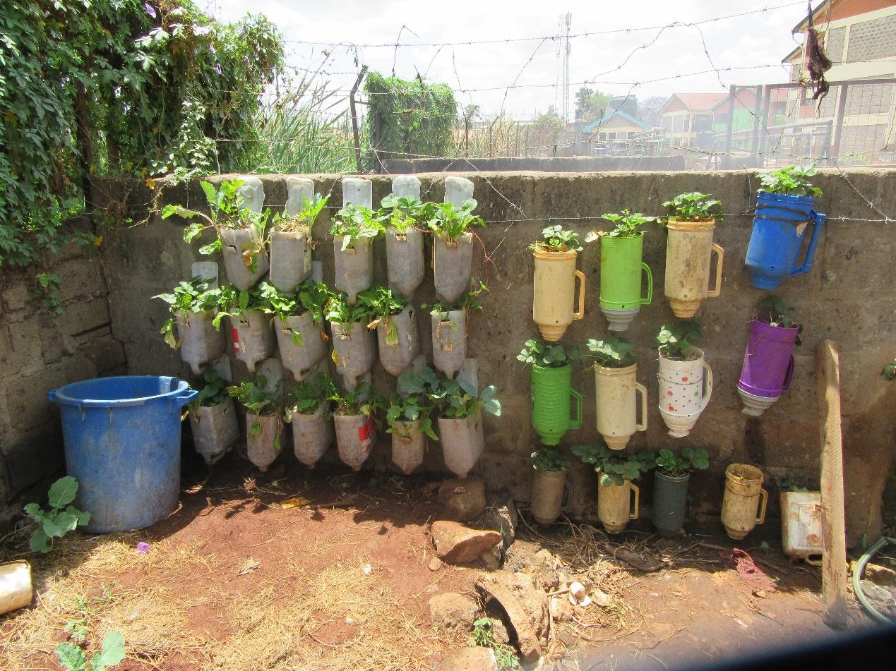
R2: I am R2 from group one. The message I was mainly trying to pass here is that (Inaudible). If it's a thermos, people break the thermoses at home and then you throw it out and we garbage collection people come and collect them and use them and sort ourselves out. So if among community members if someone who has a spoiled thermos you don't have to throw it out you could use it to grow vegetables in. If it is this 5 liter bottles many people buy 5 liter bottles to buy oil in then tomorrow as you go to work you find that you forgot your bottle and so you buy another one and you buy cooking oil and so on. And we don't use them. So what I would say is that this thing has taken very little space, a very small space and many people have a place where they can plant such things. So what has helped greatly here is that you use a small space to plant many things and you use very little water because once you sprinkle you have all of them. And so that also saves water.
M: Thank you very much R2. R2 has also taken us to that issue of urban farming. Thank you so much and we had already spoken about that so let's give him flowers. Thank you. Photo number 6 group 1. Okay tell us briefly.

PHOTO 6, GROUP 1.
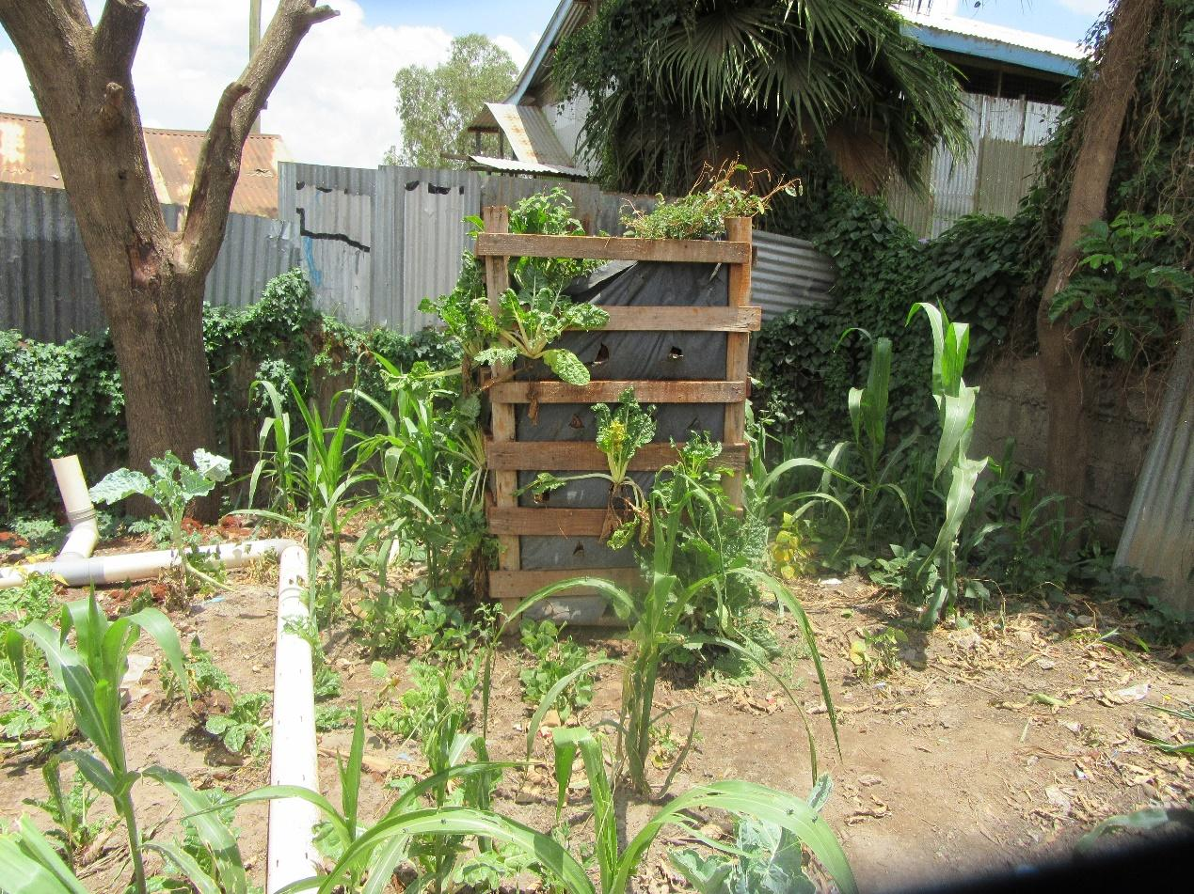
R2: Briefly what I was trying to show people is about this palette. These are like pallets that have been joined together. So they look like a square. This is something that is being done everywhere because maybe you find in your plot there is a small space and this space if you plant on the ground you can't harvest as much vegetables as the person who has planted here. Because the moment you pick those pallets and join them together so that you're planting on this side and the other side and the other side you have increased your Gardens even though you have a small space. Also when it comes to water you will use less water to grow this vegetable.
2:20:18
M: Okay thank you very much. Let's give him flowers please. Thank you. Photo number 8 group one. Number 8 Group 1. Welcome R1.

PHOTO 8, GROUP ONE
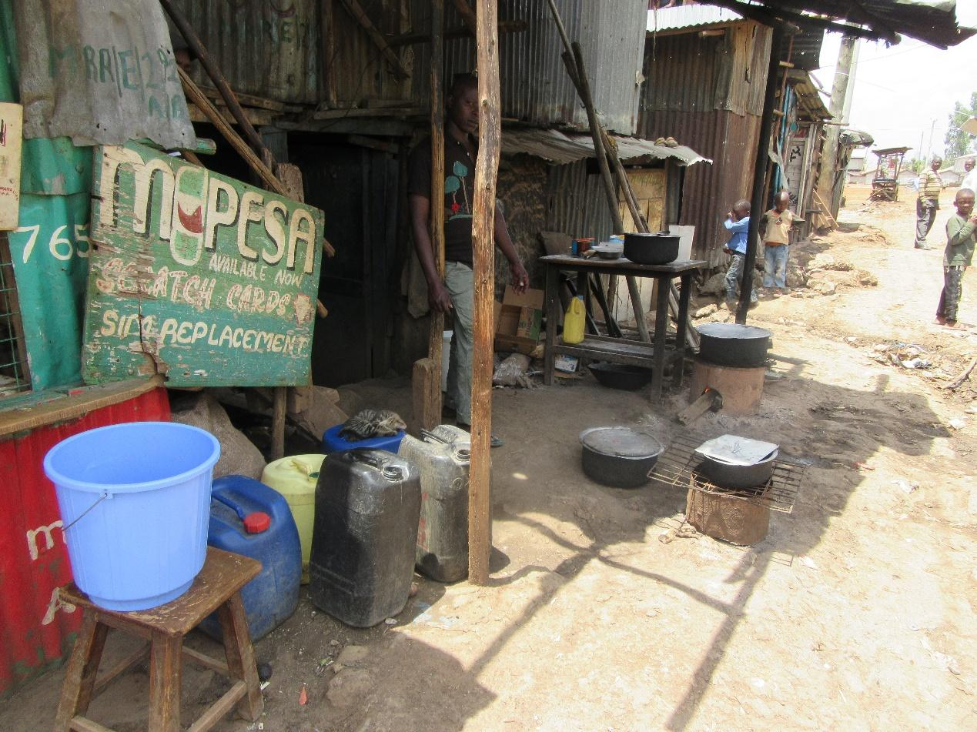
R1: Concerning this photo I was trying to show how here in the community there are people whose income is extremely low. Here there is a shack that's a hotel. There are cooking pots and charcoal burners and they're cooking. So the people whose income is very low or maybe there is a person who doesn't have time to cook because they feel like cooking is hard they find ready food here such as githeri, beans, chapati and so on at the price they can afford.
M: Thank you very much. In that photo we have also considered cost we have considered food availability and which food is cheap. We had already discussed that in detail isn't it? Flowers please drop thank you. Photo number 7 Group 1. Welcome R4.
PHOTO 7, GROUP 1.
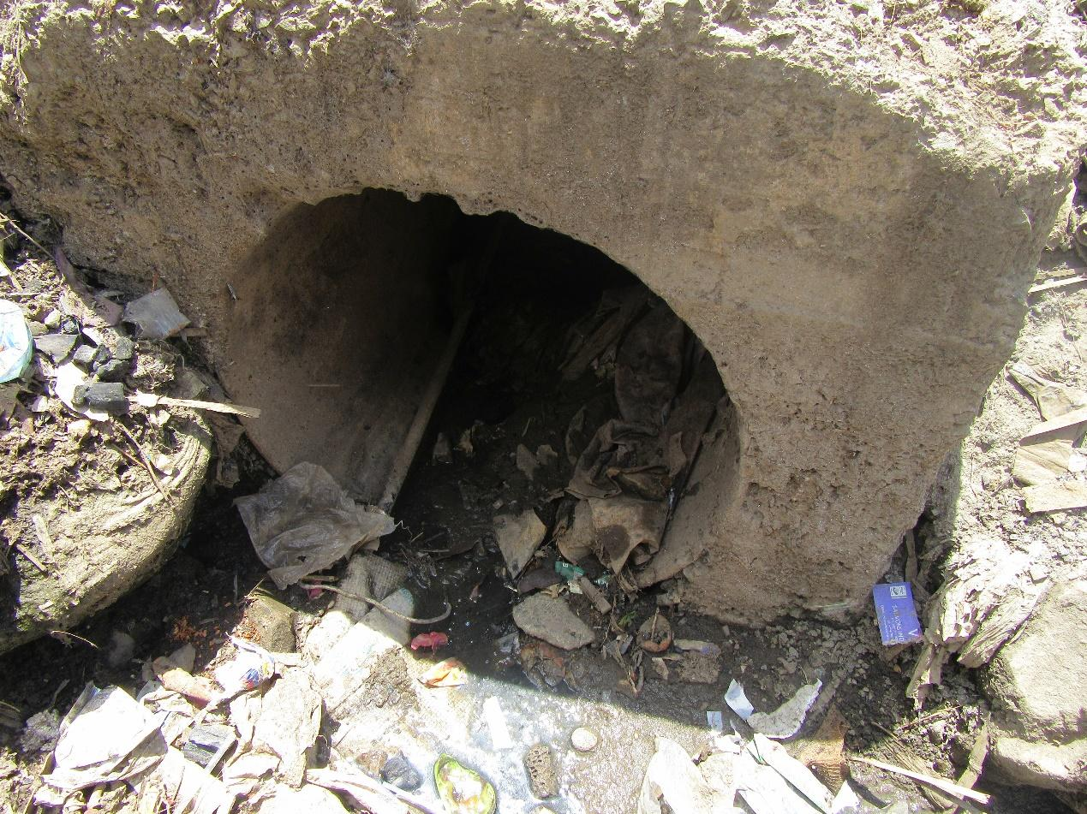
R4: The reason I took this photo of this guy as you look in that photo you will see that there's a water pipe passing there and that pipe is plastic. If that pipe bursts that water will reach the person who is selling there or when you go to collect water from the tap you will find that the water is mixed with urine and feces and everything else and cholera.
M: Thank you very much we have already spoken about contamination. Flowers drop thank you. Group 1 as we come to an end Photo number 5.
PHOTO 5, GROUP 1.
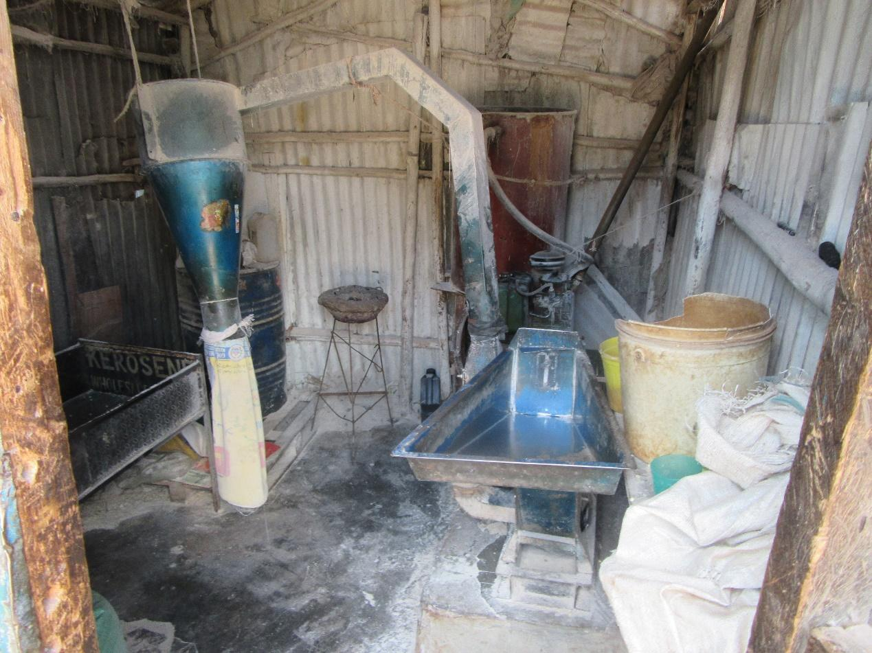
R3: How are you? I am R3. My photo is very simple it is a miller. Or a tractor. This if you consider right now our staple food is ugali. People can access maize it is cheap and from there we can get flour. At a good price.
M: Thank you very much. He’s still speaking about access to food. Give him flowers drop. Thank you so much. Let's go to group 2 and look at photo number 5. R6.
PHOTO 5, GROUP 2.
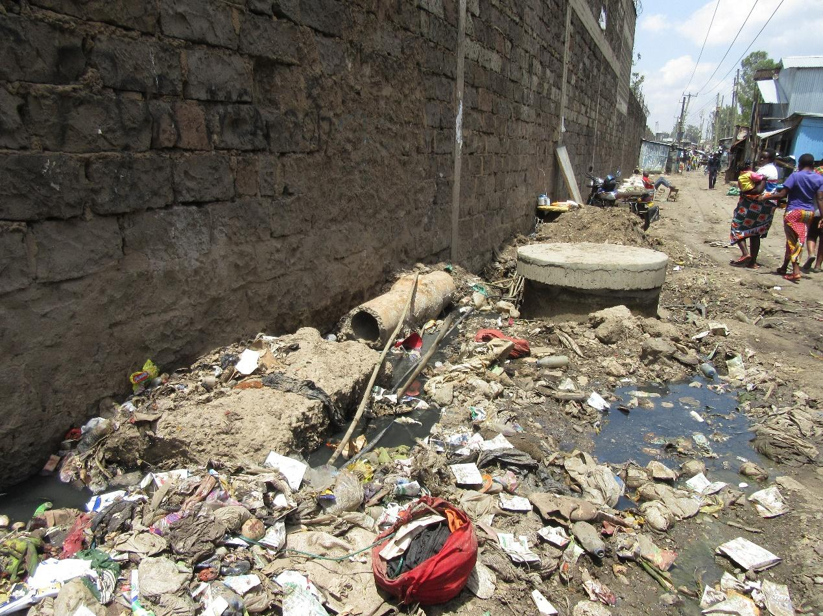
R6: If you look at the photo I took that is poor dumping and there are water pipes there. And if you look a little farther there's something that looks like a manhole for the council. There's a day when they were doing repairs there. Obviously there's one pipe there that has some leakage and obviously we will drink that while some people won't get water we will get sewage and the result is diarrhea and everything else.
M: Thank you very much. Water contamination. Let's give him flowers thank you. Photo number 2 group 2. Photo number 2 group 2. Welcome R7.
PHOTO 2, GROUP 2.
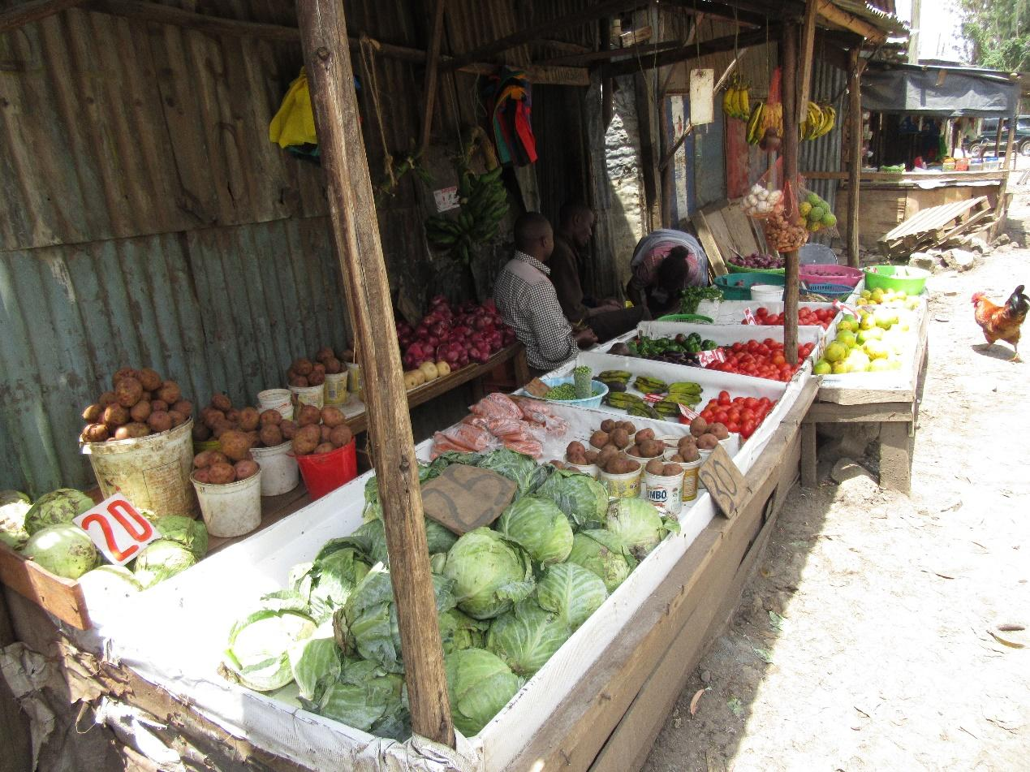
R7: How are you? I am R7 group 2. This photo number 2 if you look at it you will see that that kiosk is okay. It is clean the goods are well arranged and they are selling all kinds of vegetables. As well as all fruits. So here you can find at least a balanced diet. The place is clean and these vegetables, fruits they have put water for washing them. So when you come to buy what you want it is washed for you.
M: Thank you very much. She has looked at things that we have already discussed thank you very much for emphasis. Let's give her flowers drop. Thank you. Photo number 6 group 2.
PHOTO 6, GROUP 2.
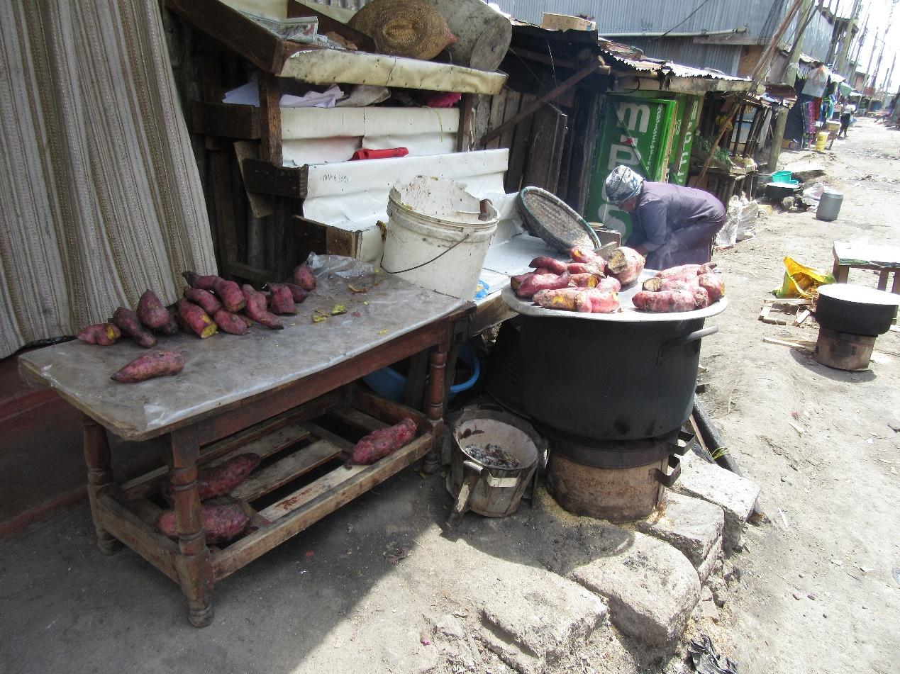
R?: This one is also speaking about hygiene. If you look at this food there is githeri, there are some sweet potatoes being cooked there. This is next to the road and as you can see some sweet potatoes are under the table others are on top of the table others are on top of cooking pots and they have not been covered. There is a ditch passing on this other side meaning that all the dirt from this neighborhood and the road and all the insects they come on to this food.
2:25:06
M: Alright thank you so much. Let's give her flowers drop. Thank you. Photo number 7 group 2. Welcome R5.
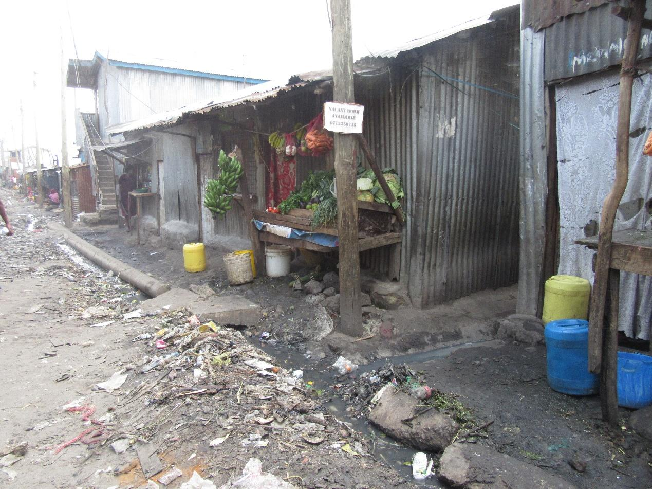
R5: I am R5. You will see that is a vegetable kiosk and there is a ditch there. So you find that perhaps the vegetable vendor even cuts their vegetables there and they can be contaminated you can even get cholera.
M: Okay thank you so much same concept flowers drop. Photo number 4 group 2. Number 4 group 2 Welcome R8.
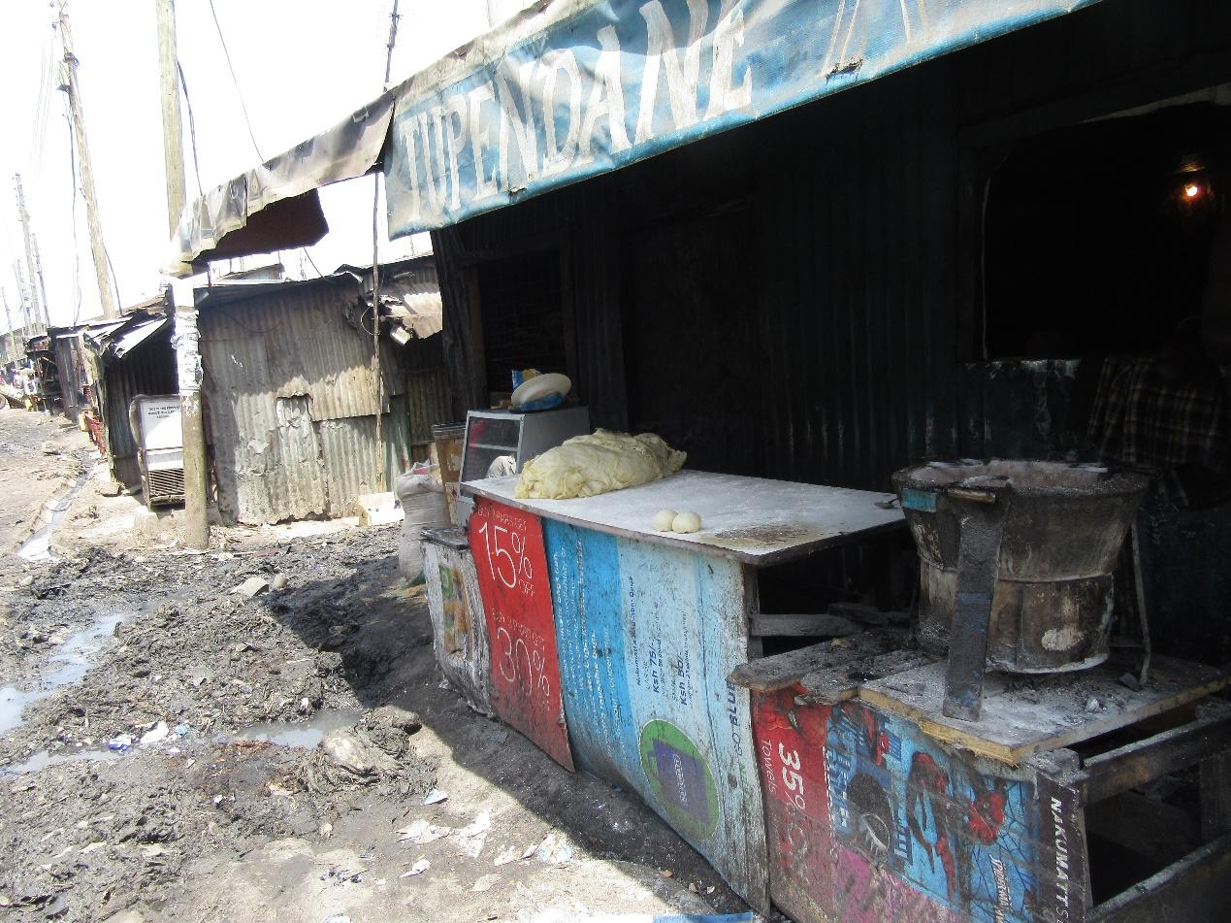
R8: I am R8 and as you can see here it's the same issue of hygiene. Yeah there is a batch of dough that has been placed at the edge on this table if you look at this table how dirty it is and the dough has just been placed on it. There's a burner next to the table and here on the ground there's a pump that has burst here a sewage pump. And here there are also water pipes that have passed here that have also burst. So you find that the water that people get is water that is not clean and also where this food is being prepared is not a clean place and the burner is close to there as well.
M: Alright that's the same concept let's give him flowers drop. We are proceeding well isn't it? We have reached group 3 as we are almost done. Photo number 2 group 3. Number to group 3. Welcome R12.
PHOTO 2, GROUP 3.
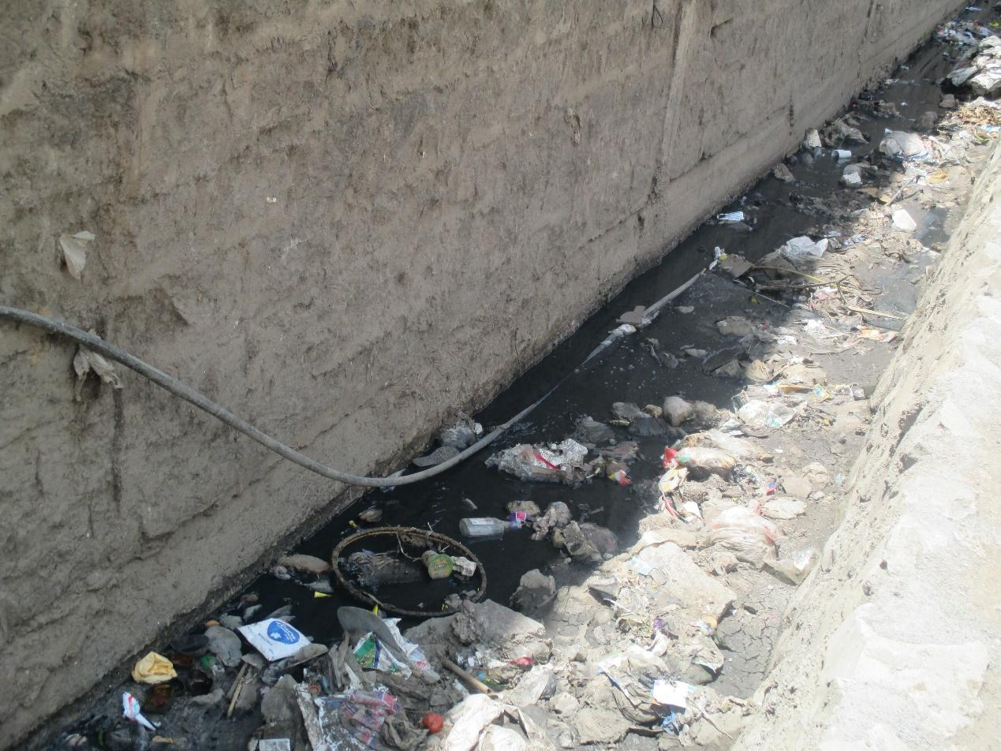
R12: How are you? I am R12 group 3 photo number 2. The issue here has to do with contamination. This is a water pipe for clean water and it has been placed above ground and sometimes it passes through the sewer the moment this pipe breaks the sewage will contaminate that water and what we would drink before it has been fixed it will affect our health.
M: Okay contamination again. Let's give her flowers. Thank you very much. Photo number 6, R12 again. Photo 6 group 3.

PHOTO 6, GROUP 3.
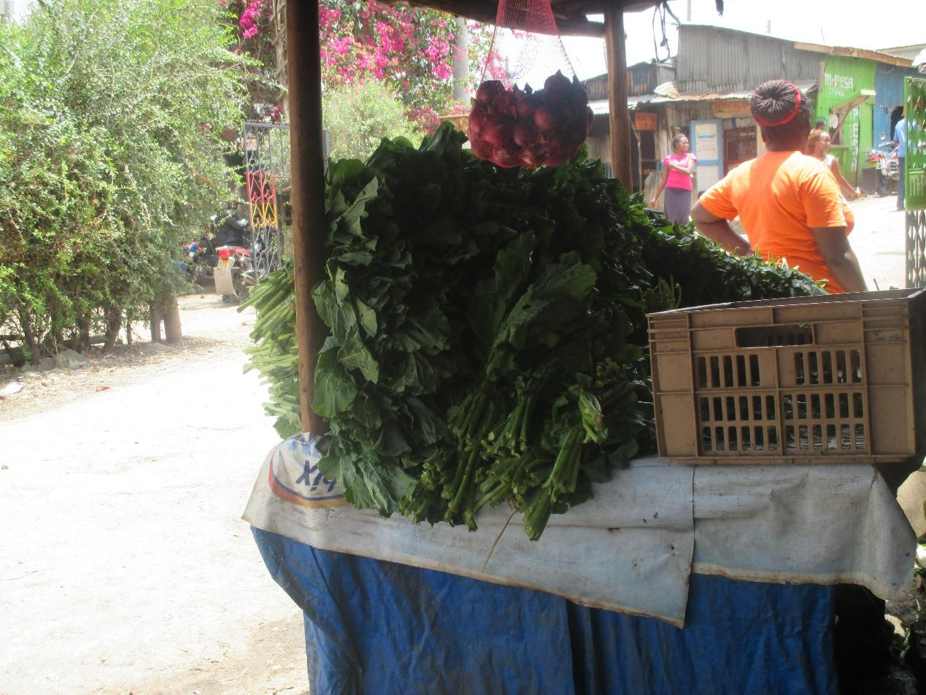
R12: This is a vegetable kiosk. You can see that it is loaded. It has vegetables of all kinds. Traditional vegetables, kales and so on you will find them there. It is easily accessible because it is right along the road. But the vegetables themselves are exposed so we need to be cautious about how we handle them. There is plenty of dust.
M: Thank you very much more flowers drop. Thank you so much. We're going to photo number 3 this is our second last photo number 3 group 3.

PHOTO 3, GROUP 3.
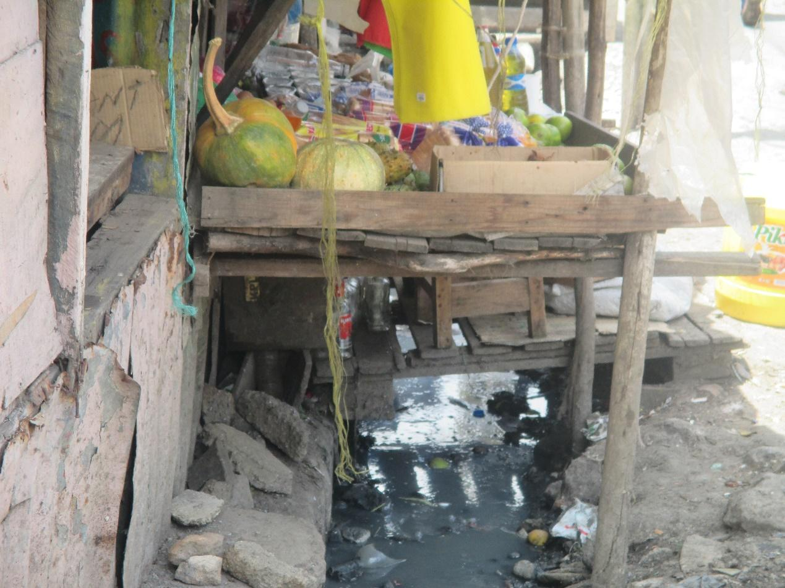
R10: How are you? I am R10. I'm in group 3 and I'm speaking about photo number 3. This photo this kiosk has everything. It has fruits as you can see there but there’s a problem of poor drainage. On the ground you can see sewage. As you can see this thing has a lot of rubbish so here we would say that drainage is what is poor because as you can see this kiosk is clean but on the ground there's a lot of dirt.
M: Alright thank you very much. Let's give him some flowers. Drop. So our last photo is photo number 7 as we haven't looked at it isn't it? Photo number 7 also by R10.
PHOTO 7, GROUP 3.
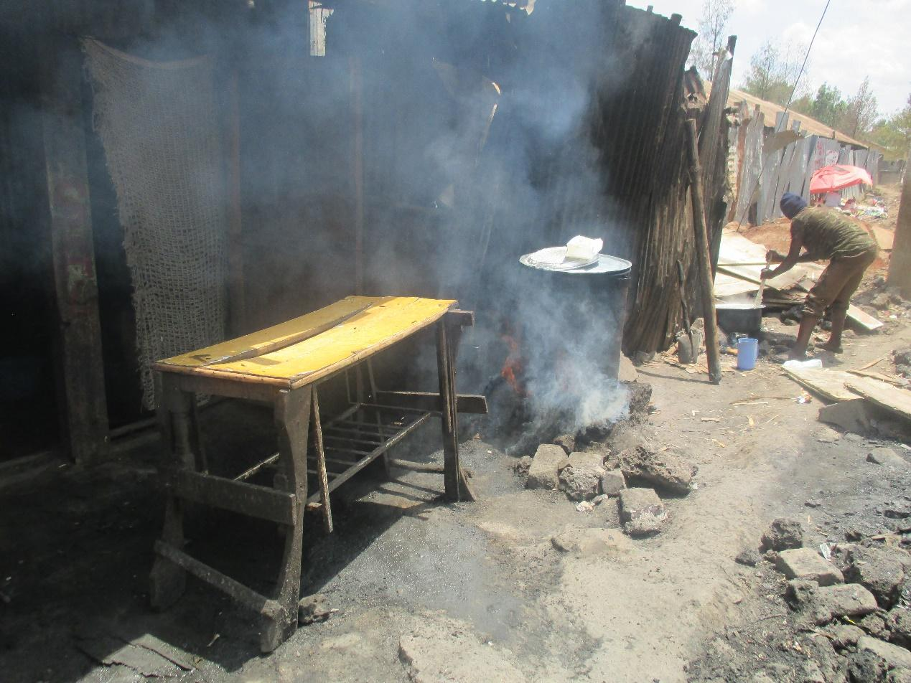
R10: I think here we’re talking about poor hygiene here there's some food that is being cooked in this cooking pot there's meat. This is a head and if you look here you'll see that this is a road. If you look you will also see someone cooking ugali. And there was even a car just before we took this photo that passed by and there was a lot of dust. Also if you look at these iron sheets they don't look like iron sheets. As in if you eat there...
M: Alright thank you very much the same issue of hygiene. Let's give him flowers drop. It's almost as though my work is finished but before I leave I would like to introduce my colleague [Name]. She will take us through the last bit about our experiences. How our experiences were. But before I step down we have spoken about many things. We have spoken about our experience what we go through about food and food security and our right to food. We have also put in place some recommendations. And [Name] has captured them very well there, the recommendations of the things that we would request to be done or whichever way you look at it in order for solutions to be found isn't it? Those we have not spoken about and we need to speak about them before I sit down. As we have put up our recommendations in what ways do we think these recommendations can reach those whom they need to reach? So we need to say “this ought to be done by so-and-so.” Those to whom we are making these recommendations how can we get these recommendations to them? What are the best channels to use to ensure that these recommendations have reached them? R8.
2:30:14
R8: I think the best way for example we have already gotten that knowledge. We have seen that these are not new issues because we live with them here but then we have taken it as though it is normal. Because we take it as normal that is the same way others take it. When we leave here we need to be ambassadors when we go into the neighborhood we need to transfer this information like I said tomorrow I may call a meeting of more than 600 people. What we are going to speak about I have seen some of the photos here and I will make sure this information has reached. For example we had a similar seminar like this one (Inaudible). Just like that because you have to make sure that your safety extends to your neighbor it's not good that you see your neighbor getting hurt due to disease or perhaps they could even die because of things that you knew about.
M: Okay thank you very much. Another channel for the recommendations? There are things that we have said or thought to be done by government for example or by our leaders for example what's another channel that we can use to communicate this information? What means can we use? What means can we use so that the leaders can know this is what we need? R6.
R6: Other channels we could say that maybe you can assist us. For example this is a process that APHRC has taken on hand. You know that for example this program itself there has been a cholera outbreak recently and it affected many casualties here at Ruben Center. So if you look at say someone takes a pipe and they have agreed with the council but they still have the pipe pass through the sewer it's not beneficial. So through our members of county assembly if they can be called and shown those photos to see that even Cholera cannot come to an end at Ruben Center and this is the cause they're likely to take action they can call the stakeholders of the water sector to instruct them that their pipes ought to pass elsewhere.
M: Is there another channel? All right I have come to the end. I would like to say thank you, you have been a good group and we have had a very fruitful discussion. Isn't it? How are we feeling do we feel like we have made good contributions?
All R: Yes.
M: So I will say thank you very much for your patience and for your contributions. I would like to invite Triza to come and guide us through the last part. (Inaudible) to give comments and hand back. But for me thank you very much.
M3: Flowers for the moderator. Drop thank you very much. I will not keep you long okay? But I would also like to know how the day has been since when you began up until now. How has the process been? It's good to give you an opportunity for feedback isn't it? How have you carried on? Had anyone heard about Photovoice before today? Had anyone heard about this before? Or was today the first day?
All R: It was the first day.
M: Okay. How have you found our process? From when we began. Some comments?
R?: What I would say is that it has been good. I have gained some knowledge I have learned a new skill that I did not have and that information also if it can be transmitted to other people in the community it would be better.
M3: Let us hear one more person. How has the process been? Yes R1.
R1: Everything has been good since morning when we began and to me it has been beneficial there are things that I did not know that I have now understood. So I thank you very much. But also let it not just be for today only we still need to know more so if you have another opportunity come and teach.
M3: Okay thank you very much. As you continue to think about that since we began I would also like to know how your experience was in regards to taking photos within the community. Were you feeling safe or were you feeling anxious? What challenges have you faced today? What can you say this has been a challenge? R6.
R6: That's where there has been a big challenge. Here as slum dwellers we look like suspects every day. So like now if there's something going on (Inaudible). Others might say what they think is that we are taking those photos so that (Inaudible) can pass. So like our group we almost got in trouble but the security person said I would have hit this person but we are working. And so we just left that person. Others were also saying we are taking these photos so that we can go and show somewhere how poor we are. So you're exposing us badly. There's a bad image. So we told them that it is within us that we find solutions. Others said that no you even take these photos to other countries for it to be seen that we have very poor and that we live in dirty conditions.
2:35:21
M3: In your opinion and the opinion of those here how can we do the same process of going into the community and taking photos and at the same time avoid those issues with other community members? When we are working and doing this? Other than the security that we had what else can we do, the same process but feel safer and more comfortable with the process? R6?
R6: I think we need to be sent to specific areas. Today we went as random people in Ruben. So for example I am known in a certain area but I am not known in the other area up there. So if I had gone to the place where I am familiar it would have been helpful.
M3: Okay someone else? Yes R12 to process and tell us.
R7: What I would request when we go to a place like that to take photos maybe we go with the people from (Inaudible). Like this people from health if we go down with them they will see these people they will also...
M3: Who are those people you're talking about?
R4: There are some community health workers who are known here in the community. So for example if I go to a certain woman she already knows me and that photo I will take it quite simply as we are talking and I'm telling her do you know this and that and the other. I will take the photo and she might not even know that I have taken it. So it is good just as R6 is saying that the area in which you are known is where you go to take photos that would be much easier.
M3: So to go in the areas where you are known and also to go around with community health workers who are known in the community right? Okay. Is there someone else so I don't lock out a contribution?
R6: Also to inform the area chairman or the elders if we move around with them it will probably be easier.
M3: Okay...
R3: Okay I would also say if you can give us the APHRC logo when we get to the ground it will be easier.
M3: So you want people to know where you're coming from?
R3: Yes.
M3: Okay someone else. Now I would like to know as I bring this to a close what have you learned today that is new? Apart from photo voice that is. Or what have you learned from today's experience? Knowledge that by the time you came in the morning you did not have it but as you're leaving you have it?
R6: What I have learned is that we may not be aware but we are more exposed to these issues and that our food security is not okay. We are more exposed. For example when you consider that water, or someone is cooking for you chapati close to a ditch that has effluent coming from those factories. We're in a bad place and there are many things that we ignore.
M3: So the challenges that are present have been brought to your awareness? You are now more exposed? Okay thank you very much. Someone else. R2.
R2: I would say that I have learnt or I have experienced or what I have gained is that there are people who still need to be taught a lot. The community still needs a lot of training on agriculture or urban farming yes. At the same time there are many children who are malnourished in the community and we don't know. So knowing such things has challenged me that we even as a group need to consider how we can help the community. To reduce such things.
M3: Okay thank you very much. Now I have a final question. Since we began we came and started and got consent forms do you remember those forms that you agreed and signed? You were taught then you went and took photos and then we have had this discussion. I would like to hear your recommendations. If we want to come again to Mukuru to come and do this Photovoice again what do you think if we had done would have made it even better? To improve this work isn't it? Perhaps for now you're seeing that if they had come and first done this or the other the process would have been better. Have you understood my question? For example someone has said if I was able to guarantee that people are going to take photos where they are already known it would have been better. That is one example. Judging from how today has gone what is it that we could have done or perhaps we can do in future for this photo voice discussion all of the entire process that we have had since morning to be even better?
R10: That option that has been given is what is good. At least you go to a place where you are known. Because even if you go in a group and people don't know you they will still not pay attention to you.
M?: So we can make sure that there is enough time to guarantee that if someone wants to go where they are well-known they can get there?
R10: Yes.
M?: Okay thank you very much. Yes.
R7: Perhaps also each group could travel with one of you guys. So that even you guys can learn how things are in the community.
M3: Okay thanks. Another idea? So that we can also see what the environment is like that's what you're saying? But also you have brought us photos for us to see right? If we come and see aren’t you going to think but they have already seen and therefore fail to bring photos? But thank you very much. Anyone else? I've seen a hand raised on that side.
R6: I also think you see like now I'm tired, this is like (Inaudible) we are not used to that, we are just used to maybe half a day for such meetings.

M3: So you would propose we have maybe half a day, half a day? Okay thank you very much. Another person. Or are we all right? These are very good recommendations that we are getting isn't it? They are good recommendations so that next time if we come and do the same thing if we don't have a reason, if I tell you why I have repeated what I did the last time, for such-and-such a reason it would be fine. But it is good for us to know what we can change so that we can change them okay? We are very, very grateful. I would like to hand over back to Faith as we wind up. Thank you very much. Flowers drop.
M2: I would like to say thank you very much. Thank you so much for joining us and being a part of this research.
END OF AUDIO
RECOMMENDATIONS
- Reclaim land for urban farming (dumping sites).
- Teach urban farming skills.
- The chief to talk to landlords to allow urban farming.
- Plant seedlings to supply to other farmers.
- Sanitation and hygiene.
- Health inspections to be enforced.
- Mapping for clean places to find food.
- Affordability.
- Urban farming: (support from other bodies- NGOs, government).
- Have a space designated for a market.
- Educate the community on food nutrition (balanced diet even on a budget).
- Food safety
- Inspection of food sold in the community.
- Combat chemical ripening of food.
- Availability
- Know where your food comes from.
- More education and empowerment on right to food.
- Contamination and waste management.
- Vet inspections of livestock kept within the community.
- Encourage the community to keep their environment clean.
- City council to be involved to do better garbage collection to reduce dump sites and reclaim spaces.
- Encourage young people to form groups that benefit from garbage collection.
- Place garbage collection points.
- Overpopulation
- Educate the community on family planning and contraceptives.
- Rural urban migration- decentralization of factories.
- Teach entrepreneurship skills and self-employment.
- Teach rural populations ways of making money without migration e.g. farming grants to youths in rural areas.
- Provide water for irrigation to encourage rural youth to take up farming.
- Access of funds to made easier for the youth.
- Malnutrition
- Educate and enforce with follow up on balanced diet for babies.
- Education and peer support to encourage balanced diet.
- All community members to be involved in child care. When there is a neglected child, the community should intervene.
- Government to ensure that organizations especially in Industrial Area follow the law e.g. giving mothers time to breastfeed.
- Balanced diet.
- Encourage sourcing of food from rural areas.
- Urban farming.
- Food substitutes with cheaper foods with same nutrients.
- Food storage and preservation.
- County to develop a proper market/ markets.
- People to be encouraged to use containers.
Recommendations for Photovoice
- Continue engaging the community.
- Manage suspicion from the community on the intentions.
- Involve community health workers.
- Have respondents go to take photos in places where they’re known.
- Involve community elders.
- Have printed out badges for identification of respondents as they go out.

