AFRICAN POPULATION AND HEALTH RESEARCH CENTER
WT PUBLIC ENGAGEMENT PROJECT
CONTACT TYPE: PHOTOVOICE-OLDER MEN(KOROGOCHO)
RECORDING NUMBER: 181119_0929
SITE: KOROGOCHO
INTERVIEW DATE: 19/11/2018
DURATION OF INTERVIEW: 01:52:56

M: Thank you very much once again for coming today and for the good work that we have been doing since morning in this Photo voice process among the elderly here in Korogocho. Therefore, I would like us to start discussing our photos, we start giving them a voice. And I would like us to begin with this side, and am requesting the owner of this photo, this photo number 1 of group 3, who is it? Welcome R8, the floor is yours.
Photo 1, Group 3

Growing vegetables along sewer lines
R8: Do I stand?
M: You can speak from there, you can speak while standing, anywhere
R8: From the research we have done, I have seen there is dangerous because when I went there at the Ngomongo bridge, I saw there they plant food in the sewage and it is not good and it is not lawful. I discovered a secret that the food we normally eat is bad food because with the food that is planted in the sewage, the leaves grow big and when you see (not audible). For example, you are told food has come from the rural areas yet it is just from around here in Korogocho, planted at the banks of Nairobi river. Therefore, another problem that I have seen there, when they go to that sewage to pluck vegetables, they have their times when if you go there you find them harvesting and they have their times when they get in there because where that woman is, even you cannot get in there. That is step one, where I went to the vegetables grown in the sewage. It is wrong for us to be eating bad vegetables. In history, I have heard that there are bad kales grown in sewage and there are special kales. Therefore, these kales are not special.
M: Okay
R8: That is one, when you go to this other one, this number 4 is mine…
M: (Interjects) let’s finish with this one first
R8: Okay, I have finished that one
M: Okay, thank you very much R8. Our colleague has talked of very important things and he has told us that we can see vegetables that have been planted in the sewage, and he has really mentioned kales and he has said that is something that has been there. I would like to ask, is it true?
Chorus: It is true
M: It is something that has been there?
R: It is there
R: For a very long time
M: Okay, let me see the numbers, R3, please comment. You have said that it has been there for a very long time, R3.
R3: Yes
M: Louder
R3: For sure, it has been there for a long time. They block the sewage and after blocking the sewage, they use that water from the sewage to plant those vegetables in the small farms. It is not a big farm, it is at the river banks. So they take advantage of watering their vegetables with the water from the sewage. So when you go and cook those vegetables, they taste salty when cooked, they don’t take like the ordinary kales, they have a certain salty taste.
M: Okay, thank you very much R3. Therefore, elders, are we in agreement that this is something that has been happening?
Chorus: Yes
M: Using that water to grow vegetables
Chorus: Yes
M: Is it something that we see here in Korogocho?
Chorus: Yes
M: Let me ask this, we as elders, and we are saying that we know that habit exists, have we taken any action or has something been done? Or have we decided to deal with our own situations? How has it been? R4
R4: Regarding that, there is no action we as residents of Korogocho can take because the vegetables that come from there are affordable to us. So when they get it from the farm there it is cheaper because there is no time to go far, the costs incurred are not many. Therefore, for us who live nearby we feel they are cheap, they sell at low prices. And if you want vegetables from far, they are expensive
M: Okay
R4: Yes
M: Therefore, the ones in our area here, the price….
R4: (Interjects) their price is lower. Even if they are harmful, what will you do and yet that is what you can afford?
M: Okay thank you. R6
R6: If I comment on that, you know, to be honest where there are many people, they prefer the things that they see are big. For instance, these vegetables that you see grown in sewages have very beautiful leaves while those that come from the rural areas you will see that they have been poked by insects. You feel that you cannot accept the ones bitten by insects and you buy those others. But the ones you are buying, you are buying diseases. Therefore, because we see them being sold cheaply, it makes us take them easily so that we go and cook for children. But cooking that for our children is adding losses in the homestead because if you eat those vegetables, the next day or the day after tomorrow you will see someone will start to diarrhea and you take the little that you had to hospital and money gets depleted. Therefore, to be honest, we residents of Korogocho need to be sought for a means and keep being taught, when we see this type of vegetables we should leave them and buy this type. And the teachings that we have got today are very many because if I go to teach at my place, I will explain very many things.
M: All right. Thank you very much elders. I am hearing very important issues and these 2 elders, R4 and R6 have talked of the harmful effects, that these vegetables are harmful. And R6 has said that they can even cause illnesses. As elders, now that we have seen people eating these vegetables and we have also eating them, what illnesses does a person usually contract when they eat these vegetables that are grown in the sewage?
R: Like diarrhea, diarrhea, now that is typhoid, so typhoid has already come in
M: Okay, R5, I can see you want to comment
R5: The illnesses you are talking about that results from vegetables, the vegetables are bad and they have insects in them and even if you cook, the eggs of those insects don’t get finished. So if you eat those eggs you can feel the stomach paining or you start vomiting and you feel like you have malaria. Therefore, we are the ones who like cheap things and they are those cheap that are hurting us. Therefore, even if you have don’t have something small, these sewage vegetables are bad.
M: Okay, thank you very much. I can see R2 wants to comment
R2: I will comment on that. You asked a question on what we as elders have seen. There is a law in Kenya that has not been changed; a law about spoiling your own things. There are those village elders here, they cannot stop me from digging and planting those vegetables there. You will just to surprised that you have been reported there that I am spoiling your farm or that I have told you not to dig.
M: Okay
R2: So there is no clear direction that has been put in place to stop us from digging there because if the chief comes from this side and the village elders also come from this side, that thing will not be there. The buyer will come from the roundabout and goes to Lucky Summer where she/he has seen the vegetables are very green and fresh, she/he will buy. She/he is a Kenyan and he/she will suffer. Do you understand?
M: Okay
R2: Therefore, a policy needs to be in place so that if there is a place in your village where those things are sold, there is a place you can report and be assisted and that thing be stopped, they should not plant.
M: Okay, thank you very much elder…
(Interruption, whispering)
M: Okay, fine, we have heard the elder’s points and the elder is saying that there is no clear law that can be used to assist in that situation here in our village. For the elders who are here, is it true that there is no law that we can use to stop or eradicate this issue of planting vegetables in the sewage? Is there something we can do? Yes, R7
R7: That is like salvation because if you know a certain thing is bad you stop because even in the salvation of Jesus Christ it says do not abuse someone and you stop abusing people. Therefore, if you see that the vegetables are planted in a bad place, there is no need of going to buy because if you see it, even in Korogocho if you see a plant that has a very good appearance then that is a bad plant, it is not a good plant, so we refuse that. Personally, I even stop my wife if she comes with such vegetables, I warn her because I have children and if she cooks and they start to diarrhea, it will cost a lot of money to take them to hospital.
M: Okay, a very good point. R8 and then R10
R8: My views are few, I am saying that something like this is done through corruption, leave alone the way you are seeing it. We are looking at the wellbeing of the children and the community. Why? Because she/he will harvest these things at night, pack them in a lorry then take them to Thika road and then bring them back. How will you know? My solution is that we do a research in our area and know in this areas, these vegetables are from the sewage and then work with the government to ensure that they are not bought, we need to stop it ourselves. If we don’t stop it, even if we say we cannot buy, they can become sly and pack them in a lorry and take somewhere else and sell. If your child has fallen ill and you take him/her to hospital and perhaps it is as a result of these vegetables, won’t that hurt you? We should not buy the ones that we have seen but what about the ones that are harvested at night, how will you know? That is my comment.
M: Okay, you have heard the old man’s point. Thank you very much. R10, you had something to say.
R10: R10, I would like to say this, what makes us buy cheap things which are not good for people’s body is lack of adequate cash. If we could get adequate money, we could buy the things that add value to our bodies.
M: Okay, R10 is saying that money is what makes a person to buy those harmful ones. Let me ask this, when you are buying the vegetables grown in sewage cheaply and then you consume and they cause harm as R8 has said then someone is taken to hospital. Will end up spending less or more money?
Chorus: More money
M: Therefore, does the money calculation really make sense?
Chorus: No
M: Okay, that is a brain teaser. I can see R1 has something.
R1: I am R1 and I can say it is the government that has failed. Policies should be created for farming in areas like Nairobi, policies. Our members of parliament do not really look after us because if they can allow a farm like this one for [name] to be farmed using sewage yet they are seeing and they are silent about it and when typhoid breaks out here in Korogocho, that is when you will see them coming. And they don’t say source of the typhoid. Why? Look at a place like Korogocho; the infrastructure. How many years have lapsed as were are told it is a government land? Infrastructure in the whole country, there was something called upgrading and it didn’t help Korogocho. The policies that exist don’t benefit us as residents of Korogocho. Let say the issue of houses, the people who are said to be the owners of those structures should have been given or the government would have come with an appropriate way of making Korogocho to have a Runda of Korogocho or there be a good estate. On the sewage system, the government should give clear direction so that people stop farming with sewage and there should be laws.
M: Okay, a very good point. I can see the elder has already given us one solution. So now we are talking about the solutions. We said today we are going to highlight the problems and solutions. So we have seen the first solution is the government and their policies. Another solution on this sewage issue so that we get to know this sewage issue or policy, R6
R6: I am R6, just recently there was an outbreak of (not audible 15:30). It started here, and as my colleague has said, the government usually take responsibility when things are bad. You heard the doctors ran to (not audible 15:47) and if that outbreak was not there, they would not have gone. And it is because of eating things that are not appropriate. The only way that can help us residents of Korogocho, because we know Korogocho more because we have lived here longer, this issues you are seeing us eating, you see even nowadays the tomatoes that are there, have you ever seen a tomato that looks a fist? What has it been planted with? It is planted in this water and sprayed with bad medicine. And if you go to the market they shine and when you hear they are going for 10shillings you decide to buy instead of buying the small ones so that you cook for the children for 1 or 2 days, isn’t it? that is again illness you are bringing. Therefore, if the government can take care of its people, to be honest this problem can end. Even nowadays you see cancer used to attack only the rich but nowadays it attacks even a young child. It is because of eating dirt which we residents of Korogocho should not be eating. Then another thing, we should focus on here alone, we have said that we are going to discuss the solution. Look at what is there, what do you think we breath in per day?
R: Smoke
R6: What do we breathe in, we breath in illnesses only. That also adds us diseases into our bodies because as we continue breathing in carbon dioxide, breathing all the time, what is that going to cause in your body? Aren’t we breathing in metal and when that metal gets to the blood, what will happen?
M: Okay, very good views
R6: Won’t we continue vanishing? Then we will start saying the air is spoilt, the world is spoilt and yet we are the ones who have spoilt the world.
M: Okay, thank you very much. Now we have said one solution lies with the government. I would like to ask this, is there anything that we as residents can do to assist in this issue of sewage vegetables? It is something that we know of. Is there anything we can also do as residents or we don’t have a part there?
R1: There is
M: Yes, R1
R1: There is something we can do. There is something called civic education. Most people, especially of our age here are not educated and most of the children that we have here have sniffed glue and become street children. So it would be better if stakeholders came to the grassroots and educated people particularly on the harmful effects of the sewage foods. The harmful effects that we get, you go the market and buy sewage food but many people don’t know, they should be taught, they should be directed. One or two people will understand and will stop.
M: Thank you very much.
R: And they will continue preaching. They will continue preaching that information
M: Thank you very much. I can see R4 wants to add something.
R4: On the same, we as residents of this village, first, the solution is, you NGOs (Non-Governmental Organizations) really help us but you call people at the chief’s place. First you start with the chief down to the assistant chief and his/her juniors too. When you leave there they forget what you have told them. As a village elder, when I see someone there digging so as to plant, I go to the assistant chief and the following day the assistant chief will ask her/him, who told you to dig there, “so and so told me to dig there” and yet you are a village elder. You can be attacked there so quickly. Why? Because those people, our seniors are bad; from the chief, assistant chief and the village elder. That is where the wrongs are. You can see it happening and then you go and report then tomorrow you will be attacked in your house. And that is where the wrong is and we as residents cannot do anything because everything is in the hands of the government. The government in this village is bad. You hear them saying alcohol is bad, which alcohol? The chief knows the bad people, who brews alcohol, the chief knows which child is a thief there, which child does this, and yet he/she cannot arrest them. So, most of the time (not audible 20:40-44) So if you report you will be attacked in your house.
M: Thank you
R4: Therefore, it is the government’s fault, and the government is the chief, assistant chief and the junior of the assistant chief.
M: Thank you very much. We have understood that there is a way the government also oppresses its people
R4: Yes
M: Thank you so much. There is one thing I would like to follow up before we leave the issue of the sewage. When this elder R1 was explaining the first one, he mentioned something about policies, that the government should put in place policies to also continue helping this food situation. The day I was discussing with the ward administrator of Korogocho, isn’t that a representative of the governor?
R: Yes
M: We talked about the issue of policies and he/she told us that the County government of Nairobi has already put in place one policy that allows those who live in towns like us to also do farming. In the past, the people living in towns were not allowed to do farming but now the policy has changed and people have been allowed to do farming here in town. I don’t know if you are aware, and if you are aware, please tell me, are there people doing farming here in Korogocho? The good, legal farming, not the sewage one, the good one for producing good food.
R3: Yes, there are
M: There are?
R3: There are
M: Let’s talk about them. Let’s begin with R3
R3: They are up here in Canaan, if you cross and come like this, they use good water, they don’t even use the river water, they just use tap water. They plant vegetables, arrow roots, sugar cane and even these coriander, and they are usually just there
R: It is called Canaan?
R3: Yes, Canaan
R: What about Korogocho?
R3: It is there in Canaan
R: Canaan
R3: Yes
M: Okay
R: There are Redeemed
R3: Yes, there are Redeemed
M: Okay, thank you very much. Let me again ask this, here in Korogocho, are there people we have seen and we know of who are doing some farming? Maybe they plant their vegetables in a good way?
R: There are organizations that have come, especially Redeemed Gospel church which has brought a farming design like planting vegetables in sacks. Someone can put up his/her about 5 or 6 of them and the water you pour on them is water you know the source, clean water. You see, these sacks provide vegetables to the homestead, be it spinach, kales, you plant them in those sacks. Many people have that knowledge and others are keeping cows, goats, pigs
M: Elders, have we seen that method he is talking about?
Chorus: Yes
M: Are there people who have it?
Chorus: Yes
M: Let me ask this, if you look at the whole of Korogocho, have many people started those projects like vegetables in sacks as he has said or they are few
Chorus: They are few
M: They are few
Chorus: Few
R: Very few
M: The voice of the elders says that they are few
Chorus: They are few
M: Now, that is where the big issue is. Since it is something that we have seen happening, my question is (phone ringing), as elders, why is it that only few people have that good project of planting for themselves vegetables? How come most people don’t have that project? R2
R2: That issue of sacks and green houses, I think and I know that space of making it something like this one here at the door is lacking.
M: Okay, this elders is saying that one reason is that there is no space.
R2: There is no space, because if you go and put it there, you will have put it in my area and I say no remove it. so you will not put it up. We don’t have green houses that we can count on that we can put.
M: Okay, thank you
R2: So that Redeemed Gospel church that we are talking about, do you see this Grogan A and B route, there is a very old bridge there. You pass there and leave Grogan B that side, you rotate like this, here, there is a green house, there are even chicken there. If you want to buy you go there and you are given a receipt.
M: Okay
R2: Now, there is no space to put those things.
M: All right, thank you very much. The elder has told us, number one is space, yes R6
R6: R6, another one, you can plant but here there are goats which spoil for us completely our expertise in doing something because at your place or where you have rented, you can just put up a sack but if you put up a sack, when you are not there a goat will come and enter and eat. At times you can put them up and when you come at night you find all has been harvested, spoilers, they just come and spoil, you see
M: Yes
R6: So those are the many problems that we have in Korogocho because a fence is supposed to be put up so that you can put up those sacks and plant those vegetables and you know when you wake up in the morning you water them. But there is nowhere you can do that.
M: Okay, thank you very much. I want us to move on but I don’t want to lock out R5.
R5: Yes, there are teachers, there were teachers from China who taught us how to plant those vegetables that we are saying grown in sewage. He/she said that for sure vegetables grown using sewage water causes illnesses but we take up the teachings on sacks. Look for sacks and manure and where you place those vegetables should have good security where goats don’t enter. Therefore, vegetables grown in sewage are eliminated by sacks. The sacks now replace the sewage vegetables. Therefore, he/she taught us that the sewage vegetables cause illnesses but the sacks produce very good vegetables.
M: All right. Thank you very much. I can see we are progressing well. I would now like us to move on and we are going to discuss this photo, photo number 2 of group 3. Whose is it?
(Silence, no response)
M: Group 3, who is the owner of photo 2? Is it yours?
R9: Yes
M: Okay, it belongs to elder R9. Let us listen to elder R9

Photo 2, Group 3
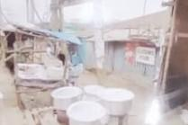
Expensive foodstuff
R9: This top photo, number 1 at the top shows a photo that I took at the road to show things that are arranged there being sold. We residents of Korogocho, at our level, we cannot get money to buy these things. There are cooking pans, there are plates and these things sold expensively and we residents of Korogocho don’t have enough money to buy such things. I thought that if we can sit down and discuss on the prices of such things, it would be better.
M: Okay, thank you very much. Elder R9 is telling us that this photo shows things that are being sold and they are things that are sold expensively. Is it true that things here are sold expensively? Is it true R5?
R5: As he has said, you will find that one banana, is it a banana or what?
Chorus: Cooking pans
M: Now let us talk about many thing, let’s just talk about everything in the area
R5: You will find that one banana is sold for 10shillings and maybe you didn’t have 10shillings. If he/she tells you 10shillings won’t you go? Therefore, bananas are eaten by those people who are able and they are sold expensively. Therefore, we who are here, the one who is selling the bananas expensively went to buy them from the market and there is no need to going to buy them sell at a loss, he/she will sell so that he/she gets his/her profit. Therefore, we have no way of stopping her from selling the banana at 10shillings.
M: Okay, thank you very much. Elder R5 is telling us that yes, it is true that there are commodities that are sold expensively and he has given a good example of a banana. I will ask you again, here in our area, are different things, and now we are talking of food stuffs, in brief if we look at the price of foods here, what can you say about the price of food? Is it expensive? Is it affordable? How is it, and can you give an example? R2
R2: The price of food in our area of Korogocho is high and since it is high, we will not direct our cry elsewhere, I will direct it to the government because long ago we had price control where they controlled prices during that time. They decontrolled them so now I sell at whatever price I want and there is no way you will stop me because it has been decontrolled.
M: True
R2: …in the Kenya Gazette. Therefore, the price of things here where we live, I know is difficult.
M: Okay, thank you very much
R2: So, for it to come down a little, we must go back to the government so that they figure out what they will do so that the burden is lifted from us.
M: Okay
R6: If I may add a little
M: Yes, R6
R6: I am looking at photo number 2. There you can see there are cooking pans and those cooking pans have food, and the food that is being cooked there could be different types of food but the prices are high. Like we residents of Korogocho, the food that is cooked nowadays is about 40shillings because you hear that rice is sold for 20shillings and you cannot even get that 20shillings. And even if you buy for that 20shillings, it cannot be enough for the family that you have. Therefore, we are saying that according to the government, because they are the ones who have erred right from the beginning, the food policy should be reduced and people will advance and will continue having food because now food has been set free so that people sell as they wish.
M: Okay, thank you very much. I would like us to look at this issue again because you have said and agreed that the prices of different food stuffs are high here. And I like what R2 has said, he has taken us back a little. He has said that there was a time the price of commodities was controlled by the government and therefore the price of commodities was not rising. And because I am talking to elders, I would like to know, elders, long ago the prices were good. What happened or where did we go wrong as a country or as a community that led to the increase in the prices of food stuffs? R2 has already told us one, the issue of controls was done away with. What else led to this situation? If you look at how it was in the past and how it is now, where did the problem come from? Lets us start from R10
R10: As R10, what makes the price of food stuffs to go high, long ago even if you had 100shillings only, you had money that had value. And now if you have 100shillings, even if you give your wife to go and buy food, there is nothing there. Therefore, the value of money has gone down.
M: The value of money has gone down. Okay, thank you very much. Let’s hear from R7 and then R6 and then R5
R7: I am R7 and I am saying this, the reason why the price of commodities keeps rising is because of debts from outside. People are borrowing debts from outside and then placing it on us. Us whose lives are very low suffer the consequence. There is no day we can go to the big people and tell them why do you go out to do this. Vegetables are here, everything is here and then you hear someone has gone out there to borrow loans of fish and yet there is fish here in Lake Victoria. He goes to borrow things from China, bad fish which are harmful and he brings them here. Such things cause the price of food stuffs to go up.
M: Thank you. Because of time, I will take these two, R8 and R6 so that we move on.
R6: Another thing, you see we have a problem regarding this government of ours. This government has added so leadership seats and that is why there is money but we lack food. A lot comes in from everywhere but it goes into paying the salaries of these elected leaders. Because, if you observe, we have 340something members of parliament and we are the people who are paying them. And to be honest, they have to increase the price of everything so that those people get salaries. Therefore, we the people at the bottom continue to suffer. Therefore, if the government could reduce the number of parliamentary seats, I think we could be better, we will not be suffering the way we are suffering nowadays.
M: Okay, R5 and then R8
R5: I will say this, the price of food, there is no bigger food than flour. Even if they increase the prices, but just one food, maize and flour, that is the most important food (not audible, cock crowing). Therefore, our maize can be taken out and then it is brought back and sold to us. It is taken and then it comes back to us. Therefore, you find that the price of food really goes up and yet it is our food. We plant and then it is taken there and when it is brought back they increase the price. Therefore, the price of food is increasing because of maize and yet we have maize. Therefore, if maize is not taken abroad, we have a lot of food.
M: Okay, thank you very much. R8, in brief
R8: Thank you very much. I think this food (not audible, cock crowing) is different. There is grade one food that is expensive. The rich people feel nice buying expensive food thinking it is good. For instance, if you get the fish called…I hear there is plastic fish, fish from China (laughter). I have heard there is plastic rice from China. That food comes to Kenya. This rich person does not eat ‘ugali’ and therefore has to look for big money to buy food so that he/she is able to eat that food and yet he/she is putting him/herself in fire. We don’t look at that.
M: Thank you very much. Let me ask this because I can see we are discussing very well and we have said this problem of prices is mostly from the government. We have seen that there are many things that the government can do so that the prices are better and affordable to the people. My question is this, we as citizens, we as residents of Korogocho, what can we also do to try and assist this issue of high food prices so that the price of food stuff is affordable, that which we can afford? What is our role? What can we do? R8
R8: That is good, we as Korogocho residents, the easiest thing, we have to follow up on the experts who understand the kinds of bad foods which usually come here in Korogocho because (not audible, cock crowing 38:01-03) with him/her. For instance, the easiest way I was saying, the fish from China should be blocked (not audible). It is up to us to leave here and go to the government department or the NGO departments who are against such food, we sit down with them and that is where you will find a way of switching it off because once you switch it off, it cannot reach here in the slums. That is what I think.
M: Thank you very much. Another elder, what can we ourselves do to control this cost of food?
R: This price of food is not just high here in Korogocho, it is high everywhere (noises of cock crowing) and it is brought about by lack of adequate food. People refused to farm. The youth are looking for jobs, they come to Nairobi and in Nairobi, there are no farms for farming, the Nairobi farms are of stones. They look for casual work in construction. At home, if people accept farming, and they accept the modern agribusiness and then the government intervenes well in issues of farming, policies to be planned well, farming to be streamlined, the price of food will go down.
M: Wow, thank you
R: And there is going to be adequate food and at a good price.
M: Thank you very much. R4
R4: On my part, the price of all commodities in Kenya are brought about by tax; the tax is high. So no matter what you do, imagine you can get something from Kisumu to bring here, petrol itself will cost a lot. If you sit down and do a budget of everything, transport, transport is high, so you will be forced to be expensive in your business. That is why you see here in Korogocho everyone selling things as he/she wishes. You can enquire from this shop and you find that half a kilo of sugar costs 50shillings, another one sells at 60, others like that. Therefore, everyone sells his/her things as he/she wants, no control. Tax is high, you don’t know what he/she gets from that sugar. Someone sells sugar at 50 while you sell at…even the cost of salad differs because you don’t know how is get it because here there is no control of commodities, it is just like that. If not that, tax is high. Everything, imagine if petrol has been increased now what will we do?
M: Okay, fine
R4: That is the mistake by our Kenyan government. If they don’t take good care, we will fall, especially us ordinary people at the very low level, we will suffer. We will continue to suffer no matter what you do, we will suffer because the tax is high.
M: Thank you very much, very good views. We have really talked about the prices, we have talked about the price, that the price of food stuffs is high. Let me ask this, since the price of the foods is high, how are the foods found? Is food available? Is there a problem in the availability of food or is price the only problem? Is there adequate food in our market? Is there food in plenty? If one had money today, will you get the foods that you want here. That is the question, R6
R6: I am R6, you know, there is inadequate food. Why, you know most of the large farms occupied by the big people, they don’t allow them to be farmed.
M: Okay
R6: They don’t allow them to be farmed. So some areas of the farms which are farmed are dry. You know most people rely on the rains so when it fails to rain and where the place is fertile, irrigation can be done and yet the farms are lying idle and animals are grazing. But if they accepted, those farms which are just lying idle should be given to people to farm. Food can be in plenty in Kenya because that is a farm that is lying idle, no one is doing anything and there are animals living there. So if they were ploughed and all that food comes everywhere in this country, people would be having food problems.
M: All right, thank you very much. Before I take another person, let me ask again this; in our markets here in Korogocho, if you go to the market, are there foods? Is it available or it is not also available? Because we have previously talked about prices a lot, talking about these foods, if you are given money today and you go to the market, will you find the food that you want or is availability also a problem? R2
R2: As R2, I think we have really been lied to because we need to point finger at someone in this parliament. What has messed us are things called industries and they have been messed by the government itself. Industries, my son just leaves school and immediately… industries are in Nairobi. Those farms which are in reserve have been left like that and they have come to Nairobi where there they will get employment. So if the industries were constructed at county level and not just in industrial area in Nairobi, they would get jobs there. They would work there, in the morning one ploughs with oxen, weeds in the morning, maize grows and he reports to work, over the weekends he/she would be here. At the moment, there is a farm in our home, who is ploughing it? Will I be able to dig with that hoe for dragging in the morning and my son has run away, he is these sides looking for employment. Industries should go back there. Plough and then go to your job. When you are not going you continue with your farm and food will be available there. Now, the little that I have farmed is what I again sell in order to buy ‘omena’ (fish) to eat, you see.
M: Yes
R2: So, it cannot be available in plenty in the market as we are saying, who has farmed there? This one for irrigation alone is not enough for the country.
M: Okay, all right
R2: The market is for the country
M: Thank you very much
R2: The market is not for Kisumu Ndogo, Korogocho
M: Thank you very much. If I understood the elder well, it is that if one wants vegetables here in Korogocho, will you ordinarily get the vegetables if you go to the market or you will find it difficult to get vegetables. If you have money and you want liver, you want fruits, if you go to the market do you get them or is it also a problem to find them at our market? R6
R6: There are vegetables in Korogocho but it is not grown here, it comes from outside. And if you get vegetables here, let’s say vegetables are usually cheaper on Wednesday and Saturday but on these other days, they are sold very expensively. Even if you go to the market to buy cabbage, you cannot get cabbage for 50shillings it is from 70
R: (Interjects) 80, 100
R6: 80, 100
M: Thank you very much. Perhaps my last question on this before we proceed, we have said that if you go to the market you will get vegetables but…
R: (Interjects) the price is high
The problem is the price. Let me ask this, how is the food situation in our homes? Do we have adequate food in our homes? How is the situation? (Laughter) let us start with R4
R4: I am R4, in our home…
R: (Interjects) there is no food
R4: There is no adequate food. I cannot get food for my children or my grandchildren because there is no money.
Okay, the old man has talked of lack of money
R4: I live in Kisumu Ndogo near the big market. Everything is there. In case you have some little money, we have to wait till late in the evening to go and buy the left overs in that you get tomatoes.
M: Okay
R4: I can wait till evening and that is when I can get things a little cheaper but at a time like this you cannot get because there is no money
M: Therefore, we are talking about money
R4: Yes
M: Thank you very much elder. Let me ask this, we have seen that one major reason is money. Is there any other reason apart from money that can make a resident of this place, Korogocho, to lack food in the house yet that food is there in the market? Is there any other reason?
R6: If there is no employment, to be honest, won’t you sleep hungry?
M: You will sleep
R6: You will sleep. Where will you get that food and yet you don’t have anything?
M: Thank you
R: Excuse me, I need some clarification on what is adequate food
M: Okay
R6: It is what can satisfy the family
M: Okay
R: What is adequate food?
M: That is what he has told you
R6: It is what is adequate for the family. Does your family get satisfied?
R: From what I know, adequate food means that you have stock. Not like this one of ours that what you get today is what you budget for. Majority of the people from Korogocho, if you go for employment today, if you get some casual work, whatever you earn is what is being waited for, you cut and cook. In the morning, you go to work and bring again. If you don’t get work one day…
R: (Interjects) you sleep like that
R: ….great danger (laughter), there is danger
R: Hand to mouth
M: Is that the situation?
R: That is the life
R: Yes
M: Do we agree?
Chorus: Yes
M: That it is hand to mouth.
R: It is hand to mouth
M: I can see the elders are in agreement
R: I don’t think, you can even ask these ones
Chorus: It is true
M: Is that the life?
R: Ask them
R: Yes
M: Thank you very much. I would like us to move on. R8 I can see you have a burning point
R8: In addition to the difficulty of getting money like for us village elders, let me just say when evening comes and you don’t have money because you were just seated so you are worried, you don’t know what you will eat. So your child may mug someone in order to bring for you. So you will just take and yet you don’t know where it has come from. So here in Korogocho when evening comes it becomes dangerous.
M: Okay
R: Yes, it is dangerous
M: So we have all said in one voice that the problem is money
Chorus: That is what separates us from the food that is in the market
R: Even if you get money, I am one of them. I can sell for 1,000, another one 1,500, another one 900 yet some the police are seated at the side, the police who mug you. (Cross talk) They just appear when you are leaving where you were after selling. The moment you keep it, “remove everything”
R: (Interjects) and it is daytime
R: Yes, plus the phone and people are seated outside just looking at you. After you have been robbed everything is when someone comes “how much have they stolen?”
R: (Interjects) “how much did you have?”
R: You hear, and at that time you are going to sleep hungry. That is how it is
M: Okay
R6: You also sleep hungry the way he slept hungry. And you are not rescued. Even if you are robbed as I watch, I don’t rescue you because….
R: (Interjects) you will be killed
R6: If I rescue you…I used to sell shoes, sorry for taking you back
M: Yes
R6: I sold shoes for many years, 30years and I used to sell where that old man is. You know, once I display my shoes like this, he waits for me to sell to someone. When that person leaves here and reaches there, he/she is robbed. One day I asked them a question, if you come to steal from the person I have sold to will he/she come back tomorrow? They asked me, “[name], have we ever robbed you, why are you quarrelling us, then be giving us food”. I moved from that place, I stopped selling at that place completely. I used to go to Kibera and elsewhere and the job was messed up. Even there where we were going, there are thieves. So we were also left wondering what kind of job we would do and that is why you see most people in Korogocho don’t have stock. No one should lie to you, even those people who are in the market, not many of them are residents of Korogocho
M: (Interjects) they just come
R6: Yes, not many
R: Thy come, do business and then they go in the evening.
R6: You should not be cheated because in Korogocho late in the evening, even in KB where I live there are no shops, they are not there. Maybe if we go to those sides of Kisumu Ndogo to buy because if you set up shop, when 8o’clock reaches…
R: But the security situation in Korogocho has reduced nowadays
R: It has reduced, yes, it is okay
R1: Nowadays, even if we are talking…(cross talk), congratulations to [name]
R6: That is good but….
R1: We are saying, we were at 78% and now we are heading to 50%
M: Therefore, there is improvement
Chorus: Totally
R6: But earlier on, we had problems
M: He is talking of the past
(Cross talk)
R4: He is talking of 50% for himself not for anyone else. Yes, we don’t feel it because recently I was robbed of 20,000shillngs and I was going to buy suitcases and I went and reported to the chief yet those thieves are known there and the chief was calling [name] who, and I heard his name is [name]. He searched his name on his phone and called him at once there. I ran away because I don’t want to see him. I am the one who has reported. When I went back to the chief he asked, “why are you saying 20,000shillings yet he is saying 12,000, why are you saying 20,000?” You hear, now who can assist you?
M: I am so sorry elders, those are very good views. I request that we proceed
R: Let’s talk about food
M: I can see we are proceeding well and I can see the security is affecting the food and financial situation here at home. Therefore, I am saying thank you very much. Let’s move on, we are on this photo number 3 of group 3, this one that is here. Whose is it?
R10: It is mine
M: Okay, elder R10, go ahead, lets discuss that photo
Photo 3, Group 3
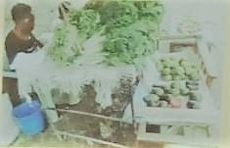
Food sold in a dirty environment
R10: I am R10, this photo is about those vegetables and foods that are there. They are good vegetables and good food but where it is being sold it cannot be sold because there is dirty water from the trench that is passing there and the food is open like that, it can cause problems in someone’s life here in Korogocho.
M: Thank you very much old man, thank you very much R10. The elder is telling us that this photo shows very good food that is sold here but the environment where it is being sold is not clean. I would like to ask this, is our situations normally like that? Do we have such a situation whereby good food is sold but the environment is not good?
R: It is there in every estate
Chorus: There is
M: There is?
Chorus: A lot
M: A lot
Chorus: Yes
M: Why? Elders, why should food be sold in such an environment? What normally makes a trader to come and sell here where the place is dirty?
R6: It is because if lack of means
M: R6 is saying it is because of lack of means. R4
R4: It is because she/he doesn’t have a good place to sell because maybe he/she is selling near her door and yet at her/his door there is a trench flowing.
M: Okay
R4: And there are people near there so they get food nearby where she/he is because there is no good place for selling something like that.
M: Okay, thank you very much. Anyone else, R5
R5: How can that woman be clean and sell food in a dirty place? She must bath and take her food to where people like and her food should be clean.
M: Okay
R5: Where you are selling at must be clean, how can you be selling dirty things in a dirty place and yet people are coveting the things.
M: Thank you very much. I would like to ask this, for those people who are selling vegetables or those foods here where there is sewage, in a dirty place like this, and you have said that it is a normal thing. Normally when people buy foods in a place like this, are they affected health wise or they are just okay? What happens when you eat food that has come from such an environment?
R6: It is because they are sold cheaply
M: Okay, after buying it there, and you have told us that it is cheaper, does it have health effects or it is just okay.
Chorus: It is just okay
R: It could have health effects, you can contract cholera
M: Okay, thank you very much. My other question is this, if we say for instance vegetables, because here I can see vegetables, I see avocado, I see like mangoes, so let us use examples that are here. Here we can see this person selling the food here above the sewage. Are there others in our environment who sell vegetables where there is no sewage, in a clean place or do they all sell in dirty places like this? How is the situation? Are there some who sell in good places? R5
R5: There are very smart women. When she takes things to her kiosk to sell, she has to sweep the place where she will put them, she displays them well so that people can see her as clean woman where she is selling and people will like going to buy things from her but if she is dirty and where she sits is dirty people will just pass.
M: Okay, thank you. Therefore, there are people who sell in clean places?
Chorus: There are
M: I want to see if the elders are agreeing with me.
R: There are
M: Are there those who sell their foods in clean places?
Chorus: Yes
M: Now, this is my question. Let’s say there is this one selling her vegetables here above the sewage, there is also another one here also selling vegetables but in a clean place and I know that sells vegetables and that one sells vegetables, that one’s are above the sewage and that one’s are in a clean place. What can make someone to leave those clean vegetables there and go from this one who one has her’s above the sewage? What usually happens?
R6: Let me give the reason
M: Yes, R6
R6: I am R6, the reason is this. As you are there the 2 of you, there is one whom if I go to her when I don’t have anything she usually gives me. You see she gives me when I don’t have what….
R: Anything
R6: …When I don’t have anything. I cannot miss to go to her even if she is selling at a bad place because when I go there she gives me on credit but this other one doesn’t give me on credit. Then another thing is knowing one another. I can go to a particular lady because she cuts them well or because she packs a lot, you see. Therefore, there it depends on how you know one another and how she gives you on credit.
M: All right, thank you very much. R4
R4: I am R4, you know, (not audible) well. You may find that the prices are different between the one who sells her commodities in the trenches and the one who sells her commodities up on a stall. She feels proud that she is clean and that those who are clean like her will buy from her. You may desire to buy oranges from her, when you leave your house you really desire to go and buy oranges but when you go to that woman whose things are in the trench, the price is lower than the one whose things are up. So when you go there, one orange costs 5 shillings while here it is 4 or 3 shillings, let me go back there and you go back to the place they sell at 3shillings, why? Because you have little money and you are craving for an orange, you are craving for fruits. What will you do, won’t you just go back there? When it comes to vegetables, that one packs a lot of vegetables like this while that one packs very little because hers are clean, you run to the one who packs a lot, the one what has some volume because she gets.
M: Okay
R4: Yes, there is a very big difference there
M: Thank you very much. I don’t know if there is anyone I am locking out yet they have a burning point
R1: Yes, I am R1
M: Okay
R1: I would like to say if you see something so much, you see something with your eyes, there are times you get used to seeing it. There are things sold here called ‘chongo’, I don’t know if you know her
R4: What?
R1: ‘Chongo’
R4: Yes, ‘chongo’
R1: They are sold
R: Even ‘anyona’
R1: And honestly, people don’t see it as wrong. Being sold for vegetables on top of sewage is even better than ‘chongo’ that comes from sewage in Mukuru then he/she comes and cleans a little for you with a piece of cloth like this and then someone like me, R1, in a suit I eat ‘chongo’ (laughter).
R: You eat ‘anyona’
R1: Yes, you get used to it. I don’t know whether we are lacking education or what. There that issue of getting used to it, we are so used to seeing them. We have seen them so much and we think it is normal
M: Very good views, I would not like to lock out R10. R10 speak and then we move on
R10: I would like to talk about what can make one to eat dirty ‘chongo’ is the lack of money. If you have good money, you can go and buy those ‘chongo’ where they are sold. Lack of money is what makes people eat that.
Photo 1, Group 2
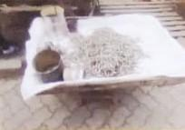
Poor quality but expensive
M: Okay, thank you very much. I would like us to move on, let’s come here. Group 2, the 1st photo, whose photo is that?
R4: That is my photo
R4, the stage is yours
R4: There, let me stand up, I am even tired of sitting. This is ‘omena’, it is fish. I felt that we should talk about this fish because first, fish comes from the lake, let’s say Lake Victoria and by the time it reaches here, there must be some little changes in smell and appearance. You may see some are yellow and some are okay. When they are brought, the ones that are brought today are of a different price from those brought the day before yesterday. That is the problem that is here in Korogocho. I don’t want to continue, let others also comment about ‘omena’ on that. At times ‘omena’ can stay, if you price yours expensively, there are 3tins. They are the same size but there are 3 different prices; the ones for the day before yesterday, those for today and…
R: Yesterday
R4: …the day after tomorrow
M: All right
R4: The ones that have stayed there for long and changed appearance into yellowish, some carry and take them to the flour mill and they make manure or they make chicken feeds because they have stayed for too long and nobody can buy.
M: All right
R: But their price is usually low
R4: Here in Kisumu Ndogo, I am mostly talking about where I have lived for more than 30years, I know much about ‘omena’. That is the problem that we have. You can take that thing, ‘omena’ which has stayed a bit, the cheaper ones, the tin is the same size as this but the price is different. I go for the small one and it is adequate for my people.
R1: And is it all ‘omena’?
R4: It is all ‘omena’
R1: And the price is different
R4: Different prices, (cross talk) that is what I see people should discuss about this thing so that we see what happens.
M: Thank you very much R4. He has highlighted a very important point and I can see we have already begun debating. That ‘omena’ is there and they are brought and the more they stay the more the prices keep changing; those that have stayed for too long their prices go down. Let me ask this, why is the price of those that have stayed long brought down? What is the real reason why they lower the price? R10
R10: As R10, I am saying for the one that has stayed for long, the owner feels that he/she should sell cheaply so that he/she doesn’t lose her/his money.
M: Okay
R10: Because if you compare with those that came today, no one will buy those ones for long ago.
M: Okay, by the time ‘omena’ stays that long for him/her to decide to lower the price, how is the quality of that ‘omena’? Is it still in good quality, the original state or how is it usually? R2
R2: As R2, I have bought ‘omena’ at our home and I have sold them here, is I know the ‘omena’ is in 3 types. There are some which are small like their young ones while others are big. Those small ones really stay long in dry places like here. If you wash them and place them there, they can even stay for a month. But for the big ones, if they stay for 2days here they turn red and bitter when you cook them. Even if you wash them with warm water, they will still be bitter, so you lower their prices. And there are others we call medium, in between the very small and the very big ones. The medium ones are sold like that but if they stay there for more than 3 weeks they also become bitter so their prices will have to be lowered.
M: Thank you very much
R2: That is the thing with those things
M: Thank you very much
R6: Then another thing, as R6 commenting about ‘omena’, you know, it is not one person selling, they are many people and some people don’t like (not audible), they sell as if it is a competition, they want theirs to get finished quickly so that they are seen as if they have sold and maybe they have gone at a loss, you see. Another person may say, since I want to go back quickly, let me lower the price and for sure he/she brought according to the price he/she is selling at while others prefer to get back their capital. There are those who might say let me get back my capital so that I go and bring more and he/she goes, comes back and finds the other one still selling at that price. You see he/she has gone twice, come back and found the other one still selling at that price.
M: Okay
R6: Then as they bring the ‘omena’, there are those who come to sell to the others. The and those who sell in tins, those who sell in wholesale while others sell in tins. Therefore, they cannot be the same.
M: Thank you very much. Let me ask this….
R: (Interjects) there is a day I assisted an old man with that ‘omena’ the new ones that you say have come in today are put in top of the old ones. So when you come, at first you will see the ‘omena’ is good but the person selling them knows the secret. He/she will talk to you “the ‘omena’ is very good” while doing this “the ‘omena’ is very good and he/she scoops for you the other one plus this and puts the good ones on top and they pack for you and you go with the ‘omena’.
M: (Laughing) thank you very much. I can see there are secrets even in business
R: There are secrets in business
R: That is a secret
M: I am asking this, as the price of the ‘omena’ continues lower, they stay for long and the price gets lower, is there a time the ‘omena’ go bad and they are still sold to people?
Chorus: Yes
M: Is there?
Chorus: Yes
R: You cannot throw
M: They are sold to people after they have gone bad?
Chorus: You are sold for
R: Especially those of us who don’t know about fish…
R: (Interjects) they buy
R: Like I recently bought and threw them away
M: Okay
R: If you taste that thing, it is very bitter
R: It is bitter
R: Something bad
R: Until it forces you to cut off the heads thinking they are the cause of the bitterness
R: Especially the people from Central, you know they are not used to the issues of fish and we have come to learn to eat fish here in Nairobi. We hear ‘omena’ is good and even the children, since they have schooled with the children from Western, they know about fish. When you go to the market, “mum, bring for us ‘omena’”, when I find ‘omena’ in the market I just buy.
R: (Interjects) you don’t know which ones are good
R: When I get home I try to eat, I try to do what, even washing, “you are the one who didn’t wash with warm water”. Today is when I have discovered that there is bad ‘omena’.
M: Okay, thank you
R2: There are problems, there are those which have stones in the head.
M: Thank you very much. Let me ask this, since we have really talked about ‘omena’ and I want to follow up a little on the last point. You have told me that there are times you are sold for the ‘omena’ when they have started going bad. I am asking this, let us leave ‘omena’ a little and come to all these other foods that we are sold for in the market. Are there times we are sold for foods that have started going bad, which are not of good quality or is it just ‘omena’ that is sold like that?
R: We are sold for even food.
M: Okay, can someone give me an example of foods that people are sold for when they have already started going bad. R3
R3: I am R3. For instance, you may find cabbage that has been brought today morning we are sold for 80 each, it then stays overnight then tomorrow we are sold for at 70 each, then it stays overnight again. You see it continues to turn color, it changes. Now the following day, they will start announcing to you 20, 20, 20 so that they dispose them and not to incur the losses. We will take those ones for 20 and when you get to the house and cut it, you will feel that thing smelling even before whatever.
M: Okay
R3: When you cut that cabbage, you feel it smelling
M: All right, thank you very much. So you have said that there are times we are also sold for these other foods when they have gone bad.
R3: Yes
M: Earlier on, you told me that the reason why you buy some things is because of their low prices
Chorus: Low prices
M: When they have started getting spoilt. Now I will ask this, why do those traders who sell these foods sell to people foods that have started getting spoilt; foods that are not in good condition?
R: (Whispering) we don’t want loses
M: Why do they sell to people such foods, R4?
R4: As a business person, you sell like that because you have not yet gotten back your money, your capital. You are forced to sell like that so that even if we incur losses, we incur less loses than losing everything.
M: Therefore, if I understood you well, a business person looks after his/her money, so that he/she doesn’t lose it
Chorus: Yes
M: He/she doesn’t think of the person, he/she is looking after his money
Chorus: Yes
R6: He/she is after the money
M: Are we all in agreement?
Chorus: Yes
M: Another question is, this business person also has pressure that his/her commodities have started getting spoilt and he/she doesn’t want them to get spoilt because he/she will lose money. Instead of that business person selling to us, what can be done so that those foods don’t get spoilt when they are many there? Maybe there should be a good storage system so that the business person’s commodities don’t get spoilt. Plenty of ‘omena’ has come from Western and it is here in the market, what can be done or what can be done so that the ‘omena’ doesn’t go bad so that even if we sell to people slowly, we sell when it is in good condition, even after 3months it is still okay. What can be done and by who? Let us look for a solution. R8
R8: One short cut to ensure that his/her ‘omena’ doesn’t go bad, as a businessperson, you know he/she has brains, he/she is just interested in selling them cheaply so as to get back the money so that the next morning he/she goes to buy others which are fresh
M: Okay, R6
R6: I am R6. For his/her food not to go bad, be it vegetables or what, if he/she had the ability, he/she would have bought a fridge because that is not something to be sold in one day. If there was a fridge, they would be stored inside so that even if he/she is selling for several days, they will not have gone bad but since there is nothing that can prevent these vegetables from going bad, that is why you are seeing him/her selling to us even the bad ones and he/she doesn’t see as if he/she is harming us.
M: Okay, thank you very much, anyone else who would like to add?
(Silence, no response)
M: What can the government do to try and help this situation; to protect the business people so that their commodities don’t go bad? R2
R2: I am R2, I think there is nothing they can do, there isn’t because if I have taken one trough of his ‘omena’, that is what I am selling and it doesn’t get finished until it gets spoilt there, will it make me to buy a fridge to store ‘omena’? No, and the government also cannot store ‘omena’, they have been unable to even at City Market. They don’t have that….
M: Okay
R2: So there is no other way, we will buy these things
R3: We will just continue eating those things
M: Okay
R2: We will buy those things because a fridge is not possible. All the big government markets in the counties don’t have the fridge put there for them. Go to Gikomba at the fish section there, try really hard to befriend one woman or one man selling the ‘omena’. There is ‘omena’ that was stored there before you were born.
R: (Interjects) True
R2: And you will find some insects with black covering, small black like this walking there, how long as that ‘omena’ been there? Do this, you will see dust that the insects have ground, I don’t know what they are called and they are not cockroaches and they are black…
R: Insects
(Noises in the background)
R2: They are insects, they are there. If you dig inside like this, you will see it. That is why I told you that businesspeople have secrets about these ‘omena’, same to ‘obambo’ what you call ‘obambla’. Some liquid cooking oil is usually applied on the ‘obambla’, it is polished and then it looks new there on the table. There are secrets there.
M: (Laughs) okay
R2: Now, they take the new ones which they brought yesterday and place them on top. “[Name], sell for me ‘omena’, eh, Anyango give me ‘omena’” and yet Anyango has put something on top. So Anyango will mix your ‘omena’ and when you go with it and pour somewhere that now you want to select and cook, there are those who don’t select, they do this and put them in water and when they remove from there, direct into oil and tomatoes, you see.
M: Thank you very much
R2: There is nothing we will do so that those things don’t get spoilt.
M: Thank you so much. I can see we are progressing well and as we go to talk to those people to reduce the noise, I would like us to take a break of just 30seconds. A break, we see where we have reached and then we continue with round 2 as we finish, okay? So we will take a break
(Interview paused 01:15:45-01:15:55)
M: All right, you are so welcome again. As we move on, now we are going to discuss photo number 2 of group 2. The owner of photo number 2 of group 2 please, you are welcome.
PHOTO 2 GROUP 2
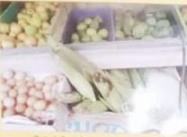
Expensive commodities
R: Neighbor, tell us about your photo
M: Photo number 2 group 2, R10, welcome, tell us.
R10: Concerning maize, we must have farms for farming which we depend on. Those who farm maize in the rural areas, that is why you see that when maize comes to these sides, like now in Kikuyu land, they cut maize and bring to the market here and the prices are high. But if you are in the rural areas, your maize will dry up in the farm, you harvest, you take them home to go and store in sacks. Like this year, my own brother farmed and go 30sacks, with those 30sacks hasn’t he become rich? Therefore, during hunger, he will sell them at a high price because at a time like this the price of maize is not high, it is a bit low. Therefore, maize farming, and that is flour, maize is flour and it is food. And when there is a lot of maize, food becomes cheap because that is the shield for human beings.
M: Okay, thank you very much R5. The elder has told us about the availability of food, that it can be planted at home so that we have food. And he has also talked about the price that when there is a lot of food in the market, the prices become low. Isn’t that true?
Chorus: Yes
M: So we really discussed a lot the issue of food and prices in the previous photos so we move on. Photo number 3, group 2

PHOTO 3 GROUP 2
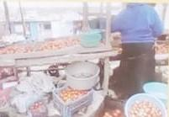
Poor hygiene
R6: That one is R6
M: Yes
R6: From what you can see in that photo, if you look at those tomatoes, they are too many. And where those tomatoes are, they are at a place that they should not be because there is a gutter there. And that is why you can see that woman packing a lot of tomatoes so that people can be attracted to them. Because if those tomatoes were in a good place, she would not be putting so many like that. And if you observe, those are the big big tomatoes and people’s eyes like those big ones because they think they are the good ones yet that is endangering the health of citizens or people’s health because those tomatoes because it seems she went to buy the spoilt tomatoes.
M: Okay, thank you very much. He has highlighted something that we had really talked about regarding the hygiene, where things are sold and that those who sell in places that are not good usually pack for us a lot so as to attract us, especially those who sell things that are not of good quality. Therefore, thank you very much elder R6. Let us move on, photo number 4, group 2.
PHOTO NUMBER 4, GROUP 2.

We desire this type of food but cannot access due to price
R7: R7
M: Yes, R7
R7: That is meat that I photographed there. I felt that meat is expensive and we cannot buy and there are others who have decided to be going for the ‘katakata’ (cut pieces). Instead of going to buy meat from the butchery, it is expensive so you for the cheap one that has diseases. That is my issue there.
M: Okay, that meat has become expensive and so people go for shortcut, they go for what he has said is called ‘katakata’ and he has said that it is meat that causes illnesses. Is that true?
Chorus: Yes
R: It is true
M: Is it true?
Chorus: It is true
M: What is the difference between this one and the one cut in pieces to the extent that the other one causes illnesses? Let me understand that, who will help him?
R: The price
M: Yes R3
R3: As R3, the difference between this one you can see here and the one cut to pieces is our income.
M: Okay
R3: Yes
M: Therefore, it is the price that takes people there
R3: Yes, the income
M: And if you look at the meat that is cut to pieces and this other one, what is the difference in quality? R6
R6: It depends on where that meat is kept. The one that is cut is kept in the open, it is kept in a place that is not safe because all the dust from everywhere lands on that meat and you know the way it is kept there, when it is roasted or soup is made, that dust gets in and when that dust gets in and someone comes to buy, he/she is just served and cooked for. What is he/she drinking, isn’t she/he just drinking illnesses, yes, but when it is in that glass, when it is in that glass, it prevents all that harm from entering into that meat.
M: Thank you, R8
R8: When it comes to meat, there is great danger. (Not audible), there are 2 types of meat now. First is that which has stayed for so long in the depot. The second meat is the meat of different types of animals and not cow or goat. There is human meat, it is available now because if you observe keenly, if you check the internet, it shows canned meat, the canned minced meat. If you look at that meat well, it is either human or dog meat but it is not normal meat. Therefore, this meat causes illnesses. In fact, leave alone that, the price, it is very harmful because even the cheap one still harms you. If you go for the expensive you, it is pressure because you don’t have money and if you go for the cheap one (not audible) cancer because there are 2 types of meat as I have said, there is human meat and meats of different animals.
M: Okay, thank you very much R8. Let me ask, R8 has said that there is meat for those other animals that we don’t normally eat and even human meat is sold and is available in some places. Is it true?
(Laughter)
M: Have we seen that situation here or do we just hear about it?
R: We hear about it from the newspapers
M: You hear of it from far
R: Yes
M: All right, thank you very much. Let us move forward and touch on this photo number 1 of group 1
PHOTO 1 GROUP 1
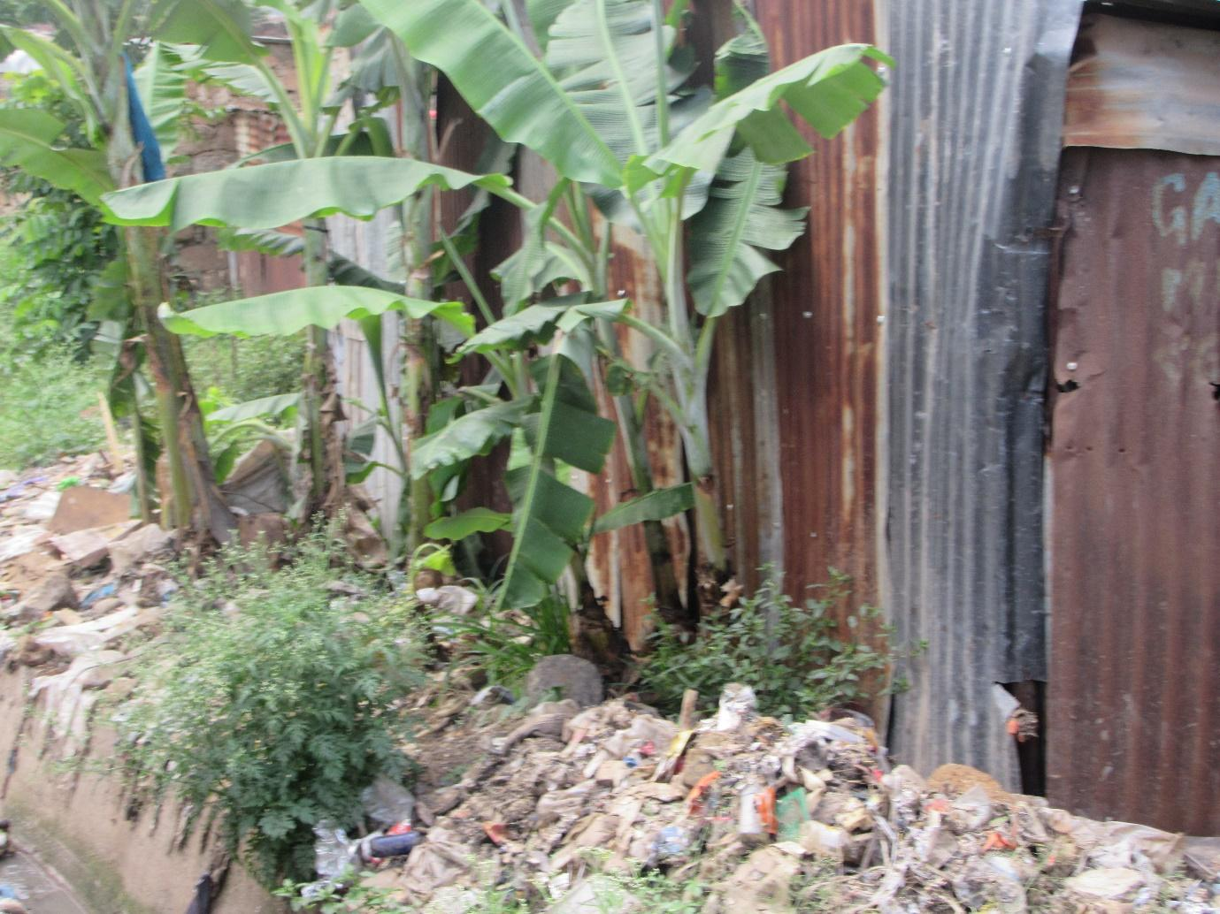
Poor housing program
R1: Okay
M: Yes R1
R1: That photo is mine. I was asking the policy makers like the one of our area, [name], if I could meet him face to face, is such an environment fit for human habitation. You see this is a door and the gate has a head of fish or I don’t know that is there, such a house should not be occupied by anyone. You cannot even understand how the housing program is. The government should clear construction laws or policies.
M: Okay
R1: The sewage system, that food is near….like where the bananas are arranged, those bananas are absorbing sewage water. We need to have direction as a country and if life will continue like this, there will be no future.
M: Okay, thank you very much R1. Let us move on, photo number 2 of group 1. This one here

PHOTO 2, GROUP 1
XXXX
R3: That is R3. If you look at that stall, yes, you will find things displayed there and from the way we observed and asked the price, for instance, I asked the price of tomatoes and I was told 3 tomatoes cost 20shillings. I tried to select the tomatoes that were there and I found that the tomatoes are smashed and I wondered these tomatoes are smashed, they have water meaning that is acid already. I will buy them for 20shillings, go to the house, cook and eat them I get gas in the stomach and those are illnesses.
M: Thank you very much. He has told us what we have talked a lot about, the cost of food and foods that are not of good quality to be sold to us, isn’t it?
Chorus: Yes
M: Therefore, I request that we move forward. Photo number 3, group 1
PHOTO 3, GROUP 1
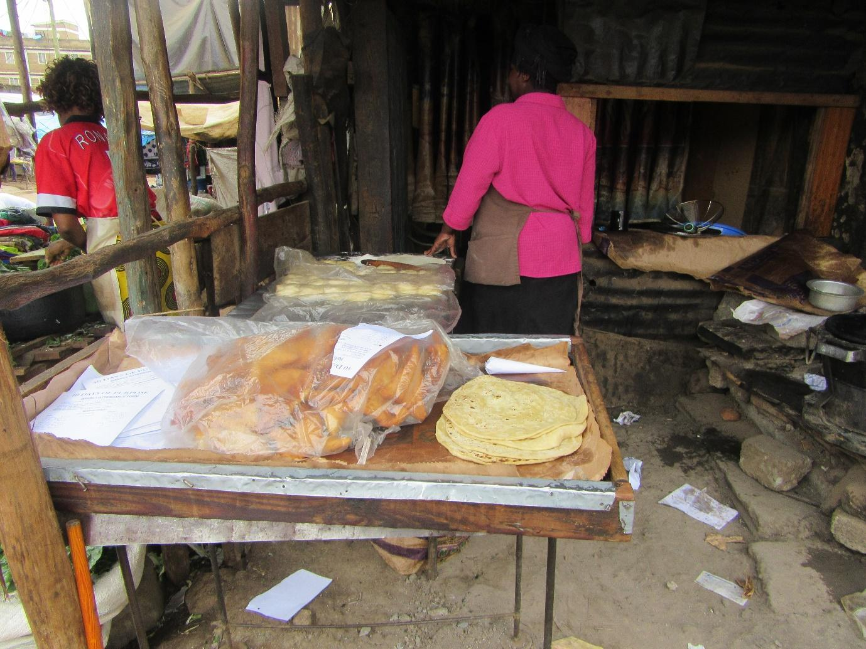
High cost of living
R2: Photo number 3 is R2. When I reached there, I talked to that woman who has displayed her things there. I asked her the price of a packet of flour when she goes to buy and she told me it is 120. For sure, she has covered her ‘mandazi’ with polythene, her ‘mandazi’ are put in polythene (not audible) but she complained to me about the price of buying. The buyers also find the price to be high, so they don’t come in plenty. She stays the whole day selling 2 packets in a day.
M: So she feels the price is high
R2: It is high
M: Thank you very much. We have talked a lot about the price we move. I wouldn’t like us to dwell on that, I request that we move on and go to picture number 6 of group 1
PHOTO 6, GROUP 1
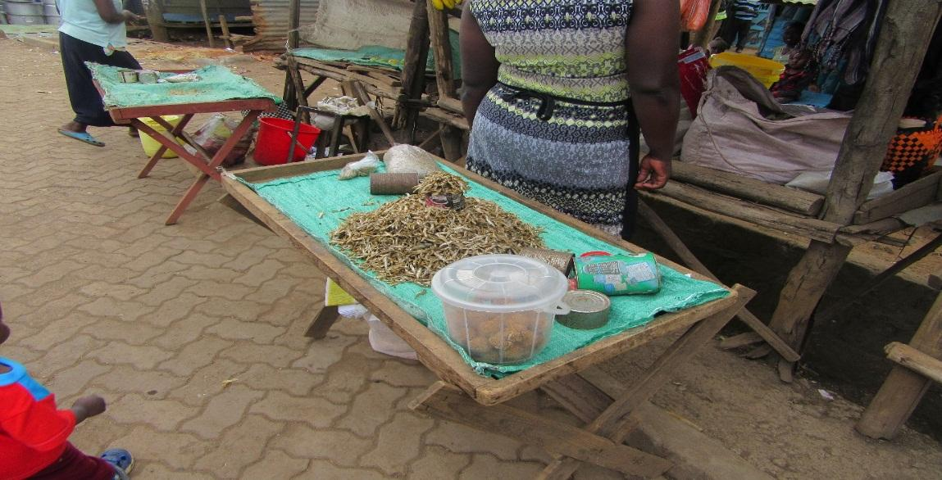
Health hazards
R2: Picture number 6 is still R2
M: Okay R2
R2: I went to the corner near sets here near where you found the (not audible). You see the design of her ‘omena’, I think you can see (not audible) and the ‘omena’ that she has is on the way. Vehicles pass like this on this road that you can see from the board there and all the dust goes there and it is not usual when cooking that the way you clean them is the same way I clean them too. So maybe I just washed them roughly and that way I contracted some illness like typhoid, TB all the diseases that are caused by dust. So that is why I told her “put a mat here and then (not audible) the tins”. I requested her “mum, you will just use your brains (not audible)”
M: Thank you very much R2. R4 also told us that ‘omena’ is on the road and it can get dirty, isn’t it.
Chorus: Yes
M: So we are not going into contamination, we really discussed that. So we will proceed. Picture number 5 group 1
PHOTO 5, GROUP 1
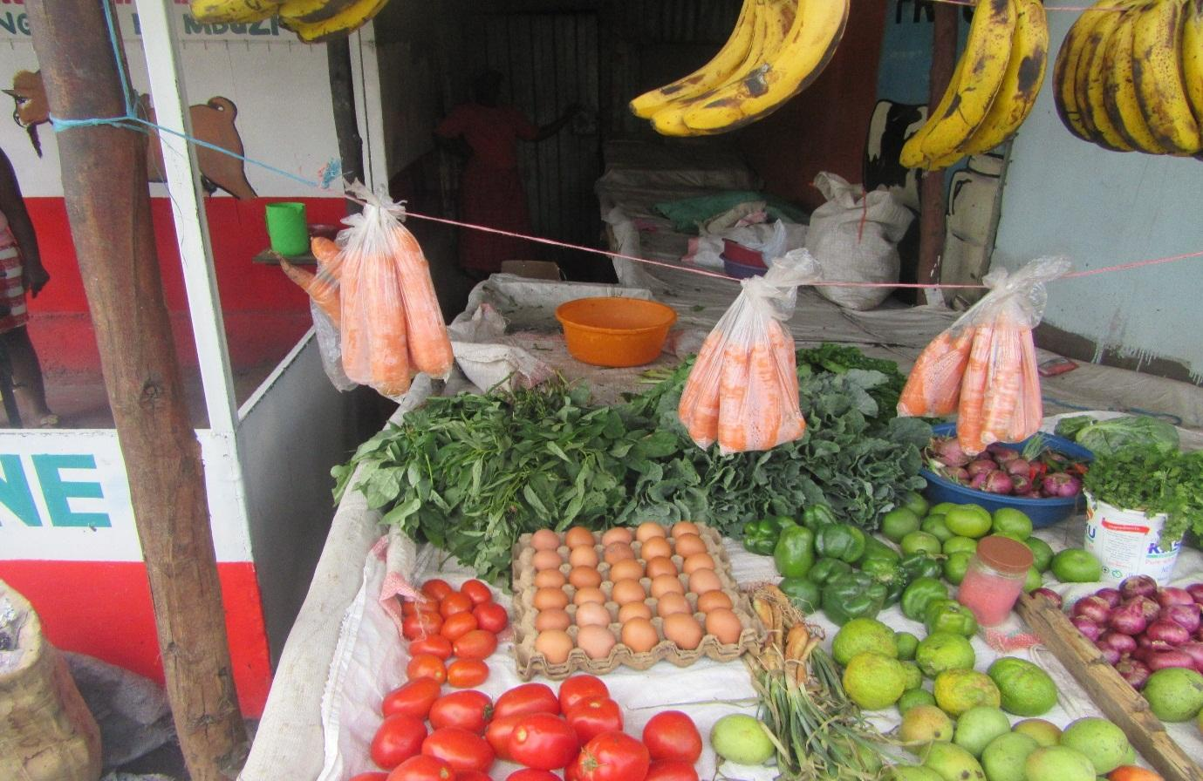
Contamination
R3: It is R3
M: Yes, R3
R3: Where I went to the stall, I went and found a big gutter down. There was dirt which had blocked that gutter so it was full of water. At the top, it was looking smart but at the bottom, there was water.
M: Okay, thank you very much. You have told us the situation of dirty water near foods that are being sold, the issue of contamination. Thank you very much. Photo number 4 group 1
PHOTO 4, GROUP 1
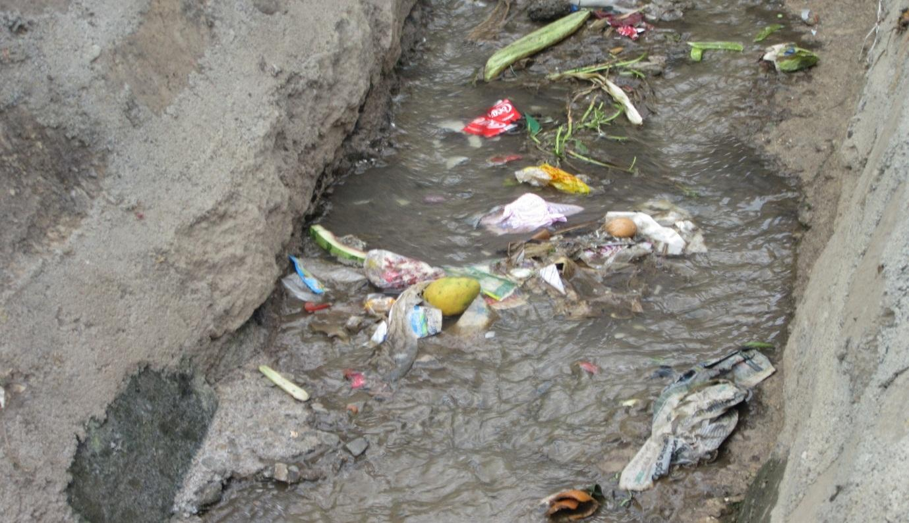
Sanitation
R1: I am R1. This issue of sanitation is still (not audible) and you have to know that all the blame is on the government. There should be some order and policies to finish issues of sanitation.
M: Okay, thank you very much R1. We have also talked about sanitation, thank you very much. Let us go to photo number 8, group 2, this one here
PHOTO NUMBER 8, GROUP 2
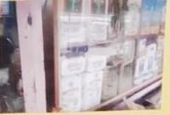
Variety of food but expensive
R: Neighbor
R: R7
R: Neighbor
(Cross talk)
M: No, photo 8, group 2
Chorus: Group 2
M: For R7
R7: There, we went to the shop and took that photo and she said the price is 120 and we wondered if a person who doesn’t have good income can buy that. Even the shopkeeper just laughed and then we just parted like that as he/she continues.
M: You are saying that the prices are high
R: Yes
M: The price of food, thank you very much, we have talked about it. Photo number 7
PHOTO NUMBER 7, GROUP 2
XXXX
R6: That is R6
M: R6, yes
R6: According to how I found that stall, as you can see those bananas are not bananas that should be sold for10shillings but that woman told me that she sells for 10shillings because she gets them from far, she gets them from Gikomba, she doesn’t get them from here Korogocho. Therefore, I observed keenly and saw that those bananas, together with those spinach, cabbage and mangoes; whereas she should be selling mangoes for 5shillings, she is selling them at 10shillings. Therefore, I feel that life is very hard here in Korogocho. If one needs a banana, he/she cannot eat it without 10shillings.
M: Thank you very much. He has again mentioned to us the situation that there is food but the prices are high and we also understand because even those who sell get them at high prices. And on that, perhaps I will ask, as elders here, and we are talking of all the people of Korogocho, do people here in Korogocho eat this food that we call balanced diet or this food is not in the homes?
Chorus: There isn’t
(Crosstalk)
Chorus: No
R: Where will you get a balanced diet?
R: As long as the stomach is satisfied
M: As long as the stomach is satisfied
R: As long as the stomach has become big
M: It is okay
R3: In fact, it is even very strange that I have eaten lunch today.
(Laughter)
M: All right, thank you very much. I request that we move on. Photo number 6….
PHOTO NUMBER 6, GROUP 2
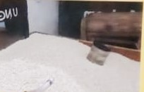
Maize is available but expensive
R3: It is just super only
M: Super
Chorus: Yes
R3: Yes, we depend on super
M: 6, group 2
R6: It is rice, whose rice is that?
Chorus: It is maize
R5: Oh, that is me
M: R5
R5: That maize has been bought by a trader and taken to the flour mill so as to grind it into flour. That flour is our food which if you lack, I don’t know which food you will eat. So he/she is helping the citizens. He/she has bought and then he/she has come to grind so that we get flour.
M: So this is that flour that is ground for you there
R5: Yes, just here
M: Thank you very much. It is a good thing. Let me ask this, we know there is flour that you buy and then it is ground for you and then there is the flour in packets, which one do people here in Korogocho prefer?
R3: The one for grinding
M: The one for grinding
R6: We like the one for grinding
M: Why do people prefer the one for grinding?
R6: Because it has all the energy
R3: And the price is low
M: This one is strong
Chorus: Yes
M: And its price is also good
Chorus: Yes
R: That one is a whole one
M: What about health wise, which one?
R: It is just that one
R: Health wise it is still the same one
M: Still this one
Chorus: Yes
R1: People like the packet one. This is one it is just because it is cheap. If you observe between a flour mill and a shop, where do you find a variety? If you go to the shop, you will find that the packet flour is bought every day. As for the one for grinding, you cannot find a queue.
M: All right
R1: It is true
M: Therefore, as R1 has told us and as you have also said, is that there are those who like the one for grinding
Chorus: Yes
M: And there are those who like the packet one
(Cross talk)
R: The one for grinding is better
M: Can I ask this, what can make someone to like the one for the shop and not like the one for grinding and yet we have heard that the one for grinding even its price is good?
R6: Let me explain
M: Okay, let us begin with R6
R6: With the flour that is ground, even if you have children, that is when you will hear them say that they get satisfied better than the one from the shop…
R: (Interjects) I am not yet satisfied
R6: They say that the packet one is like rice, they don’t get satisfied….
R: (Interject) many things have been removed from it
R6: …but when they eat the one for grinding, they say the energy is there (laughter).
M: Thank you very much, R2
R2: If I comment on the maize that has been processed and the one that has not, this one has not been processed, the outer cover is still there. Many people don’t like it as this elder is saying because this ‘gorogoro’ (2kg tin) of theirs….they call it ‘gorogoro’, don’t we all understand ‘gorogoro’?
Chorus: Yes
R2: Some have discovered that it is not that ‘gorogoro’, you see. Which ‘gorogoro’ is that which you touch down here till the end, (Laughter) a 2kg ‘gorogor’?
R: (Interjects) that one has been cut
R2: No, that one has been cut and repaired by the companies which manufacture those tins long ago. Now they see that this one is little, it is not 2kg.
M: Okay, thank you
R2: You see there, now that is what makes it remain there and its price has come to I don’t know 80….
R: 70
R2: There is 80 and 70 and 75, I usually see there and then grinding is 10. Now you see, and it is not 2kgs.
M: Okay, thank you very much
R2: The problem is there. There is conning there
M: Thank you very much. I request that we move on. Photo number 5, group 2
PHOTO 5, GROUP 2
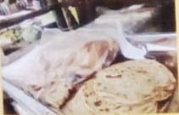
Poor hygiene
pR4: That is for R4. I went there, it is hotel and they are cooking that food outside the hotel. There is nothing they are covering those chapattis with in the first place and it is near the road, imagine. And I tried to ask her/him how much it is and she/he said one costs 20. “Why are you selling at that price and yet the chapattis are this small, the chapatti are small in that you can see someone through?” “No, it is the expense”. The expense she/he is talking about is the oil, charcoal and also that she/he gets her/his little profit there. That is why she/he is selling like that, but it is not good; where she/he is preparing them from, it is not right.
M: Thank you very much. Okay, let us move on, photo number 6 group 3, this one here. Remember we are only left with these 3, therefore the rest should be ready to come here. Number 6
PHOTO 6, GROUP 3
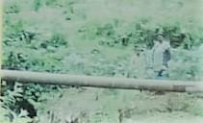
Vegetables irrigated using untreated sewage water
R10: That is R10
M: It is R10
R10: There we took a photo there because there were vegetables that had been planted near the sewage. Therefore, we found when those vegetables were being harvested and the water that they had used to plant and watering with every day was sewage water and you know with sewage here in Nairobi, they usually even pour in there even fecal matter from the toilets. Therefore, that is dangerous to the lives of people.
M: Okay, thank you very much R10. The issue of sewage vegetables which we really talked a lot about has come back, thank you so much. Photo number 5 group 3, that is our second last, photo number 5 group 3
PHOTO 5, GROUP 3
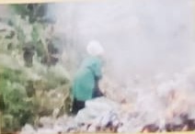
Vegetables grown along sewer lines
R9: There, a farmer can be seen harvesting vegetables now and where he/she is putting those vegetables is a very bad place. There are leaves being burnt there, garbage, and vegetables are being harvested there at the gutters.
M: Okay, thank you very much R9. Even his is looking at the issue of the sewage, vegetables being planted at the sewage. Thank you so much. The last photo, photo number 4, group 3 this one down here.
PHOTO 4, GROUP 3
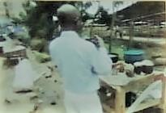
Food contamination
R8: When we went there, we found a woman selling fish called ‘mgongo wazi’, in Luo language we call it ‘mbuta’ (Nile perch), yes ‘mbuta’. And when that fish is prepared in the morning, there are 2 types of dangers. There is one type of fish that is gotten from the mud when it is (not audible), that is step one. If we look at that fish called ‘mgongo wazi’ is brought in here, it is cleaned well with clean water. Then when it is sold it is sold cheaply, mostly it is sold here in Korogocho because it is in Korogocho. If you want to know, look at the price. There ‘mgongo wazi’ which is cheap and there is that which is expensive. The one that is cheap is there being sold. When we tried to ask the price, she was so harsh that we ran away. But it is because of the price, we wanted her to give us the difference in prices because she had already prepared. That was ‘mgongo wazi’ fish, the Nile perch.
M: Okay
R8: We call it ‘kamongo’ (laughter)
M: Thank you very much elder and he has highlighted very many things and if you realize, we had mentioned most of them earlier. And because that was our last photo, we have finished giving our photos voices. Therefore, now voices have reached for all the photos. We have discussed them, we have already known what you were trying to show using these photos and we have talked about recommendations. We have seen where there are problems, you have said how it can be corrected and we have said if this is done, if the government does this, if this one does this, it can change the situation. My question is, for instance, you have really talked a lot about the government today, R1 we have talked a lot about the government, isn’t it?
R1: Yes
M: And you have also talked about other stakeholders, the community as part of these solutions that we are talking about. For this information that we have gathered here to reach those that it should reach, how would you like it to reach them? What means would you advise us to use in order to pass this information to the government, to those stakeholders and to the community members? R6
R6: I will try. I think for this information to reach them well, do you see these photos that we have taken, because you are the ones who usually go close to them, if you are going to tell them, keep these photos…
R: (Interjects) Show them
R6: Show them so that they know the problems we usually have on the ground regarding food.
M: Okay, thank you very. R6 has said that we go with these photos
R6: Those are my views
M: And we explain just the way we have discussed here. R4
R4: This information is very easy to pass to our leaders because you, the NGOs (Non-Governmental Organizations) can pass it to them because you can call for a meeting in their office one day. Even if you are going to a government office in their hall, you call the chiefs and all to sit together one day. That information will reach them, it is much easier than us. You have a right because you are the ones who have the capability, you visit down here at the ground and you take it to all of them.
M: Thank you very much. The last one, R8, in brief
R8: Mine will be brief. I think we are the ones who will decide and we are the ones who know how it is. I would say this, we as residents of Korogocho should unite and collaborate with you, prepare that report. When you see it has reached some point you move your pants and look for sewage that is nearby but be on the forefront in saying that according to the research that we did in Africa, that is what made you to come to the slum here to ask these questions and not just you saying all the time, asking us questions and us responding these photos would not have existed.
M: Okay, thank you very much and I am grateful. Now we have come to the end and before we close the sitting, let’s move a little from here. We have had a long day. We started there and we were taught new things, a new way called photo voice, something that was very new, isn’t it? Had anyone ever heard of photo voice before we came here today?
R: No
M: We have all heard of it for the first time
Chorus: Yes
M: And you are very good elders, you have been taught and you grasped it quickly and we went out there, worked took and it is here we have even come and discussed. I want to understand, this whole process that we have done today, let us start here, this one of taking photos, this one that we did before lunch, when you were going out there to take these photos and all that experience. I want to hear from every elder because everyone took photos. In just a few seconds, you tell me your experience. How was this process of taking photos, going out there and what we have done today, your experience? Which side do we begin? Let us begin here with R10
(Noises in the background)
R10: I am R10 and I am so grateful, today I know how to take photos, that is number 1. Number 2, you know we don’t eat good food because of lack of money therefore if you have another way you can assist the elderly who have already reached 65years like me, you should see how you can help us so that we eat good food.
M: Thank you very much. Elder R9, how have you felt today doing all this process today since morning going there to take photos? How has it been?
R9: As R9, I have felt that process is very good because it has taught me how to take photos.
M: Okay
R9: I had never held a camera, it was my first time.
M: Okay, thank you so much
R9: And I am very happy because I have held a camera and taken photos where I wanted (not audible).
M: Thank you very much. R8
R8: First, I am happy. Secondly, I am grateful
M: Thank you
R8: Because this is our first health project in the whole of Africa. I think we will be the first to discover such issues in the whole of Africa, leave alone Kenya, the whole of Africa. I think if it will proceed well, if it will move forward, we will form part of the first history.
M: Okay, thank you very much. R7
R7: Yes, I am grateful for everything that we have done here because ever since I was born, I had not even known how to do te, te, te like that. And the important thing I am going to to at home is to give my wife, my children and my friends the information on how they can feed.
M: Okay, thank you very much. R6
R6: I am R6, first of all, I say thank you because when we were going out there to take these photos, we didn’t know that those people who are out there would cause challenges because many were asking us, “why are you taking photos of us?” And from the teaching that we were taught here, we told them that this is information which we want to assist you regarding food because here in Korogocho we have a shortage of food and therefore we want to learn and then bring you good information which you will continue eating good food.
M: Thank you very much. R5
R5: I will say this, I am grateful
M: Thank you
R5: And the teachings that you have brought to us which we didn’t know, these teachings, bad tomatoes, bad vegetables, whatever, life, we are very grateful for teaching us such things.
M: Thank you very much. R4
R4: I am saying thank you very much Mr. [name] and this sister of mine. This is now the second time to meet with you and I appreciate it so much.
M: Thank you very much
R4: And the important thing I have got from you today is how to get data, how to approach someone. Also, today I am very grateful for playing with cameras the way we have played with them like a child. I am requesting the 2 of you, when you go there, tell doctor and the rest, we as residents of Korogocho, let it not be the last, continue to meet with us.
M: Okay
R4: Anytime, any day, you are welcome. Thank you for all that.
M: Thank you so much, we will deliver the message. R3
R3: I am very happy for the teachings of that short time. I never used to understand about food, I used to think all food is food. Even that one from the sewage, in fact I have eaten it for a very long time but I had a stomach problem and now I have come to realize that the thing that was disturbing me was that food from the sewage. From today, I will not eat it again.
M: Thank you very much. R2
R2: R2, I am grateful to all of you and APHRC in general as an organization for bringing us important teachings. I have taken photos but today I have taken difficult photos because it is a photo that requires me to go to someone that I don’t know and he/she understands me, to listen to me and understand me. And by the power of God, I tried and they didn’t even disturb me, I was not asked questions, I just talked and I was told okay. So today, I have learnt how to approach a person that I don’t know so that he/she fulfills what I want.
M: Okay
R2: You see, again, there is a question that you asked, I will request you to pass the information to other stakeholders, I can see there you are showing the government and whoever and there are others in government. So you should coordinate so that if possible we also sit with them one day and do these things together with them, with their representatives.
M: Thank you very much
R2: So that they see these things on the ground in the beginning at the very bottom because if they are here and they have come from wherever, the county is here with those people, the ministers are here, leave alone those ones of Kenyatta, they come and see this house belongs to someone.
M: Thank you very much, I am grateful R2. R1 finish for us.
R1: The first one is gratitude. The second is thank you for waking us up. We have also woken up a little, we have known that the situation is not good. Things do change at times. Like me, I didn’t know there was someone who could think of issues concerning the elderly like these ones. Issues of food are important and should be discussed, let’s say in your whole life because if you eat a good diet, some diseases like the ones you are seeing disturbing us and you see old people walking slowly, it is not that they are not healthy, no, they don’t have energy just because of food. Thank you and again thank you.
M: Okay, thank you very much. We are also grateful
R: Thank you
M: But before I close, I want to close completely. One last question, all this experience, because you have all said that it was the first experience, this issue of photo voice. As you have seen it, according to your experience, let’s say we would now like to go to Mathare or even Dandora to do the same thing with the elders like we have done with you here today, what advice can you give us? What can we correct or do more or what can we do differently so that the process is better than you have seen it? R8
R8: First of all, (not audible, noises in the background 01:49:28-01:49:50)
M: Thank you very much. What else can we change, what can we do better, what can we maintain? We now want advice.
R1: The first thing
M: Yes R1
R1: Those elders that you want to meet with, first of all take to them the agenda so that when they come they will open up completely. This agenda, like I didn’t know what we were coming to talk about. With an agenda, if that person sleeps for one day he/she will expand his/her mind and will have very good points.
M: Thank you very much, is there anyone else we are leaving out.
(Silence)
M: We are okay. I would like to close the meeting, and before I close our meeting for today, my colleague [name]… two or three things
M2: I am just saying that I am very grateful for today’s sitting, we have heard your views and I also want to thank you for that time that you have sat with us. As R7 has said, he will pass on the information to his wife and his children, I would like to also tell you that at home and also other friends who were not with us here, you can go and pass to them today’s information. That is all, thank you very much.
Chorus: Thank
M: Thank you. As I finish, first let me say thank you very much because we have had a long day and you elders have really made me happy because you have not gotten tired and you have maintained that energy and we have done all that we wanted to do very well. Therefore, I am saying thank you. The second thing, if you look at the work that we have done here, from the photos to discussion that we have had, it is very good work. Therefore, thank you very much and when you leave here, you should have that pride that although you are old, you still have a lot that you can contribute to this society in all things, in all ways. Even in ways that are seen as digital and modern, still if you are given that chance, you just do it well like the youth and other people.
R: True
M: And you have seen it for yourselves. As elders, you should just know that you are very important people in the society and you can do anything there if given a chance and told how it should be done.
R2: We are digital (laughter), what we don’t have is one thing, I hear about all the rights but none of your organizations has come up with the rights of the elderly.
M: Maybe it’s on the way.
R2: Only that, I don’t know if it will come
M: Thank you very much.
R2: We are digital
M: On behalf of our organization, APHRC, on behalf of my bosses, I am saying thank you
R2: Thank you
M: And the very last thing before I leave, I am requesting, I also have elders, those parents who gave birth to me are elders like you back there at home and they usually tell me that whenever I meet elders, I be passing greetings. Have you received greetings from Siaya?
Chorus: We have received
M: Okay, thank you very much
R: Which part of Siaya?
R: But wait a minute, we want to escort you with some little airs
M: Okay, let us first close this
R: Elders, elders, elders
R: Raise your hands, raise your hands (laughter)
……………………………………………………………………………….THE END…………………………………………………………

