AFRICAN POPULATION AND HEALTH RESEARCH CENTER
RIGHT TO FOOD PROJECT-(ENDLINE
ARCHIVAL NUMBER: 181106_0930, 181106_1419, 181106_1421
CONTACT TYPE & DESCRIPTION: PHOTOVOICE–MOTHERS OF CHILDREN WITH SPECIAL NEEDS (KOROGOCHO)
DATE: 06/11/2018
START TIME: 2:00PM
END TIME: 5:00PM

M: How are you? Are we all ok? Are we full of Ugali? As Moderator Two has explained when you go to the front you will introduce yourself by saying for example I am R5 talking about picture two from group two and this picture talks about abc. When I was talking this picture I was thinking about ABC because of abcd. So it is like you are giving us a story about the picture. After we have discussed the picture when we go to record the information we will give the description of your picture as you have given to us. So we can start with group one the first photo. The owner of the picture can stand and give us their explanation.
Photo 1, group 1
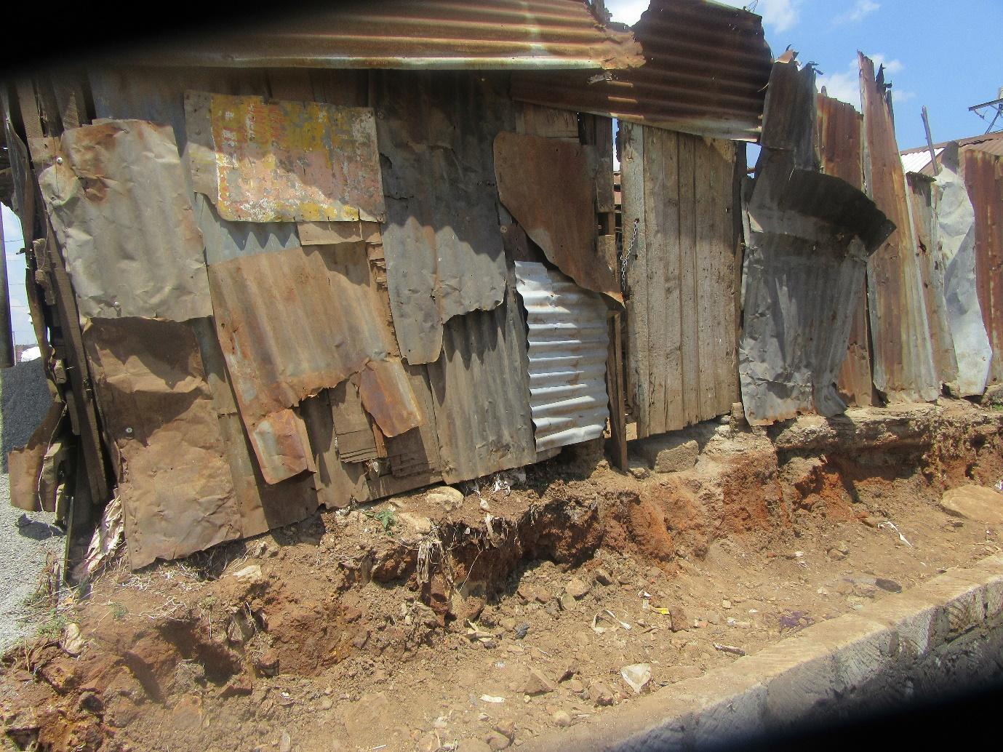
R2: I am R2 from group one. I took this picture because of the insecurity. Insecurity here in Korogocho makes it difficult to access food. Even when suppliers want to bring food when they come here to Korogocho and see a house like this they get scared. They ask themselves whether their car will reach. There boys seated out there and you wondered whether you will be robbed and your car stolen or you produce stolen.
M: I will ask a question but she is not the only one who has to answer. If anyone has an answer you can introduce yourself and give us an answer. Has what she has said true? Those houses with the youth seating there are they the ones who steal from people?
R4: I am R4. In houses like that young people hide there and you may not see them well but they have already planned how they will steal from you. When you just appear they are ready and waiting and most times you had no idea they were there. You find you have been attacked and your things taken.
M: So it is not just people coming to sell things. Even just people who live here are robbed?
R12: I am R12. Sometimes you might even be just a supplier who has brought things to a shop. You know sometimes you may have brought things for orders and you will be paid later. You bring them and end up being attached and so you go at a loss. And the person who ordered has also not received what they ordered.
M: R2 you may sit down. Let us give here flowers as she seats. But we are still discussing this picture. Is there anyone else who has something to say about security and not having food? Security here in Korogocho how does it relate to lack of food here? R2 then R1.
R2: also I relation to these houses that we live in, sometimes you have cooked food and left it. You leave it closed but sometimes you come back and find it has been opened. You had planned to eat that food at night but you find that the food is not there anymore or it has been eaten by rats. So food security is tricky because you live with cats, rats, so it forces you to sleep hungry.
M: Thank you R2. R1?
R1: Sometimes you may send a child to the shop to buy food. As the child is going the young boys will be seated and because the child does not know whether the boys are bad they will come and hold him and steal his money and the child will come back and find that that is all the money they had so they will have to sleep hungry on that day.
M: R2 did you want to add something? Is there anyone with something to add? What time do the people selling this close their shops here in Korogocho? If you have a shop? R3?
R3: They close at 9pm or 10pm.
M: around 9 or 10pm? If it’s around that time it means it’s safe to be outside selling things around that time? Is that security or its lack of security? Because it means that vendors can stay out until that time selling and for you if you get home at around 8pm you can still get something to buy?
R chorus: Yes.
M: so the insecurity of the vendor starts at what point in the night? R6?
R6: I am talking about, before you get to the vendor you may be attacked along the way.
M: So the vendor is safe but for you as a buyer may not be safe? Is that true? Is that something that happens here in Korogocho?
R chorus: Yes!
M: Okay, thank you.
M1: Thank you very much M. there is one question I would like to ask. Because it is to do with something I have heard from you. Firstly, we are talking about security and the young men. You yourselves have spoken about the things that they do. Let me ask, is it normal for us to hear that the insecurity of Korogocho is only for those of us who do not live here? Is it that those of us who live here we are safe? Is it true? Please help me understand. Usually when we hear about insecurity because we don’t live here when we are seen around the areas it is easy for us to be stolen from but those who live here are just safe? Is that true? R2?
R2: The true is, maybe I live, and we have different names in this area. May be I am not known in a certain area so if I am crossing through Highridge and they don’t know me I am not secure. The people in my area are the ones who know me.
M1: Alright, would someone want to add something? So what you are trying to tell me is that here in Korogocho even you locals when you go somewhere within Korogocho you may not be secure?
R chorus: Yes
M1: Let me then ask I have heard you talk about rats and the animals that enter the house and spoil food. Is it something that happens?
R chorus? Yes.
M1: Why does it happen? Why do this happen and where do they come from? R1?
R1: our houses are built with iron sheets, others are built with wood and when a rat wants to enter the house it will be simple for it to make its own way. Then the terraces that take water to the sewage is usually alongside our houses so when the rats go to the sewage and eat and when they are full they come back to your house. If they do not get enough food in the sewage, they will enter the house and take even if its flour and eat. The rat can also flee easily because the house is made of either wood or iron sheets making it easy for it to leave. And the same whole that the rat makes its way through is the same on that a cut will use to enter the house and also eat.
M1: Okay, thank you. Let me pick my question from there. These animals when they enter the houses and eat the food apart from the inconvenience of the food getting finished are there other issues? R9?
R9: There is an issue where this rat you can be sure it’s coming from and what it has touched. If it has passed through garbage and it touches the food and a child eats it they can get sick.
M1: Is that true? Is it something that you have seen or is it something that you have not seen? R11?
R11: the illnesses are like cholera because it comes from terraces that flow to the sewage. So it has picked the dirt with its legs. So the dirt from the toilet stays on its feet. So it can spread cholera and polio.
M1: The last question then we move I don’t want to take too long on this issue. You as residence of this area is there one or two ways in which you have tried to prevent the pests from entering your houses? Let’s listen to your insights.
R5: One thing we have done is to try and put for them poison. But one problem is if you put for them poison they will eat and go back to the terraces with dirty water so keeping them from coming back becomes hard.
M1: Okay, thank you very much. Does anyone else want to add something? Are there methods we use to try and avoid the pests from entering the house? R1?
R1: For example if I want to stop this rats from entering the house I cover my food. And when covering my food I take a stone so that even if the rat tries to push it it’s a bit hard especially if I can’t afford to but the poison I will just use the stone. That is the best way I know how to protect my food.
M1: Okay, thank you. I want us to look at another issue that I heard discussed here. It was said that because of the insecurity there are suppliers that are afraid to bring their supplies here. Is that true?
R chorus: It is true.
M1: my main question is. As a resident of this area are there other foods that you feel like if there was no insecurity they would be able to get to you. Are there food that do not get to you because of insecurity? Any foods or supplies that you feel would get to you if people were not afraid of this environment? Do we have examples? Who can give us some examples? Are there any?
R2: Food we have. Sorry I am R2. The food is coming but due to the insecurity it is being left very far so that we ourselves go and bring them in.
M1: Alright. Usually where are they left? How far?
R2: Like in Kariobangi.
M1: So those selling are the ones who have to go and get the goods? As a result of that has there been an effect of the price of products? Because of having to source them from so far? Is there a difference in price?
R2: Yes there is a difference. Because I will have to put my transport cost in the cost of the produce.
M1: Alright. Thank you.
M: Thank you very much. Is there someone else with something to say or do we go on? We go on? Okay, we will go to group two, photo number two. The owner of the photo? Group one photo number two?

Photo 2 group 1
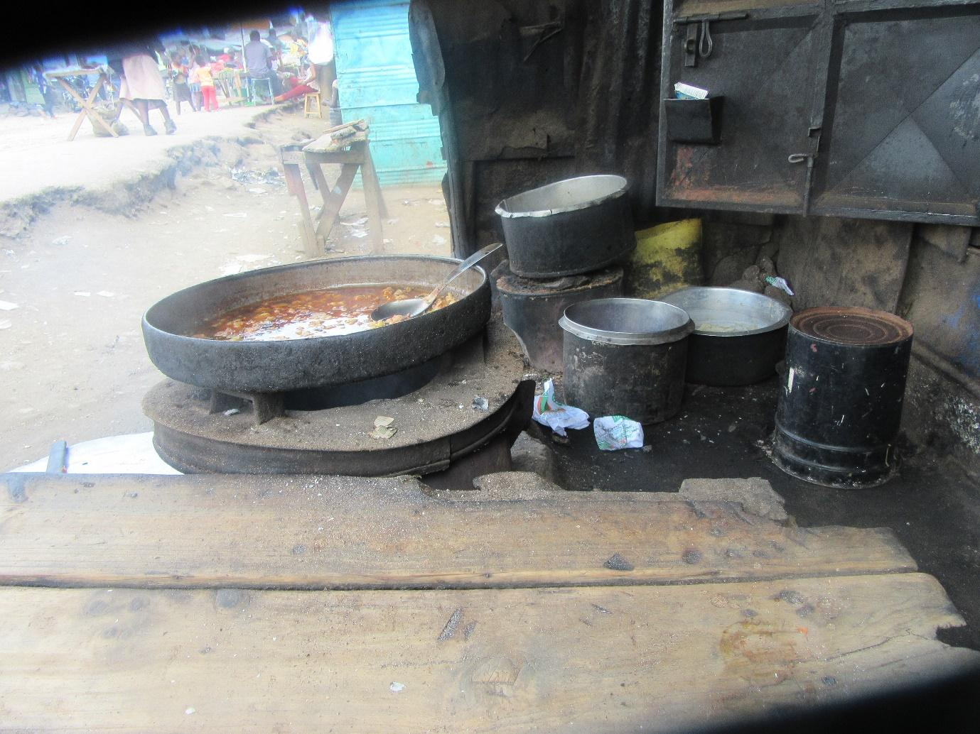
R1: I am R1. Picture number two of group one. When I took this picture I wanted to talk about the issue of cleanliness. Because if you look at the picture you see that that table is clean. It has been nicely spread. The papers on top, the colour is bright. So if it is dirty it will be clear to tell from that paper. If you also look at the bucket used to keep the chapatis after they are cooked. It is white, I mean it is clear. You can see till the inside of it. If you also look at the area where the chapati is being cooked. It is clean and when it is removed from the fire it is put in a clean place that has a lid. So that means cleanliness in this place has been observed.
M: Let us give her some flowers. Okay let us talk about cleanliness a little bit. Is it normal to find people that pay attention to cleanliness of food here in the slum? R9?
R9: I am R9. There are those who pay attention to cleanliness and then there are those who don’t pay attention.
M: when you say that they pay attention to cleanliness, what does that mean? R7 if you want to buy food and you go to a kiosk. What are the things you will be looking out for that show cleanliness?
R7: I am R7. When you reach the kiosk you will look at the person selling. You will look at how they have arranged their things and you will think to yourself if I buy this one then it should have no problem.
M: is it common to find people who do not consider cleanliness as they are about to sell.
R chorus: There is.
M: R3 and then R10.
R10: what I would say is that it is common to find someone who does not care about the cleanliness of the area from which they are selling. When you are a person selling things ideally you should be clean and also the things that you are selling also need to be clean. So that when someone comes to buy they will look at how you have displayed your things.
M: Okay, thank you R10. R3?
R3: not all of them pay attention to cleanliness. For some people you will go and buy from them and find that flies have surrounded the place even If they are selling chapatis you will still find that the place if dirty.
M: The reason why that owner of the kiosk does not consider cleanliness and still has a running kiosk is because people still eat there? Why do people go to a dirty kiosk as opposed to a clean one? R11
R11: It is possible that people will not pay attention the area because the person may be selling at a cheaper rate. There may be a person who is clean but is selling things expensive but there is a person selling this at a cheaper price but is not paying attention to cleanliness. So for me I may want to buy something but I may not focus on the cleanliness because of price.
M: Another reason for going to a dirty kiosk and not a clean one is? R1 and the R12.
R1: Many people sometimes feel that cleanliness is necessary or they have not understood the importance of cleanliness. So you will find the place is dirty, the price is cheap and even the person selling is dirty. And most of the people they are selling to are similar to them. They are either dirty too or are also not keen on cleanliness. Many of them are drunkards and even the person selling to them is also a drunkard. They are happy with the standards that are there.
M: so that is like customer service? He has customer service to those people who are like him? R12?
R12: You will find that children will go to those people because of language. There are those people that have convincing language that makes many people go the kiosk. And sometimes you may go to a place and find that it is clean, the person selling is clean but they don’t have the ability to draw in customers. So you can come and ask them how much is chapati and they talk to you badly. Someone who knows the value of a customer will talk to the customer so that they don’t go somewhere else.
M: Okay, you have said that you will go to a shop that chapati is twenty shillings and then you will go somewhere else and find that chapati is ten shillings. Why is there that difference in price? R9?
R9: You can find that the person selling the chapati for ten shilling it might be bigger, it may be clean and the person selling is clean as well. For ten shillings you may find that it is little and the person selling is not clean.
M: R11?
R11: I was saying that the reason someone may buy the cheaper food is because of quality and quantity. You can find that in the more expensive one they have used oil called “salad” and in the cheaper one they have used a cheaper one. The expensive chapati has been cooked with flour from the packet and the other one has used the flour for weighing. So the price depends on the quality and quantity.
M: Okay M1 do you have any thought?
M1: Thank you very much M. I can see that we are having a very good discussion. And I am happy with the points that are being brought out. Let me just follow up on one point. You have all said the reason why someone would buy from a dirty shop as opposed to a clean shop. First let me ask the cleanliness that we have been shown there. That space is actually clean. If you looked at our environment here in Korogocho in regard to the cleanliness, are many of the places where we buy food clean or are they dirty? What is more common, people selling things in a dirty area or people selling things in a clean place? R12?
R12: I am R12. Here in Korogocho most of the areas people sell from are not clean. Because for some people you may find that they are selling from a place on the road that is not near the sewage but most of them the space they will find is near garbage or sewage and some at the dumpsite.
M: Okay, thank you very much. Does someone else have anything to add? R11?
R11: Here in Korogocho you may find that some places are clean but this photo we are discussing if you look at it closely it is near the road. Here we usually have human waste being disposed of in drums or there are some trucks that come and pick up the human waste. Just the other day I saw a child who was swinging on the track and foods are being sold just close to there. So the child jumped on to the track but by bad luck he landed on the lid for the storage of the waste and it opened and all the waste went on the things of the person who was selling close by so the dirt we are talking about is the likes of such. By bad luck anything along the road can fall on the food.
M1: Okay, thank you very much. Let me ask. When someone is buying food from a dirty place the way you had said, if people eat food from such places do you usually find yourselves with any illnesses? R9?
R9: I am R9. I would like to say that in my opinion I do not thing that food sold on the street is clean. Because even if we say that someone is cooking in a clean place I don’t feel like the food will be clean. For example for the chapatis just in front of the shop cars will pass and motorbikes and all that food gets the dirt that is left behind by the cars and bikes. So in my opinion I don’t see how that food can be clean.
M1: Okay, thank you. So when we eat this street food and it is not clean the way our friend has said and I don’t want to say that it is all dirty but we have seen people eat from this place so usually what effects if any does eating this street food have on us? R7?
R7: I am R7. You will find that some of the people who may have eaten that food will complain of things such as stomach aches and the likes.
M1: Okay, thank you. Does ant one else want to add something? R9?
R9: I wanted to add on to that. There is a time I left the house and passed by the market and on my way I passed by a place selling meat. It looked very appetizing so I bought some and ate it. But when I got home at night it gave me quite a problem. My stomach was bloated, I was feeling sweaty. So from that time I became afraid to buy street food even if it is being roasted it is not clean.
M1: Thank you. Does anyone want to add something? Alright, let me ask another question. When you buy food from the street the way our friend has explained and then you fall sick in the way she has described or any other illness because of eating that food. I want us to be on the same page. You have bought food there, then it makes you unwell and back at you home you are the bread winner of the family. You being unwell, I what way does it affect accessibility of food in your home? Let us start with R12.
R12: I think for example if I am the bread winner and I fall sick and I am the only one who is able to go and source for food the children will not have food to eat and if they don’t have food I will have to send a child to go any look for anything they can find to bring back to the house for us or that they themselves can eat and that food too may not be clean.
M1: Thank you very much. Please give me some more points. R5?
R5: I am R5. If I may add on to the point about food, if I get unwell and I am the bread winner even the children are affected because even if that child will not get enough to eat even the little they may get becomes even more difficult to get. So it forces the child to go to the neighbours to look for food to eat.
M1: Thank you very much, that is a very good point. So as they have both said that is R5 and R12, if you are the bread winner in a home and you get unwell it becomes very difficult. I want us to look at another angle. What are other effects apart from the ones that they have mention? If you are unwell and you are usually the bread winner how will your food situation be affected? R2?
R2: Where food will be affected or even it becomes unavailable is the same place. Let us say that I am the one who wakes up every morning to go and I find that I have become unwell I will not wake up the next morning to go and look for food.
M1: Thank you very much, those are some good points. Anyone else with something else to say that is different? I request us to speak. Let me expound on the question. Us as women. I will also be a woman today because I am the only man in the room. We as women, people say that we like to talk a lot. We like to talk so much sometimes we are said to have a lot of gossip? So today I want us to continue here. I want us to talk and say as much as we can. Who will add some points? We are okay? Okay, R8?
R8: For me I would like to say. If for example by bad luck you die from the illness cause by the food that you ate that will affect the children completely.
M1: Okay, thank you very much. We are progressing well. Is there anything else that we have not mentioned? Is there another point. I don’t anyone to miss a chance. We have said today we will talk as though it is our last day on earth. Okay, my last question then is. We are talking about cleanliness, we are taking about matters of hygiene here in Korogocho and you yourselves have said yes there are people who are setting up their food in clean places but there are those people who do not pay attention to the cleanliness of a place and where they are setting up their food. Can this situation be rectified? What should be done or can be done to change this situation? To help those who are selling for us food in places that are not so clean. What can we do or what can be done? Please tell me what should be done, what can be done and who is responsible for it? Let us start. R5?
R5: I am R5. First it starts with me myself who is doing the business. First I need to make sure that the place if am setting up does not have dirty. The place where I am doing business the terraces should be clean even everywhere is not clean I should make an effort to make sure my surrounding are a bit clean. If in front of me there is a road I should try and find a way of preventing too much dirt getting on my produce or food.
M1: Thank you very much. What else can be done? R4?
R4: I am R4. If I want to start a business like that for food, I should first make sure that I have bathed and I am clean. If I am selling cooked food I need to look for proper storage for the food. Also the area where I am selling if it is morning I should sweep the area, if it’s a kiosk I should clean it well and then start to arrange my things. When it comes to the things I am selling I need to arrange them well. If its tomatoes set them up in a presentable way and even if someone is coming from far if they spot your tomatoes they will want to come and buy from you.
M1: Thank you. That is very good insight. Anyone else? What can be done? What else do you want to be done? R6?
R6: For me instead of going to buy things at the kiosk I would rather go to the market myself, choose my own produce, come home, wash them well and prepare them in a way I know they are clean and we can then eat it with my children.
M1: Okay, thank you very much. Anyone else?
R2: I think the best would be to create awareness. We can call together business owners and even involve the chief. If I find myself from food from one of the shops I can go and tell the chief so that he can call together a Barraza where he calls the business owners together and tells them what has happened.
M1: Thank you very much. That is a very good point. We are all okay. How do you all feel? Do you feel like we are discussing matters that are relevant to you and important? Do you feel like we are talking about important things?
R chorus: Yes.
M1: Okay, my last question to the person who took this photo. Who was it? R1? When you were taking this photo, because it has brought out a very good discussion about cleanliness, my question is maybe there is another photo you would have wanted to take to communicate the same message but you were not able to take that photo? Is there another picture you would have wanted to take that shows about cleanliness but you were not able to take it?
R1: I took the picture but I was not able to put it up.
M1: You took the photo but did not put it up. What was in that photo?
R1: The place it’s as I took that picture because there was meat that had been cook and I had no desire to eat it even if I had been given the meat for free. Because the place itself, yes it is in door but the roof of the place. If you can see the photo it has the same things but the things are black. It’s like they do not was it and even the cooking stick that was on top of the food was black so you could not know whether differentiate the cooking stick from charcoal but I was able to differentiate it because of its shape.
M1: Thank you very much. Let us give her flowers. Very nice flowers ladies.
M: Alright, thank you very much. We will go to group one, photo three.
M1: As people come to the front let us come with some swag. You know you are now the teacher, you should come with psyche. Alright, thank you.
Photo 3, group 1
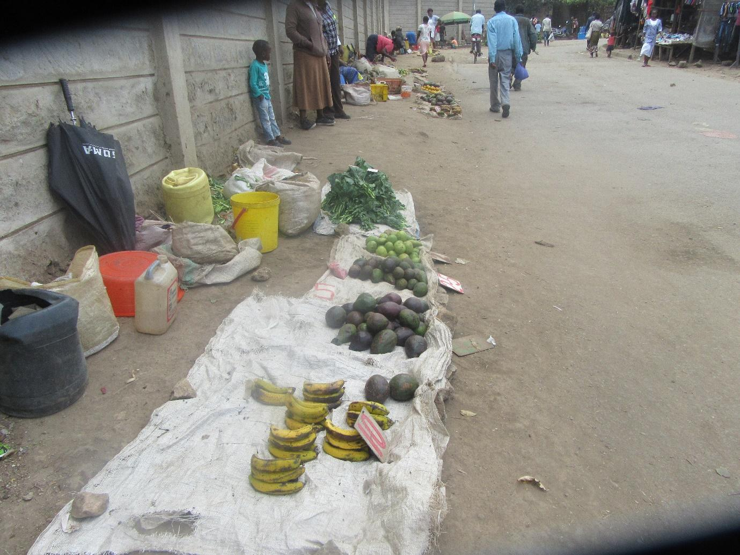
R3: I am talking about photo three. In this photo the vendors have set up their produce near the road. Which means all the dust from the road is going onto the products. This space is even small. He should have a table to put the things on top. But the food is a lot.
M1: Okay, thank you very much. Before I let you seat down. You have talked about food being in plenty there. Is that at a market or where is that?
R3: It is next to the road.
M1: He was selling next to the road. So the food you are talking about is what is sold there.
R3: Yes
M1: That is to mean here in Korogocho the food is in plenty? Is that true ladies?
R chorus: Yes.
M1: So what the vendor needs is like a shop to set up his things?
R10: Yes he needs a kiosk so that his things can be put up.
M1: Here in Korogocho is that a normal occurrence? Do many people sell their produce having laid them on the ground?
R12: Some people have just bought little produce and put them on the flour.
M1: So it is fifty fifty?
R chorus: Yes.
M1: Okay, thank you very much. M?
M: Why do some people put their products on the floor while other put have been able to get a shop to sell their products in? R12 then R 10.
R12: Some people sell on the road because that is the space they can access and you cannot set up a shop next to the road.
M: Why can’t you set up a shop?
R12: If you set it up it will be demolished because it is on the road.
M: R12?
R12: I think some people set up like that on the road because those who have the shops there have stayed there for a long time so now they have the space. For someone like me, maybe I feel instead of just staying in the house, I would rather start a business but I have not been able to find a shop. So I think it’s better I find a place to set up my produce even if it is by the road side I lay them down and then sell them. That is what bring about the difference. You will find that someone else I have started the business but I have not found a good place to sell and I also need to do business.
M: What is needed to be able to build for yourself a shop that will enable you to earn money so that you can buy food for your daily upkeep? What do you need? R2?
R2: You need enough capital but you see here in Korogocho we live from hand to mouth. What I have sold today for one hundred shillings is what I will use to feed my family on that day as well.
M: Apart from capital? R12 what would someone need?
R12: Apart from capital someone also needs space. You need a good sight for your business. Some can have a good product. You see like those vegetables, are very green and some people have set up on the floor and all the dust is going on them and some people their vegetables are not as green but they have raised their products up but they have been able to set up in a shop where there produce is raised. So the sight for the business.
M1: R12 has talked about a very important point but she has talked like a business owner. Is it only me who has heard that business angle? We have heard it right?
R chorus: Yes.
M1: which as a very good point but I would want to ask that same question but to look at it from the point of view of just a normal member of the community. The foods that are being sold at that stall and the food that has been set up on the floor when we eat them back at home do they have a difference? Do they have any difference health wise? R8?
R8: There is a difference. The food that is sold in the kiosk is raise so it does not have as much dust as the one that has been put on the ground. The one on the ground gets a lot of dust and sometimes even sewage can go on it. So it’s just more risky.
M1: Okay, thank you very much. Does anyone want to add something? Do we all agree with her in one voice?
All R: Yes.
M1: So R8 that is how people give you leadership. You see the way they have agreed with you they should continue to agree with you and give you the role of MCA in this community. Is that true? Why it is your friends are not responding to giving you the position?
All R: (laughing)
M1: Back to the point. Here we have exhausted the point about putting produce in a shop as opposed to putting it on the floor. You yourselves have told me that here Korogocho the food is in plenty? My question is because there is food in the market does it mean that there is also food in our houses? Just because there is food in the market does it mean that automatically there is food in our houses? Let us start with R12.
R12: Food can be a lot in the market but I don’t have food in my house because I don’t have money. The food can be in the shop but I do not have money to buy it.
M1: Thank you very much R12. Someone else? Please let us contribute. R9? Just because there is food in market we may not have access to it because we do not have money. Is there another reason?
R9: Yes the problem can be money. It is true that in Korogocho has a lot of food. But the biggest challenge is money.
M1: Thank you very much. Anyone else? R2?
R2: Food is in the market in plenty but because of money or lack of work makes it difficult to have access to that food.
M1: So we are all complaining about not having enough money?
R chorus: Yes.
M1: I want us to leave the issue of money for a bit. We can not only focus on the lack of money. If we come back to the conversation we have said that food can be in plenty in the market but we do not have food in the house. What are the other reasons?
R1: R1. Here in our community the food is in plenty but you will also find that people are used to a life of being helped. You will find that many people do not like to get tired working. Someone will go and get drunk in the morning and when they get drunk and that will be the end of his day. He will wait by the street side to steal from people and those he steals from can’t do anything. So sometimes you will find that people are just idle. They don’t want to do a lot of work or exert themselves because there are other jobs they can do.
M1: Okay, so we have money and then we also have work. Is there another reason? R11 then R12?
R11: Another reason is that food can be in plenty because of storage. I will buy food enough for only one day. I don’t have a fridge in my house to be able to buy in bulk and keep. So they are many in the shop but I will only buy what enough for me to cook and finish in a day.
M1: Okay, does anyone want to add something? Okay, let me start there where you have ended. You have raised a very important point about food preservation. You have said that sometimes the problem is that you do not have enough money to buy a lot of food but even when you have a lot of money you still cannot buy it because you do not know how you will store it.
R11: Yes, I have no way of preserving it at home.
M1: Okay, let me ask. At the moment for those who do not have a fridge, if you find that you have left over food or you happen to have bought more food then you need what methods do you use to preserve the food? The one that you have already bought for those who do not have a fridge. How do you preserve the food? Yes R11?
R11: If it is for example vegetables you can preserve by boiling them. If you have bought a lot and you want to cook some the next day you will boil all of it but fry the one for the following day the next day.
M1: Thank you very much. Another way? R9?
R9: Let us say it is something like tomatoes and onions you can buy the in bulk even if you do not have a fridge. For the tomatoes you would need to tie them up well because of rats but the onions will most likely not get spoilt. Onions can last for even a whole week.
M1: Alright thank you very much. Someone else? Another way of preserving food if you do not have a fridge? I am sure has women we have many methods. Let us talk about the ones we ourselves are using at home. R8?
R8: Okay, some foods if they are put near where there is water they get spoilt faster. Like “Omena” you will make sure you will put it in a place that has no dumpiness.
M1: Okay, thank you very much. Let us go back to the market. We have said that sometimes food is food in plenty at the market. Let me ask my question this way. At the market there is a lot of food, is it common to have all the food at the market sold? Tell me?
R chorus: No.
M1: The food that is left, what is done with it?
R12: Okay you will find that sometimes when someone has brought a lot of vegetables and they have sold but some of it remains. So the following day when customers come they may most likely not want to buy what is left over because they may have turned colour. Most people will not want to buy those vegetables that have turned colour. They would rather go and buy what is fresh. So for the ones that have turned it forces the vendor of the vegetables to have to throw them out. There is nowhere they can take them and that will be waste for the business owner as well.
M1: R9?
R9: If you happen to be a person who sells vegetables, here in Korogocho you have people who keep cows and goats. You can make an agreement with them that when you have leftover you can sell the leftovers to them so that they can feed their cows and goats.
M1: Okay, thank you very much.
R4: I am R4. Some foods for example like potatoes. If you find that your customers have bought an amount but they are still not finished you look for somewhere that has soon light and you lay them out to dry or to make sure they are not near what. Then the following day you can still sell the same potatoes. Business just continues.
M1: Alright. Thank you very much. Let me ask this question. We have talked about food and that sometimes it is thrown because a vendor may have excess. What can be done or what methods used to make sure the food that is excess in the market do not get spoilt and can be used again another day. What can be done? Maybe not by you buy generally? What can be done with that food to avoid being thrown away so that on another day we can use them?
R4: I am R4. Let us say that the same way we have talked about potatoes and putting them in the sun to dry so that they avoid having a lot of water. If its vegetables you can put them in a sack, put little water and poke some holes on it so the fresh air is entering so they stay longer.
M1: Thank you very much. Anyone else? R7.
R7: I am R7. In my opinion I think the easiest thing is just to buy vegetables that will just be used for the one day and then the next day you go and look for vegetables for the next day so that people can buy all the vegetables so that the vendor does not go at a loss.
M1: Okay, thank you. Someone else? Alright. Let me then ask. I want to ask my last question. Is the food that is found in the market in plenty found in plenty all year round or is in it in plenty depending on the season? Is the food always available or is it available in seasons? Can we please give examples as we respond? R10?
R10: in my opinion I feel like it is in seasons. For example tomatoes right now are a bit expensive. They were much cheaper in the other months of the year.
M1: Alright. Thank you. Someone else? R5?
R5: Food is available in season because you will find some months you have some things while during other months they are not there. For example there are months when vegetables like Kale and spinach are in plenty and then there are months when they are not a lot.
M1: Thank you very much. My last question is this. We have said that food here in Korogocho is in plenty, where do these foods come from? What is their source?
R chorus: The farms or village.
M1: The village? Do we have farms here in Korogocho?
R chorus: No.
M1: Okay, one person to explain to me. R8?
R8: I think most of the food like potatoes come from the central part of the country. I hear they come from there. Things like “omena” come from Nyanza province. That is what I think.
M1: Okay, thank you very much. R1?
R1: Here in Korogocho the food is in plenty because it is right next to the sewage line. You will find that people have planted vegetables like spinach along the sewage line. You will find that many of the vegetables sold to us are from there or from the central part of the country because it is also near here. Some of the food also comes from Machakos County because it is also near us.
M1: Thank you very much. I want to follow up on something that she has said. She has mention food coming from the sewage line. Is what she has said about food grown next to the sewage line true?
All R: Yes!
M1: Is it true? Vegetables are planted next to the sewage line here in Korogocho?
All R: In fact that vegetable grown next to the sewage line is very green.
M1: Wait! You want to tell me that the vegetables we have eaten today were from the sewage line because to me they looked very green.
All R: Laughing…
M1: Okay let me ask this. So we all know that some of our vegetables come from the sewage line. You have even said that it can be very green and have very big leaves and it is brought right to the market. If it brought to the market to do we just buy it? Why are we buying and yet there is the other one? What would make someone buy the one that is from the village and not the one that comes from a farm?
R10: Sometimes you will find that it is v=being sold at a lower price.
M1: Okay R10 has said it is because of the lower price. Another reason? R5?
R5: Sometimes it can be difficult to tell the difference.
M1: Another reason? R8?
R8: Those vegetables are usually very pleasing to the eye. They are green and very healthy look so they attract someone to want to buy.
M1: Is this true?
All R: Yes!
M1: I don’t want to think about the vegetables I have just eaten here. Okay, my question we ourselves know that the vegetables sometimes come from the sewage line and we are sure that it gets to the stands at the market. We are also most certainly sure that we have eaten it at one point or another. What action can we take to make sure that we are not eating those vegetables or that it is not getting to our markets? What can our leaders do? Is there anything that can be done or should we continue to battle with our situations? R8?
R8: Those people planting food along the sewage line need to be arrested because those vegetables can affect the health of those who eat them. Those vegetables can cause illnesses like cholera.
M1: Thank you very much. Someone else? R3 should we just live with it?
R3: You see that vegetable from the sewage line when you go to the market it is hard to differentiate from the rest of the vegetables. If you go out here you will find that the vegetables look very appealing so that when you look at it you long to cook it.
M1: Alright. So we should just live with it? Okay, someone else. R11?
R11: I was saying, there was a woman who used to sell vegetables from the sewage line near where I live and she was told to stop selling to people those vegetables but she insisted that she was not selling vegetables from the sewage line so it becomes very difficult to know what to do with them because you can’t prove it. Because she is harvesting them but she is not the one selling them. There are those who come to buy from here and take to the market so when they get to the market you would not be able to tell which vendor bought them. But when you find here where she grows the vegetables she is quick to say that those vegetables are just for her consumption and she has not sold them to any vendor.
M1: And was she harvesting them?
R11: I heard that she was even selling them. But she does not sell them herself. She sells them to other people who take them to the market. Those going to buy from her either go very early in the morning or late in the night. So you will not know who they are when you go to buy your vegetables in the market.
M1: And that lady, does she also eat the same vegetables.
R11: Yes she eats them.
M1: Might you know whether the vegetables used to affect her in any way health wise?
R11: The stomach gets used to the vegetables. If you have eaten them for long your stomach just gets used to them.
M1: Okay, thank you very much. Does anyone want to add something? A final comment before we move to the next thing? The final question. Any more example of things that can be done? R1?
R1: I think one of the ways that our leaders can help us is to arrest one of those people and when they are caught they should not be caught alone or also the people selling those vegetables in the market because some of them are known. If they are caught and arrested those vegetables may stop being brought for sale. Because all the vendors at the market must know where they get their vegetables from.
M1: Thank you very much. R9?
R9: Those vegetables may be very hard to stop selling. There is a time Citizen Television showed a feature that showed the same vegetables ending up being sold at a supermarket and it continues to be sold.
M1: Okay, thank you. R11?
R11: Another way that our leaders can help us is by stopping that sewage water from passing by our houses. We all know that the sewage water is opened at certain times of the day. If it did not pass through here then there would be nowhere for those people to plant those vegetables.
M1: That is some very good feedback. Thank you very much. M back to you.
M: We will go to the next photo. Photo four group one.
M1: We need people to come to the front with some swag! Today is your day to model a little.
…..laughing….
Photo 4, group 1
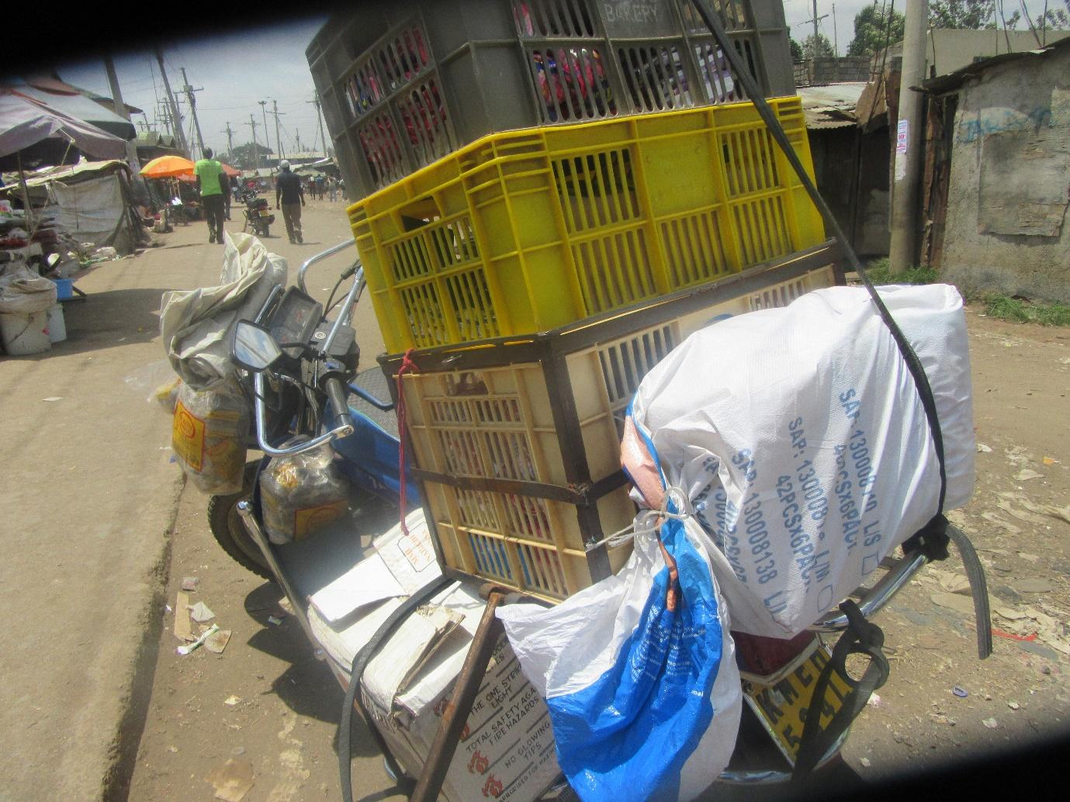
R4: I am R4. Talking about photo four of group one. This photo is about transport. The reason I took this photo, you can see that that is a motorbike and it has carried crates till up and then it has carried paper bags on the side and people are passing at the front, the road looks small. That is what I was talking about in this photo. Transportation in regards to having carried such a heavy load.
M: Okay, let us give her flowers as she seats. Now I would like to know, how does transport affect availability of food or accessibility of food? R8?
R8: Transport if it is good. Let us give an example of the road if they are good at least the cars can come to supply food but if it is bad it makes it hard for suppliers to bring for us food till here.
M: How else does transport affect accessibility of food? R1?
R1: If you find that the road is not good it means that many foods are carried using hand carts and you will find that sometimes handling the handcarts are usually drunkards so even if he has to pass through the sewage he will not be keen to avoid splashing the sewage water on the vegetables or produce.
M: Okay, R12?
R12: I think transport can also affect accessibility of food for example if you look at how the motorbike has been overloaded. It has many crates so when he is on the road he could come across a pothole and the rubber band holding the crates could break and then the food can fall. For example if its tomatoes, if the tomatoes fall they could be smashed and that becomes a loss to the business people.
M: Does that happen a lot? Motorbike dropping food in transit?
R chorus: Yes!
M: When that food falls what does he do with it? Does he pick it? Does he leave it?
R12: He will pick it up and return them on the crates. For him he is not the owner so for him all he wants to do is get the goods where they are meant to go no matter the condition. All he wants is to get paid after delivering the goods. For the owner of the supplies he may never know that the things dropped at some point along the way. The owner will receive the good and then sell them as usual.
M: Thank you R12. Apart from the motorbike, how else does food get to Korogocho? You had said it is usually dropped at Kariobangi and then owners find ways to get it here? So from Kariobangi how does it get here?
R?: If it is not brought by a motorbike it is brought by handcarts or bicycles.
M: How is the safety of the food affected by the mode of transport?
R2: When it comes to the handcart the handler can decide to pick some of the things from the handcart and put them in his house before he delivers to you and act like the food was never in the cart to begin with. So the food can get to the owner when they are less.
M: Thank you R2. How else does the mode of transportation affect food accessibility? The route the food takes to reach from Kariobangi to Korogocho? R12.
R12: Let us say for example when it’s the rainy season the roads will be full of water so the food will not here on time. The people transporting have to wait for the water on the road to reduce before they can deliver the supplies. So even those of us waiting on this side will have a hard time because the children may not be able to eat till the transporter brings the food.
M: Okay, thank you very much R12. I have a question. Are there times when you go to the market looking for something specific and are unable to find it?
All R: Yes.
M: When you go to the market and can't find what you were looking for, let's say it is- what could it be? What vegetables for example?
R12: You may have gone for traditional vegetables.
M: So you've gone for traditional vegetables and haven't found them. What do you do when you can't find the vegetables you were looking for? R12.
R12: What I would do, it depends, you see, it will depend on time. If your time allows you to wait you can because the vendor may tell you it is on the way being delivered. But if it's totally unavailable, you find that someone goes to plan B which maybe they hadn't planned for because maybe they're in a hurry to make lunch for her children so they will be forced to buy a different type of vegetable that they hadn't planned to buy so as to make sure the children don't go back to school hungry after their lunch break.
M: So how does having to buy plan B affect the health of the food? Or rather how does it affect the quality of food? R5.
R5: I am R5. That having to work with plan B, maybe you had planned with those traditional vegetables most of which are very nutritious. So you end up settling for different vegetable just because it's food even if it's not a balanced diet.
M: She has spoken about balanced diet. Is providing a balanced diet a priority for us when we cook at home?
R?: We try.
M: You try. Normally what does the food you eat consist of? In order for you to say “today I have eaten a balanced diet.” R2 and then R12.
R2: The food you eat everyday ought to have protein, carbohydrates, vitamins and (inaudible).
M: Okay, R12.
R12: It's just the things she has spoken about.
M: Okay, when you go to the market and you find that you have to settle for that plan B, what is it that you would normally lack that would cause you to say “this food is not a balanced diet.” What is the thing that would normally be lacking in that meal? R12.
R12: Sometimes, it's not even that it will be lacking, vegetables give us a balanced diet, isn't it? And maybe I was going for the traditional ones because maybe the other time I had eaten kales of cabbage, you see, so all I was trying to do is to have a different meal. And also getting a different meal, if I don't get the traditional one I will be forced to go and have the same one I had had the last time.
M: Okay. What are the advantages of changing and eating various foods? R1.
R1: Okay, you can eat food, the advantage of changing foods is, in my opinion, the advantage is just taste. Provided it's a balanced diet. If say yesterday I ate githeri that had maize, beans and I added some amaranth and drank some water, I can say that that was a balanced diet. So since tomorrow I don't want to eat the same food but I still want to eat a balanced diet you will find that I have cooked ugali, those traditional vegetables and because I can't afford meat, I have added some beans or some green grams on the side and then I have had a balanced diet. The goal was to get a different taste.
M: So it's just that you're mouth wants different foods not necessarily the stomach?
R1: Food gets boring. When you eat this today, you can't eat the same thing tomorrow.
M: R5.
R5: having variety in food also gives you an appetite. Because if say today you ate ugali and kales if tomorrow you eat ugali but with traditional vegetables there is a difference where it will feel like today's food isn't the same as tomorrows.
M: Okay, can speak about that point of appetite? Let's stop looking at our perspective as mothers and now consider our children. Are there foods that they prefer above others?
All R: Yes.
M: Will they normally go for the ones that consist of a balanced diet? R1.
R1: No. You will find that children really like junk foods if the mother won't be strict with what they eat and that child won't get a balanced diet.
M: Are there mothers who for several days will allow their child to eat food that is not a balanced diet here in Korogocho?
All R: Yes.
R1: Poverty and education.
M: R1 please expound that point a little bit.
R1: On poverty or education?
M: You can do them one at a time, decide where to start.
R1: You could find that this mother has a very poor income so she simply eats whatever she can access. She says all she needs is for the children to eat and not sleep hungry because that is the only income she is able to access. But you will also find that for others, their level of education is very low so the woman hasn't learnt the importance of giving the child a balanced diet and that it will benefit the child physically.
M: Okay, what can we do to change that poverty and to change that lack of education? R5.
1:05:14
R5: I'm R5. How we can change the issue of knowing about what foods to give the child is by creating awareness and educating the parents on how they ought to eat that the food need not be expensive and does not have to have meat for them to get the protein they desire but that there are other foods that have protein, it doesn't have to be meat or other things.
M: You said that “we” need to create awareness. Who is “we?”
R5: Us, other parents who know and have the information ought to speak to those other parents and educate them on issues concerning food.
M: The point about poverty, what do we need to do in order to make a difference? R1.
R1: Creating jobs. I think we can get those who are living below the poverty line and get ways to give them work or we could educate them that you don't have to get work that has a very high income. That a woman can live her house in the morning, go to another woman's house and do her laundry and she will leave there with her 200 shillings. This 200 shillings can help her that even if she spends 100 shillings on food, she can still save the remaining 100 shillings. She will get out of her level of poverty and at least rise slightly in her circumstances.
M: Okay, thank you very much. Apart from- she has spoken about doing laundry – apart from doing laundry, what other jobs can we do to at least earn some money to make us independent? R2.
R2: We can create work for ourselves. For example I learnt how to make soap. So I make soap in bulk and sell in small quantities. I leave the house having filled my bottles with liquid soap and then I walk around selling, visiting my friends who then buy from me so that at the end of the day when I get back to the house I get back with some flour and enough money at least for food.
M: What else can we do? Another example of work that we can engage in? R8.
R8: If you're talented in plaiting hair, if you plait lines for someone you wouldn't fail to get at least 200 shillings with which you can buy food.
M: Okay, what other work can we engage in? R10.
R10: I am R10. Someone could also go to the market and buy bananas, oranges or water melon then you go selling them in the estates.
M: R12.
R12: Okay sometimes you find that those who sell at the market might need help tying up their vegetables in bunches because maybe there are many buyers and the seller is by themselves. So you can go to them and ask to work for them, you see? They might allow you to work with them helping them to tie those bunches and after you help them you won't leave there empty handed, you leave there with something. And then there are those who make beaded ornaments. You can go to them and if you don't know how to make those ornaments, making them doesn't need too much training, you can just speak to the person making them and watch them as they make them. After some time you can request and say “why don't you show me where you buy these beads so that I can also start making the ornaments?” If you sit an start making them you will at least earn something as opposed to just sitting idle and gossiping because if you start making bit by bit at least you get to the place where you're earning something to keep for yourself.
M: So we would be right in saying there's work that everyone can learn to do which would make it possible for them to get access to some food and a balanced diet, isn't it?
All R: Yes.
M: Okay. Does anyone have something they would like to add to that point? We proceed? Okay, group 2 photo number 1.
Photo 1, group 2
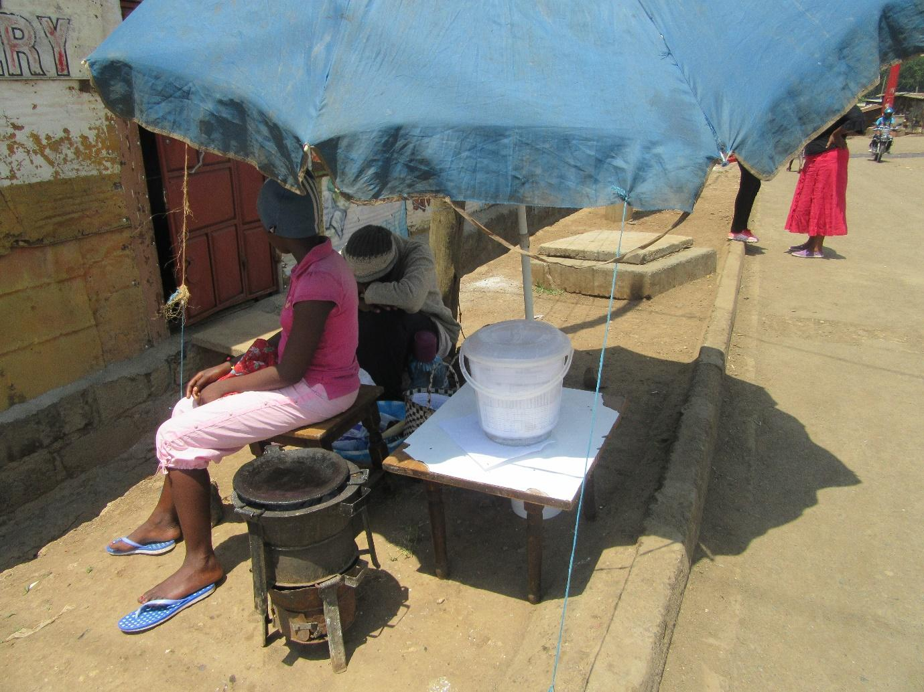
R5: I am R5 from group 2 and I took photo number 1. This photo is speaking about foods that are cooked by the roadside, foods cooked by the roadside. If you look here, this is a road, there's a drainage/ditch here, and the food is being cooked here. So there are vehicles passing here and on the other side the drainage is dirty. So I looked and saw that yes it is food being cooked, chapatis, but there must be dust getting to them because they're being cooked in an open place. Then on the other side there is a dirty drainage so there is a bad aura coming from this drainage.
1:10:18
M: Thank you very much R5. Let's give her some flowers. I know we have discussed the point of contamination, so because we had already discussed contamination, let's discuss the next photo after which we can take a short break, isn't it? So that we can relax a little bit. So photo number 2 group 2.
Photo 2, group 2
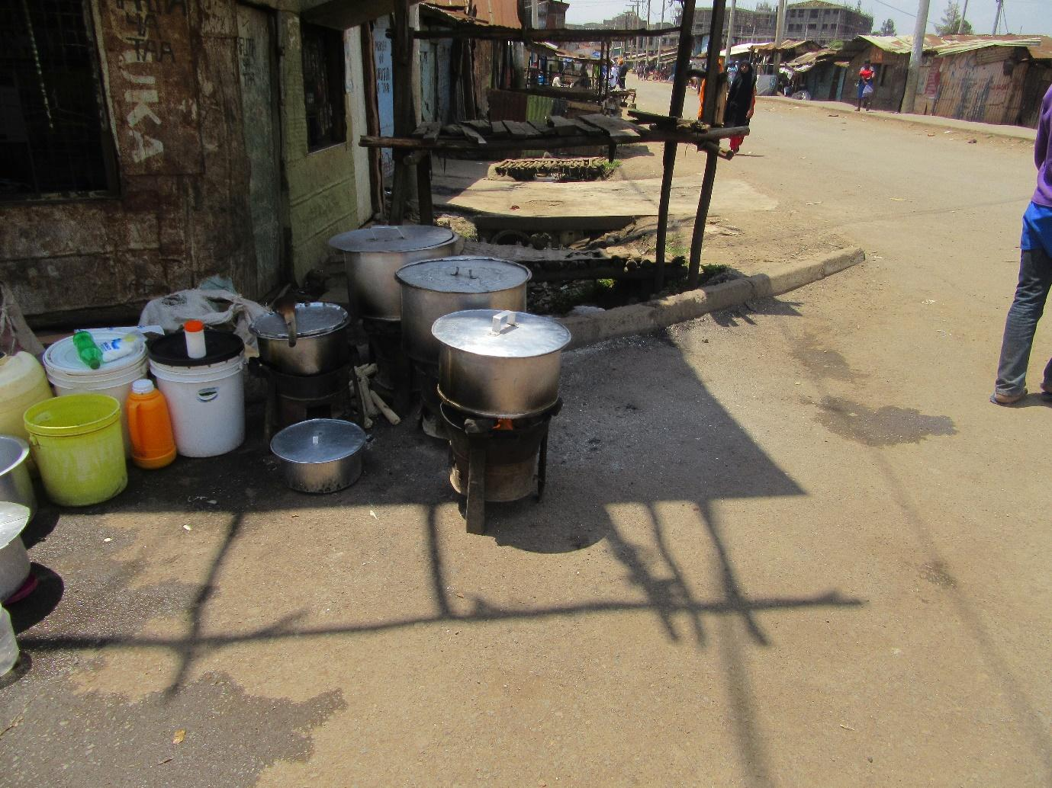
R6: I am R6 from group number 2 discussing variety of foods. When I was taking this photo, you can see that there are cooking pots here, there's githeri, there's green grams and turtle beans. If you look next to that there are some water basins there and there's a road on this side. When I took this photo I was showing that because if you look on this other side here, there's a hair salon. So we were of the opinion that- as we took the photo – that when the hairdresser is blow drying hair, the smoke can end up in these cooking pots. The road as well, when motorcycles pass or even cars, the dust can end up in those cooking pots. So we saw that here this vendor has placed their things nicely but these things passing on the road like smoke will end up in the food.
M: Thank you very much R6. Let's give her some flowers. Okay, her photo has brought out many points but I would like us to discuss the very first point she brought up about variety of foods, is that alright? Normally, what types of foods do you find vendors like this one selling? R12.
R12: For such vendors, they usually sell- you will find githeri, you could find beans boiled by themselves, turtle beans, green peas, different types of foods. Yes. Cooked rice as well.
M: Cooked rice as well. So you will buy your rice and beans and go ahead to eat. So will you eat there or will you go to eat at home?
R?: You could even eat there.
M: Okay, so my question is this: this business brings in money, doesn't it?
All R: Yes.
M: Why would I choose to buy food from this person instead of going to cook for myself at home? R4.
R4: In my opinion when you see someone buying this food, sometimes they have done their budget and found that the money they have won't be enough. Sometimes I need kerosene, I need to buy beans and yet I can't buy for 10 or 20 shillings, maybe a quarter kilo costs 30 shillings. And maybe you have 50 shillings. So you decide that with my 50 shillings, if I buy rice for 30 shillings, and beans for 20 shillings, it will serve me and my family well. Because if I look at this 50 shillings and consider buying kerosene, I have to include tomatoes, raw beans that I have to boil, I find that my money is too little, I am better off buying my food from the roadside for my children to eat and forget about it, that will be lunch.
M: R12.
R12: I think what might also contribute to someone opting to buy food from the roadside vendor is time. It also depends on the time, maybe you're making lunch for the children. You can't boil anything, maybe beans won't cook on a kerosene stove and be ready in time for the children to eat. Or it could also be about the time you get home from work. Maybe you left the office late at 6 p.m. Yet you want the younger children to eat early at the right time for them not that you start cooking until 10 p.m. and then have to wake them up to eat. So the time constraints as well will cause you to prefer the food that is cooked by the roadside.
1:15:18
M: My question has to do with something slightly different. Other than kerosene, what else is used to cook food here?
R?: Charcoal.
M: Charcoal. What type of charcoal? Is it the energy saver one or is it the old one that comes from trees? So the one from trees? Do most people use charcoal or kerosene stoves? R3.
R3: Most people are using stoves because the price of charcoal went up. So now people are switching to kerosene.
M1: Okay, I see we're moving along well and unless someone has something to add, maybe we can move ahead. Or do we take a brief break?
M: You don't want to take a break?
R?: No, there are too many photos.
M1: No I insist that we take a break. Here's why I'm insisting we take a break. I don't mean a break in which people leave or go outside the room, I mean a break of just 1 minute. Let's take a short break.
Audio paused.
M1: Welcome again.
M: Okay, thank you very much. Welcome to part 2 of the Focus Group Discussion. So we're going to move on to photo number 3, group 2.
Photo 3, group 2
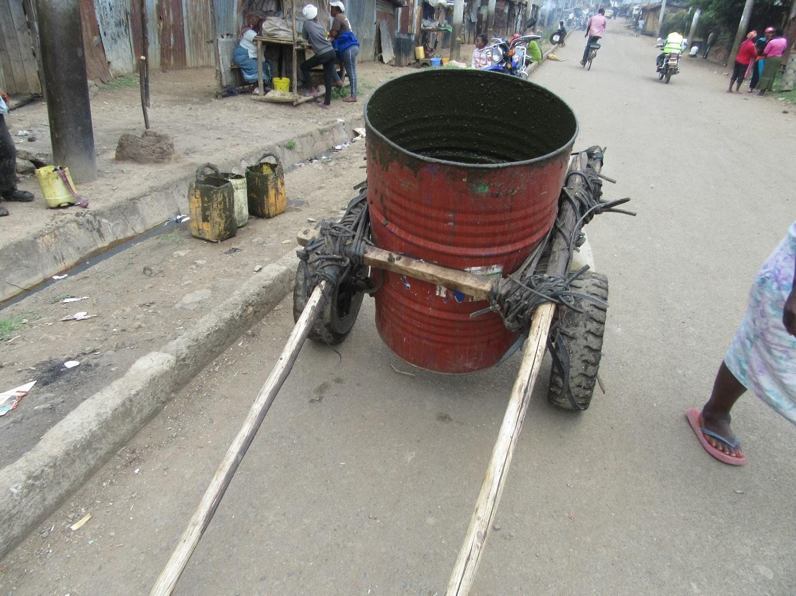
R7: Okay I am R7. If you look here, this is the dirt that has been drained from our toilets here in the community. If you have eaten some food, you will have to go and dispose of it. So if we had found a good toilet here, we wouldn't have needed to go and drain it to come and throw that refuse here or somewhere else.
M1: Okay, so you're saying that that is how the situation is here? Toilets are not working? Is that true?
All R: Yes.
M1: Okay, thank you very much. So I would like to ask this. Maybe explain to us if there is any way in which this situation of draining toilets like that is connected to our food situation or any sort of health issues.
R7: Now you see there's a place just past there where there's a kiosk in which food is sold. It could happen that as someone is carrying something and by mistake it slips off their hands and ends up in the food and that would be bad.
M1: Thank you very much. So this photo is still speaking about our issue of contamination. Thank you very much let's give her some flowers.
M: I have one question. The way she's saying that something could happen and that waste spills and ends up getting in food, what normally happens if it spills on vegetables?
R?: It is washed.
M: So it is simply washed and then the vendor continues to sell?
All R: Yes.
M: Okay.
M1: Right, since we have spoken a lot about contamination and hygiene, we won't dwell there too much. The only question I would ask, since we have seen that this is something that affects us, what can be done or what can happen, in order for this situation to change? In order for us to stop having this type of situation? Recommendations. R9.
R9: Building toilets and those sewer lines that then drain the waste far away.
M1: Who can help there?
R?: The County Government.
M1: The County Government, okay. Another recommendation? What else can happen? It's just that for now. Thank you very much. Let's move to the next photo, photo number 4, group 2. Photo 4 group 2.
Photo 4, group 2
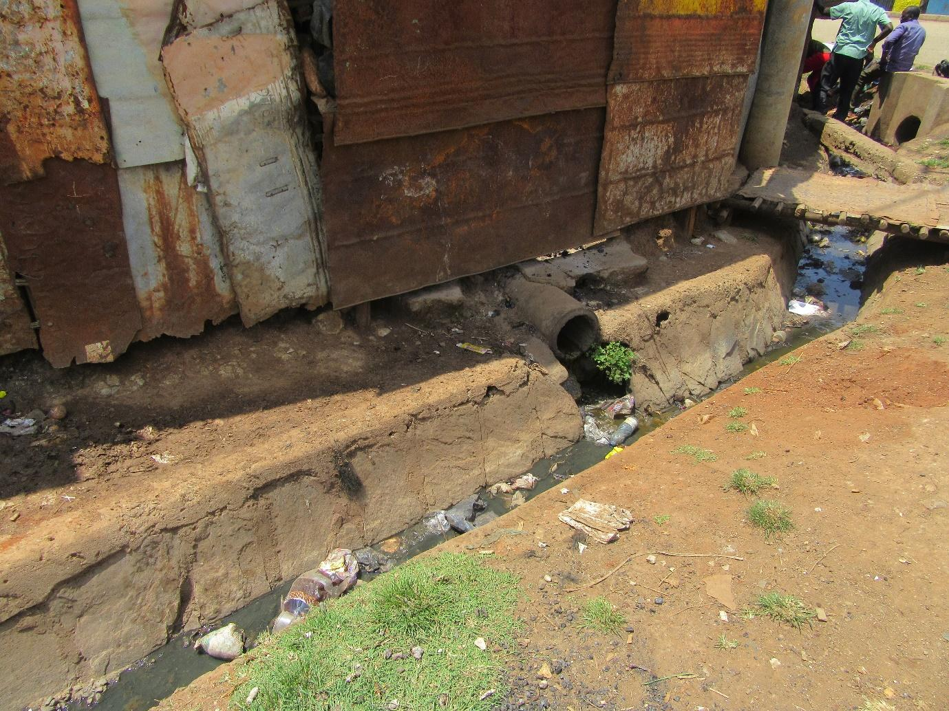
R8: I am R8 speaking about photo 4, group 2. There's a ditch here and this is alcohol, alcohol was flowing from those houses there so obviously that means that this place isn't safe to run a food business. So if at least there was better drainage where this alcohol can pass through, even if it's a pipe that drains that alcohol even if it passes underground and goes to the proper place as opposed to it coming to a place like this. So you will find that the people who pay attention to hygiene won't start food businesses so you're then forced to walk long distances.
M1: Alright, before you go, I still want to understand this photo well. You have said that at that place alcohol is spilling and ending up in that drainage system. Where does this alcohol come from? Help me understand.
R8: The alcohol comes from these houses of theirs, these shacks.
1:20:03
M1: So inside there someone is making alcohol?
R8: There's a brewery.
M1: There's a brewery there? There is?
All R: Yes.
M1: Okay, what type of alcohol?
R?: “Makali.”
M1: So the one that is draining out, is it the waste or is it the one that is being manufactured?
All R: It's waste.
M1: Okay so what we're seeing there is waste from “chang'aa” and other brews that is draining into the sewer line. Alright, I understand it now, thank you very much. What I would like to know, and because today we have spoken about contamination many times here, there's one question I would like to ask. These drainages, because we've seen them severally, running close to food, close to where people live, is it normal to find this situation where the water from maybe sewer lines contaminate our drinking water? Do we have those situations? R12.
R12: You will find the answer further ahead.
M1: The answer is further ahead?
R12: Yes.
M1: So I should be patient? No let's just speak about it now, there's no problem. Tell me about drinking water and sewage, are there instances where they come into contact resulting in contamination of water? Because we've spoken about food contamination. Is water contamination there?
All R: Yes.
M1: R9.
R9: I am R9. The challenge with water, the problem with this dirt is that you could find that a water pipe is running close by and if it has a small crack then the water from the two systems gets mixed up and this is the water that people use to drink.
M1: Is this a common occurrence or is it a one off occurrence?
R9: It's common.
M1: It's common R9?
R9: Yes, it's common because even recently when they were giving out polio vaccinations it was announced and we were even shown on the television how polio had been found along the sewer lines for Nairobi County Government which is why the polio vaccinations were being given to children because it has been found in our sewer lines.
M1: Okay, so we're discussing some very important things and we can see that still connects with the issue of diseases but we already spoke about that at length, isn't it? So maybe let me ask this. You're all saying that there are many contamination points. What can be done to rectify this situation? How can we rectify this situation? So that we stop having this situation where water and sewage come into contact and contamination happens? R1.
R1: I am R1. There was a time when we were told that water pipes and sewer lines go, as in they're like brother and sister- they go together. So the best thing we can do is to treat our water. We need to either boil it or treat with chemicals.
M1: Okay, thank you very much. Another option? What else can be done either by ourselves or by someone else somewhere in order to make this situation better? Or will we continue with our current situation? What can we do about the issue of sewage coming into contact with clean water?
R2: These things just need to be separated, these pipes. For the water pipes to be separate and the sewer lines to be separate.
M1: Okay, thank you R2. Another option? Okay, we're fine? I can see that R4 has something to add.
R4: I am R4. In my opinion, if the health people walk around and see things such as those, they can break those connections so that people start to build those pipes anew and they can totally separate the sewer lines from the water lines.
M1: Okay, thank you very much R4. [Name] I don't know if you had something to add before we move along? You're okay? Alright, Faith says we're doing well so we can move forward. Where have we reached, is it here? First let the teacher mark. Did we get this one?
All R: Yes.
M1: We got this one?
All R: Yes.
M1: Here?
All R: Yes.
M1: This is a marking scheme. This one?
All R: We got it.
M1: This one?
All R: Not yet.
M1: Alright, so we go to photo number 1, group 3, this one here.
Photo 1, group 3
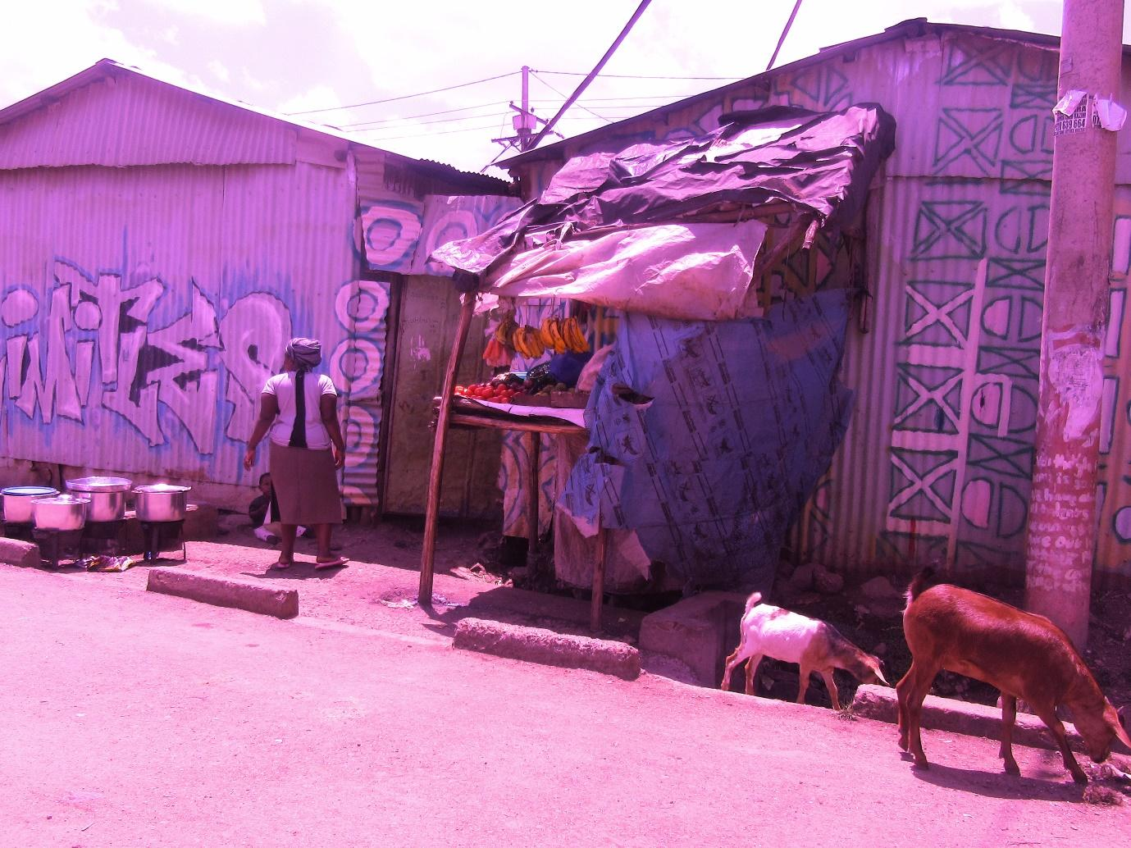
R9: I am R9 from group 3. I took this photo because I saw that these foods are close to the road and then this is a dumpsite. Then if you look closely, these are goats walking there, but the good thing I spoke to the owner and they told me they stay there guarding whatever may come and that they cover this food properly due to dust. So they told me that the food they’re selling is safe.
M1: so they told you that their food is safe, but what did you see for yourself?
R9: The thing I was looking at mainly is the fact that it seems these goats- you see like this one is right in that drainage there- so when the goats pass there, they can cause the foods to spill over into that ditch for garbage.
M1: Okay, very well. So you have said that in your observation and from talking to this person, they’re storing their food properly?
R9: I saw that that place is clean and the vendor has stored their food properly.
M1: It’s as clean as this one that we’ve spoken about?
R9: because like now I found them wiping dust off the cooking pot lid. So I got the impression that they are taking good care of the space and you see they’re always close by.
M1: Okay, because we had spoken about cleanliness at length, I won’t go in that direction. But then there’s something new that has come up in this photo and it has to do with this goat. I want us to discuss this goat a little bit. You can see the goat in the ditch right? So let’s consider the goat briefly and what I would like to know is this: in this neighbourhood, do we have these cases of animals roaming around? Like goats roaming around in the neighbourhood, is it a common occurrence?
All R: Yes.
M1: Where do they normally come from?
R?: We rear livestock.
M1: So you rear them?
All R: Yes.
M1: So they belong to people here?
All R: Yes.
M1: And they have released them they’re just roaming around?
R?: Yes, they know their way home.
M1: Okay, let’s move slowly. First, I heard someone here say they know their way home. Is that true that they know their way home?
All R: Yes.
M1: So these goats that know their way home, are they real goats or are they landlords?
R?: They’re real goats.
M1: They’re real goats? Okay then let’s go back there to our topic. So you’ve said that there are people rearing goats here and that they release them to go roaming. What do they eat? (Group chatter) Let’s go slowly. R4.
R4: A goat in this community is sought for food such as if you see women chopping vegetables there are the parts that are thrown away, if there are tomatoes in the market that have been thrown out they collect them, there are cabbages, they are collected and taken to the goats. But sometimes you also release the goats to roam free and relax.
M1: Okay, would someone like to add on to that? What do our goats eat? R1.
R1: Oftentimes Nairobi goats eat food from the market but Nairobi goats also know how to eat food. They know how to eat foods like ugali and githeri.
M1: So these goats of ours, number 1 they know their way home. Number 2, they know how to eat our food. Are they really goats? Okay, other foods? As they walk out there here in the neighbourhood, what else do they eat? R1 yes.
R1: A goat is also not like a person, they can’t think. They can even get into a ditch and collect whatever dirt is there and they eat it.
M1: Okay, does that happen?
All R: Yes.
M1: Thank you very much. So let me ask this. These goats of ours that we’re rearing here, normally, where do they end up? Do we sell them later? Do we eat them? What happens? R9.
R9: These goats of ours are very beneficial to us because there are those that can be milked which once you feed them well, you can milk them and their milk sells at a very high price. So that can even make it possible for you to become financially independent.
M1: So that’s a source of income?
All R: Yes.
M1: Okay, are there many people selling that goat milk?
All R: Yes.
M1: Alright, thank you very much. Another way? R8.
R8: Some are also sent to the abattoirs just down here for money. There’s one here “Kia-Michael” and the other one.
M1: Okay, so in that case their still bringing in an income?
All R: Yes.
M1: Thank you very much. Something else we use these goats of ours for?
R4: I am R4. If it’s Christmas day, you can invite your friends or family members, you slaughter the goat and celebrate.
M1: So here in our community when Christmas comes we slaughter goats for meat? Okay, thank you very much. Oka, another way? Okay, let me ask this. Apart from goats, what other animals do we rear here in our community? R1.
R1: We also rear chickens and pigs.
M1: So pigs as well. Another person, R9.
R9: Sheep.
M1: Sheep as well. R10.
R10: Rabbits.
1:30:03
M1: We have rabbits here? Okay, R11.
R11: There are some dogs here that are different from these random dogs that roam around, there are some dogs which when the owners are selling they tell you if you don’t have 30,000 shillings you can’t have a deal. Let alone these other random dogs that roam around. I don’t know what they’re called.
M1: So they sell those as well?
R11: Yes they sell them.
M1: Thank you very much. Other animals we keep?
R?: Cows.
M1: We have cows here?
All R: Yes.
M1: We rear them for milk as well?
All R: Yes.
M1: So they’re milked and the milk is sold here?
All R: Yes.
M1: Okay, thank you very much. So now I am left with this question ladies. So please allow me to ask. When we started here, we said that there are lots of vegetables in the market and other foods such as potatoes. We have reached here and now you’re telling me that we rear almost all types of livestock. Starting from cows all the way to rabbits. We get milk and even on days like Christmas we slaughter goats to celebrate. Here’s my question: why is it that previously you were telling me that we still have challenges accessing food in our homes? What is happening? R9.
R9: Let’s say if for example you don’t have work and you don’t have goats they belong to your neighbour, they won’t help you because they belong to the neighbour if you don’t have money to pay for them.
M1: Okay, alright, someone else. R4.
R4: Not everyone is rearing those goats or other animals. And in terms of the environment if say you’re staying in a house built of iron sheets, and you know rats and so on can prevent it.
M1: Okay. R1.
R1: We were saying that in here there are many problems because you will find that many of us who live in Korogocho, we don’t live in our own homes. Most of us have rented the houses because we can’t afford to pay for expensive houses, we come to rent cheap ones. So those animals may belong to the landlords.
M1: Okay, let’s go to R12 and then R11.
R12: Okay I think even if we have those cows and so on, these animals that we rear need space. So if I’m a renting a house that’s this size, where would I even fit a chicken or a cow or a sheep? So those who have these animals I think are the ones who own those properties. They are the owners.
M1: Okay, thank you very much. R11.
R11: I would say this, even if I own some goats and I said that I have trouble accessing food here, it is true that accessing food is a challenge for me and yet I own goats. Because I’m a hustler and the goats are also goats “mwitu.” We all leave in the morning, we all leave in the morning and the goat hustles in its way and I hustle in mine. We call them “mbuzi mwitu” (goats “mwitu”). In the evening when 6 p.m. reaches, we all come into the house. In fact the goat only comes home to sleep. The next morning, the resume the program.
M1: So let me understand you clearly. You’re saying that you don’t pay attention to what that goat eats?
R11: It’s a goat “mwitu.” We both leave in the morning and in the evening we all come home.
M1: So a goat “mwitu” like this one…
R11: So I won’t not have challenges accessing food because I have a goat. The goat is by itself.
M1: So what is the purpose for which you are rearing this goat?
R11: I rear it because I need it.
M1: So it benefits you?
R11: In December it will be deceased.
M1: Alright, thank you very much. R9. Okay R4 and then R9.
R4: I would say this. Just like I said earlier, when December comes the goat can be slaughtered just like my colleague has said.
M1: Okay, thank you, R9.
R9: When I keep that goat “mwitu,” it can help me at other times. For example you could find that you have a financial emergency. I can take the goat and sell it and that money will be beneficial to me.
M1: Okay, I don’t want to continue too far due to time. But we’re happy about how the discussion is going. So now as I close, before I give this over to [Name], maybe I would ask this. Because I have heard that you love turning goats into meat in December, and December is almost here, I just want you to know that I also enjoy goat meat. Are you going to invite me in December?
R?: You will be invited by those who rear the goats.
M1: Okay, thank you so much, back to [Name].
M: Okay, I think we can move to the next photo, group number 3 photo 3. Oh sorry, photo number 2, group 3.
1:35:08
Photo 2, group 3
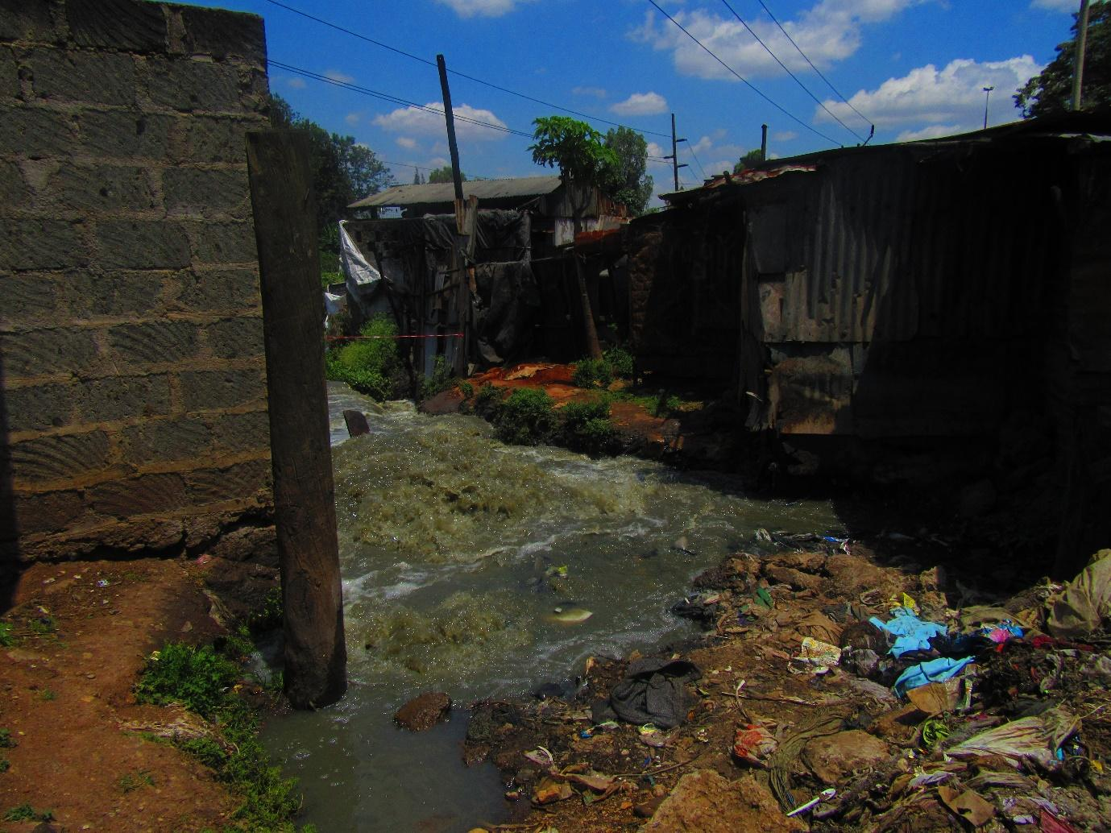

R11: Now I am R11 and I took photo number 2 group 3. I am the one who took this photo and it had many meanings but I will look at one particular meaning. The meaning I took is this. This is a sewer line that is broken here. If you look close by here, there are some residential houses and people live there. Now because the county government has taken so long to repair this sewer line, it has been dug and dug until it has reached people’s residences. If you look here there are houses that have almost been reached by water. Because the sewage is flowing fast and it hasn’t been repaired in a long time so it has eroded the soil to the point that it has now reached people’s houses. And then here there was a tap where people were collecting water but I didn’t put that one and that pipe passes under here although we have already spoken concerning that. So the main point is that the sewer line broke and the sewage is flowing all the way almost reaching people’s homes.
M1: Okay, thank you very much.
M: May I ask a question before you proceed?
M: Yes please.
M1: I have a question. A sewer line like this one when it breaks in that way, who ought to fix it?
R11: The people who live there, for example those who own those houses ought to go to Nairobi Water and Sewerage Company, it’s just here in Kariobangi. So they ought to go and report there.
M: So what it means is that if a sewer has stayed like this for a long time, is it that the people close by haven’t gone to report at Nairobi Sewer?
R11: It could be that those who are close don’t have the information that they ought to go and report. It could also be that they have built there illegally, maybe that entire area is reserved for the sewer line because all that is sewage that has spilt out. In that case it may not be easy for them to go out and report because they will be asked why they have built there because that land is for the sewer line and they will be asked to demolish their houses so they may choose to tolerate the leaking sewage.
M1: Okay, thank you very much. I have understood many things concerning this discussion. What I would mainly like to discuss is what you have mentioned about the sewage getting into the homes. Did you say it’s getting into the homes?
R11: Yes, even if you look there you will see that the sewage is coming at high pressure so it erodes the soil and carries it away, these houses are made of mud. So the sewage is taking more and more space as it flows and maybe the person living there will have a problem when they find the water just flowing in.
M1: So depending on this situation, let me first ask is this situation a common occurrence here? Is it something that happens every now and then or does it just happen once and then doesn’t happen again for a long time?
R?: Especially when it rains it happens a lot.
M1: So when it rains this is something that happens a lot. So when it happens in this way, does it by any chance come with any diseases? Do people fall sick?
All R: Yes.
M1: Since we’ve spoken about diseases at length, I didn’t want to focus on sickness, but let us discuss sickness from an angle that we haven’t discussed it from so far. When this happens to houses, and you have said that people get sick what demographic of people are most affected? Would it be women, children, men, old people, what demographic is most affected by diseases when such things happen?
All R: Children.
M1: Children?
R?: And expectant mothers.
M1: Okay, thank you very much. I think we can move forward.
M: So we’re going to move to photo number 3 group 3.
Photo 3, group 3
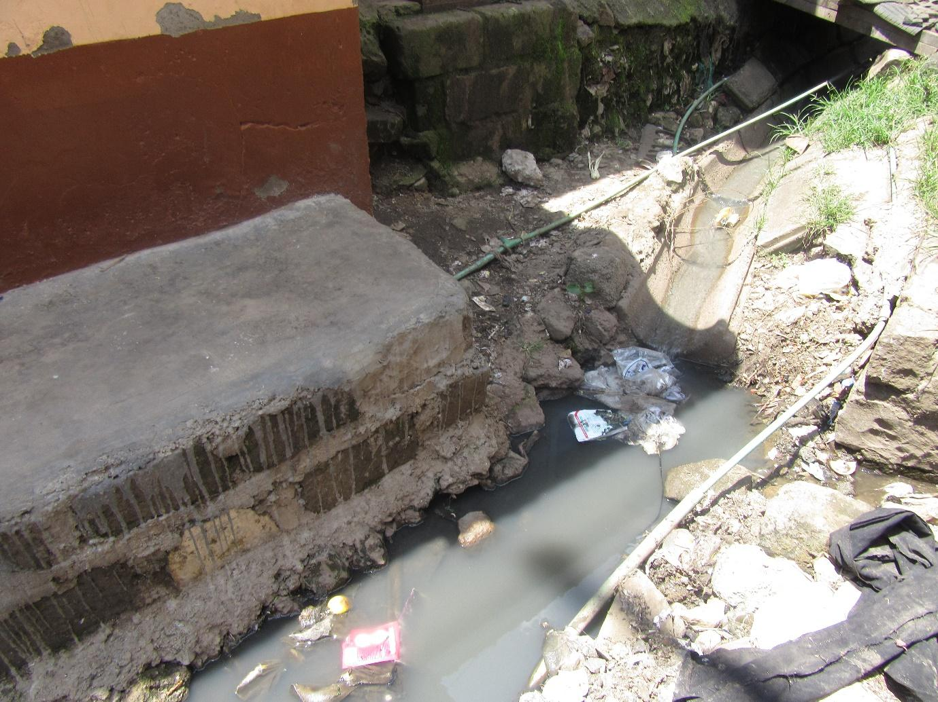
R10: I am R10. When I took this photo what I meant to communicate is that this is sewage, this is a drainage through which sewage runs and these are water pipes whose water people use in their homes. And right next here there’s chalk. So I was seeing that sometimes this drainage has a leak and the sewage leaks a bit. So sometimes you can fetch water and find that that water smells of sewage. So I saw that that causes harm because even in food, that is the same water you will use to cook the food and it can even cause diseases.
M1: Okay, thank you very much. So this one is the one you were telling me to wait for when we were discussing the issue of water?
All R: Yes.
M1: So we have already discussed it, isn’t it?
All R: Yes.
M1: Let’s give her some flowers. Receive your flowers. Thank you so much. [Name] you can proceed.
M: Okay, we shall move to the next photo which is group number 3, photo number 4.
1:40:05
Photo 4, group 3
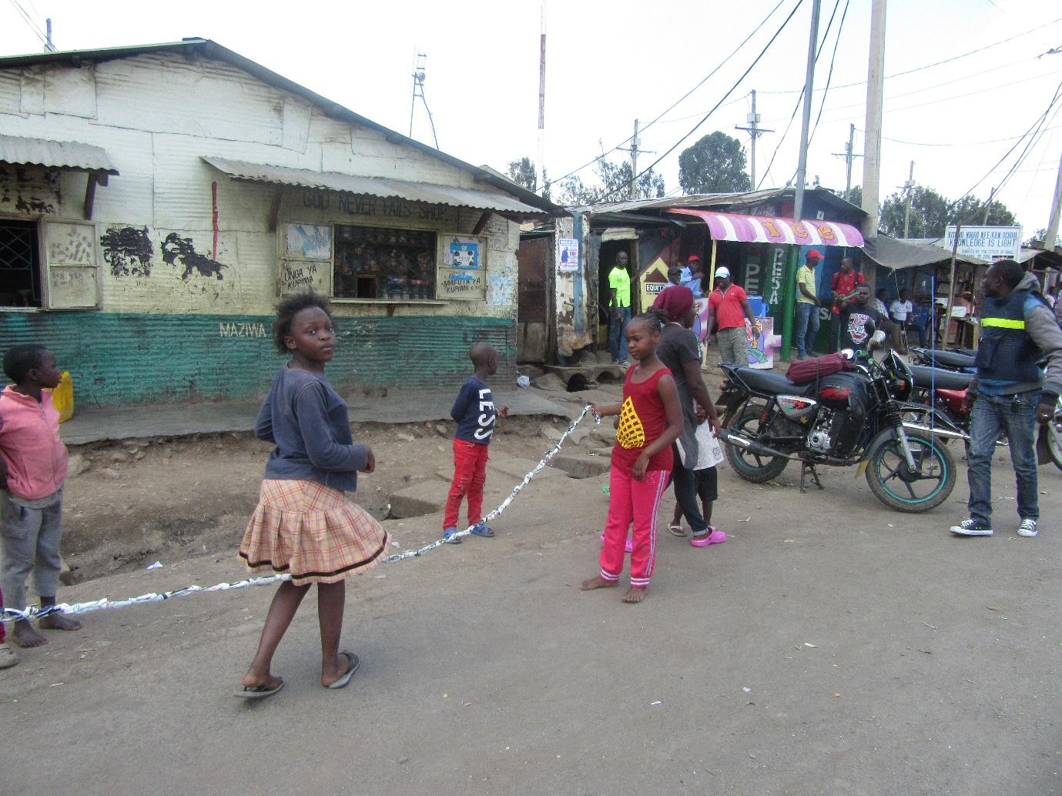
R12: Hallo, hallo. I am R12 from group number 3 and I’m going to speak about photo number 4. As you can see, children are playing there, isn’t it? Among those children there are those who are playing without shoes, there are those who are playing barefoot, they don’t have anything on their feet. Right next to that, there’s sewage, there’s a drainage/ditch that has dirt in it. This game that they’re playing is that game of jumping. So a child can jump and by bad luck they fall into the ditch. Or even as they’re playing, the child might bend over and touch the ground. And children as usual, children are children, right? So they will go there and get something to eat and they won’t remember to wash their hands, they’ll simply get that food and eat it. Once they eat that food they will be affected, right? So I was trying to get that photo so that in any case even these children who are playing can find a better place, a playing ground where they can play that will at least be safe as opposed to playing by the roadside where they could also be bashed by a bicycle, a motorcycle or a car or they can jump and find that they have fallen in the ditch. Yes.
M1: Thank you very much R12. R12 has highlighted many important things. First she has highlighted that playing grounds for children are an issue. She has also highlighted the possibility of a child getting hurt there. We had said that if a child gets hurt we’ll see they’re not well, isn’t it? We had spoken about all the effects that will result in in the home in terms of the economy there, there’s no money and so on. She has also spoken about contamination that a child can fall there or touch the dirt there which they will then go and touch their food and we have considered that point of contamination, isn’t it? We have spoken about it, right?
All R: Yes.
M1: So we’ll just mention as we move on. But before we move on from this photo let me say this, because I have seen that this game that they’re playing and remembered something. I really used to enjoy this game. And on the day when you guys will invite me to come and eat goat meat with you- that by the way is how someone invites themselves to a place where they haven’t been invited to – on that day, I will request that you come with some rope and then we can compete, me and you, right? In this game, right? Okay, let’s move on.
M: Have we given her flowers? Let’s give them. We’re going to move to the next photo. Group number 1 photo number 5.
Photo 5, group 1
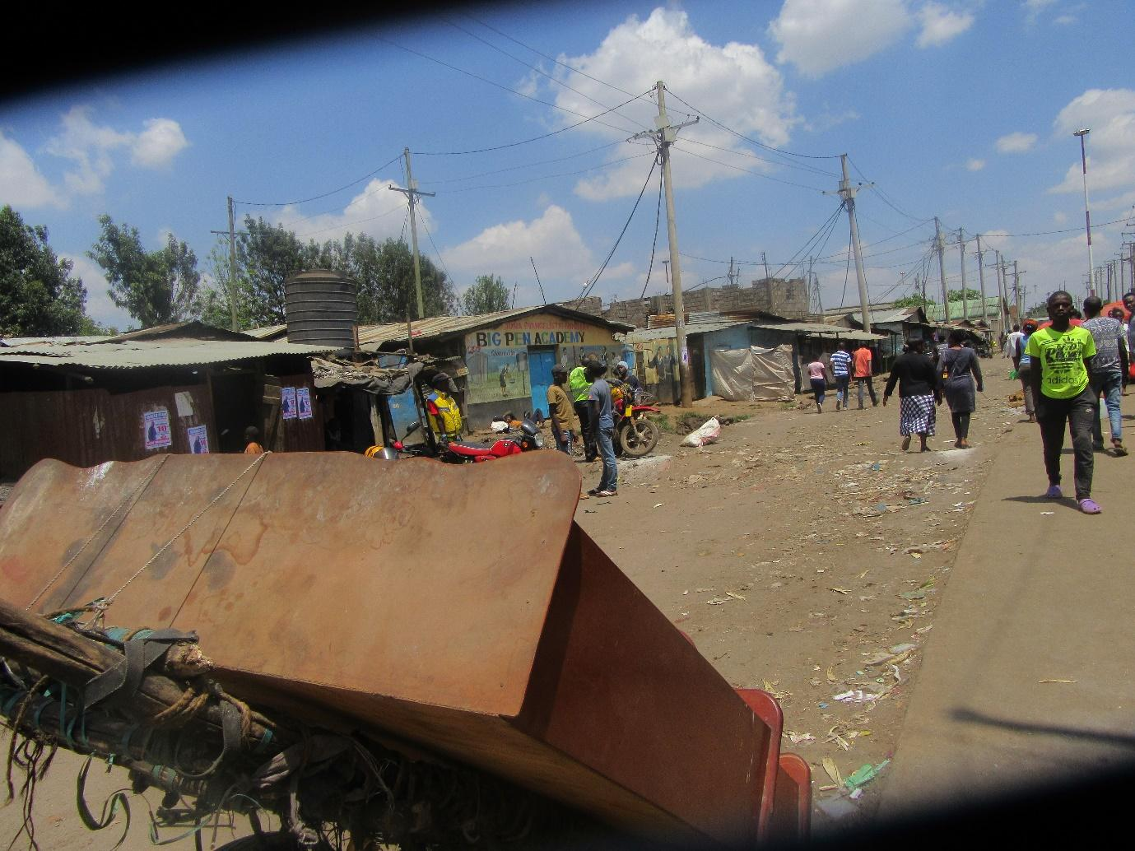
R2: I am R2 and I took photo number 5. What I was saying here is that there is security. When I look here, this is by a road. A handcart has been left by the road. The owner even as I was taking this photo was not close by. Which means there is security in this place. They have understood that even if they go far, they will still find their handcart, and this rope on the handcart will still be there.
M1: Okay, thank you very much. Thank you very much R2. Let’s please give her some flowers. R2 has brought up once again the issue of security. Which we had already discussed isn’t it? So as we give those flowers we say thank you. [Name] you can move us along.
M: Photo number 6 group 1.
Photo 6, group 1
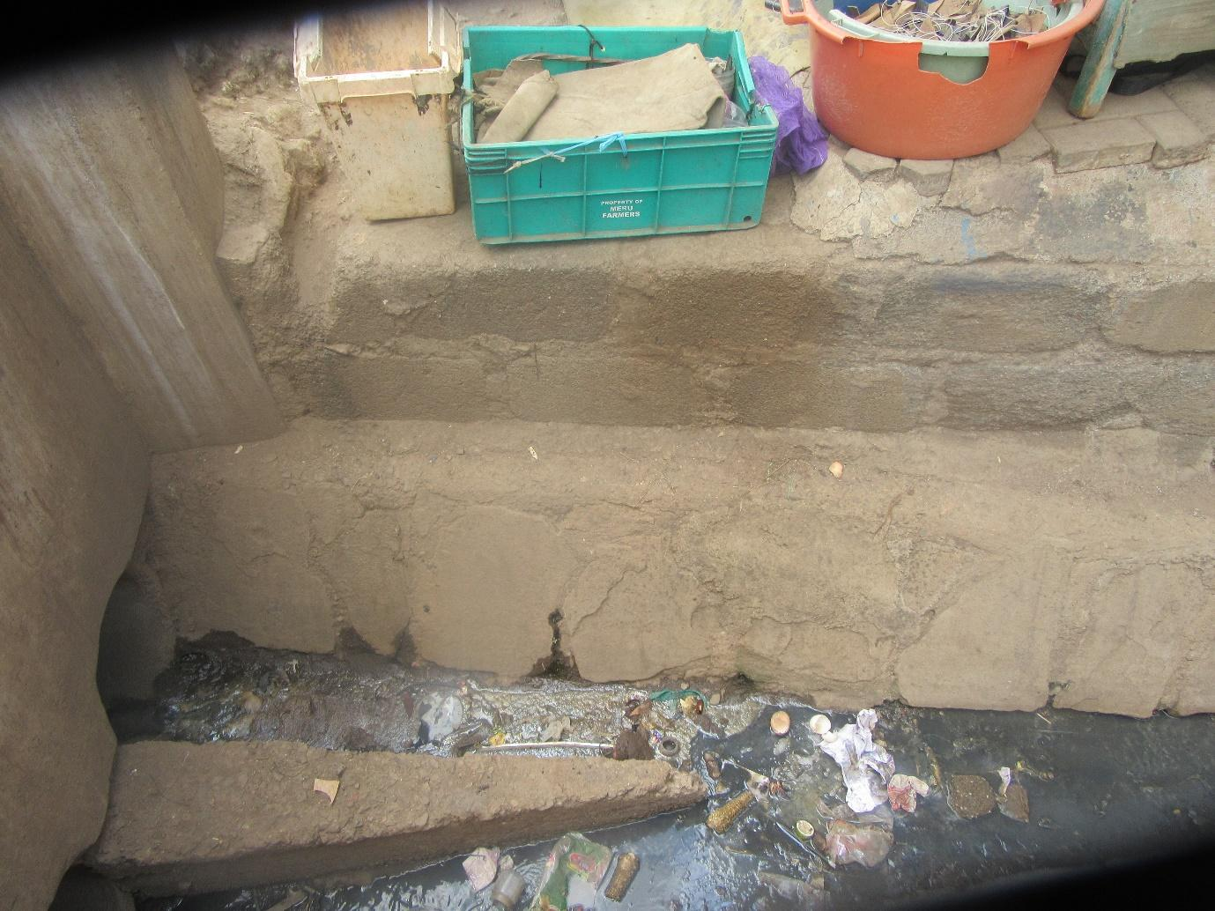
R1: I am R1. When I was taking this photo, like I had said I went somewhere and found that some food had been cooked. The food itself was good but you wouldn’t desire to eat it. So if you look at this, this is sewage and food is being cooked close by. So I saw that the hygiene there is poor.
M: Some flowers. I have only one question concerning hygiene. I’m wondering who should be the starting point of cleanliness. Where should it start?
All R: With you.
M: Cleanliness starts with me? So now for such a person who is selling food close to the sewage, what can they do to guarantee cleanliness? R6.
R6: I think that thing can be covered with something to stop it from getting into the food. That dirt can be covered to ensure it doesn’t get into the food.
M: But will covering the dirt move it away?
All R: No.
M: R4.
R4: I am R4. In my opinion, they should have looked for someone if they had a little money, who can clean up that place for them to make it clean and then proceed with their business.
M: And if they don’t have money? R1 and then R5.
R1: I’m R1. If they don’t have money, or even if they have money, the responsibility of cleanliness is their own because the business is theirs. They should have washed that place, if it is that drainage they make sure it has been unblocked so that the dirt flows and even them because I found cooking close by there, which is why I said even if they had served me food I wouldn’t have eaten it because the person was also quite dirty themselves. So this is someone who has no idea whatsoever that food ought to be cooked in a place that is clean and that the person cooking the food ought to be clean. So I wondered because it was as though in that area there are no health officials. Because this person ought to be arrested and stopped from cooking for people.
1:45:36
M: R5.
R5: My point is the same as the one R1 has made. The person selling food from there ought to first make sure that the place where they are near that drainage, they make sure every morning they have cleaned out whatever dirt is there so that way even the dirt that flows later won’t get clogged there it will simply flow through.
M: R12. The point has already been covered? That’s okay then. R1 has mentioned that health officials who can be coming and doing some things. Is it common place for health officials to visit the neighbourhood? R10.
R10: It seems to me that when those health officials walk around they take money.
M: By that do you mean they ought to be paid or are you saying they collect bribes?
All R: Bribes.
M: Oh, okay. R9.
R9: Most of them come when there has been a disease outbreak. That is when they run to come and look for people to arrest. But if there’s no outbreak of say cholera and so on, it’s difficult to see them coming to clean or to inspect on cleanliness.
M: R1.
R1: At the same time security is also a problem you might find they have come to arrest only to find that they are the ones who have been arrested.
M: R12.
R12: Okay, you know sometimes you can find at times that these business people care for each other. Provided one person has seen the health officials, they will communicate among themselves. By the time you get there you will find that there’s no food and everything will have been cleaned up. It’s like for example I hear when county police come to arrest hawkers, when the first person is seen the news spreads and no hawkers are found. They will have tied up their goods and placed them somewhere. Once the officers pass, then everything is displayed for sale again.
M1: Okay, I have heard that there are times when health officials can come here and get into trouble, isn’t it? Okay, Faith, move us forward.
M: Okay we’ll move to on to group number 1 photo number 7.
Photo 7, group 1
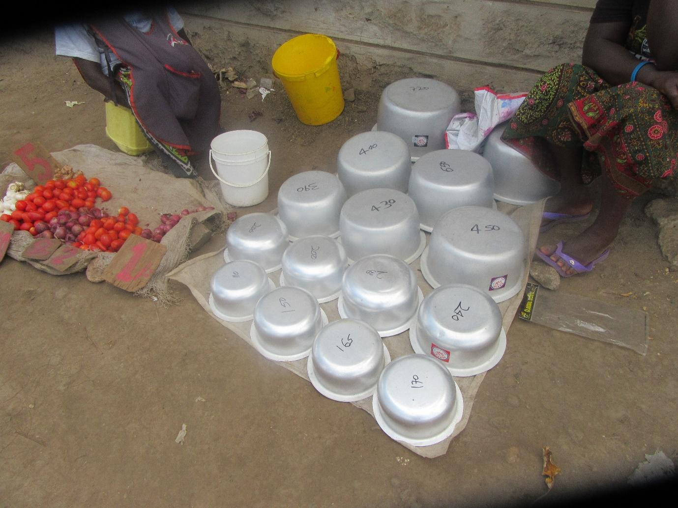
R3: I am R3 from group 1. You see here there is lack of food. There are tomatoes but there are no vegetables. There are some cooking pots close by and only tomatoes. There ought to be vegetables here because you can’t eat tomatoes on their own.
M: Why should vegetables be added there?
R3: So that when you come to buy tomatoes you also buy spinach, or kales, and then you buy onions and go. So if you don’t have cooking pots, there they are.
M: What if your neighbour has vegetables?
R3: Life as it is right now, your neighbour wouldn’t even share their vegetables with you.
M: Not your neighbour at home, the neighbour at the market.
R3: At the market? Well if the next vendor has vegetables you will be forced to go to them but it seems they might be far.
M1: R3, thank you for some good contributions. There are 2 things I can see there. You’re saying that this is the market right?
R3: Yes.
M1: So there are tomatoes, for example, but the vendor doesn’t have vegetables. We had discussed that point that there are foods that aren’t available there at the market. I won’t dwell on that because we had already discussed that. But there are some issues that have come up with that question that [Name] asked, a very good question. Let’s discuss ourselves as neighbours. We said that sometimes we lack food in our homes as well, right? So let me repeat [Name’s] question. If you don’t have food in your house but your neighbour has food, what normally happens? Do people help out one another?
(Group chatter)
M1: Okay, let’s move slowly. R10. You’ve said that it’s hard to find people helping each other out. Why is it hard?
1:50:11
R10: It’s hard for me, when I don’t have food, to go to the neighbours for assistance because here, everyone is a hustler.
M1: Okay, alright, R9.
R9: It could be that even if I have the food, I have cooked at night the meal that we’ll have for dinner and the children will eat for lunch tomorrow. So sharing becomes a challenge.
M1: So it’s hard to share, are we in agreement that it’s a challenge?
All R: Yes.
M1: Let me ask again. Are there times that in our neighbourhood a neighbour can go without food for some time and their next door neighbour has food?
All R: Yes.
M1: R12.
R12: Sometimes you can find that I have food, okay? I cooked a lot of food and have some leftover and then the other person was totally unable to get any food today. And you know there are people who don’t believe in being given. So I could have a heart of sharing and I have seen let me get that left over food and take to them. But on their side, maybe they start to wonder about my motives. “Why has she brought this food for me? What does she want?” So that could also prevent me from taking that food.
M1: Okay, thank you very much. R11.
R11: Mine is different. When we’re at the plot I hear that we live with people from western Kenya and Nyanza who are the majority. So they tell me that “you can sleep on rice and potatoes but to us that is simply a snack to be taken with tea.” So even if they fail to find what they usually eat- ugali and traditional vegetables, I won’t give them my rice and beans. Since it is simply a snack to be taken with tea so even if I give them I will as though I haven’t helped them.
M1: Okay, thank you very much. R9.
R9: I am R9. It could also be that I don’t have food and my neighbour has but then they happen to be those people with a big mouth. So when they give me they will go broadcasting out there that I don’t even have food. So I won’t want them to give me. Instead of them going to broadcast, I am better off sleeping hungry. Because out there everyone will know.
M1: Thank you very much. That has brought up another question that I would also like us to discuss. As women- because at home it is said that when it comes to food issues it is the woman who decides, isn’t it? – When there is no food at home, what means do we normally use to see to it that the food at least becomes available? What strategies are available? Yes, maybe you didn’t manage to get something today but (unclear) what strategies do we use as women? R7.
R7: I am R7. There’s a place, maybe a kiosk where you normally buy from. If you fail to earn something today, you won’t fail to earn something tomorrow. So you go and buy on credit so that the children don’t go to bed hungry.
M1: Okay, thank you very much. Someone else with a different way? Something that you work with, R9?
R9: I am R9. You can go to your friend who you know that even if they give you food they won’t broadcast it. You can go there and they will help you and the children will be full.
M1: Okay, thank you very much. I would request that we stop broadcasting each other’s issues.
R1: I am R1. Because nowadays we have come together and we have organised ourselves, we have groups through which we buy food. So when my food runs out, I will go to the woman from my group with whom we buy food together and if she’s the one who had gotten food the last time, she will give me some so that when my turn comes to get, I will give it back to her. And it will be easy for her to give to me because she already knows where she will recover it from.
M1: Wow, is that happening? Do you have that strategy?
All R: Yes.
M1: That story is very good I think you should cheer for yourselves “ladies hoiyee.”
All R: “Hoiyee.”
M1: You need to praise and celebrate yourselves, that is a very good strategy. I would like to ask this. In those groups where you buy each other food, what type of foods do you usually buy? What food is common? R5.
R5: Flour, rice, sugar, bar soap.
M1: Okay, why have you chosen those specific foods? One at a time. R4.
R4: Those ones that she has mentioned are the most important in the house.
M1: Okay, thank you. R11.
R11: We can’t buy things like vegetables because they’re perishable. Storage would be the challenge. So we look for the things that will last long in the house.
M1: Okay, thank you very much. R9.
R9: We usually buy like that because if say I want my neighbour to bring me flour, and then let’s say we’re 10 of us in the group, we agree. If I want you to bring me flour, I will bring flour, if I want someone to bring me rice the next time I will take rice. And so on, the things I will buy are the things I will be brought for.
M1: Alright, thank you very much. I would like to ask my final question here. I have heard that you women have organised yourself well. You have strategies, if you fail to earn you have option B, isn’t it?
All R: Yes.
M1: So, your men there at home, do they also have option B?
(Group chatter)
1:55:04
M1: No, you won’t speak about men badly here. Okay, I will close that discussion about men. Why do you want to discuss men so much? Okay, let’s move forward. We can speak about men when we’re done. So photo number 8, group 1. Photo number 8, group 1.
Photo 8, group 1
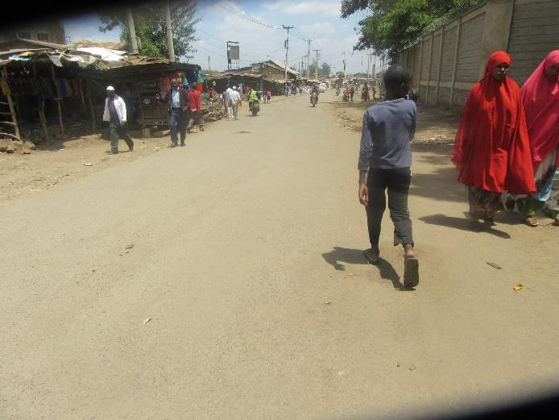
R4: Discussing photo number 8 group 1, I am R4. What I was trying to say here, the reason as to why I took this photo is that the road is safe, and it is clear, even if you want to transport some goods it’s easy because the road is totally safe. When you’re in a vehicle, if you’re coming from the market, you can pass without any worries. That is the photo I had taken.
M1: Thank you very much, we have been told that our roads are good, they’re safe so even if you need to transport things like food you can do so without any concerns. Is it true that this is the situation? Are the roads in good shape?
All R: Yes.
M1: Okay, one thing I can maybe discuss there, because you have said transport becomes easy, the foods that come to our markets, yes the transport is good, but what is the handling situation when they’re being dropped? How are they handled? How are they handled, how are they carried? What is the situation? In the process of getting the foods to us in the market. R9.
R9: The lorries drive all the way into the market then there are people whose job it is to offload the lorries and deliver the goods in the different kiosks.
M1: Okay, how do they carry them? What is the situation? What is the situation there? R2.
R2: The porters carry them on their backs.
M1: On the backs, okay. I see that R9 would like to add.
R9: There are those who do that work. When a lorry arrives, there are those whose job is to carry the goods from the lorries and take them to the owners in their kiosks. By the time goods are being packed in the lorries, everyone knows their products that are in the lorry. So they already know in that market that if this package is labelled so and so it take it to them. So there are guys whose work it is to carry those goods on their backs.
M1: Thank you very much. Maybe let me ask a final question. The way we see the food being handled there at the market, in our opinion, are our foods handled in a clean way? In a hygienic way there at the market? What is our opinion? R12.
R12: The way they’re handled, for example as my colleague has said, there are those who offload them from the lorries, right? When they’re climbing, they don’t pay attention to where they’re stepping. Since everything is in sacks, they’re forced to step on sacks as they try to reach other sacks to offload it. Because maybe the person who has already been reached here, their sack is further inside while the ones that are close to the door are going further ahead. So they won’t drop all of these that are close to the door. They will be forced to step on these in order to reach the others.
M1: Would anyone like to add onto that? Alright, thank you very much. [Name] I don’t know if you have an issue? [Faith] says she’s fine. Let’s move forward. By the way let’s give flowers, whose photo was this? Thank you so much. Photo number 5 group 2.
Photo 5, group 2
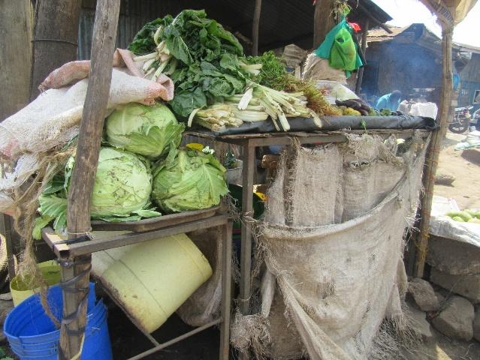
R5: Presenting photo number 5 I am R5. When I was taking this photo I looked and saw that there are plenty of vegetables in the market but the challenge is with where it has been placed. If you look here, these vegetables have been kept together. And this kiosk is very small. So even if they wanted to present them in manner such that the display is big, they wouldn’t have manged due to the fact that the kiosk is very small in terms of space.
M1: Okay, thank you very much. So what we’re seeing is that there are many vegetables here but the space is limited, isn’t it? In terms of the ready availability of food here in our community, we have spoken about that at length, right? And then we had also spoken about the issue of space and we said that sometimes we don’t even have space and we end up placing them in a place that is not appropriate, isn’t it? So let’s give her flowers so we can move forward. Thank you very much. We’re now at photo number 6 group 2.
2:00:02
Photo 6, group 2

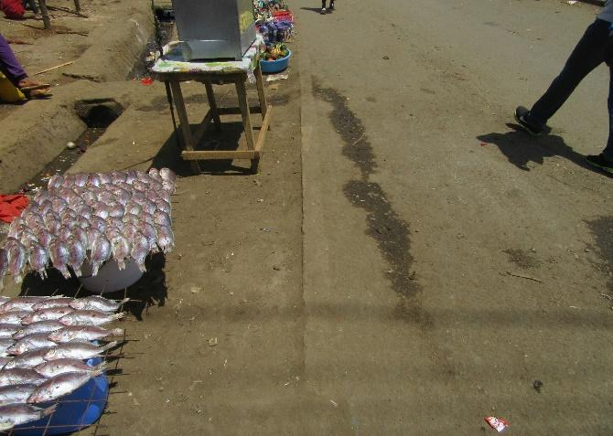
R6: I am R6 from group number 2. So here, as I was taking this photo of mine, as you can see this is fish. Fish is very good because it gives us many nutrients for the body. It has omega 1, omega 2, omega 3 and those are very good, they’re very beneficial to our bodies. The owner of this place we took the photo was clean. But here you can see this is a road, the fish are by the roadside. The only negative thing is that they have displayed their fish right by the road. Because now every time vehicles pass, all that dust will end up on this fish of ours. So once we eat this fish, they may bring diseases to our bodies.
M1: Thank you very much R6. She has explained to us that there are fish there which is very good food that she has said has many good nutrients like those omega. But there is a challenge because the place where these fish are is not clean so at the end of the day you might end up buying that hoping to get the benefits but instead end up getting sicknesses. Is this a situation that we encounter?
All R: Yes.
M1: Is it a true reflection of our reality?
All R: Yes.
M1: Okay. What can be done in order for us to come out of such circumstances? This is food that has all the good nutrients that we need. You have bought it so that you can get the good but you end up getting sick. What can we do? Or what needs to happen in order for the situation to change? We want to leave here with solutions. R8.
R8: At least they should have built a kiosk for it in order for it to not be so exposed.
M1: Okay, thank you. Someone else? R9.
R9: The way they have washed the fish, if they could’ve washed them at home where they live and allowed them to dry there where they won’t get dust like they are here by the road, so that by the time they come out to cook now, at least they wouldn’t have collected too much dust, they won’t be too dirty.
M1: Thank you very much. Allow me to ask this. Here we’ve been told that we have fish which is food with some good nutritional value. Do we normally cook fish here?
All R: Yes.
M1: Do we love fish?
All R: Yes.
M1: Okay. Where do these fish normally come from? R9.
R9: Most of them buy them from Gikomba.
M1: Gikomba, okay, anywhere else? R12
R12: Dawanol.
M1: This go down? They have fish there inside Dawanol?
R12: There’s a place in there where people sell fish.
R?: If it’s a company, they buy from places like Naivasha and come to sell.
M1: Okay, thank you. Here in Korogocho, is there a place where we produce fish? Is there a fishpond anywhere here in our neighbourhood?
All R: No.
M1: Okay. How is the price of fish here in our community? R9.
R9: It depends. There’s “mgongowazi,” there’s fish heads, it depends on what you want.
M1: So it depends on your pocket?
All R: Yes.
R?: Because even if you want fish for 10 shillings there’s “bones,” there’s a fish called “bones” that goes for 10 shillings.
M1: Here in our neighbourhood are there people who don’t eat fish? Who don’t like fish?
All R: Yes.
M1: They’re there. So what foods can they eat in order for them to get those benefits that the person who eats fish gets?
R?: Eggs.
M1: They can eat eggs right?
R12: Beans.
M1: R12 says beans as well. Anything else?
R?: Meat.
M1: Meat. Okay, so what nutrients are we considering?
R?: Protein.
M1: We’re considering protein. Okay, when mum was taking this photo she said that this photo had omega. Where else can we get these omega nutrients for the person who has not cooked fish or hasn’t eaten fish? R1.
R1: We can just buy the ones available at the chemist and use them, the supplements.
M1: Alright, thank you very much. Someone else? Are we Okay? I think we’re okay there, [Name]? [Name] is good so let’s move on. Did we give her flowers? Let’s give her please. Okay, thank you very much. The next photo is photo number 7 group 2.
Photo 7, group 2
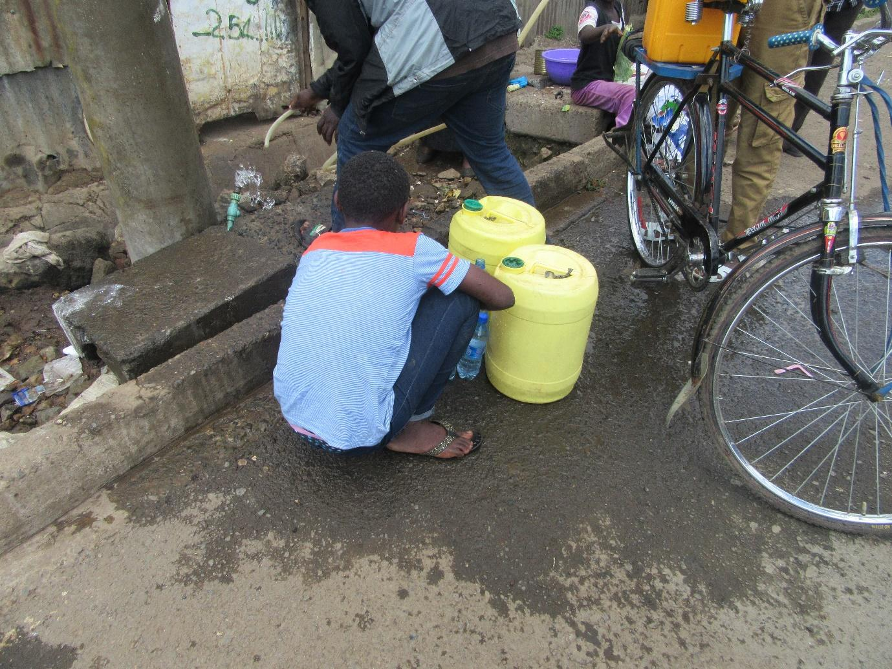
R7: I am R7 from group 2. If you look at this photo this is water. They have enough water there. But where the pipes pass through, they have been dug for under the ground and there’s a drainage passing through here. So in my opinion, it may not be clean.
2:05:10
M1: Okay, thank you very much. Before I release you, where is this water coming from?
2:05:14
R7: The pipe is coming from down.
M1: So this water we're seeing here, these containers are fetching water from a council water pipe?
R7: Yes. Okay, thank you very much. Just have your seat. And as I continue with this question, let me hear apart from this council pipe as we're seeing here, what are our other options for getting water? Where does our water come from? The water we use at home. Do we have other water sources or do we all collect water from these council water pipes?
R?: We get from those ones.
M1: The pipe ones? There aren't any other sources? Do we have boreholes here?
All R: Yes.
M1: Okay, let me ask again, do we all have pipes close to our homes? Do we fetch water from taps or from those pipes?
R?: Not everyone.
M1: You're saying not everyone. So those who don't have piped water at home, where do they get their water from?
R?: They buy. You see like those people who are fetching water in that photo are buying the water.
M1: So are there people who sell water, who distribute it, maybe using handcarts? Are those people there?
All R: Yes.
M1: Okay, I would like to know, in your view, those who distribute that water, the way they carry it and so on, what is the state of hygiene? Okay, these guys are a little bit distracted. I'll ask this. Those who sell water, they go and fetch it and sell it to us, in our opinion, when we consider that entire process, how they handle it, the things they use and so on, what is the situation in terms of hygiene?
R4: It's poor.
M1: R4 says it's poor. Why is it poor R9?
R9: I am R9. You can't know where that person collected the water because they're simply doing a job. And that is their job. So they simply go to buy that water and then come to sell to us. So even if they get it from a place where a pipe is burst, they won't want to know because all they're after is money. They will simply collect the water and bring it to you.
M1: Okay, so have those cases been there where people find water in a place where it isn't clean and they then come to sell it to people? Have those situations been there?
All R: Yes.
M1: Like in what instance? Give me one example. R12.
R12: Okay, there was a time when there was no water. You see the sewer line, when it's passing it seems very clean, isn't it? When you don't consider the one that has leaked and passed through ditches, the one that flows through the line it looks very clean. So there was a time when the handcart operators, you see the water had been disconnected, so we were being forced to buy even one 20 litre can for 70 shillings or 80 shillings. You would find the handcart operators queueing there and collecting water from the sewer line and then sell to people. What made people notice that the water wasn't safe was that before buying you would ask the handcart operators “is this water safe?” “Yes it's safe.” “If it's safe, here's a cup of water, please drink so that we can know that it's safe for us to drink.” At that point they would refuse to drink which automatically told you that that water wasn't safe.
M1: Is it true that that situation is there?
All R: Yes.
M1: Alright, thank you very much. [Name] I don't know if you have something to add?
M: I don't have anything to add.
M1: Alright, then we can move forward. Photo number 8, group 2.
Photo 8, group 2
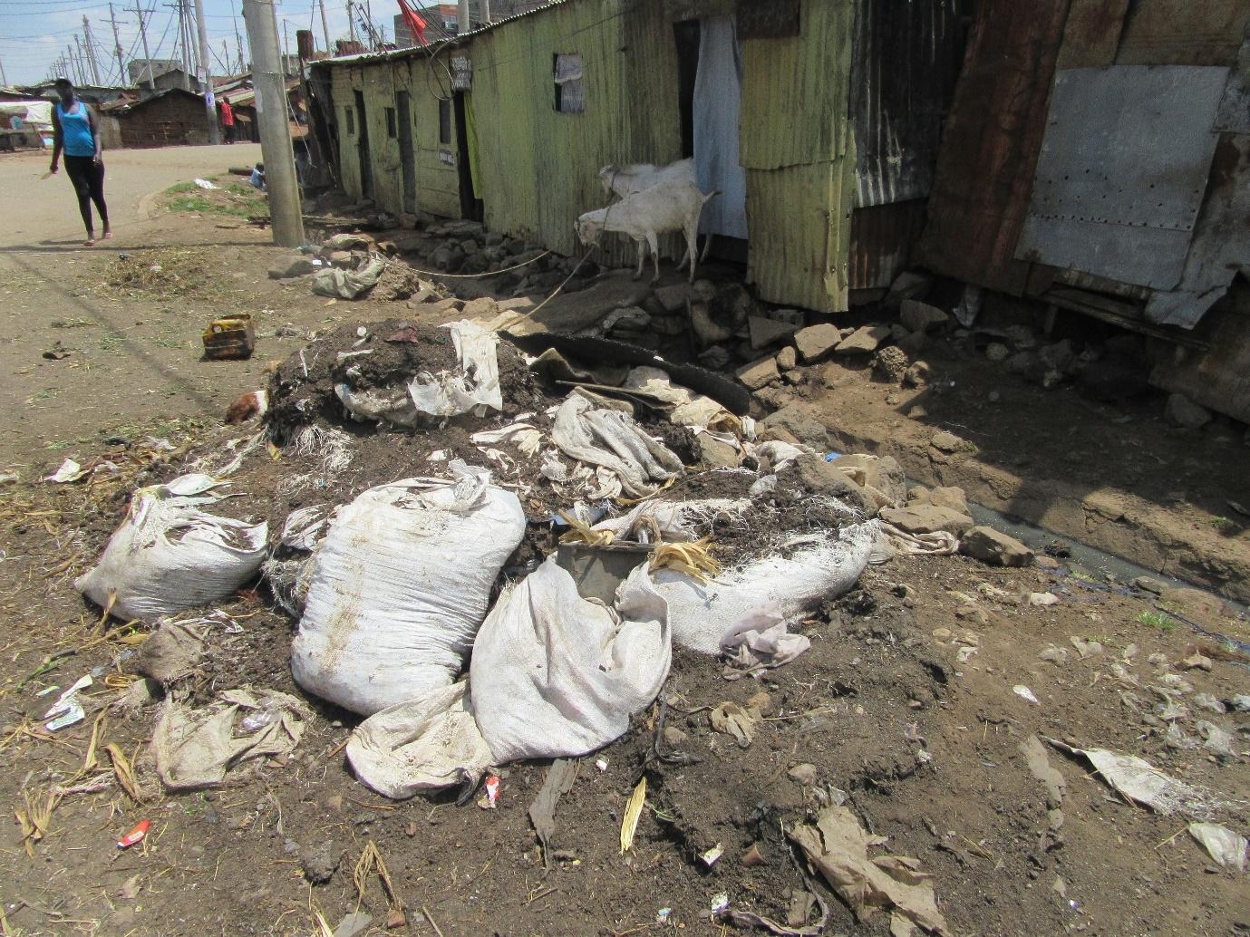
R8: I'm R8. So this is manure which means the residents of this place are engaged in farming, they're trying to make sure there's enough food. So the only problem is that there's inadequate space so at least they would've something like a small structure where they can store that manure so that they can preserve it well so they can continue to increase the supply of food.
M1: Okay, thank you very much. You have said that this is manure right? Is it here for sale or not?
R8: They've just stored it there.
M1: So they're simply placing it there, they've collected it from that place?
R8: There are some goats in that place.
M1: So these are the people who own goats?
R8: Yes.
M1: So where do they normally take this manure?
R?: Most of the time they sell it because there are those of us who plant after we were taught to plant kales in sacks, so we buy a little manure measured in cooking fat containers and then you add the manure to the sack where you have planted kales.
M1: So there are those who have these kitchen gardens, who are involved in urban farming? There are those who have that?
All R: Yes.
M1: Okay, who taught us?
R?: We were taught right here.
M1: Where did the training come from? So for example would you know which organisations planned or it?
R?: It had been brought by Light and Hope but now we don't know the rest.
R?: Handicap International.
M1: Handicap International? Okay, thank you very much. So women nowadays, everyone has their small garden? What do you plant in those gardens? R1.
2:10:05
R1: We plant spinach, kales and onions. And some tomatoes.
M1: Okay, thank you very much, anything else that we plant? Okay how do you find the gardens, how do they perform? R9, would you like to add to that?
R9: They're good because we have no way of knowing where the vegetables we get from the market come from. But then if I grow my own vegetables, I will know that they don't have any chemicals. I'm the one who has planted and I will have watched them grow. Also, once you plant them like that, the money you used to spend on vegetables is now freed to assist somewhere else.
M1: Okay. Is it all women who have those sack gardens?
All R: No.
M1: Why is it that some of the women haven't planted them? Okay, R12.
R12: Many of us don't have depending also on the space. Where you live, the space is very small. Where would you place your sacks and the landlord will ask you “if you place your sack here, where will people pass?” so you might desire to have the sack garden but then you won't have a place to put it.
M1: Okay, thank you. Does anyone have something to add? R8.
R8: Also due to security, where I live, if you plant those vegetables today you won't find them tomorrow morning.
M1: Really, they disappear? Meaning that there are people who steal them?
R?: Yes, at night while you're sleeping.
M1: Okay, another reason? Is there another reason? Okay, these sack gardens, in your view, what ought to happen or what can be done for you or what can you do yourselves in order for many people to have them and so that production from those sack gardens can improve? R1.
R1: We just need to have space.
M1: Okay. What can happen in order for you to have space? This space challenge, how can we solve it? (Group chatter) This space challenge, what will be its solution? If you were told that from today you are a leader and you need to solve for people this space challenge because people are willing to have these gardens and to grow these vegetables and not grow anything else, what can you do for the people? R1.
R1: I'm R1. Recently we were at a training and we were saying that the only challenge is space but then we were told that at the window in your house, you can nail 2 pieces of timber on either side and place the sack there and you will manage to have your own vegetables even if you don't have space. They will get sufficient sunlight, you will just need to be watering them. And then down here because we're living in a storied building, in order for it not to spill to the lower floors, you place something below that timber so that when the water and soil spills it is collected by that thing so that you don't end up making someone's plot dirty.
M1: Alright, thank you very much. We've been given an example of a solution to the space problem, isn't it? Okay, what else can be done or can we do, in order for all women to have these sack gardens for, for many women to have them so that our food production can improve? What can be done and by whom? What do we need to do and who ought to do it? Recommendations, R2.
R2: We need to have trainings like I had mentioned before. The chief can be instructed to invite people to meetings where they can be taught how to plant vegetables in those sacks. He would have created awareness to many people.
M1: Awareness and trainings there, thank you so much. Anyone else? We've been given an opportunity to give solutions. Assume the solution you give here will be implemented. What would you suggest to us? R5.
R5: In my opinion, some of the churches here have large compounds. If they can be spoken to, maybe by the chief, and agree then women's groups can be allocated space where they can grow vegetables.
M1: Okay, thank you very much, that's a very good contribution. Another idea? R1.
R1: There was a time when we had come together as a group with some other parents and we were given a place but I don't know whether it was out of lack of understanding or what it was, we didn't utilise that space, we just let it get lost like that. So sometimes it's ignorance or lack of awareness.
M1: Thank you so much. Another idea? R11.
R11: I am R11. I was saying like here in Korogocho, there are no multi-storey buildings. So we could say that everyone has space, the challenge is awareness and lack of information. The people are lazy, maybe it's not even laziness it's a lack of knowledge, they don't know that something like that can work. So people think that maybe they will plant and it will be harvested by others. But even if someone picks two vegetable leaves on one side, you would still be left with one side and you will still benefit.
2:15:23
M1: Okay, thank you very much. R9.
R9: The challenge with a place like that is that it depends on the place where you live. There are also children to consider. You can plant today and find that tomorrow it has been plucked. You can plant and they grow a little bit, and then you find that they have plucked them or cut them up and spoilt them. So it also depends on where you live and the people you live with.
M1: Okay, thank you so much. I think we have completely exhausted that point. [Name], you're okay? Alright, then let's carry on. Where have we reached? Is it photo 5 group 3? Okay photo 5, group 3.
Photo 5, group 3
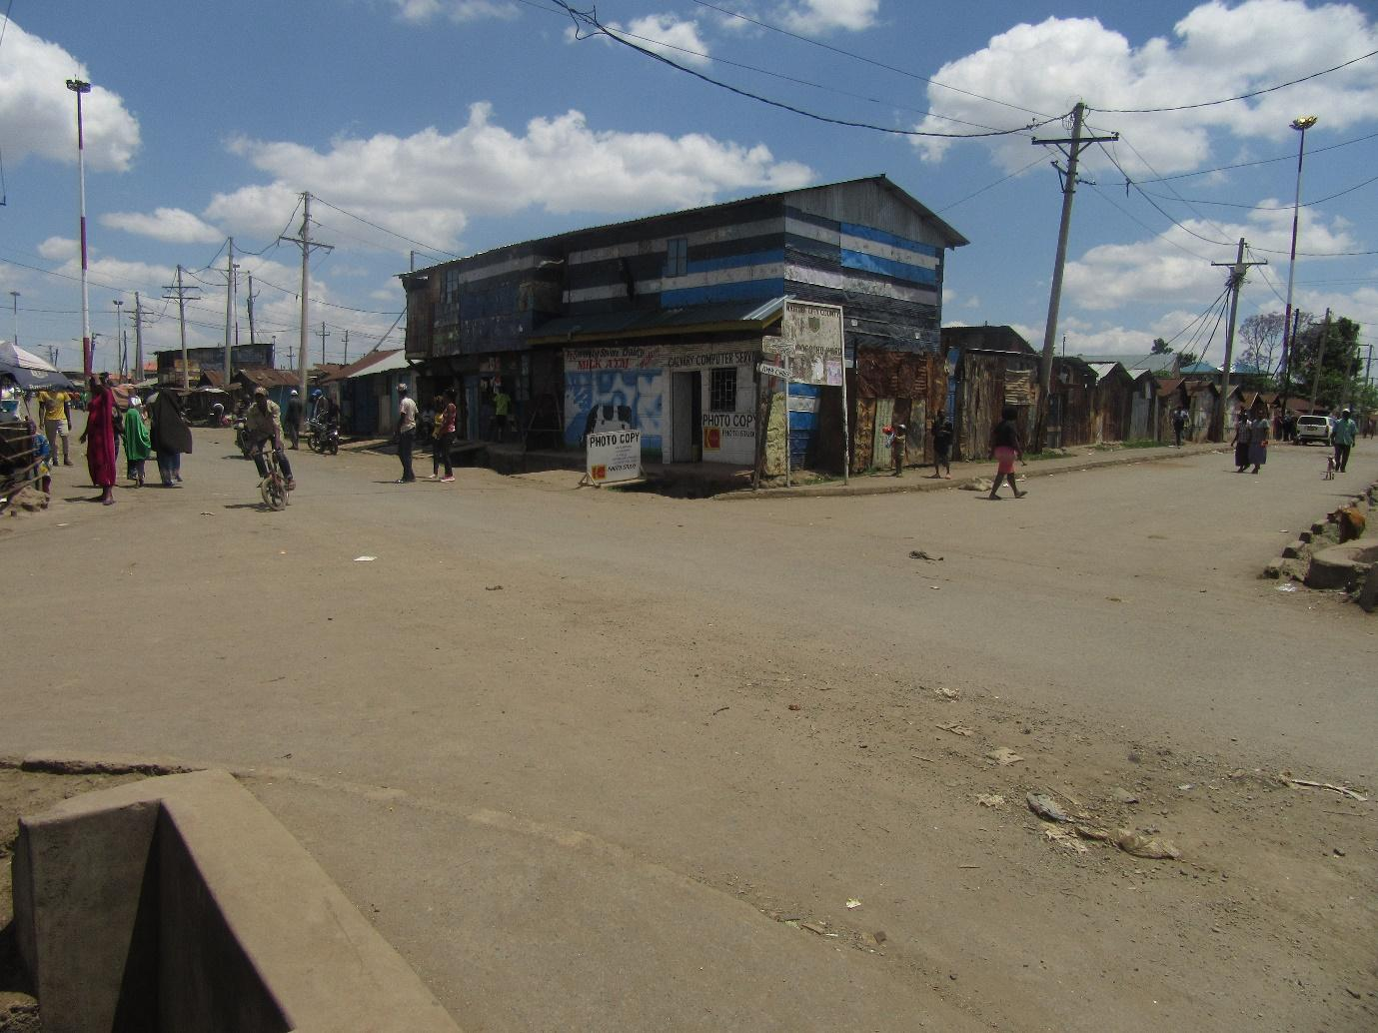
R9: I'm R9. When I took this photo, I wanted to show that here we don't have a problem with roads. Because when we look at the other slums, when we go to places like Kibera or other places, there are no roads, they don't have roads that go into the neighbourhoods. But here in our community even if we have other challenges, when it comes to this issue of roads, God has taken care of us.
M1: Okay, so the roads are in good shape? Here when it comes to roads we have been helped? Is that true?
All R: Yes.
M1: God has blessed us there?
All R: Yes.
M1: Then let's give God His amen. He hasn't heard, say “amen.”
All R: Amen!
M1: Thank you so much. I think we had highlighted the issues of roads earlier so we shall move on. Have we given her flowers? Let's give her flowers please. Thank you very much. Let's move forward, photo number 6 group 3.
Photo 6, group 3
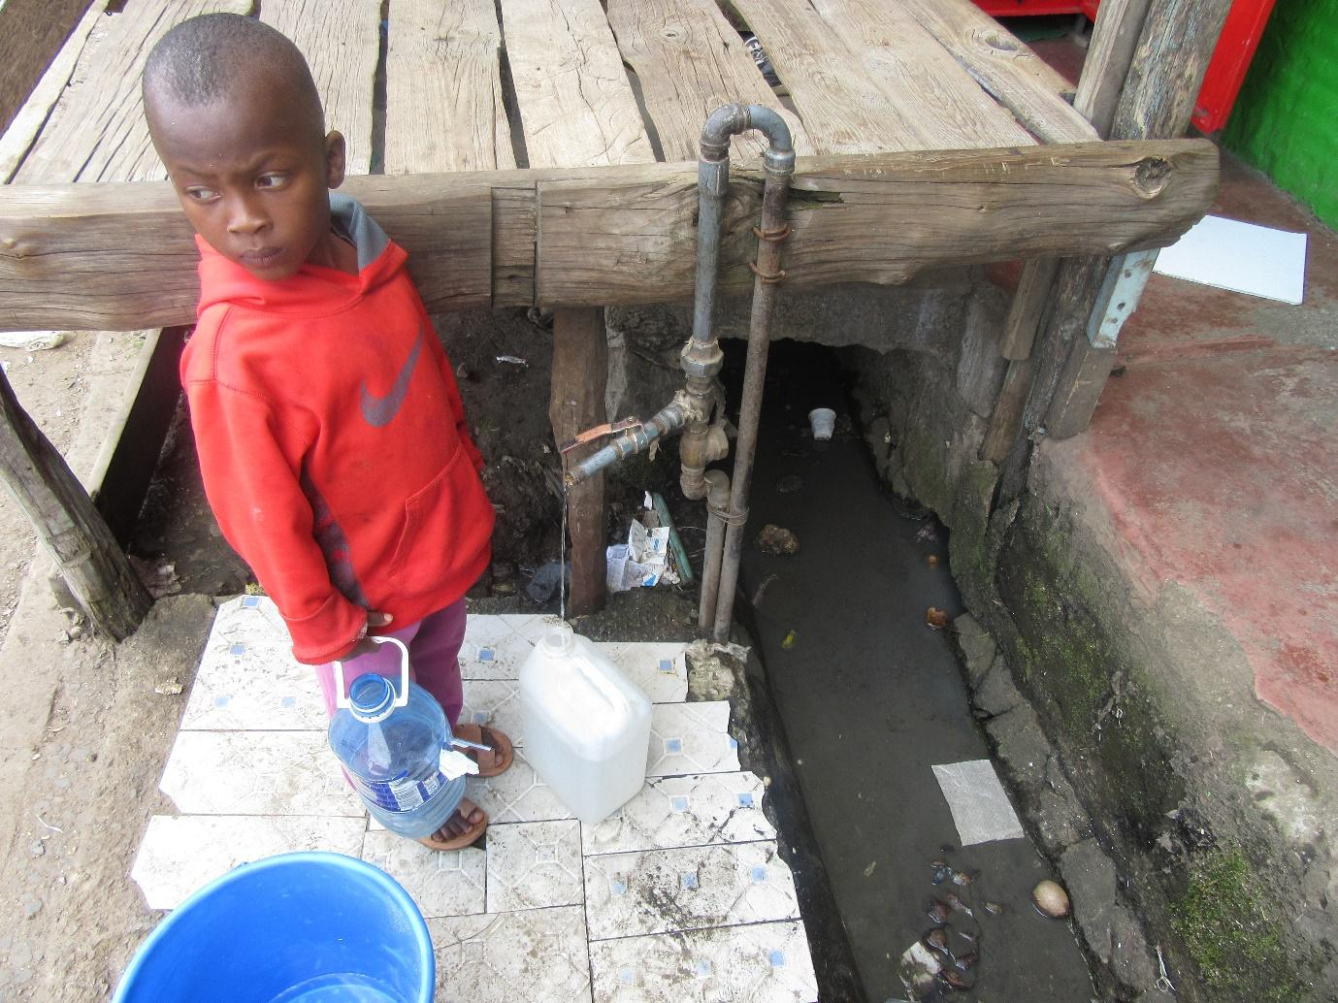
R11: It's me again, R11, from group 3 and I took photo number 6. So what I wanted to show here is that this is a child you see fetching water and the water itself you can see it's coming from here. But if unfortunately this container falls into the water as the children are playing, and it is half full, the child will get shocked because they've dropped and they will simply pick up the container and continue collecting water. So what I was saying is that here where we live, if we need water fetched, we should accompany our children as they do it because otherwise they will bring us dirt in the home and we won't know about it. So let's not be so lazy that we're sending a child to fetch water as we remain in the house. You should just leave both of you, you help the child fetch their water and start off as you also fetch in your container. Because this is a sewage line.
M1: Thank you very much R11. R11 has explained to us and even given us a recommendation, isn't it? So this has to do with sanitation and contamination which we had discussed at length. I would only have asked for recommendations but she has given us that as well. Let's give her some more flowers. Thank you so much. We're left with 2 photos so we're moving along well. Photo number 7, group 3.
Photo 7, group 3
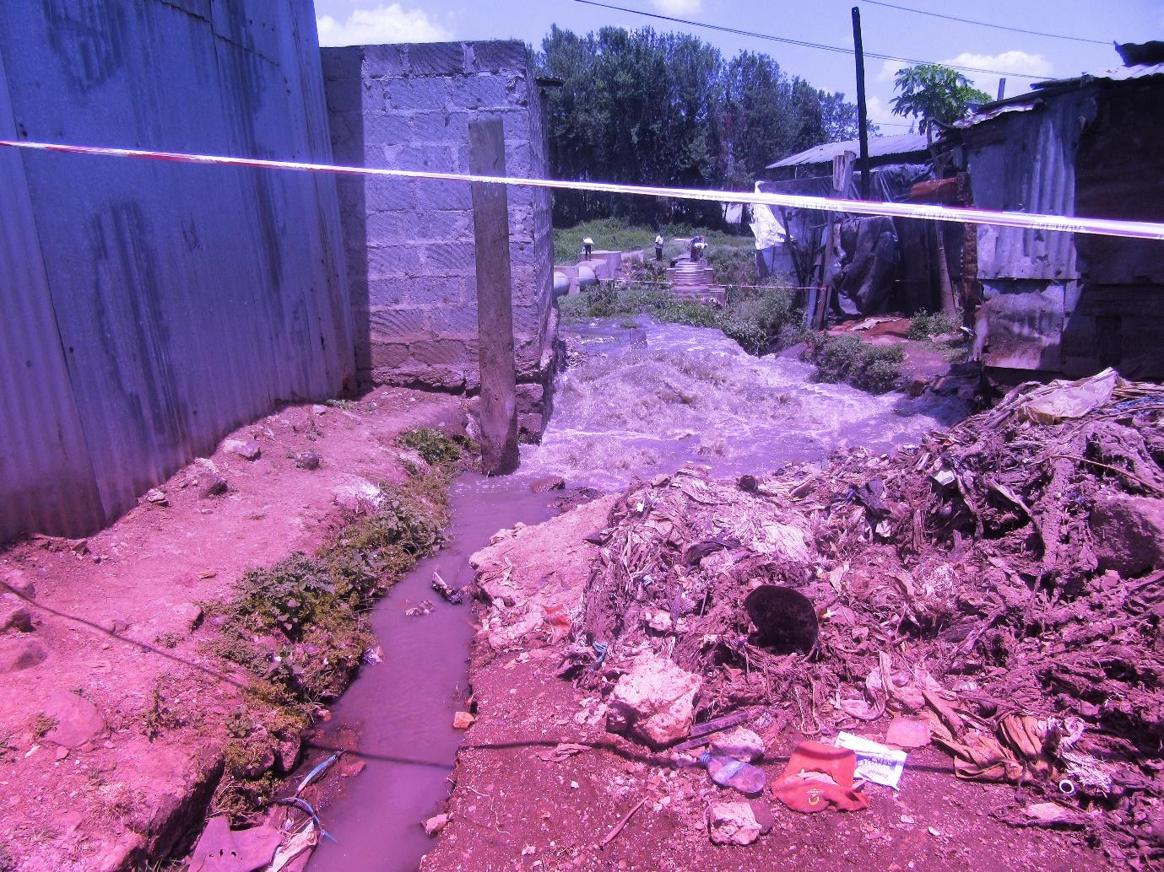
R10: I'm R10 from group 3. As I took this photo, this is a ditch that is used for rubbish. So I'm speaking about drainage. When the rubbish accumulates here, they don't go anywhere and these are people's homes.
M1: Okay, thank you very much. She has told us once more about disposal, about sewage, about sanitation, isn't it? It appears these are very common issues because they've come up a lot. Is that so?
All R: Yes.
M1: Okay, let's give her flowers. Okay, as we finish let's to our final photo, photo number 8 group 3.
Photo 8, group 3
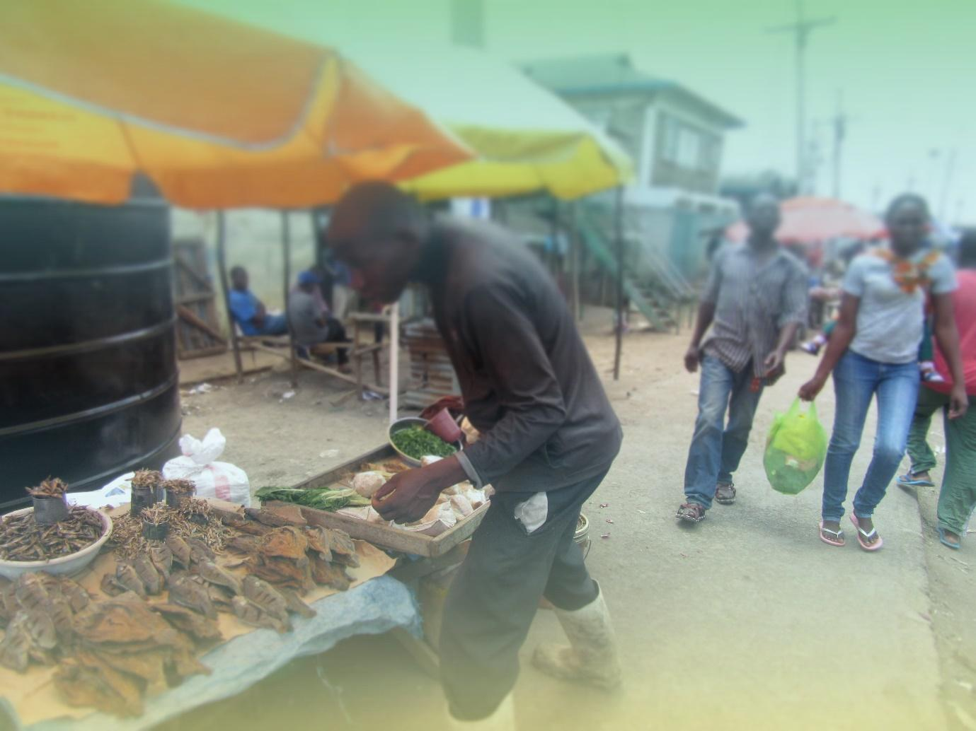
R12: I'm R12 and will be speaking about photo number 8, group 3. As you can see here, there's a vendor selling fish and here there's also a vendor. Even if the seller is clean, we don't know where the buyer is coming from and what they have come into contact with, right? So you may find that the buyer comes and touches several fish as they're choosing which one to buy which is inappropriate because we don't where they've come from and what they've come into contact with. Even if as the seller you're clean, we also need to look at the buyer. So with foods like fish, the seller ought to have something like a paper that they can give the prospective buyer to put over their hand as they're selecting their purchase because if they use the paper to touch different fish, they won't get any dirt from their hands, right? So we also need to consider that, looking also at the cleanliness of the buyer.
M1: Alright, thank you very much. Let's give her flowers please. Thank you. The issue that comes out there is the same issue of hygiene and how we handle food, isn't it? She has also given us a recommendation, so some good ideas there. So we won't dwell on that for long because it's something that we have already spoken about. But as we sum up all these photos before Faith can take us forward, the reality is that very many issues have come up, isn't it? You have seen that many issues have come up, right?
All R: Yes.
M1: But there's one issue that has come up the most, what issue is that?
All R: Hygiene.
M1: Hygiene is the number one issue. So if it was an election, hygiene would have become president, right?
All R: Yes.
M1: So all to say many issues have come up and it is a very good discussion. So I will hand over back to Faith and then I will come back to wind up.
2:20:39
M: Okay, thank you, some flowers for him. I have a question. I think there was a photo that we were discussing and we spoke about, we said that work is available, right? That if you go out in search of work you will get work, right?
All R: Yes.
M: Is it common to find that women are not going out in search of work? That is are there times when you can find that yes work is available, that if you go out you will find someone who you can assist, you will find a place that needs to be cleaned up and you can clean it up, you will find a place where there's a woman who needs her laundry done and you can do it for her and earn some money. We said there is work that you can do. So are there times you find that you aren't going out in search of work? What would make you not go out in search of work? R12 and then R9.
R12: what would cause us as women to not look for work, is that it also depends on our men. There are those who feel that their wife cannot take on other people's laundry as their job. They feel that they will be looked down upon by the people who live around them. So you find that the woman may have the desire to go out and search for work so they can get an income but then they can't owing to the strictness of their husband.
M: And will that man be able to provide for the entire family?
R12: Not all of them are able to provide for all the needs. In my view there's a sort of ignorance. Because the man thinks that those who are close to him will look down on him and yet they aren't able to earn enough.
M: Is it common to find that you're being told not to go and do certain types of work?
All R: Yes.
M: Okay, R9 and then R1.
R9: Another thing that I would add there has to do with responsibilities in the home. Like right now schools have been closed and I believe all of us here have children with special needs. So now you wonder who you will leave those children with. Yes you desire to go out and do that work but then when you look at those children, there's no one to leave them with. If your child is a bit troublesome, no one will agree to mind your child for you. You're forced to, you could even be called for work but you can't go because even if you go and then maybe the child wanders off and gets lost, you're the one who will end up in trouble or even if the child gets hurt in some way. So you're totally forced to hang in there and you may desire to go out and work but you wonder what you can do.
M: So when schools close, Light and Hope also closes?
All R: Yes.
M: Do they close for the entire duration of the holidays?
R9: They usually close after the other schools. The other schools can close and then ours go for an additional 2 weeks before they close.
M: Okay, but like now they're closed?
All R: Yes.
M: For how long?
R?: Until January.
M: Till January, so like now when they have closed, the children are home?
All R: Yes.
M: So either you will find someone to mind the child or you yourself will mind them?
All R: Yes.
M: Okay.
R4: I am R4. With these children of ours it is very difficult to find someone who will agree to mind them, it is very difficult. So even if you get that job of doing laundry, I can get it, I can be called for the job right now but depending on the child, you're forced to give up on the job and just mind your child.
M: Okay, R1 and then I will ask my question.
R1: Here's what I wanted to say. It will also depend. Because I won't wait for my children to lack food because their father is afraid of me being seen on my way to work and he gets embarrassed. I will organise myself, he won't know I went to do laundry and the work available to women isn't just doing laundry, there are many jobs we can do. You can think about it and do something. For example if you know that your husband doesn't want you to go and do laundry for other people, you don't have to tell them you're going to do laundry. Look for other work to do like making bead ornaments, manufacture soap and go out to sell, stop being idle. When you're idle is when you're challenges continue to increase. There's something you can do and still be able to put food on the table.
2:25:34
M2: Okay, I have a question. R9 told us that if you have a child with special needs as a mother you may be forced to stay with them so you can't go to look for money to buy food, right? So I have a different question. For these children with special needs, are there other challenges when it comes to food? Do they need special food or are they okay with regular food? I would just like to know a little more. For example this is a group for women with children who have special needs, right? If we had another group of mothers whose children don't have special needs, are there needs in your homes in terms of foods that are different? I had seen a hand- R12.
R12: Even if we don't consider the types of foods they eat, there's a way they ought to be fed. There are those who eat mashed foods. So like if it's me, I know that I ought to feed my child in this way. There are those who you feed and they don't eat fast. They eat little by little, slowly. As the child's mother, I will take time because the child is mine. Imagine you've left the child to someone else like at a daycare who doesn't have a child like that one. They will feed the child in a hurry and when they see the child doesn't want to eat, they'll leave them. So you see your child will be suffering as you go to earn money so that money won't benefit you because your child will be suffering.
M2: Okay, thank you very much R12. Let's move to R11.
R11: In terms of special foods, there are children who are on special diets. So for example they can't consume sugar, they can't eat anything made with wheat flour, and on top of that they use medication.
M2: I didn't understand that very well. Are you saying that when they consume such foods they need to take medication or are you saying that there are foods that they ought not to eat?
R11: They ought not to eat wheat and sugar and many other things and it's not that they use medication because they have used those foods, what I mean is that they're on medication consistently and they ought to take their doses.
M2: So what you're saying is that whatever money you have, you can't spend exclusively on food, you also have to buy medication for the child.
R11: Yes.
M2: Okay. Someone else? R1.
R1: Also, these children with special needs, you may find that they have a recommended food diet, they have medication- there are those who take on daily basis – and at the same time those children use diapers throughout.
M2: Now I want you to tell me one thing, because I don't want to make assumptions. I had assumed when she was speaking that the medication affects the food and yet perhaps that is not the case. I would like to know from the others as well, whether these additional needs that come with children with special needs, I want to know these additional needs, how do they affect the diet of that specific child, but also how they affect the diet of other people in the home, you understand? I want to hear from you. We haven't heard you speaking here.
M: I can give an example. R11 has said that sometimes they aren't supposed to eat wheat products. Since the child with special needs ought not to eat wheat, does that mean that the rest of the family can eat or will you decide that “we don't eat chapatis here.” R5.
R5: You're forced to find another way, say if you're eating chapati, you have to get them different food. So that costs more than what you had planned.
M2: Okay, thank you very much.
M: R2.
R2: That affects the whole budget for the home because they're not supposed to eat. If they eat, they become hyper and they end up doing things that they shouldn't. So it affects. It can even mean that the whole house you all stop eating that food. If you're going to eat it, the child can't be close by.
M: R9.
M2: I have another question, so let's have R7 and then I ask my question.
R7: I'm R7. You see now like my child, I can say I will buy mandazi in the morning. If they see the others eating mandazi and maybe you have bought for them even if it's brown bread, they will refuse it, they won't eat. So they will have to not be close by for the others to eat. But at the same time they will wonder “why are they separating me from the others?”
2:30:06
M2: She has answered one of my questions well. The second one, not yet, right? You told me here that if as a mother I have a child with special needs, I can't be comfortable leaving them with someone else, right? The child is mine and I want them to have the best so I won't go out to look for money. This child with special needs might need medication. Maybe they also need diapers. These extra expenses, do they affect the diet for the entire home or not? Let's start with R9, R12 and then we'll come to you R1.
R9: It affects because that child has to take that medication. The food you will give them, you will give them what you can because that medication is a must. They won't sleep like mine, and I can't leave them with someone else. Mine is one of those children who take other people's things so I can't even leave them with a neighbour. I would rather even tie their leg to the table but not leave them with someone else. Because wherever I leave them, they will spoil things so even if I had gone out in search of money, I will end up spending it to replace the things they have spoilt. So I'm better off not going out in search of income and just staying home with them rather than looking for an income that I will spend to replace people's things.
M2: Thank you very much R9.
R?: They can spoil things even if it's the father who is out earning. If you leave household utensils, you will be forced to (inaudible). So at that point everyone's budget will be spoilt.
R?: If I can add onto that, now when the father gets some money, and they know that when the child is in the house there's nowhere I can go, they then prioritise getting that medication. In fact they would rather not buy food for the house but first buy that medication because it is almost the most important thing because if the child misses a dose, we won't sleep. We'll be forced to go to hospital. And rather than going to hospital, the father plans himself so that the moment he receives some money the first thing he does is pass through a place to buy the medication before planning for the rest of the money that is left over.
M2: So in the home as you're looking at the needs, you first consider the medication for the child and the other needs come after that?
All R: Yes.
M2: Okay, thank you very much. Let's move to R12.
R12: Okay, sometimes you find that it affects everyone's diet in the home where for example the child has to use a diaper and the money is little. So maybe you had said “today let the children eat some meat.” You will be forced to forego that meat and have the children eat vegetables to make some savings with which you can buy that diaper because that child can't stay without a diaper. So that also affects the entire family.
M2: Okay, thank you very much R12. We had someone else. R1.
R1: If I also respond to you what I think I heard you say, I think you asked whether we can leave this child with special needs. These children are not all the same. There are those you can leave and it also depends on the attitude of the child's parent. Because if you feel like the child will be harmed if you leave them, you won't leave them. But if you will want to leave them somewhere, you will go to the person you want to leave them with and tell them about your child before you go and leave them. So if the person says they can manage the child, you can leave them for some time, say 2 hours. When you get back, you will be able to tell whether this child has been well taken care of or not. And if it's a daycare, then obviously even you in your mind you will have to understand that your child won't be the only one in that daycare. So you will just give a minimum- you will explain to the person to whom you're leaving your baby knowing that it's not 100%. So most of the time, we were being told recently at some other place that parents of children with special needs, we ourselves need to teach people about the nature of our children so that even if you leave the child with someone you can give them some space and also as you take that child to that daycare, since you're going out in search of money, the first thing you will do is pay for the daycare, those who have husbands the husbands will buy the medication, but if you're a single mother you can't say that you won't leave that child. If a centre like this one is closed, you have to survive because life doesn't know that you have a child with special needs. So you will organise yourself. For sure your budget will be affected. You will come and pay that 100 shillings at the daycare so if your earnings for the day were 200 shillings then you're left with 100 shillings. That 100 shillings is what you will budget for. And this is why you find that many parents have depression because they still need, we still need education in order for us to get to the place where we can leave the child, go for work and get back.
M2: Okay, thank you very much R1. Is there someone we have left out? Yes R9.
2:35:00
R9: If I can add on to that, it also depends on the child. There's a child who if you place them here, they will stay there until you get back and there's the one who won't sit still even for one minute. So this second child is more difficult to manage than the first. So like mine is like that and I also have a friend whose child just sits still. So we can even leave her child and go for 2 hours. When we get back, we will find them right where we left them. But my child, I'm forced that if I'm going somewhere I have to go with them because I can't leave them. So it also depends on the type of child.
M2: Okay, thank you very much R9. R12.
R12: It's what she's said.
M2: Okay, thank you very much.
M: Okay, I have 2 questions. One, are there times when you can take your child to the daycare and they say “no we're not able to take in your child?”
All R: Yes.
M: So you have to first get there and explain about the child and they either accept to take them on or refuse?
All R: Yes.
M: Okay. R1 you said that there are some jobs, that if there are some specific jobs that your husband has refused you to accept, there are other jobs you can do. The women's groups you spoke about, are you in the same one or in different ones?
All R: Different ones.
M: So in those women's groups, are there things you do to help one another find work or do you only help each other with food?
R1: I'm R1. There's somewhere we went and we were taught how to make flowers and that is not the kind of work that your husband would refuse you to undertake because if you make those flowers and get market they will be bought and even my husband will be proud because I am making something of value. There are jobs like beadwork. Those who are in groups know how to make those beads. Something like making beads is not something you're going to do for someone. You will make the beads and find your friend who can go and sell them for you in the market. Something like manufacturing soap isn't something embarrassing. You will make the soap and the people you're always with, I even wish I had brought some because you would have bought for 50 shillings, you for 100 shillings, you for 100 shillings and the child would've gotten some diapers. So that is the life we're saying there are things which we can do and you find that we're able to put food on the table. Because if I come and borrow 100 shillings from you, you can lend me today but tomorrow you won't do it again. But if I come and tell you “buy this soap from me, the child doesn't have diapers,” you will buy that soap and it will help you and then you will pay me money which will also help me and there'll be no place for my husband to be included in that transaction.
M: Is there a final comment? Would anyone like to give a final comment before we call [Name] up? Okay, [Name].
M1: Thank you so much [Name]. Let me first come to the front. We have come to the end, right? How are you feeling?
All R: Good.
M1: We still have the energy we started with?
All R: Yes.
M1: So we've come to the end. We've had some good discussions and I want us to wind up. But before we wind up, I want us to do 2 things. There's a small section remaining there at the end. We want to know how your experience was in the field. As we went through all we've done today and our experience today the whole day. And I want to give some work. I want to give my boss some work. Have you allowed me to give her some work? Have you allowed me?
All R: Yes.
M1: So because today the women have given me the power, [Name] please come. I want to give her work to wrap up that session and then I will come back and say my goodbyes.
M2: How are you again?
All R: Good. He has said I am his boss but it's because he wants to give me work, isn't it? From the time we started until now, I see you've been alert and we've had a long day, isn't it? So the first thing is to say congratulations, isn't it? I don't know whether before today there's someone who knew about Photovoice? Had anyone heard about Photovoice? No one knew about it?
All R: No.
M2: How have you found this process? How did you find it? I want to know your opinions. Yes R1.
R1: I think it is a good process because it has given me exposure. If I have an issue that has me hard pressed, and I have people who are my friends but I can't reach them, I can draw that picture and send to them and it will explain to them the problem that I am facing if I haven't already explained it.
M2: So you can take a photo and send it, you don't have to tell them? Okay, someone else. Let's hear one other person. What new thing have you learnt today? R1 now knows that if she wants to explain to me the experiences she's going through, she doesn't have to call me over the phone and start explaining to me. Perhaps I won't understand her. If she just takes that problem she's facing and take a photo and write down one caption beneath that photo and send that to me, I will know her entire problem, isn't it? Someone else? R4 I think you have something to say after R12.
2:40:41
R12: What I have learnt today is that no matter what problem there is, there must be a way to resolve it. Any problem, must have a means to solving it. So even if I have a problem in that I don't have water, I have to have a plan B to know that even if I lack water here at the plot where I leave, I can go and buy in such and such a place.
M2: Okay, thank you very much. You have heard R12? The most important thing is that even if you have come to your end, don't sit down and start to have a pity party, isn't it? There's always a solution. Okay, someone else who hasn't said anything today? I would also like, yes R4.
R4: What I have learnt is that much as we women are starting businesses where we sell food, hygiene is of paramount importance.
M2: Okay, thank you very much. And there is something else I would like to know. How has your experience been? Yes R8.
R8: The experience we got out there in the field is that there are some people who were hostile who would ask “how money will you give us?” Then for some people only understand their language, I know many of them are Kikuyu, so it meant a Kikuyu among us had to be the one speak to them.
(Group chatter)
M2: Yes R9.
R9: For example there were challenges where you get somewhere and explain to someone and they say “I know many things and I have never seen anyone bringing me anything so I don't want.” You would then be forced to give up on taking that photo because you couldn't take it at their place.
M2: Okay, thank you very much R9. R12.
R12: There's also a place we got to and provided they had spotted us with these labels and cameras, and they said “we won't earn for you your salaries as you come here to take photos for where you're employed. Am I your salary? Don't take my photo.” To the point where you would find someone covering themselves and turning away and yet you didn't have any interest in them. So there was some hostility.
M2: Okay, R11.
R11: There's a place we went to and we found people fetching water. So when they saw us they thought we're officials from Nairobi Water and Sewerage Company. So they started shouting “You close that tap” as they started to run away. So we told them we're not from Nairobi Water and we're not interested in the water all we're doing is taking photos.
M2: Okay, thank you very much R11. Another experience? It doesn't have to be a negative one, it can also be a good one. R1.
R1: The experience I got I saw that if you speak to someone concerning their business, there are those who welcome you until you feel that you're appreciated. So I found it to be a good experience. You first speak to someone, you respect them and then they give you a chance because there was one who even wanted to tidy up their place for it to be even better than what we had found.
M2: Okay, thank you very much. It's as though R1 read my mind because I wanted to ask you, now that you went and found hostility which would sometimes make you feel uncomfortable, what can you do, or what could we have done, or what can we do if we ever came back in future to avoid that hostility? These ladies have responded to many questions, I now want to hear from this side. From R2 to R7 here. What in your view can we do or when we send you to take photos, how can it be done differently in order for you to feel safe in the community as you take the photos? Let's hear these first and then we'll come here. R6.
R6: When you go to someone, just explain yourself and be humble. Greet them so they can see that you've greeted them well. Like the person we found there with the fish was about to run away but when we spoke to her properly she realised she was safe and allowed us to take the photo.
M2: But why was she running away?
R6: She was running away because she saw us with this labels and didn't know what was going on. But then we explained to her that we're being trained, please allow us to take a photo of your business.
M2: Okay, thank you very much. Yes, R9.
R9: Something that can help us avoid those challenges is a badge or a waistcoat that shows the people you're not coming for the things they're thinking about.
2:45:00
M2: So a badge that identifies you?
R9: Yes.
M2: Okay, thank you very much. R12.
R12: I wanted to say about the badge.
M2: Okay, who else, I had seen a hand. R2.
R2: Sometimes when you're doing something like this let it not just be like that. Perhaps they people can be informed that on this day we'll be doing such and such a thing in such and such a place so that they can be aware in advance.
M2: So more awareness for the community?
All R: Yes.
M2: Okay, and how can we get the awareness to the community, apart from TV, how can we create awareness?
R2: Hanging posters.
M2: Okay, thank you very much. So apart from those that she has told me, from the time we began this process, what else were you unsure of, maybe wondering when we sent you out to take photos “what photos did they send us out to take?” Or when you got back I saw some looking at others when we were making the posters like they were unsure what they were expected to write or do. I saw a bit of that. Next time if we came back and did the same process again, what can we do differently in order for you to feel like the whole process has become easier? Yes R9.
R9: Now we won't be the same way we were because we didn't know, we had never seen this. So next time we can't be the same way we were.
M2: Okay and for example if I took a different group how would you advise me? Would you advise me and say “with the other group, do this and that and the other or explain further here.” R4. Okay as R4 is processing let's hear R1.
R1: Here is what I would say. For the first time, even if it's a different group, before people have gotten to know one another because we hadn't know each other to an extent of knowing each other well, people have to have a little fear. Because you don't know what next. You don't know if when you take this camera and go with it and press somewhere by mistake and it locks or gets spoilt, you don't know what will happen when you get back. Or if you go and get robbed, you don't know what will happen so I think exposure is also good for people to have earlier.
M2: Okay, thank you very much. And I have also learnt something there that next time I should tell you what will happen if you get robbed and they take the camera so that you're also not nervous when you have it. Yes, R11.
R11: I wanted to speak about what you said if you get another group tomorrow that you want to go out what you would do differently, I would say they shouldn't go with these bags. They should come and get the bags later because now on the road people would see us and wonder “these people who have these things, what's going on?” So you would even get confused so that the photo you wanted to take, depending on how people looked at you, you decide not to take it at that place. So since you know what they're thinking you're doing isn't what you're doing, you just walk past. So at least they should leave these bags and come and get them later. (Unclear)
M2: Thank you very much R11. R12.
R12: You see most of the people know that when you're called for a seminar, you will go and sit down and take notes. Or what were you guys expecting? Were you expecting that you will go out there with cameras? We know that seminars are places where we go and sit and use pens and answer questions. So we were surprised to hear that after this we're going outside to take photos out there. So that also brought in some anxiety. So you're going and you're still asking yourselves “how will this go?” So you need to at least let people know. And for those of us who are here, we have learnt. When you're called to any seminar, you should be ready for anything.
M2: Okay, thank you very much. R4 you had something to tell us?
R4: I wanted to say that considering how we have walked some people were asking whether there is something small in order for them to allow their photos to be taken or whether you're the ones going to benefit at the end of it all, such things.
M2: Okay, thank you very much. I have another question. Now that you have come, taken photos, had a very good discussion with [Name] and [Name] and given us a lot of information, not that you have understood what Photovoice means, and you as caregivers or parents of children with special needs, if I came and did another Photovoice with you, concerning the issue of food, will the photos be different or will they be these same ones?
All R: They will be different.
M2: I want to hear from about 4 people, what would be different? If you're given another opportunity to take photos, what type of photos would you take? Let's start with R5 and then move to R10.
2:50:00
R5: First I would go to the kiosk if say it's a vegetable kiosk, I would go to the one that is properly arranged. You can speak to the vendor and explain to them what it is that you're doing and why you're taking that photo. Also what you're saying about that photo. So after you've explained to them all those things, even if they weren't welcoming you before, they would then welcome you so that you can then take that photo and not have to move to a different place to take a different photo.
M2: So if you were given another opportunity you would have more confidence to take the photos you want to take and speak about?
R5: Yes.
M2: Okay, thank you very much. R10.
R10: On my part, based on what I've learnt, if I were given another opportunity I would go into the neighbourhood and take some very good photos.
M2: Like which ones? Or photos that highlight issues such as?
R10: For example when it comes to food, if I look at a kiosk that is extremely well done, that is clean, I would take that.
M2: Okay, thank you very much R10. R1.
R1: If I were given another opportunity to speak about food, because I want that photo to educate many people, I will try and reach every group. So for example if I reach old people somewhere, I will be very eager to speak to them to understand what types of food they normally consume, if it is those children of ours that we have spoken about that have special needs I would like to know what special foods they use and have it there because if that photo was seen by someone from whichever place they would be able to know that children with special needs have special diets.
M2: Okay, thank you very much R1. Thank you all so much. I have another question. When we discussed these photos, you have given us a lot of information that is important and you would also tell us that such and such a thing can be done to such a person, isn't it? So these photos of yours and the voices that you have given them, because everyone has come and given their photos a voice isn't it? Who would you like this information to reach? Do you understand me? Who would you like us, as a research organisation, to show these photos to or communicate that information to? Speaking about the photo as well as the information you have given us, you have given us a lot of information, isn't it? You have told us about finding food, not having enough money, how having a child with special needs affects the diet for the entire home, you have told us many things. Who would you like this information to reach? Yes R11.
R11: I would like mine to reach the people at Nairobi Water and Sewerage Company to look at this issue of broken sewer lines next to people's homes. It should also reach the County Government of Nairobi so they can see how things are in Nairobi.
M2: Okay, thank you very much R1. R12.
R12: For me as I look, I see only issues that have to do with food, mostly and issues of sanitation. So the health officials need to be serious. And when they come, since we have also been informed that when they come here they need to come prepared, so when they come they need to be given security. So that this issue of poor sanitation for food can be resolved.
M2: So the people from the Ministry of Health can also be engaged?
R12: Yes.
M2: Okay, someone else. R1.
R1: Okay I would like for that to reach, if you can reach people who are able to, okay like now Light and Hope has been supporting us greatly. We have gotten wheelchairs, we have gotten other things, to use for our children who you have heard many have said they don't leave their children, so I don't know whether the husbands are the ones who are home today or who it is. So you will find that most of us have a challenge in that we want to go and do some things but we find that it's almost as though that child has tied us down. You're capable of doing something but you can't do it, not that you're unable but when you look at the child you have you find that they're still tying you down. So I would also like for that voice to also reach people if there are people out there who can support in any way because there are also children who require some devices and they haven't gotten them yet. These children of ours need schools for them because like here at our school they don't have teachers for children with special needs so if you come here you will find that we have mixed up all the children. We just bring them because they're well taken care of here. So you will find if a child has cerebral palsy they're in the same space as an autistic child, you can find a child who has spina bifida is very sharp, when they get in class, they can do wonders. You find that an autistic child has something they can do. You find that a child who has cerebral palsy can do something else. So you will find that here we have mixed up all the children in one space so the child will take on other disabilities and start to mix them. And finally you will find that it's almost as though that child is mixed up. It's as though they don't understand themselves and yet they understood themselves.
2:55:33
M2: Okay, so you would also like for these photos to reach people who support special needs children?
All R: Yes.
M2: Okay. Thank you very much, you have also given us examples. R2.
R2: I would also like these photos to reach policy makers, these parliamentarians, so they know these are slums there are things that don't reach the lowest citizen.
M2: So it should also reach parliamentarians, lawmakers so that as they make policies they can know that there are people who are lacking food. Okay, thank you very much. Let's hear the last person. Let's hear one last person. R7 you look like you have an issue. Who would like to help R7? R3? Okay, I have one final point. Who would you not like to see these photos? Which group or what people or who is it that in your mind you're thinking “I would rather this person doesn't see my photos.” R1, who would you rather didn't see your photos?
R1: Okay, maybe where we took the photos because if those people saw them they might think that maybe we wanted to take some action against them without their knowledge.
M2: Okay, someone else? R6, who would you rather didn't see these photos?
R6: I would also say the same as R1 because we requested them in great humility and they told us not to go and sell them out. Because if they were disallowed from running their businesses tomorrow, they would take us really badly.
M2: Okay, someone else? Okay thank you very much. I think what I would like to say is that when we share pictures or when we print them, if the photo has anything that would make it possible for us to know that this kiosk belongs to so and so, we don't print it or share it. For example, you can look at a photo and see that it has a name, isn't it? If a photo has a name, we can't use it. But if it's just a kiosk and there's nothing visible on it that can identify it, we can't see the face of the person selling and there's no image, that kiosk can be in Korogocho, it could be in Kibera, it could be in Viwandani, isn't it? If it's fish, and it's the fish alone the vendor isn't visible, isn't it even possible that the fish are in a kiosk that is in Nakuru?
All R: Yes.
M2: So we use photos that, and I'm sure when Faith was training you she told you don't capture faces when you take the photos. For example this photo here, if we wanted to use it, we will edit out the person whose face is visible. Because even if they're not in a kiosk they're simply passing by, perhaps they didn't want everybody to know that they're in Korogocho. So any photos that have people's faces or photos that have any identifiers, for example I can see that this one is written Light and Hope, we won't use. Because we want to use photos to do good work that is research. Isn't it? We don't want to affect anyone. I'm also sure that Faith told you that when we share your voices, we won't say that “this photo was taken by so and so who did this and the other.” Which is why even as you were introducing yourselves you would say “I am R1.” Isn't it? We will say this is a group of women from Korogocho. So you won't go and hear your voice somewhere that “I am [Name] and this is my photo.” You're understanding me right?
All R: Yes.
M2: So we're also using your new labels. Have we understood each other? We don't use names and we don't use identifiers. I am very, very grateful for your time and also for being patient especially now that you have said that and we understand that you have special needs children and you want to go and take care of them. So I will give the chair back to Osogo but from me, thank you very much and I hope that we will meet again, you're great women.
M1: Okay, thank you so much M2. Let's give her some flowers please. Okay, so with that we have come to the end, I want to (unclear) and then we'll have 2 or 3 minutes after switching off the recorders to get to know one another. So from me as well, I want to say thank you very much. Thank you so much for coming and for the good information and may God bless you.
RECOMMENDATIONS
- Hygiene:
- Vendors should make sure that their shops are clean and should also make sure they themselves are clean
- Instead of people buying food from kiosks they should go to the market on their own and buy their own produce and cook at home to ensure cleanliness.
- Create awareness about the need for cleanliness and tell the chief if a vendor has sold food that has affected people health wise.
- Makes sure food is well stored or covered.
- Vegetables grown on the sewage line:
- Sewage farmers should be arrested and charged with a criminal act.
- Our leaders can help by finding a solution to the opening of the sewers. If they made sure it is kept closed then the farmers would not be able to use that water.
- Lack of balanced diet.
- Create awareness about the importance of a balanced diet.
- Poverty
- Educate mums on the possibility of doing different job to be able to make a living.
- Poor sanitation
- We need to get good toilets made
- County government should step up to improve sanitation in the area.
- Water contamination
- Health workers should separate water pipes from sewer pipes.
PHOTOVOICE FEEDBACK
- Hostility from community who were asking for money.
- Communication Barrier
- Community was not cooperative
- Some water vendors ran away from us thinking we were from Nairobi water.
- We need training on how to talk to vendors politely
How can project be improved?
- Give badges and dust coats.
- Communicate earlier about what we will be doing on the ground to help us prepare better.
- We should have tags in the field
- Create awareness in the community earlier so that we can have less hostility.
Who should be given your feedback?
- Nairobi water to close the sewer lines and county government as well.
- Health officers so that they can be more serious with their work.
- Stakeholders who can come along side us to help make our lives better. Just like light and home helps us we still need special school for the children.
- Policy makers and law makers
Who not to tell?
- Street vendors who we took photos of. They may not take it well.

