AFRICAN POPULATION AND HEALTH RESEARCH CENTER
RIGHT TO FOOD PROJECT
ARCHIVAL NUMBER: 181012_0915, 181012_0918
CONTACT TYPE & DESCRIPTION: PHOTOVOICE–KIBERA (ADULTS)
DATE: 12/10/2018
START TIME: 8:30AM
END TIME: 12:00PM

M: Ok, welcome again to our Photovoice session today here in Kibera. First let me thank you all, since yesterday we have had a good time. I am hoping that today as well we will have a wonderful discussion. Yes? Yes?
ALL R: Yes
M: People! Why are we bored? Yes?
ALL R: Yes
M: So I want us to start our discussion for the day. As we had been briefed, we will start with photo one. So if we call upon your photo you will go to the front. You will introduce yourself. For example, you will say “I am R1 or R2”. We will avoid using our names as earlier explained. You will tell the group what photo you are discussing and what group you are from. I have said all this so that we all remember. So we’ll start with the first photo up there. Welcome!

PHOTO ONE GROUP ONE
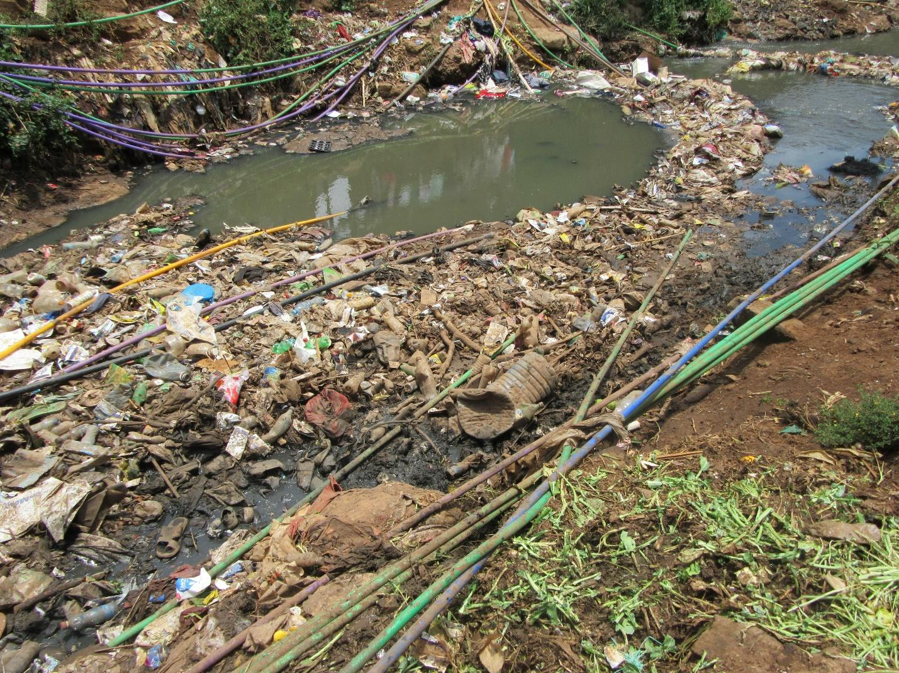

R3: I am R3, representing group one, Photovoice Kibera. In this picture we were trying to capture the pipes that have passed in between the sewer line. And the reason why we were trying to capture this picture and the pipes is because sometimes there are broken sewer pipes right next to clean water pipes that is used in homes to cook and clean. Due to the demand for water it’s hard for people to know whether the water they are consuming is good or bad. So they end up using that water without treating it. So you will find that on most occasions for those of us living in the ghetto water is cheap for example five liters is sold at one Kenya shilling and twenty litres at five Kenya shillings and cause we believe we are people from the ghetto we will just buy what is cheap not knowing that it has not been treated. If you look at the illustration on the photo it shows directly one side there are clean water pipes and on the other side there are sewer pipes and the broken pipes are visible and we are not sure when the broken pipes meet with the water from the sewer line they are both transported into the main water taps. It may come out of the taps a bit clear looking but it’s contaminated. It’s something that is dangerous for us as residents of Kibera because we don’t know how we can come up with a solution that can separate the pipes.
M: Thank you very much R3. You have mention that this situation hurts the community. How?
R3: It hurts us in a way that this sewer line when the pipes burst it’s easy for sewer water to mix with the clean water and enter into the clean water pipes. So when it enters it comes directly into our taps and it’s hard for us to know whether it’s contaminated water. Sometimes we are told water is not available and when it becomes available again the water looks dirty and we can’t be sure where the dirt is from. So maybe it can be one of the causes of the water being dirty when it comes back after not being available.
M: OK, so that dirty water that you say sometimes comes in through the taps, if someone uses it in the house what happens?
R: What happens if they use that water they can get sick, like diarrhoea because we believe if someone drinks water that has not been treated they get such illnesses. They can also get cholera and it becomes something hard for Kibera residents to know where the illnesses are coming from.
M: I would like to open up this discussion. R3 please remain standing. He has said that when people use the contaminated water they get the illnesses he has mentioned. My first question is this. The situation he has explained of the pipes passing the same place and people using that water and being affected is it a true reflection of what you have experienced?
R12: Hi, I am R12 and his is an issue we have gone through it is very common as you walk through Kibera, you can find many pipes passing, many are leaking and it is normal, they are very many. So it is a common issue. You won’t find that someone is surprised “have I seen a leaking pipe somewhere?” As in it is a normal thing to see some pipes passing, some pipes are leaking and others are fine. It is a normal thing to see every day.
M: Okay, who would like to add something? R8.
R8: I am R8. It is a normal thing because finding these pipes passing next to sewer lines or leaking is not a surprising thing but a normal thing and for many people you find that they can’t treat the water either by using treatment aids or by boiling so you find they use it just like that and by using like that you find that often times that’s how typhoid becomes a real problem and disturbs the community greatly. So it is an issue that is there.
M: Thank you. I also want to ask: this situation of contamination as we have been told and those effects that we have spoken about saying that sometimes you find that people contract diseases, this entire situation is there a way in which it is connected to food security? And if so in which way? Who will contribute? R3 do you want to go first?
R3: I would say it is connected to food security because number one in like 100% of the food we eat water is utilized to cook, you see, so you find that even if it’s this sweet, there is water that’s used inside for it to become a sweet you see? So it is something that is 100% connected to food security because it’s very hard in this community of ours to find food that is cooked without water. In fact maybe you will find they say it can’t be fully cooked, you see? Unless maybe if there are people who roast meat at least they can avoid this issue of water a little bit but the high percentage of the food we use even beyond Kibera you will find they are utilized with water. So this water even if it is out of well preservation you find that it affects us, yeah.
M: Okay, thank you very much. Anyone else who would like to make a contribution? R6?
R6: I would add to that and say that also if the water has become contaminated, sometimes it can adversely affect food that was clean. For example someone could have gone to the market and bought kales that are clean but before cooking they wash it with water that is dirty. At the end you will find that their food is contaminated, not that the place where they bought the food it was dirty but it got contaminated by water that was dirty that they had in the house.
M: Okay, thank you very much. R8.
R8: okay, water can also be food to some people. Because you may find someone has totally lacked food but what they can access is water. So to me, water can be food because they don’t have anything else to eat. They can only afford water as their food.
M: Okay, R4.
R4: As R4 I would like to support that by saying that there are many people who are going through challenges in life here in Kibera, isn’t it? Because you may find that maybe to buy that food that doesn’t utilize water is difficult for example roast meat, isn’t it? But when we find people living in Kibera you will find many times they consume foods like porridge, like ugali, and all these foods use water. So it is a must that it affects them in their lives. Thank you.
M: Okay, R12 and then we can carry on.
R12: As we speak about food security, we must also speak about the quality of that food. So that we’re not just saying “food availability” but also that it needs to be good quality food. This means that we aren’t just looking at the fact that food has been cooked. Or simply looking at “I have food.” But we are also looking at the quality of that food. So that whether you are eating meat, or you’re eating ugali or you are eating vegetables it isn’t just that you have eaten and you are full but let it be that the food you ate was quality food. And that quality is measured by the different ingredients that have been used to prepare the meal. And since water is a major ingredient in that food, if the water is contaminated, no matter how delicious the food is, or how good, or even balanced, it will be a balanced diet but not a balanced diet that is good quality.
M: Thank you very much. Before we continue, I think my colleague wants to say one or two things?
11.00
R(?):What I wanted to ask, I have seen that later there are some questions that are connected so when we go through them we can address them together.
M: Okay, before I release R3, before I release you, you said at the end as you were describing the picture that you don’t know how you will change this situation. I want us to speak about this situation briefly. So, and this is to all of us not just to R3, as people of Kibera, whose responsibility do you think it is to ensure that this situation is changed and how would you like it to be changed? R3 you can sit. Yes, R4.
R4: For me, what I would say Is that the government has responsibility to change water usage because if they can be successful to construct pipes transporting petroleum products underground, it means that water pipes as well there is a possibility they can give instruction that no pipes should pass through ditches or through rubbish. They should only be allowed to pass under the ground through the soil.
M: Okay, thank you very much R2.
R2: As R2, as I speak concerning poor sanitation and the manner in which pipes pass through sewage what I can say is that there are programs that I saw as if someone has started here in Kibera, people from [place]. So that now pipes aren’t passing underground, he has built so that they are elevated. If that is what the government can help us do that, building so that pipes are elevated, it will be helpful to avoid consumption of contaminated water. That would be my contribution to this.
M: Okay, I would like someone who hasn’t spoken. R7.
R7: What I can contribute concerning how we can get clean water as an important element in food security is that it is a must that change begins with us. Before the government has intervened or before we have cried for government to help us it is necessary that we also have the habits that are beneficial to us. There are procedures we can put in place for example boiling water before drinking, making sure we boil our water. Another thing is that there are chemicals such as chlorine that we can add to ensure that the germs that are associated with impure water are got rid of. Yeah, those are some procedures that we can start as citizens or inhabitants of this area before we have started to ask for help from the county or the government. Because you know, government issues also go very slowly. So now these procedures that we can put in place that are immediate are the ones that can save us from water borne diseases.
M: Thank you very much. So we have been told that there are recommendations of what government ought to do and what we ought to do ourselves. Is there another recommendation? R12?
R12: Sd R12, what I can suggest is that if you look at water supply here in kibera, you look at who are the owners? Because as these pipes pass, they are owned by some people. These are private suppliers who get water maybe from Nairobi Water and Sewerage Company and then they supply within the community. So I think that there ought to be a partnership between the county government and these suppliers and they ought to be given rules and regulations. If you intend to supply water use pipes of this type, those that don’t break easily or metallic ones. So that we prevent leakage of those pipes because these people are the owners, these private owners who supply water within the community. So they ought to be the first target. If Nairobi County is giving them water, they give them a policy that before we supply you with water as the county government, let us see your method of transmission of this water in the community.
M: Thank you very much. In order that we can move forward, R3.
(16:01)
R3: I would like to add a brief contribution. Like if we want to help this (inaudible)We can start with those who install these pipes themselves and have them pass close to the sewer lines, we need to address them first. Because they do it as a business and they want profits and I know of many rich people who live here in kibera who survive off this water business. So as we come up with ideas such as elevating the water pipes, they will feel like their business is being taken away and given to someone else. So if say we’ve said give the government the responsibility of elevating tunnels for the pipes to pass through it will be something that for someone who has established their water project will see their business profits dropping. So if we can organize to get people like these business owners first we speak to them and let them know the importance of why we would like to implement such a thing, we say to them a,b,c,d, is due to this, that and the other which is why we want to do this. But if you just come at it abruptly, believe you me they will start having conflicts with us because they will think we’re going against their business.
M: Thank you very much. As we finish with photo number one and move on, R3 I would like to come back to you. Since you’re the one who took this photo I want to ask you, when you were taking it and you wanted to show us what you have described about contamination and sanitation, are there other photos that you would perhaps have liked to take to show the same thing that you were unable to take?
R3: Yes.
M: Explain to us what the image looked like.
R3: Okay, like opposite where I took this photo, there was something like a kiosk belonging to someone who sells kales, tomatoes and so on. Right next to the kiosk you could see stems from kales have been disposed. You see, so like right next to this rubbish is where this person is running their business. So you find that the moisture that comes from the sewage, perhaps 50% or 40% when it comes up, that dirt and moisture, it comes to the place where they are selling from.
M: Okay, let me ask. Why didn’t you take the photo?
R3: I didn’t take it because I was following the directions I was given.
M: What directions?
R3: That I was supposed to capture two photos of something specific that I want to communicate.
M: Okay, thank you so much R2. I would like to move us forward. Let’s go to the person who took the photo at the top written photo number two. You can see it? It’s on the same chart. Yes.
PHOTO TWO GROUP 1
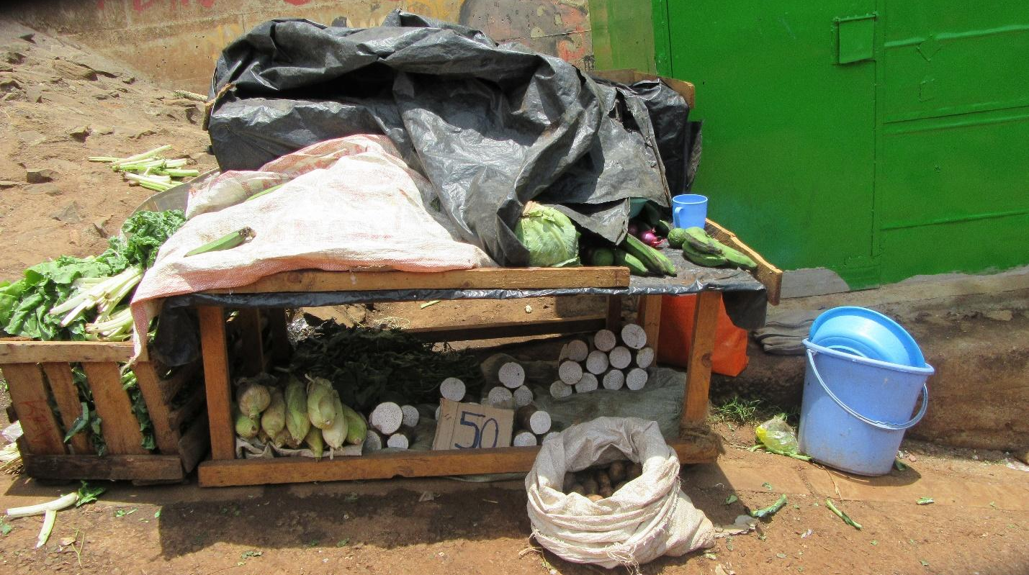
R2: Okay, as R2 from group one, I would like to look at photo number two concerning the fact that vegetables are exposed directly to sunlight. On this we found that as we were taking photos, we found that the vegetables have been laid out next to the road and as the vehicles are passing, dust ends up on the food. So the food is not safe for eating. You will find that the food has dust and such things cause diseases. You find that you eat food and find that your stomach is getting upset and other such problems. So the best thing I can say is that if a selling point like this one, if they can build it so that it is closed, so that even when a vehicle passes dust is blocked, it would be better. That is my view.
20:00
M: Okay, thank you very much. You have mentioned that since they are exposed they get dusty and can cause diseases. What types of diseases can be caused by this situation?
R2: You will find that the way they are directly under sunlight, dust and dirt, the food is not safe. You find that it becomes contaminated and can cause diseases such as typhoid.
M: Okay, thank you very much R2. I want to expand the discussion slightly and ask the group members. This situation, is it normal, is it common? Is this your normal situation? Is it something that is there?
All R: It is.
M: Who can contribute? R9?
R9: This occurrence is there because you find that someone has chopped their vegetables, it is in a basin but has been left uncovered. You will find that I’ll come from wherever and buy those vegetables and after buying, I won’t go and wash them. I will go and start to cook them. And my guests will eat the food. So sometimes the guests leave the house and start to complain that they have stomach aches. It would be automatic that it is the food they ate at someone’s house. They would start to ask, how did they cook their food? Whereas the real problem is that it is the vendor who has stored their food poorly.
M: Okay, thank you very much. I would like before I come to R4, I go to R1 and here is what I want to ask you as well as the rest of us: R2 has brought us this photo that shows exposure and has also connected with the issue of contamination and issues of disease, right? While discussing the first photo, we spoke in depth about issues of sanitation so I want to ask as follows: apart from sanitation, how sanitation and contamination affects food security, because we have already discussed that, this exposure, the way the vegetables are exposed, other than sanitation, are there other ways in which this exposure impacts on food security? That’s what I would like to know. We’ve spoken about sanitation. But in regards to this exposure, are there other food security issues that come into play other than sanitation? And what would those be? I see R1 preparing, R5.
R5: I am R5. My contribution to this would be that the way those vegetables are exposed to direct sunlight, the nutrients are adversely affected by the sunlight. So even by the time someone will consume this food, they will find that yes they’re full, but they didn’t get the nutrients.
M: Okay, thank you very much. R4, thank you.
R4: I would also say that, you know, vegetables carry vitamins, right? And when they are directly exposed to sunlight, those vitamins are reduced because the vegetable cease to be fresh, right? Also, you find that by the time you eat it you will find that you eat to be full but physically you are not healthy. You are not healthy because we believe that when you eat vegetables they are supposed to fight infections that are in the body. But if you eat vegetables that are directly exposed to the sunlight then it means that there’s no benefit to your body. You’ll simply be full but at the end of the day there really won’t be much gain for your body.
M: okay, thank you very much. R5 and R4 have spoken at length concerning nutrients and nutrition. I would like to get another issue outside of nutrition and nutrients. R1.
R1: Speaking into this outside of sanitation, foods like these that have been exposed to dusty conditions you will find that there are those who will buy. The seller was looking for income. So you may fail to buy because you see that the food is exposed and you’re unwilling to buy dirty food. That would in turn mean that the seller misses out on their income for that day which means it will have a negative impact on them economically on that day.
M: Okay, when this person is adversely affected economically, they have missed out on their income, how does this connect with the issue of food security? R11.
R11: For me as someone who has worked in kibera, there’s one final question that I’ve asked, we try to answer and then I make the contribution I would like to make.
25:00
M: okay.
R11: When someone misses out on their income, as they were expecting to get from the vegetables or food they were trying to sell, it will mean that this person won’t go back to the market to buy fresh supplies to bring to the neighborhood. So people will lack food. You can find that there are times when there’s lots of food in the market and at times the supplies are low. Because if people fail to buy food due to lack of income they too will lack money to buy the vegetables the vendor is selling. So this also has a negative impact on the amount of food available in the market. I would respond in that way. As a specialist/consultant, I have worked here in Kibera. I have observed that when food is exposed to sunlight, for instance mangoes, tomatoes, these foods that ripen fast and go bad it means that we find a lot of food in the market that is highly perishable. So you will find that within a short time, such as when we were walking yesterday, you will find that there were many tomatoes in the market but people are throwing them away. So it will be good for us to find ways to collect those foods and store them appropriately because we know that there are different seasons. There’s a season for tomatoes, a season for onions, a season for mangoes. But once the season passes, because there is oversupply at the market, the food gets spoilt due to poor storage and it’s thrown away. And then afterwards we speak of famine. This means that for us as a country, God has given us arable land, we need to figure out how to store food for use at a future date. That is the main problem with exposing foods to direct sunlight; they get spoilt and once they run out we have no way of getting access to them until the next season.
M: Okay, thank you very much. I don't know if there's anyone who would like to add something before we proceed? Anyone with something to add? Okay, I would like to ask a question before we continue. We have spoken about nutrition here and I would like to know when the nutrients are not available as we have spoken about how does this impact the issue of food security? R12.
R12: Nutrition and food security are totally connected because as we were discussing the previous photo we said that let's not just have food in plenty, let's not have quantity while lacking quality. Because we can have food in plenty but it is food lacking in the nutrients that we require. So it could even be that we're eating mangoes but they're mangoes that aren't beneficial. It could be vegetables but vegetables that don't add value. So as we discuss food security, we're speaking about food that will assist so that everyone who will access food, will actually access food that is beneficial. So let it not just be that we have food but it is food that is not beneficial. Let it be that food is available but it is also food that to the person consuming, it is beneficial. I think that is food security that we have food but also we have food that is of good quality and that can help sustain a life.
M: Okay, thank you very much. I want us to carry on, let's listen to R4 and then we can carry on.
R4: I can also say that the high percentage of people in Kibera, many are HIV+. When you are infected with HIV there are foods that are highly recommended, isn't it? And if there are highly recommended foods, then it means that these foods are supposed to be of proper quality, right? This means that if the foods aren't of the necessary quality then you're working in vain which is why we're saying if you have been prescribed for certain foods to consume, I know very well that someone who is HIV+ doesn’t consume meat. They consume foods such as cowpeas, African nightshade, fruits and so on. So if you come to the market and find that these dishes are banged up, are drying under the sun and so on, you will get discouraged and feel like it’s the end of the world for you.
29:56
M: I would like to ask this; we have spoken about several things. We've spoken about nutrition. We’ve spoken about food going to waste. What shall we do? What can be done and who needs to do it in order for that situation to change? To avoid contamination, to avoid food wastage, to avoid nutritional loss as we've spoken about. How do we avoid having this situation that is portrayed in this picture? What needs to be done and who needs to do it? I would like to hear someone who hasn't spoken a lot. R10, what do we do in order to avoid situations such as this one? As R10 is processing, let's start with R3.
R3: I would say that the solution lies with the vendors themselves. And it comes this way. Let's say for example we want all vendors with selling points in Kibera, what do we need to do in order to find them? We can have a training like this one. You guys have knowledge of what they need to do as they're selling in their kiosk. Now if we took this knowledge and imparted it to them and say to them, from today, we would like you to handle your vegetables in this way. As your constructing your kiosk, make sure it has some shade. You see? At the end of the day that is where they earn their living, I would look at it from that angle. So we can't ask them to stop vending entirely. But how do we help them to do it properly? We sit down with them, we teach them that by food security we mean this and that and the other. I believe if you walk outside and you’re selling sweets like these, you put it on a plate and cover it, it will also attract people to come and buy. But if you just toss them about it's different. So if we give them such information and ideas they will also begin to process and in their minds they will see how it can be attractive to bring some more customers to whatever thing they're doing.
M: Okay thank you very much someone else. R7?
R7: R7, my contribution is that the government needs to understand about those people, they are productive and creative and they're willing to help themselves and to improve their lives.
M: Let me interrupt you a little bit sorry I would like as we move on because we look to the government many times we know that we have two levels of government the County government and the national government. I would like for us to be a bit specific and say whether it is both levels of government or whether it's the county or a Ministry in the national government. We need to understand who it is in government who can assist. R(?)
R(?): I think about the County Government should walk together with the ministry to come up with programs to make sure that the foods that can be processed say for example if there is an oversupply of tomatoes the people of Kibera can know that they are tomatoes that are too many they can take somewhere being assisted by County Government so that it can be processed into something else. For example tomatoes can be processed into tomato sauce which can then be sold in supermarkets or others can be processed for export to other countries. This would also bring an income to the traders. So instead of having food wastage unnecessarily they can be processed and value added, working through groups from among members of the Kibera Community making it possible for them to earn income.
M: Okay thank you. Perhaps a final contribution before we move on R6?
R6: You can look at the possibility of increasing durability of the product in the market. We can think for example is it possible to bring those engaged in that business together and train them on ways to preserve their products together. For example, is there an option of constructing refrigerated warehouses that can be self-built simple homemade technologies? They could build that and each person finds they have a section in the house where they store their goods and they only bring out what they need to sell at a given moment. What they don't need to sell remains preserved for a long time and refrigerated.
M: I would like us to proceed I want to move to R2 when you were taking this photo I would like for us to proceed and before I'm done with R2 as you were taking this photo and it has taught us many good things, is there perhaps another photo. You would have liked to take and that shows us the same lesson but were not able to take.
35:08
R2: Okay as I had said you will find a road right next to the vendor. The road is the likeliest source of contamination for the food to not be safe for consumption. So I would like to take the road a photo of the road but I couldn't because cars were passing so that's what I would have liked to take to show that the food is not safe because of the dust settling on the food and the fact that food is exposed directly to sunlight, yes.
M: I would like to move us forward. I would I would still like to appreciate someone when they finished talking so I would like us to appreciate R2 and R3 so we're going to do flowers so that we don't make noise. Do you know flowers? Let the flowers go, send them flowers, prepare, send them, thank you so much. So as we move along I would like us to look at this picture the one who took this photo number 2 on the board please come forward tell us what your number is and what picture you are presenting yes.

GROUP 2, PHOTO 3.
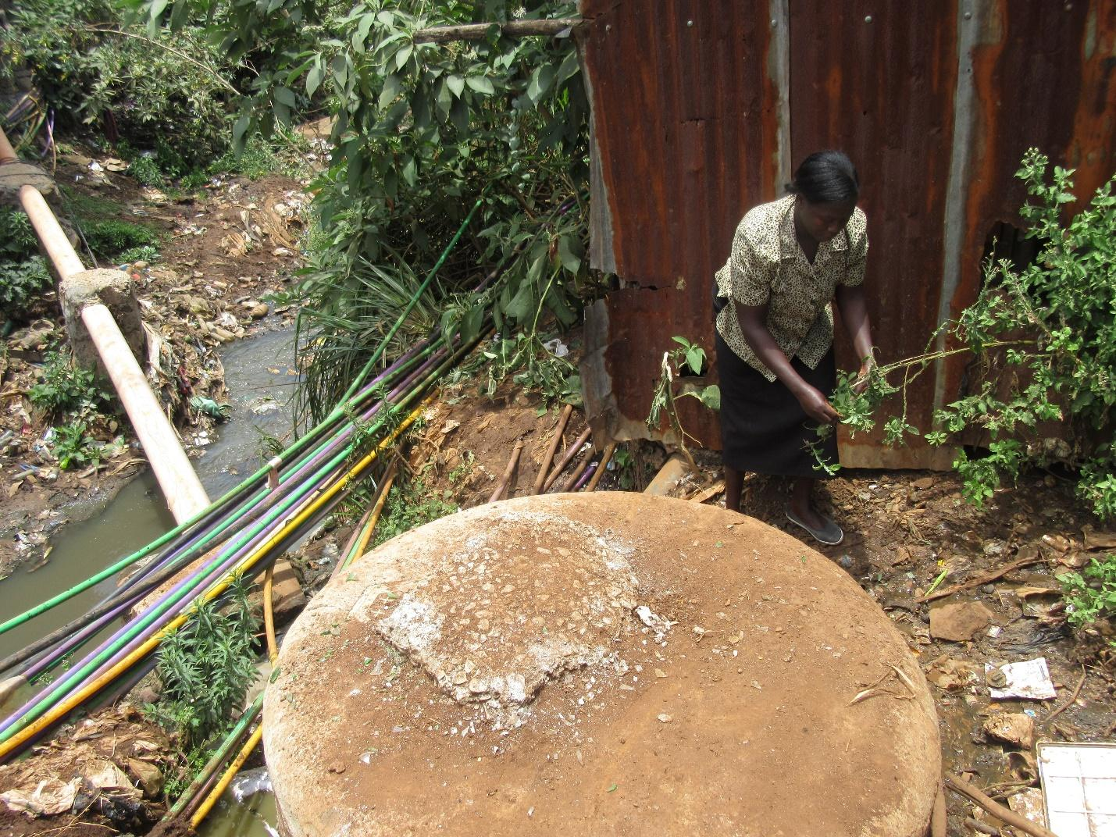
R9: I am R9 and I'm speaking about photo number two. I took it because this picture where I took it there is a house, that is a house and there's a sewage next to it.

M: R9 so let me interrupt you briefly. Please clarify which photo you're speaking about number 3? Okay
R9: I'm seeing this is my house and these are vegetables that I have planted in my backyard and this is a sewer line. And this sewer line is leaking. When I pick these vegetables I take them to the road where I sell them. These vegetable are hidden behind my house and when I leave here with them to sell no one will know that I collected it next to a sewer line. And when I wash it well I will take it by the roadside and I will sell it and make some money and come back to the house and buy flour. These vegetables might affect other people out there. But this sewer line is installed and now it is leaking and those who installed it have never passed by that sewer line to check whether that sewer line where they installed it is it still functional or is it leaking. At the same time this is a water pipe that passes here this is water that we drink and these are vegetables and this is my house and I have children in that house. So the vegetables benefit me but they might hurt other people out there. So I can make a profit from these vegetables and I live in that house but the government does not know that I am hurting other people out there. So I have come to this group seeking assistance on what I can do to avoid hurting other people out there.
M: Alright thank you very much. Before we help her I would like to ask: that situation that she has described concerning those vegetables is this an issue that's affecting us here in Kibera? R7.
R7: It is an issue that is there and not just in Kibera but in most of the slums. There are many vegetables that I see on my way to Marikiti that are gleaming and seem to be very healthy but in reality they have been grown along sewer lines. Now you see this issue is real. You find that the elements that come from the sewer lines get into these foods that we eat. So whether it's kales or spinach you eat or when you prepare these Foods in the house you are eating the elements from the sewer line such as lead and so on that even effect and cause brain illnesses. So this is an issue that is openly there in the community.
40:09
M: Okay thank you very much. You have said that it is an issue that is openly and clearly there. This situation where vegetables have been planted in that manner and are absorbing those elements, how does this affect the issue we are discussing about food security, the issue of right to food? Who can explain to us? R1.2
R12: That photo has to do with food security because when you see vegetables planted next to the sewer line it shows the link, that there is a need for food and it shows the extent to which people are willing to go simply to access food. We know where vegetables ought to be grown we know in which ways vegetables should be grown. We know what the places that are appropriate to grow vegetables are. However when you find that vegetables have been planted next to the house or next to a sewer it shows that there is a big need for food in the community but there isn't enough land to grow the vegetables. So people go to any extent to obtain food. That shows that there is a shortage of food that is needed to sustain the community.
M: Thank you R12. Let’s hear from R1.
R1: I would like to emphasize his point that there is need for food so when there's such a need you find out when someone proceeds to plant their food in such a place they are aware that they will find customers. Because there is a need for food wherever they're able to plant food and take it to the market they know it will still be bought.
M: Is there something you'd like to add R10?
R10: In my opinion I would say (inaudible) this person has chosen to plant those vegetables as they have so that they can find an income. But in my opinion I think that some people with the sewer as it is some people continue to (inaudible). I would ask for assistance for these people who grow this food to be given places where they can grow it so that where land has been lacking resulting in them growing food where they are, that can be resolved.
M: Okay because we have started speaking about assistance I would like us to speak about assistance briefly. This issue what can be done for there to be an improvement and who bears that responsibility? R3.
R3: Okay what I would say is that judging from the fact that vegetable in the time back there was a project where people would plant vegetables in sacks. Even if it was close to a sewer line it wouldn't be affected by the sewer water. The vegetables would be fed by the clean water coming either from a pipe that has clean water. Maybe we can find those people who can bring that project back to our community that project of growing food in sacks and explain to us clearly how we ought to grow vegetables it would be helpful to us. Because if you walk through the neighborhood you find that that project has died out. But a long time ago you would find that someone lives here but almost a half or a quarter of the house is surrounded by sacks in which they're growing vegetables. And it would be fresh vegetables that would be very delicious.
M: Taking over from where R3 has left off, in regards to the project he has mentioned, whose responsibility is it to ensure the resumption of the project? R7.
R7: What I would like to ban is this issue of saying we would like them to come and do for us. It is important and good when it comes to some issues that we implement them ourselves. You can't all the time be seating idle asking for assistance from outsiders. It is important to exert ourselves to help ourselves. That way, even those who might come to assist us by the time they come they'll simply encourage us or assist you. When someone comes and sees your effort, it's much easier to get assistance then. My friends the thing is that we ourselves need to help ourselves. The issue of say sack gardens we can do it ourselves. We can start off small scale but then you'll be eating healthy vegetables. So this thinking that let people come in and assist us is an issue that we need to combat.
45:21
M: Thank you very much. R4.
R4: I would also like to say that even in our class there are things that you learn isn't it? So if my lesson is agriculture then I will grow food. But if my lesson is not agriculture then I will not come and grow food. So those who started the project it would be helpful if they come in trained us again because they have the know-how. Also, those who bring those projects and those who implement them let them be assisted so they can nourish the community.
M: I would like to know those who had come up with that project of growing vegetables in sacks who were they? And where did they go?
R3: I can recall those who started this project in the neighborhood call themselves keeper Tech. It was an NGO. They were doing it in partnership with another NGO call CDC. I'm not sure what to CDC means I just know that it was CDC. So they would come and ask you if you would like them too give you that plantation. And you would find out there was a way that they could convince the house owners or maybe they would convince the landlord's so you can find that at the end of the day the entire plot belonging to a landlord each tenant would have a sack where they can grow vegetables. But when the project began to diminish the vegetables ran out. I'm not sure what happened.
M: Okay another question there. For us as members of this community when a project such as this one is introduced and the donors have started of the project what is our responsibility to ensure that even upon their departure the project proceeds? What is our responsibility? R5.
R5: The thing we ought to do is that anytime a project is introduced in the community and this is a project that will bring transformation that will change lives I think it is good for us as members of the community that we embrace it. Because it is not good to always be dependent and expect to be given fish every day. It is good that you learn how to fish so that you know you'll be given these nets and you can fish for yourself. I think that is where we're lacking. We find that we just want to be recipients. But we need to learn those techniques in order that even when the donors have left we can hand over the projects to the next generation we can still be learning and we can be self-sustaining even without the donors.
M: I would like us to proceed. But before we wind up with that picture R9 this was your image and it's a very good photo. Might there have been another photo that would have shown us the same thing but you did manage to take it?
R9: There was another photo I would have liked to take but what he has said about growing food in sacks I was one of the people involved in that project. But where I was growing the vegetables the people who came and they would complain that you're trying to encroach on their land. So you would leave and when you came back would find that your sacks have been toppled over. So you start to wonder I don't have a garden I'm simply trying to grow some vegetables for myself but then now I had to leave, let it go. The place where I had put my sacks I came and found that someone has planted bananas so I would have liked to take a photo of those bananas where they have been planted but I wasn't able to take it. The landlord came and said I shouldn't take the photo.
M: Thank you very much. I would like us to give her flowers. As we proceed I would like us to consider this image, Photo number 4. Here in group 2 who is the owner of this photo?
49:49

GROUP 2, PHOTO 4.
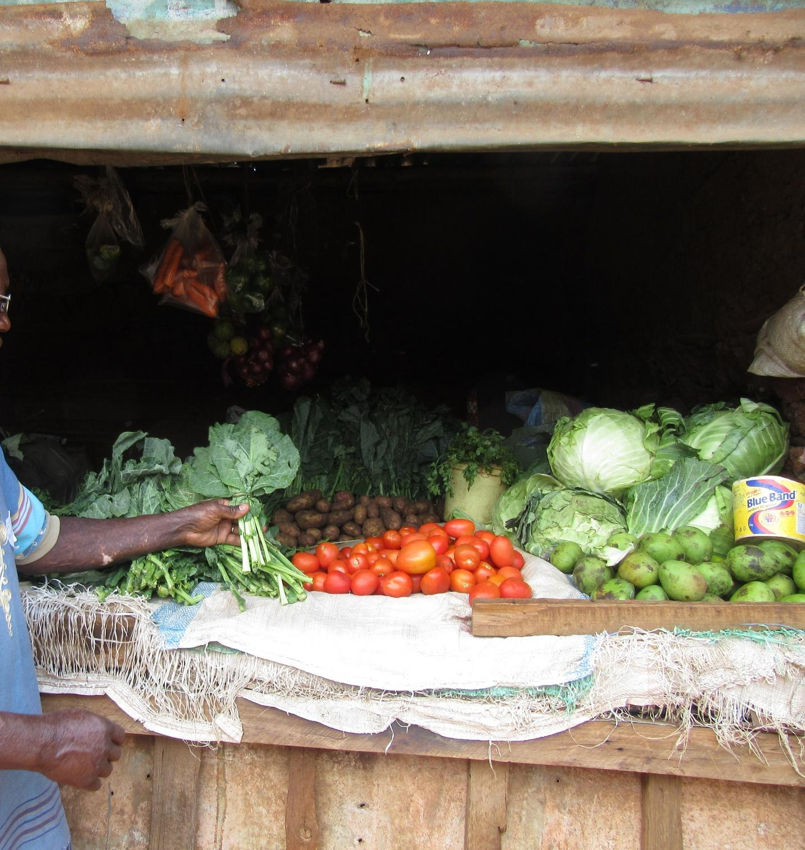
R11: I am R11. The image you see in here is vegetables that give health. There are cabbages there are tomatoes there are kales and many others. As we were taking this photo we were looking at the market. There are times when you find that the market is full of food and the food there is food in plenty. But if you look at how this food is kept together the cabbages are in one section those that perish quickly and those that last long have not been separated. They're not stocked separately according to the nutrients they offer. So what we wanted to communicate here is that there are times when the market has food in plenty but because there is no way of preserving the food you find that they're being sold at throwaway prices. You buy tomatoes for five Shillings and are given 5 Tomatoes free. Maybe you buy kales for five Shillings and are given additional kales free. So what we're trying to communicate is that we have the ability to produce food and bring it to the market but because we lack means of preserving the foods we are forced to put them all up for sale at the market at the same time.
M: Thank you very much are 11. You have spoken about having food in plenty and good food which is then sold at throwaway prices. You have also mentioned that the challenge is there is no place to store and preserve the food. I would like you to expand a little bit on that issue and how it effects food security and the right to food.
R11: Thank you for that question. As we were walking around taking these photos we found that many of us have gone to the supermarket and found mangoes that have been dried. There's something called Baobab seeds. There are traditional ways that we can use to preserve these foods. The first that we spoke about in terms of having good quality food and adequate food supply we thought about tomatoes first. I had traveled somewhere and found that people take things such as bottles and dry tomatoes even without use of chemicals. There's a way in which you can dry tomatoes in sufficient heat and dry them. Without even necessarily producing tomato sauce and they can be converted into a paste. The paste is then placed inside a bottle. The paste would be mixed with something I'm not sure if it was salt and then be stored. At that point the tomatoes would last longer and serve you for longer. When it came to mangoes we saw that instead of simply dumping them in the market and they can be chopped up dried in the sun which would mean that they don't get spoilt and will last long. They would then be available for use at a later date. When it comes to cabbages if they're getting spoiled people could be taught how to boil them a little bit and then finding ways of storing them. If such skills are taught to us I think we would be able to implement them.
M: Okay R1 thank you very much. I would like to move the discussion along. R1 has informed us that the photo in itself has been taken and shows that there are times when there is plenty of food. Is this a true reflection, is this something that happens? Are there times when there is a lot of food? R13.
R13: There are times when food is truly in plenty especially after harvest. So you find in the homes during the harvest season everyone will have it and will be taking their produce to the market. (Inaudible) so if the food could be preserved and used at a later date it would be helpful.
M: I would like us to focus on our context here in Kibera. I want to know here in Kibera are there times when food is truly plentiful in the market? R8.
R8: It is true that there are times when you will find plenty of food in the market. You can go to a kiosk and you find that the magnitude of vegetables in a bunch is high. You find that even tomatoes which usually will cost 5 Shillings you can find that for that same amount you buy more tomatoes. So there are seasons when food is plentiful.
54:51
M: I have a follow-up question. You have informed me that there are times when food is in plenty in the market. Here's my question are there times when food is very scarce in the market? R4?
R4: There are times when food becomes scarce because just as we have been informed by R11 he has said very well that food is in plenty but there is nowhere to store it. So when the supply comes to an end or when the food goes bad we then end up with a scarcity of food.
M: Now let me ask this when you see that there is plenty of food and you also know the times when food is scarce I would like to know in those seasons when food is plenty what is it that happens for that situation to arise? What is it that causes the fluctuations that sometimes there is oversupply of food and sometimes there's food scarcity? What happens?
R12: What causes the oversupply of food sometimes and then scarcity of food at other times is the source of the food. Here in Nairobi there are very few places where agriculture is taking place. What this means is that Nairobi residents are dependent on other counties on the outskirts of Nairobi to supply food. What happens is that those counties or those areas outside Nairobi when they have a bumper harvest they bring the supply to Nairobi and there is oversupply. So here in Kibera and in Nairobi at Large we don't have much agriculture so we are dependent on agriculture happening elsewhere. So if there's a bumper harvest the food supply is plentiful.
M: All right I can see there are many contributions. Let us go to R3.
R3: Okay what I would like to say is that in most locations what you find is that the government also contributes to the oversupply or scarcity of food. For example before the handshake issue that was a lack of food. You would even find that stores such as Nakumatt crumbled, you’d go there and find out there was no food. Even simple products you would not find. This was simply because our top national leaders were not in agreement, you understand? So you would find but it was hard to access food for example you would find that you have a hundred Shillings and here in the neighborhood if I have a 100 note I should be able to access food but at that time the reality was I couldn't access food. Maize flour alone could not be found for that 100 shillings so you find that to some extent and it does sometimes also contribute to these challenges. So like right now the handshake happened and the price of maize flour should not be sold for more than 75 Shillings, you see? So now food is available. If you go to my home you will find that I have stocked up on Maize flour and so on.
M: R3 I would like you to clarify for the benefit of those who will be looking at this data, maybe describe for us a little better what you mean by this handshake.
R3: Okay when I speak of the handshake walking what I mean is that before the reconciliation even you guys were able to see as you're my fellow Kenyans you are able to see that things were not working out. Also the lack of peace had a negative impact on our economy. Not just in terms of supermarkets only but even in the markets people were not showing up for business.
M: So when you speak of the handshake walking what you're referring to is the reconciliation that happened?
R3: Yes.
M: R8
R8: Another issue that causes this fluctuations is that you find that depending on the season and there are different foods that flourish at different times. So for the foods that flourished during the hot season if it is rainy they will not perform well. The crops that flourish during the rainy season and you find that if there is plenty of rain then those crops will be in plenty. So for example it has been quite hot and sunny which is why you see plenty of tomatoes.
M: I have two questions very quickly. I will start with something R8 has mentioned that there are different seasons and this means that sometimes food is available and sometimes it is not. Apart from seasons is there another contributing factor to these fluctuations in food availability? R7.
R7: What I would say to contribute to this issue of food availability and oversupply and food scarcity is that government policies also contribute. I like now the government has really tried to highlight and focus on issues of infrastructure. Good roads have contributed to the ease of transporting goods so that foods can now be transported from the rural areas and other neighboring counties to be brought to market in Nairobi. So now you find that with improved roads and as the president has spoken about the Big Four infrastructure access to good Quality Healthcare so that people can work and lead productive lives.
1:00:19
M: Thank you very much. We have talked about health in relation to food. This time he mentioned something very important in relation to food security. R3 talked about access and he used that term and he said when there was political tension we did not have good access to food. Yes? So which means there is food somewhere but we here in the slum cannot access it because of the political problems we have mentioned. I would like to ask apart from political problems what else can make us not have access to food. R4?
R4: Another issue is tribalism. You know many people here in kibera go to the market to buy certain foods. If the find at the market that the person supplying the food is from Kamba land or is kikuyu and I find that I don’t get along with him because I am Luo it means I will not buy food from them but if it happens that he is the one with the good food that should be eaten in the hood but because I do not get along with them I would rather buy elsewhere.
M: Yes R8.
R8: If I can back him up sometimes we also have Bridges or gaps for example if we go to the market you were told if you want to get good tomatoes you will get them from where a Kisii is selling. If you want fresh bananas you will go to a Kikuyu. So you find Kikuyus will sell to other Kikuyus. If you want to buy from them you have to say two or three words that they understand. If you speak in the language then they will feel like you’re part of them and so they will be willing to sell to you.
M: Thank you very much. I want to Recap so that I bring us together when we look at this issue of food security we have talked about access to food, We talked about politics making it hard to access food we also seen the tribalism has an impact, Another thing that makes access to food difficult?
R13: Lack of peace
M: Yes, lack of peace.
R13: Sometimes you find that you want to buy vegetables but the place to buy vegetables is sofa and getting there is not safe.
M: Thank you. R8?
R8: Poor transportation. For example you might find this food somewhere but because of lack of transportation I am not able to get to the food. Poor transportation also plays a big role.
M: Okay. I would like us to continue. Because I don’t want us to forget we have said poor transportation, Politics and tribalism Affect food accessibility. What can be done? To ensure that these things do not affect food security? What can be done?
R3: Before I give a solution I also wanted to add nepotism as a reason for food insecurity. You find that we Kenyans don’t want a Mexican mind and in real sense we Kenyans are dry completely. We find ourselves suspicious of the Mexican mind, saying it’s has been done for certain things. Just recently we had conflict because of mercury sugar. I personally have never come in contact with mercury sugar but there were rumors all round about it. So you see it adds on to food inaccessibility.
M: Alright. Thank you. How can we tackle the issues to do with food inaccessibility?
R4: First of all is to find out how to get unity. Because if we get unity and get rid of bad politics....
M: Whose responsibility is it?
R4: Us as residents of Kibera we know that many of our youths are talented in different ways so we need to bring them together to do what they feel can help them. And if they come together it means if R3 is Luo and can be in agreement with a Luhyah or a kikuyu at the end of the day you will find that they are working together doing something that will be helpful to them. For example singing, playing football and also the more they interact in these activities you will find it starts to expand into businesses and encourages working together.
R8: I feel the way forward is to love each other which is the greatest commandment, stop tribalism and become one people. We are all made in the image of God no matter our differences and tribes we should just come together and embrace our differences.
M: I would like to take the final comments before we move. I would like someone who has not talked. R6.
R6: I also think that politicians should also come in to help us because we only see them during campaigns. If politicians continue to use politics to divide us it means that if a politician tell people from a certain area not to take their produce to another tribe’s area it means that tribe will not have access to that food.
M: Okay, thank you very much. We have said that here in the market sometimes certain foods are available and at other times the food is not available. When it comes to the food instability what can be done to reduce the instability?
R1: I would encourage the residents of Kibera to join groups that can help them set up greenhouses so that they have access to food all the times. Things like vegetables.
M: Thank you.
R2: What I would say is maybe we should look at way that we can preserve food that we have for future use. For example if we can find a way to store what is in plenty so that in the season it is less we can still have it available.
M: Another question. When it comes to preserving whose teapot is it to ensure that things are preserved?
R12: Responsibility comes in two ways. One there is the responsibility on the part of the consumer. If they have a given amount of extra food you can come up with personal means of preservation. Secondly, in the community for example community based organizations, they are many of them within Kibera. If those community based organizations as well can be empowered with technics of preservations. So we will have preservations at two levels at the community level and also at the household level. So that lady that buys vegetables for 60 Kenya shillings and only wants to use 20 Kenya shillings worth of it the rest she will not throw away and the community at large will benefit.
M: Any other recommendations? R3?
R3: My recommendation is that we can do a food campaign in a way that maybe we can have some banners made. After we have made them we can identify various destinations where we can place them. For example let’s say this is Kibera we can have banners that talk about food preservation and even if they won’t be there permanently at least for the time being when someone comes they can see and a procedure can be shown on how they can cover their food it can help.
M: alright, thanks a lot R3. I want us to move forward, unless there is someone who wants to add something? ….. Ok. Let’s give flowers to R11. Now we will discuss photo number one of group 3. The owner of the picture you are welcome. Before we continue, we are progressing well? Are we all ok?
All R: yes.
M: Okay, technical personnel please alert us when it’s time up take a break.

PHOTO ONE, GROUP THREE
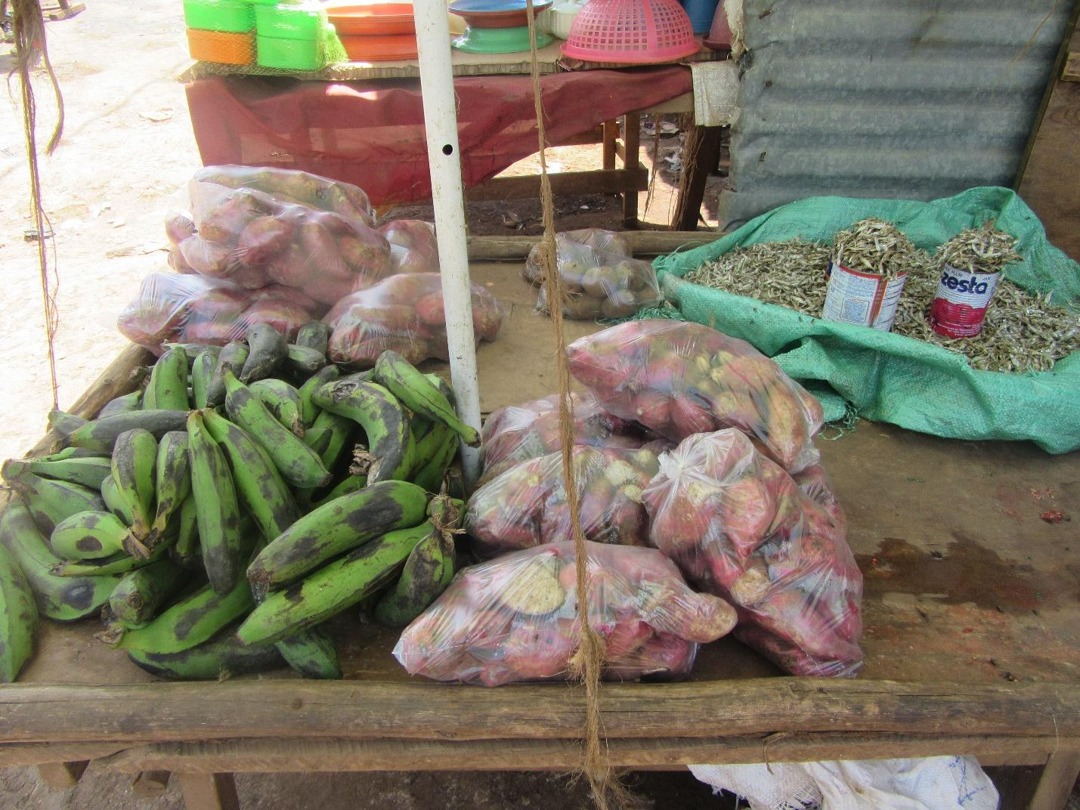
R6: I am R6 from group three and I am talking about picture number one of group three. Which is about if you can see it clearly, it has a variety of food. We have sweet potatoes, we have potatoes, bananas, and fish. In this picture I wanted to show the availability of food and the variety. Yes we may be in a slum and people may think that some things are not available and they can think that things for example potatoes are only found in the village cause that is where they are planted but even here in the slum they are available and I was able to take up the owner of the shop and I found that her selling price was not too expensive to the point at which even someone with little money can be able to afford this food as well so it’s not only people with a lot of money that can afford the food . Something else that I noted is that the things were packed depending on price. If you wanted a small amount within a small budget you could get it and also if you wanted for a higher price you could get it as well so I felt like it was able to accommodate a variety of people. Thank you.
M: Thank you R6. R6 has highlighted some good points. He has mentioned the availability of food but we will not take too much about that since we have discussed it at length already. But he did mention something else in relation to money. He said that the food is available depending on the amount of money one has. I would like to know is that the reality on the ground here in kibera? That food is available depending on how much money you have?
R2: That is the reality here in Kibera because you will find that food is packed in such a way that even that person who has very little money can access some kind of food.
M; Thank you very much. Anyone that would like to add to what she has said? R7?
R7: I would like to agree with her that for the venders in kibera they have been able to read the community and have packed the products in relation to people’s purchasing power. He in kibera it is highly unlikely that you can sleep hungry. Even if you have 20 Kenya shillings you can buy maybe five potatoes and bananas and have a meal.
M: I would like to discuss what R7 has said that here in kibera it is unlikely that one can sleep hungry. Is that the reality? Are people really not sleeping hungry? R4?
R4: When it comes to sleeping hungry there are actually many people who sleep hungry.
M: R4 let us pose there. Now we have a debate. R7 has said that everyone can access food so people do not sleep hungry but R4 says there are many people who sleep hungry. Can I hear one last comment? Are there people who sleep hungry?
R13: for me I would say it’s not possible because even if you just drink what you have not slept hungry.
M: Alright , then my question is some people are saying some people sleep hungry while other are saying sleeping hungry is highly unlikely. It has also been said that food is accessible at little amounts and so people can access it so why are people sleeping hungry?
R12: There is food but there are also people who sleep hungry. That is the question? This would be my answer there are people here in kibera who have no way at all of getting money and that is the first contributing factor so it means that if they will not go out or someone come up them and give them food and they have completely no source of income then for that person even if the food is made as cheap as possible they still can’t afford it.
M: I would like us to look at other contributing factors. R4 you have said that people do sleep hungry. What is the longest period someone can stay hungry? R13.
R13: Usually one day but what can really cause someone to stay hungry is if you remain silent in your home and don’t tell anyone. Talking to someone and telling them you have no food can at least help the situation. So you can borrow some little money. Even if it’s just 10 shillings. Because usually mothers will send their children out to school and when in school they will get something to eat so it’s maybe only the mother who may not be able to find some food.
M: Thank you. I want us to continue the discussion on people not having food for long peoples of time. Many days what is another contributing factor? R2.
R2: Okay, you will find that someone will decide that they will not eat lunch so that they are able to get some food for supper. Lunch they can decide let the children go and play, maybe they will eat at the neighbors because they can’t afford to feed them lunch so they look for some money to buy for supper.
R4: In my opinion I would say. Breakfast is not a must. Lunch is a must but sometimes it can also be 50/50. At night is when the food is very urgent because the night can be long when someone is hungry but also if the food is not available they may also come and just sleep. This situation can end up lasting for a long time. Till it has become something that people are used to. So that be operate in such a way that if they find the food it’s accidentally.
M: R4 has said breakfast is not a must. I am using his words. Lunch he said is 50/50 and supper is the big deal. The question is this the real situation here in kibera.
ALL R: Yes.
M: Okay, R8? So we are in agreement that that is the situation here? I want the recorder to pick that answer. All in agreement say “aye.”
ALL R: Aye.
M: So to my last question before we hear from R1 I would like to know are there situations where people can fail to get food completely in a day? Is it possible?
R chorus: Yes
M: And is there a situation where people can fail to get food for like two days?
R12: The situation of someone not getting food for two days is a possibility but at a very small rate. We can’t completely rule it out but even if it’s there it’s at a low rate compared to those skipping meals.
M: There is something I want us to discuss but first let us hear from R11

R11: Mine is a bit different growing up because I lived here and the other thing we experienced during that time was that there was cultural influence. Someone would say they cannot eat certain things so you may find that even if there is food but not food they culturally eat they would say that they can’t eat that food at all. So also I think it’s important to have education on food nutrition and value rather than looking at certain food as tribal and seeing them as alternative food options because during rain flying termites come out in plenty and for us we would eat them if we don’t have meat. You just fry them and cook them with Ugali and some of us also used to eat grasshoppers. We used to go to a place here behind. It used to be a forest called “foree” some of you might remember. People used to come with basins and jugs to collect the grasshoppers when they come so also people being taught alternatives to food. Because there are people who believe that if you don’t eat ugali then you have not eaten. So someone may say they are hungry but it’s because they have only eaten rice. So it’s a perspective on what satisfies me depending on how I have been brought up.

M: Thank you so much. I think we are getting into a nice discussion about food. What do you think? So I want to ask this. We have heard about perspectives but there is on perspective that I want us to focus on, about money. R12 said for some people they can’t even find that 10 or 20shillings for food. I would like to know if you look at money to what extent does money affect how we eat here or how we get food. R2

R2: Like here in Nairobi everything has money value. If you don’t have money then you won’t be able to get food or water. So it forces someone to have to look for that money. And people source for this money in different ways. That is what I would say.

M: Let me hear from R7.

R7: This mainly affects people who have a very low income. For example you are employed and you are earning 300 Kenyan shillings a day and you need to save, you need to pay school fees, so eating something like meat in your house is very difficult. So you are forced every day to eat ugali and vegetables. So you find that the little income cannot give you a balanced diet because you can’t afford to buy meat, eggs and the other things that would give you a balanced diet. Ideally food security should mean I have access to a healthy diet with vitamins, protein and all the other things.

M: Thank you very much. I want us to move. We are talking about food security here in Kibera in relation to money so I want to ask what amount of money is sufficient to be able to eat a healthy meal in a day. So let’s not talk about a family. Let us say you live by yourself. How much do you need to eat well in a day?

R4: For me I wouldn’t know others opinion but for me with One thousand Kenya shillings I can eat a balanced diets.

M: Okay, One thousand Kenyan shillings! R4 says with a thousand shillings in a day he is sorted. R12?

R12: Because we are focusing on us here in Kibera what I think you would need in a day is at least two hundred Kenya shillings. With two hundred you will be able to get something balanced. You can eat a good breakfast, you eat a good lunch and also you eat good dinner. With two hundred it’s ok.

M: Okay, thank you. What if you have a family? What is the average for a family? R8.

R8: I think five hundred Kenya shillings is enough for a family.

M: Five hundred?

R8: Even if you have a big family. You can eat breakfast. A balanced lunch, and a good enough supper.

M: Okay, my last question. Now we have described the ideal situation but the situation as it is now averagely in a day how much do we spend? R13? Just the figure.

R13: I wanted to say that it depends on what you are using to cook for example is it charcoal or paraffin.

M: Let’s talk about averages.

R13: I think with two hundred Kenya shillings someone should be ok but it may not be a balanced diet.

M: I want us to just give me figures please. R4?

R4: 100 Kenya shillings

M: Thank you. R3.

R3: For me I would be sorted with three hundred Kenya shillings.

M: Thank you very much.

R: I just have one question. In that two hundred shillings what have they bought?

M: Okay, I would like us to give our breakdowns. R4 the R3.

R4: In this life the way it’s tough I would put a budget of twenty shillings for paraffin , cooking oil is thirty shillings, vegetables are ten shillings, salt is five shillings , tomatoes are ten shillings, and water is five shillings. That money is over.

M: Alright. Thank you. R3?

R3: If I break down the three hundred. When I wake up in the morning breakfast alone I will use one hundred shillings cause bread is fifty shillings and I need to buy milk as well. Then for lunch I can eat vegetables but those vegetables have to be eaten with some other things for nutrients.

M: Thank you so much R3.

R3: But I have not finished my break down. So that is lunch. So you will find I buy vegetables for ten shillings, tomatoes for twenty shillings, and you add on some eggs and some ugali. Then for dinner maybe you can say maybe my vegetables were left over from lunch let me eat that and add some meat for protein. So at least you have made sure you have gotten to eat some meat.

M: Thank you so much. I think we need to take a short break so can we please stop the recording.

AUDIO PAUSED. BREAK

M: welcome back. Now we are on this photo. Am I right? Photo 2 of group three. Can the owner come to the front?

PHOTO 2, GROUP 3.
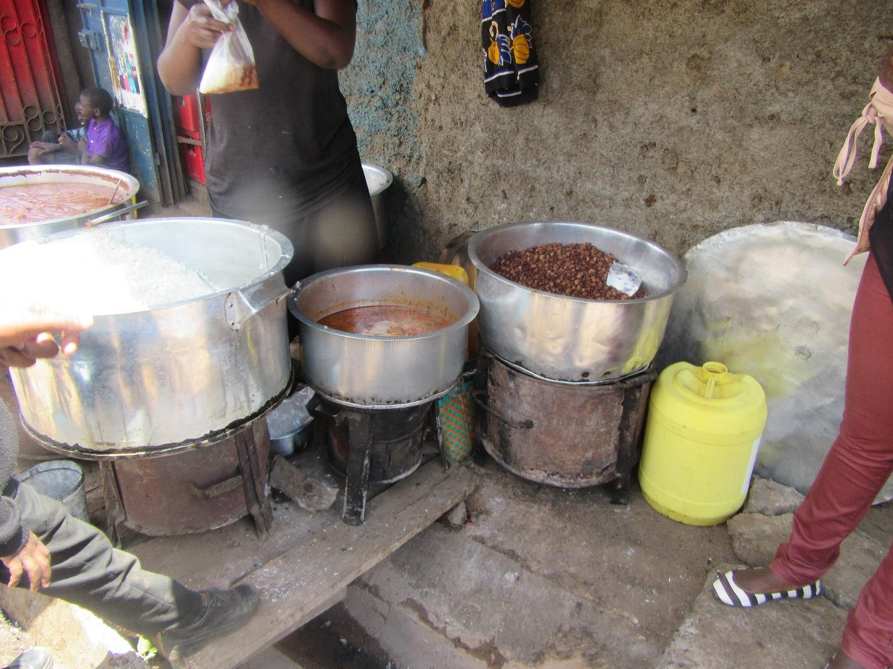

R5: I am R5. I want to discuss photo number two of group three. In this picture I noticed that the food is open. It has not been covered and down there, there is a terrace and also on living below a dollars a day this food was being sold from portions of as low as ten shillings and it sold in paper bags. You can be sold for rice and some beans soup for ten shillings. But I did notice that it was mainly children that were buying it as they were walking from school. So maybe the parents so that they don’t cook food at home they give the child ten shillings for lunch so they go and buy from there either rice and beans or rice and green grams or githeri for the ten shillings. That is what I noticed.

M: Okay, thank you very much. I have noticed similar issue. Like the food is open so it brings up the issue of contamination again but we had spoken at length about that. She has also touched on finances. So I would like to know that picture is it a true reflection of what happens?

ALL R: yes.
1:30:43
M: Okay, thank you very much. I would like us to give her flowers for her feedback. Thank you. The next picture we are here. Please come forward if this is your picture.

PHOTO 4, GROUP 1.

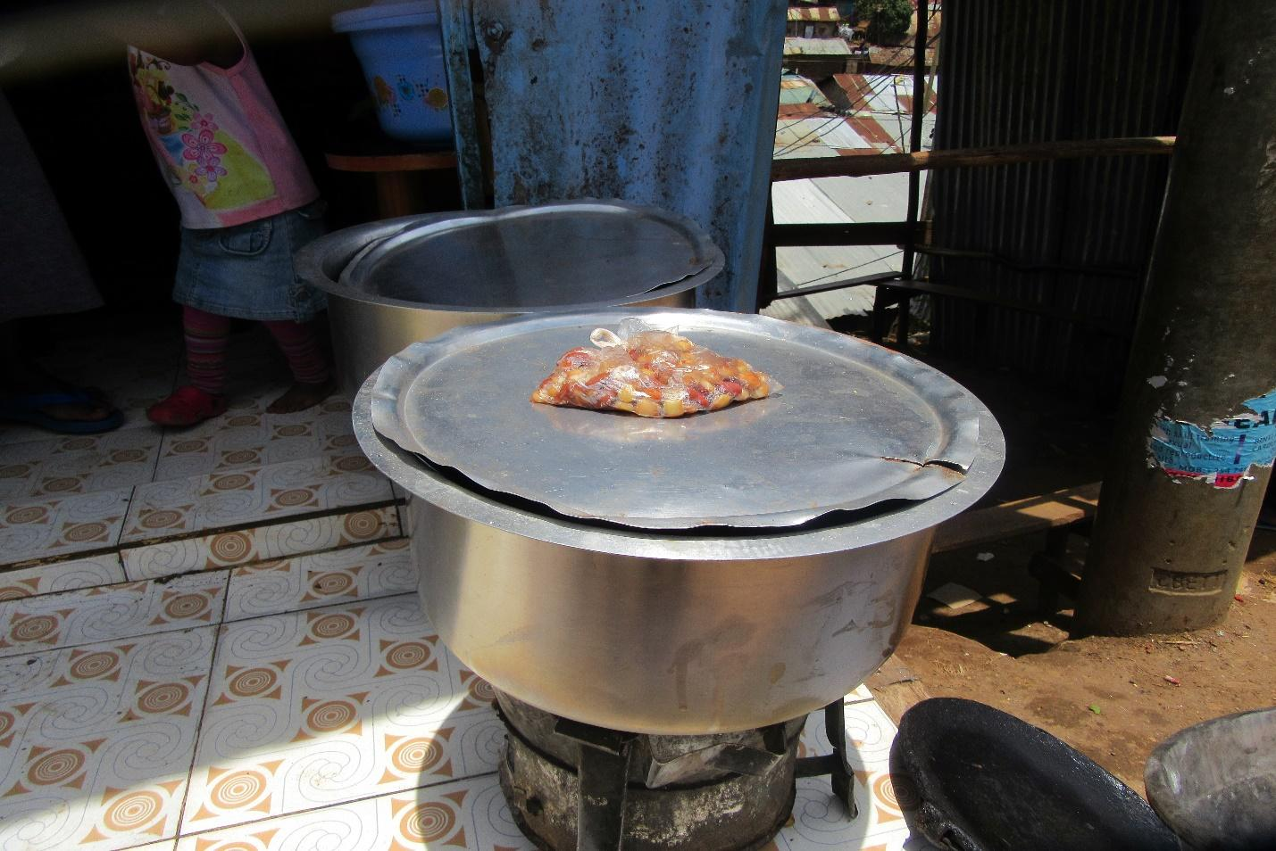

R1: I'm going to speak about photo number for I'm from Group 1. So this is a photo I was capturing what influences somebody to buy food from the way it is displayed whether it in a clean place or it's in a dirty place. So I was taking this one and this one. This one capturing a clean area something which can attract someone to buy food and also the most affordable food in that particular area. That is what I was highlighting at that place. So this one is to show that this is the food that is available and affordable in that area which is presented in a clean environment.
M: And what is that food?
R1: Githeri
M: So what he saying is that githeri is the food that is most affordable here is it true?
ALL R: Yes!
M: Those in favour say aye.
ALL R: Aye.
M: The ayes have it. He has mentioned two important things that I would like to follow up on. First he said that the food is available we have spoken about affordability. But he also mentioned that he was trying to capture the issues that influence our choice of food. What are those issues that influence our choice of food? One he has mentioned the environment right? So first and foremost how does the environment impact your choice of food normally?
R2: Okay when I look at this photo I can see that in that environment of that photo it seems to be clean. So that is the first thing that will cause me to buy githeri. Yes.
M: Normally do you consider the environment in determining where to buy you food? What is the normal thing? R7.
R7: That is an issue that is very important when you are buying food. First you look at the environment but you also consider the seller. Is it someone who is well-dressed and clean or is it someone who is constantly blowing their nose as they're serving you?
M: R7 let me ask you a question do we see that is as it ought to be or, do we think that normally when we go to buy food in this community do we actually consider how the environment looks? How does it play out here?
R12: Most of the time people don't look at the environment because if you select the environment especially in here within the neighbourhoods you will sleep hungry. Because most of the places the environment is the same. If I go to that corner it is almost the same as this corner.
M: R12 let me interrupt you briefly what you're saying is that the environment is predominantly the same?
R12: Yes
M: R1 you have told us that you took this photo here in Kibera. Is that right?
R1: Yes
M: And we have agreed that it is clean. My question is, is it accurate to say that the environment is like that all over? Is that being accurate?
R(?): It depends on the vendor. You will find someone who has preferred their selling point even if they will only sell a little but for that spot to be clean. So cleanliness begins with the vendor themselves. There are others who have preferred to simply lay out their Wares wherever they have found a spot. For example if we had walked around that area you will find that the environment there is not at all appealing. But you will find that there are vendors there who are selling and others buying from there. Ultimately the buyer must choose if they prefer to go to the dirty environment or if they will go to a cleaner space.
1:35:32
M: I would like to pick from that statement you made last. That it depends on the individual whether they will choose to buy food from an environment that is clean or from the other environment. For us we’re here we know that so and so’s shop is clean and that so and so’s shop is different, what would cause you to not select the clean shop but to go to the other side? Because we are the ones who make this Choice isn't it? R6.
R6: Okay just as we have said the environment matters for example if a vendor has kept their selling area clean it would be attractive.
M: Let me interrupt you briefly, this is the question. Where this photo was taken this person is selling githeri and we can clearly see that is a clean area. There's another lady selling at a place that is not clean. For us as the inhabitants of this area will find that for some people in spite of knowing that this place is clean and that place is not they will still choose to go to the place that is not. What I want to understand is what causes that? Why does someone choose the place that is not clean and yet they know that a clean shop is available elsewhere? R12.
R12: What causes that I think is ignorance. Someone does not see or understand the difference that whether I buy from the clean place or from the other there's a difference. For them all they need is to buy food. So you find that many times people do not consider that this person selling he is clean and this other person is clean but the other place is not. The driving factor is that I want githeri and if I find githeri here I will still take it. So you find that the environment is not considered at all. Though there are a few people who will look and consider and say that I want food that is clean and is being sold in a clean environment. But many people at the end of the day will simply go to the nearest vendor.
M: R(?)
R(?): I have a different opinion from my colleague. Let me give an example there's a place I buy meat. There's a guy who has built his Butchery very well but his price is higher Maybe by 10 Shillings or 20 Shillings. So when I'm doing well financially that is where I buy. There's another guy who has a selling area for meat but the environment is not very conducive. He sells the same item for less. So when my finances are low I am forced if I need some meat I have to go to the cheaper seller.
M: Thank you very much. R 10 I have a question for you a very quick question. We are considering the choices of where to buy food. What influences our choice of food? Why we select a certain food over another. We have considered the environment and R7 has spoken about pricing. Beyond pricing and environment what else would affect or influence the choice the choice of food? R10
R10: (Inaudible) when I want to buy food I want to go somewhere where the quantity will be enough for me.
M: Thank you very much. She has spoken to us about the quantity. She wants her purchase to come with a lot of food. Is that another factor that could cause us to buy food from the vendor whose station is not clean? R6.
R6: I would also consider the type of food. For people who come from a certain part of the country I would know that so and so makes a certain type of food. I will go to the vendor who makes the food that I enjoy. In my opinion that food is what I enjoy to eat. Friendship can also come into play. You could find that you go and buy from someone not because their food is good or the price but because they are your friend and you want to promote them financially.
M: Let's have two final contributions. R2 followed by R1.
R2: I would like to agree with my colleague and say that it is about customer relationship. You will find that you could go to a different place and this person does not serve you well. You're the one who's gone with your money on another day you might not have money and you might need to buy on credit. And this person may refuse to sell to you on credit. You may then find someone else who agrees to sell to you on credit. The result will be that you will not consider the cleanliness of the environment so much.
M: R1.
R1: There is also the issue costing. You could find a place that is clean but they're selling at a high price. You could find a place that's not as clean but the cost is lower. So people will gravitate towards the lower prices.
M: Alright thank you so much. I would like for us to give the person who took this photo some flowers. Flowers, flowers, drop. Thank you so much. To move us forward I would like us to go to photo number 7 group 2. Who took that photo? Let's welcome them with some flowers.
1:40:19

GROUP 2, PHOTO 7.
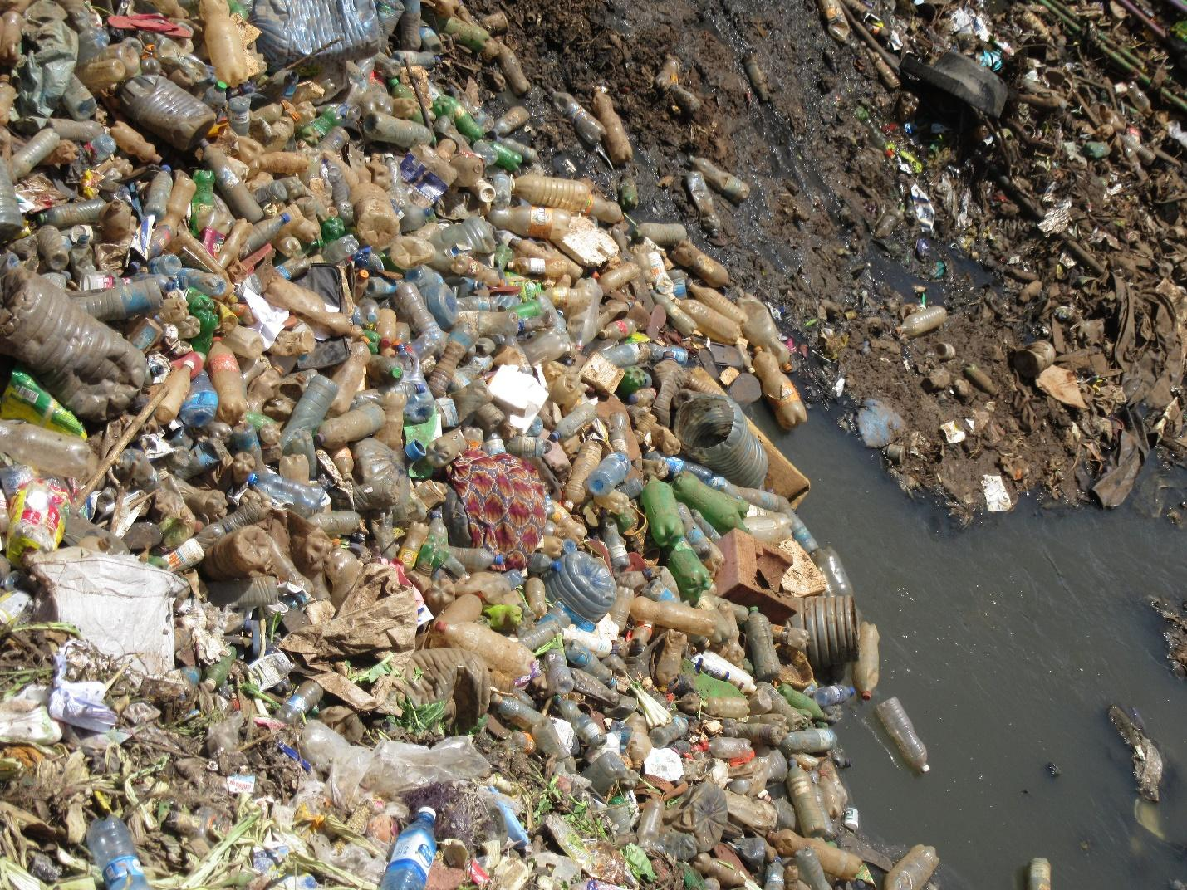

R9: I remember that there was a time when paper bags were banned.
M: Before you proceed we are speaking about photo number 7? Alright.
R9: There was a time when plastic paper bags were banned. And I feel like that ban (Inaudible). Now we're speaking about plastic bottles. Plastic bottles are quite detrimental to our environment especially and you look at a place like this. This is sewage and many times you hear the government saying that this same sewage is what they use to produce bottled drinking water. So you find that these bottles especially where I took that photo you find there are many bottles. But these bottles have accumulated at one place. So what can you do in order for us to eradicate this problem of the bottles?
M: Okay thank you very much. She is speaking about the issue of pollution. Having those bottles accumulated there. I want to open up this discussion concerning how bottles pollute the environment as we see in the photo how do they affect our issue of food security and the right to food? Who can contribute? When you see this pollution caused by the bottles how does it come to impact the issue of food?
R(?): Thank you for the opportunity. You see those bottles create an ideal environment for breeding mosquitoes. So if you consider the person living close to that site if that is someone who is a vegetable vendor or maybe goes to the market and brings their food to sell to others they have access to food and they sell to other consumers if you think about it those bottles that become a breeding ground for malaria the mosquitoes will come from the breeding ground and infect the vendor with malaria. It could be that once they're infected with malaria rather than using the time to clean their food before selling to customers to enable food security you will find that they are unwell. Maybe the kids haven't gone to school because they have not been productive. So the reality is that this is an issue that can undermine the whole process.
M: Thank you so much. There's a point I was hoping would come out and it has come out so I want us to discuss it. We have heard that at this place there will be mosquitoes and perhaps the person living close by I will get infected with malaria and yet the other person meant to go outside and earn a living to provide for the family. The things we are speaking about might not even be malaria only. It could also be that on account of the pollution of the environment you could find out the person who is the breadwinner falls sick. Is this a situation we have experienced?
ALL R: yes
M: When the breadwinner falls sick and are unable to go out and earn a living for their family how does this affect food security in our society? R12.
R12: Breadwinner who is the provider for the family is not strong enough to fend for the family or is unable to bring home the daily bread it means people will go hungry. It would mean that their food store is affected. So once the breadwinner is affected food security is affected in this way. Those who depend on the food brought in by the breadwinner will lack food.
M: Another way of looking at it? What other way? In terms of money? Let us consider when someone fall sick. They normally seek treatment isn't it? So what happens to the money that was available for use by the family? And how does this impact or affect our issue of food security? I would like someone different to contribute. R7.
1:44:54
R7: I would say that that money that may have been used for example they have gone to Mbagathi Hospital they have been told to pay a thousand shillings for that problem. You find that this 1,000 might have been used to buy good food for his family and kids or maybe they would have budgeted for a week’s worth of food to give a balanced diet to his family. But now they have been forced to use this money to get treatment for their illness. So this is definitely an issue that undermines the well-being of the family.
M: Thank you very much. I would like us to give him flowers drop. Thank you so much. Is there another contribution?
M3: I am wondering what the recommendations are when it comes to the pollution. What would you recommend?
M: Thanks for that reminder. This pollution by Plastics what would be your recommendation what needs to happen for us to resolve this problem? R5.
R5: In my opinion this would be the responsibility of the inhabitants of Kibera. For them to stop using this plastics or alternatively if they must use them they shouldn't dispose of them next to the Sewer lines or next to the lines where they can accumulate.
M: Thank you so much. Any other contribution R2?
R2: Okay there was a program that had been initiated by the County Government rather women representative, proposing that instead of throwing away those plastic bottles there's a project they wants to initiate where people can use the plastics to build homes. For example there is a house not far from here that has been built using recycled plastic waste. So what they were saying was that that would help reduce the issue of plastics being disposed of inappropriately.
M: Thank you. One last contribution due to time. R10?
R10: I would like to recommend recycling and reusing. Many of these bottles can be a source of employment for young people here in the community. As opposed to simply disposing of them perhaps they could install collection points. There are industries in industrial area that can utilize them. There are others that we can use at home and recycle them. So rather than wasting them they could be channelled back to the industries and used to make other things. While others can be used as containers and other vessels at home.
M: Thank you so much for the contribution. The last contribution R11?
R11: There’s something we did in Mathare with a group called (Inaudible) recovery. That would be my suggestion for Kibera. There's an organization, a company that collects plastics. What we suggested when I was working with them was that they identify a project and come up with a proposal. What those in the community were informed was that there would be a drop off point for Plastics. Those plastics that were collected were to be used to build an office. The plastics company as a CSR they committed themselves that they won't collect plastics from any other dealers but would only collect plastics from that organization for one month. So what happened was that the people in the neighbourhood would say since that organization wants to build an office let's deliver our plastics to them. So they had a huge heap of plastics and out of those plastics came an office. They have actually indicated that “this office came from plastics collection project.” So even here in Kibera, every neighbourhood to identify a project say the gardens, growing food in sacks and so on. For example you want to buy those sacks you can identify and say that sacks will be purchased through these plastics. And then you come up with a day when you clean since there is a huge amount of plastics that are collected and stored in a single place. But once everyone passes there when they see the Plastics they would identify with the project. So we can say that our projects can be provided for by plastics. That way you benefit from a clean environment as well as becoming a food producer.
M: Thank you very much R11. Thank you to all of you for all the good recommendations. As we move ahead photo number 8. Photo number 8 from group 2.

GROUP 2, PHOTO 8.
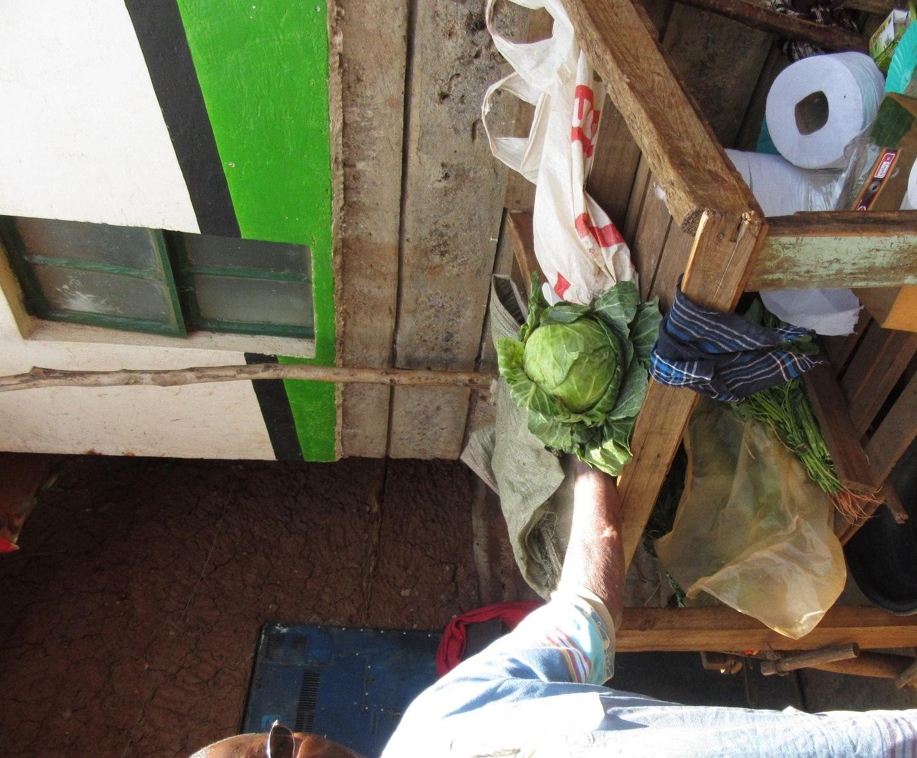
R11: So R11 is back. As you look at this photo what you can see is on one side plenty and on the other side lack. Where there was plenty we didn't take good care of it and after a short time that plenty ran out. And the opposite is true as simple as that.
M: So as R11 says we have discussed the issue of scarcity and plenty. Alright let's give him some flowers drop thank you. The next images photo number 3 from group 3.
1:50:06
GROUP 3, PHOTO 3.
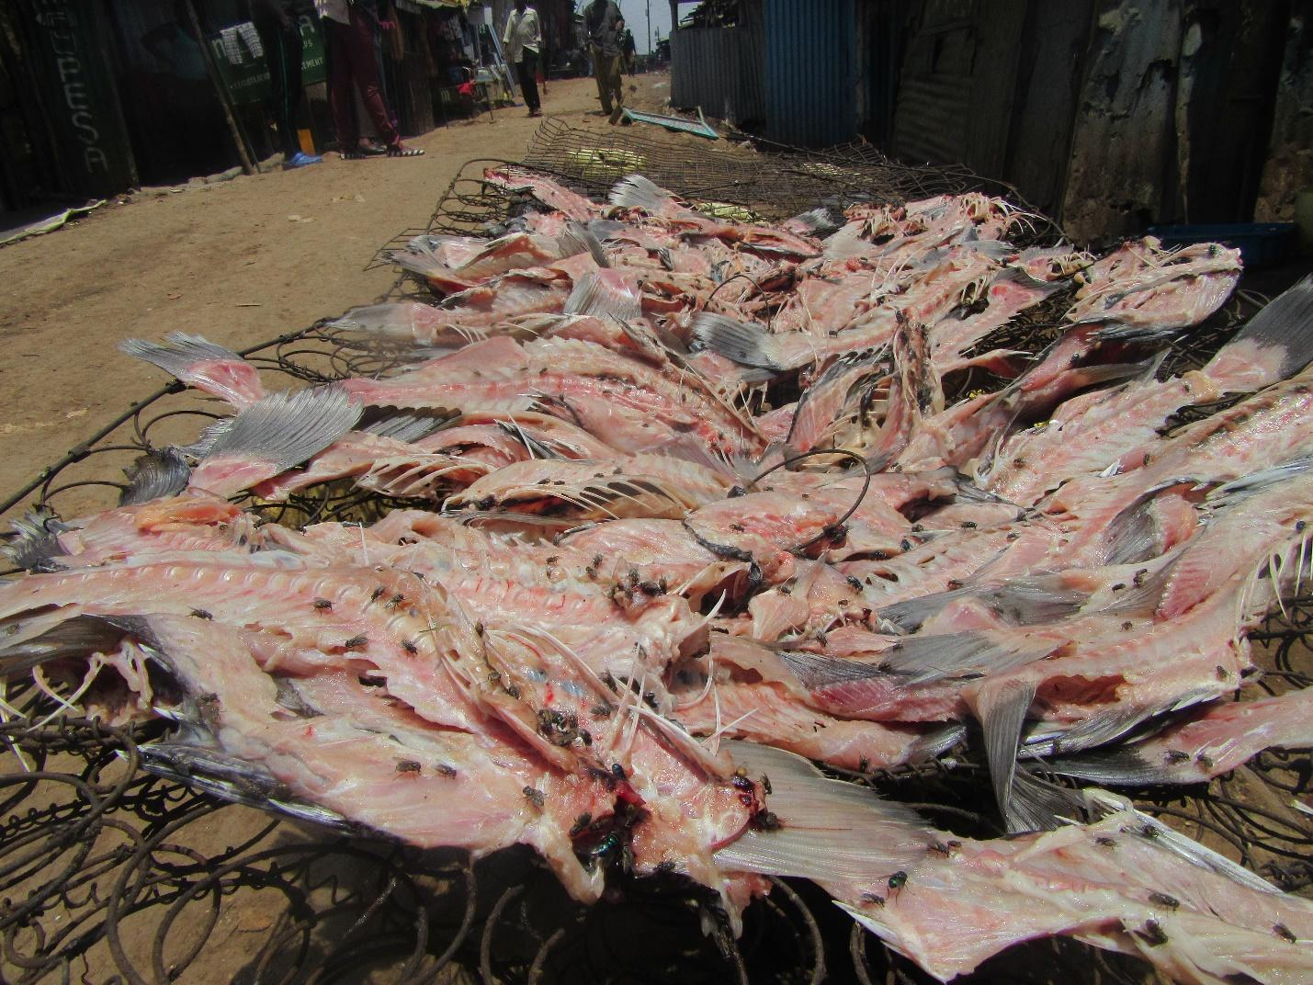
R6: Okay I'm speaking concerning this photo I'm R6. When you see this photo you can see fish that have been filleted. What is left is just bones and very little meat. They have been placed on wires to dry and that wire is a bed that is no longer in use. It is now used as a surface for drying fish. When you look at that image you can see that if you can imagine smelling that fish you can clearly see that there are flies that have been on it. I took this image to communicate that this is low-income earners fish. Because clearly this fish it's not for someone who has means to afford better. Someone who can afford it will simply go and buy a whole fish that has not been filleted. The meat has not been taken off to be eaten by other people. But for the person who does not have means they will say that since I desire to eat fish today I have to settle for this one and use it to make my soup for my meal. I will feel like I have actually eaten fish. When they're eating that food because they don't have money they might also find that they have eaten contaminated food. Because as you can see the flies hovering over that fish. Also the mesh on which the fish are placed you will find is probably something rusty. That could also contribute to bringing harm to the person consuming that food all in there endeavour to enjoy the food they like. So I understood through this image that food is available but it's not available to everyone.
M: Thank you very much R6. You have explained a lot and there's something very important that I have picked. He has spoken about income. That this kind of fish, they associate with those who do not have sufficient income. And we had spoken about the issue of income and how it impacts our choices of food. So we won't speak about it at length. He has also mentioned the flies that it reduce the risk of contamination which we had spoken about. If that thing that he has mentioned has to do with the type of fish. He said that there is something that is missing from this type of fish. The person who settled for this fish cannot afford any better. This is my question what is the difference between eating this type of fish and a better one? I ask in terms of the nutritional value to your body all the health benefits of the fish. What does it mean for someone who can only afford this kind of fish as compared to the better fish that he has said this person is unable to afford? R12.
R12: This type of fish is called "mgongowazi." The meat from the body has been filleted and what is left is just bones from which you can maybe get some soup. Even as you look at it from a distance much as it looks like there's some meat on it that meat will really have no benefit to the person who consumes it. So the person who has eaten that fish what would be nutritionally beneficial to their body is quite minimal. They will simply have the aroma of fish and soup and bones. Because the flesh which they would have eaten most of it has already been ripped off. It is at City Market, the fillet has gone there and been sold.
M: Thank you very much. So in terms of nutrition what is the difference between the person who eats this fish and the person who eats the filet that has been sold at City Market? What is the difference nutritionally? R13.
R13: What I would say is that there is definitely a difference because that one only got the soup and the aroma and they say they have eaten fish (inaudible)... so even if they don't get sick...(Inaudible).
M: Okay thank you very much. Anyone else would like to make a contribution in terms of nutrients what is the difference between the person who consumes this fish in the image and the one who consumes the fillet at City Market? Is there a difference in terms of the nutritional value they gain from that meal? Will there be a difference in the health not even necessarily on account of illnesses but on account of the food they have consumed? R12 again.
R12: When you look at this image I assume that for a whole fish there's a percentage that it carries of protein. So when you eat there’s a percentage of protein that comes to your body. For this one it will affect you because what type of nutritional value the fish carries the benefits when you eat this one will definitely be less. The flesh that carries the protein content is lost. So all you're doing is drinking soup you're not gaining nutritional value.
1:55:06
M: Thank you so much. We have moved along well and I would like us to move ahead. Let us give him flowers drop. Thank you so much. We're moving to the next image photo number 4 group 3.

GROUP 3, PHOTO 4.
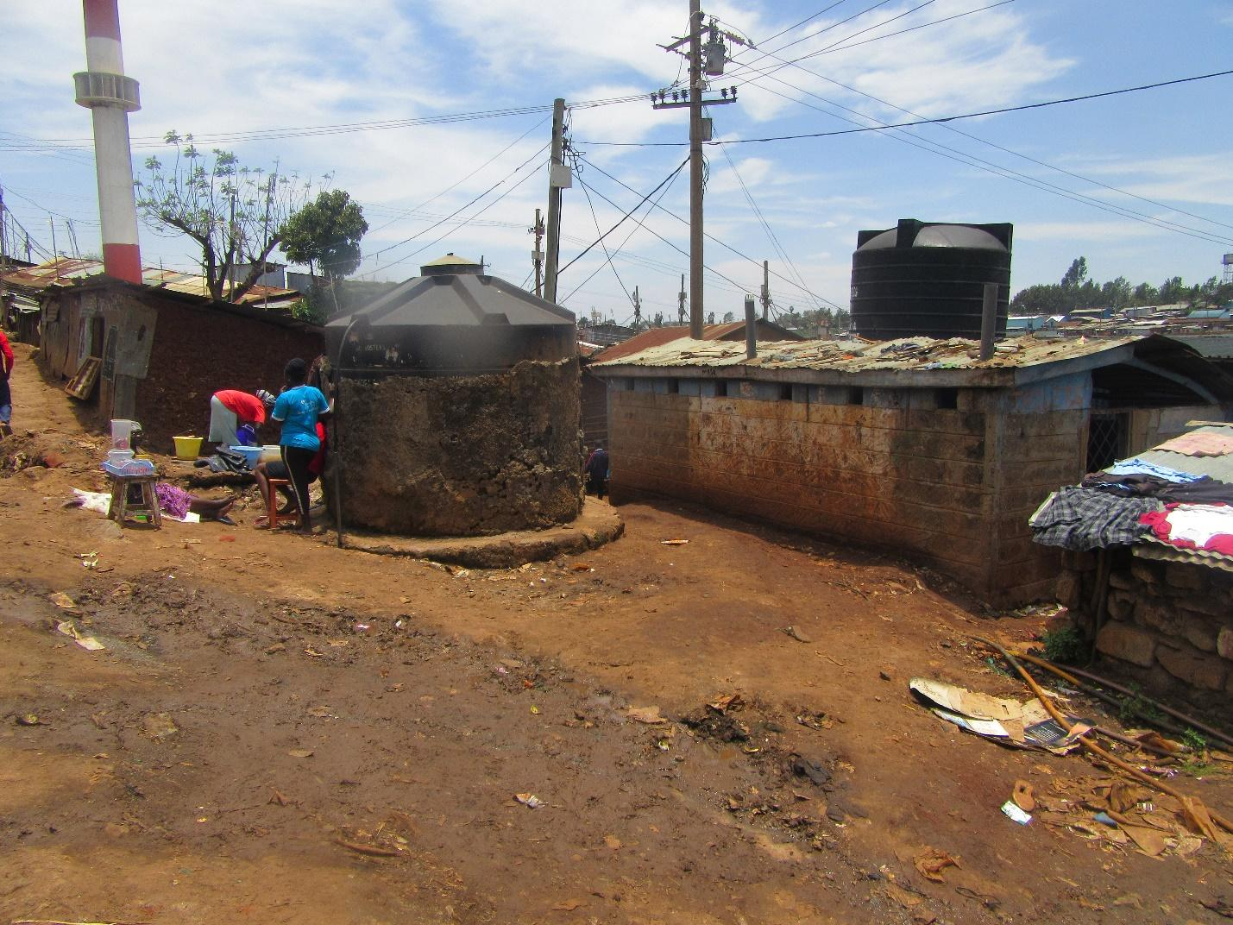
R5: I am R5 and I'm speaking concerning photo number 4. In this image there's a toilet here and close to the toilet is a tank. It's a water tank from which people get water to use in the houses. Right next to the water tank you see people washing clothes and the water they have used, they pour out right next to the tank. Also there was someone here selling some snacks close to where people are washing their clothes and pouring out the dirty water. I saw that firstly this tank that they're using for drinking water is right next to a toilet. What that means is that there's a high likelihood that the water is contaminated. Those who are washing their clothes are pouring out the water right there where people are collecting drinking water from. So that also interferes with the cleanliness of the water. At the same time this person who's selling snacks is selling their snacks right next to where people are pouring out dirty water so that food is also likely to be somehow affected.
M: Okay thank you so much. R5 has highlighted once again the issue of contamination the issue of polluting the environment and how that affect food. I believe we had delved deep into that so let's give her flowers. Flowers drop. Thank you so much I would like us to move along. Photo number 5 group one.

GROUP 1, PHOTO 5
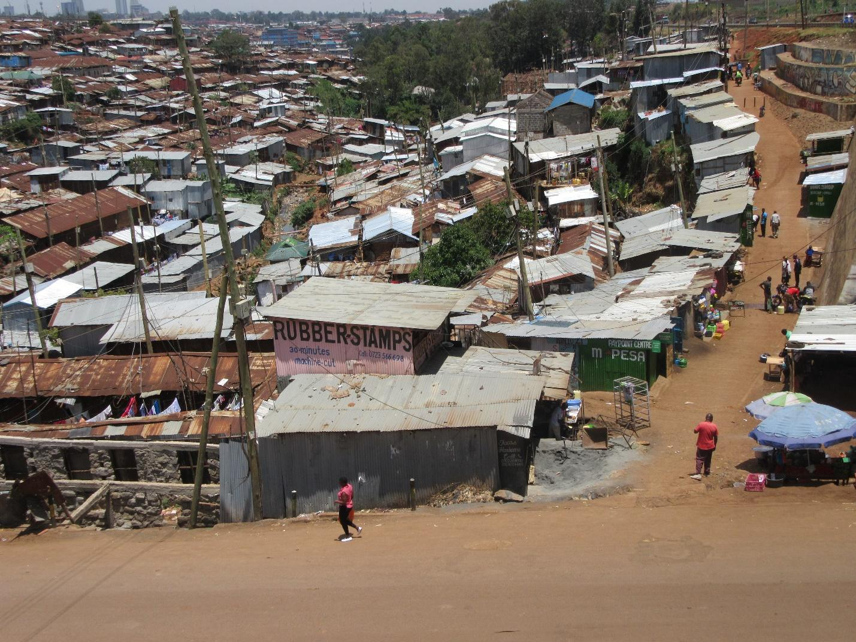

R1: I'm R1 photo number 5 group one. So photo number 5 shows to us the environment that we find in this part of the country. (Inaudible) when somebody is living in very low standards even accessing food in the evening is a challenge.
M: Thank you very much. R1 has explain to us once again about food and a certain economic status. And the reality of food scarcity sometimes. We had already spoken about that isn't it? Okay let's give him flowers. Flowers drop. Thank you. Photo number 6. R1 is back okay.
Group 1, Photo 6
R1: Photo number 6 shows us in the environment. It shows us the environmental conditions under which locals work. (Inaudible) This does not look like a proper facility..(Inaudible)... they don't have enough space to produce food.
M: Okay. So this lack of adequate space to produce food how does it impact food production?
R1: It has an impact because if they had hoped to produce a certain amount of food they will not be able to reach or exceed that quantity because they lack space. They will not be able to expand their food production.
M: Okay I would like to expound on that discussion. When this person who is producing food or cooking food doesn't have sufficient space to grow food or to cook a lot of food and so they only cook a little food for sale how does that affect food Security in the community? Does it affect our food security and if so how? R12.
R12: They end up cooking little food which means that only a few people are able to get a meal. If only a few people can get it means that there is a greater population that will lack food and go hungry. Yes.
M: Is that the situation that we see? For the people who cook the food we like that when they cook it at a small scale allows end up liking food? R5. Is this the situation?
ALL R: Yes.
M: If that is the situation let's say aye.
ALL R: Aye.
M: Thank you so much R1. I'll move us forward. Let's give him flowers please. Thank you. Okay, we will move to photo 1 of group 2.
PHOTO ONE GROUP TWO
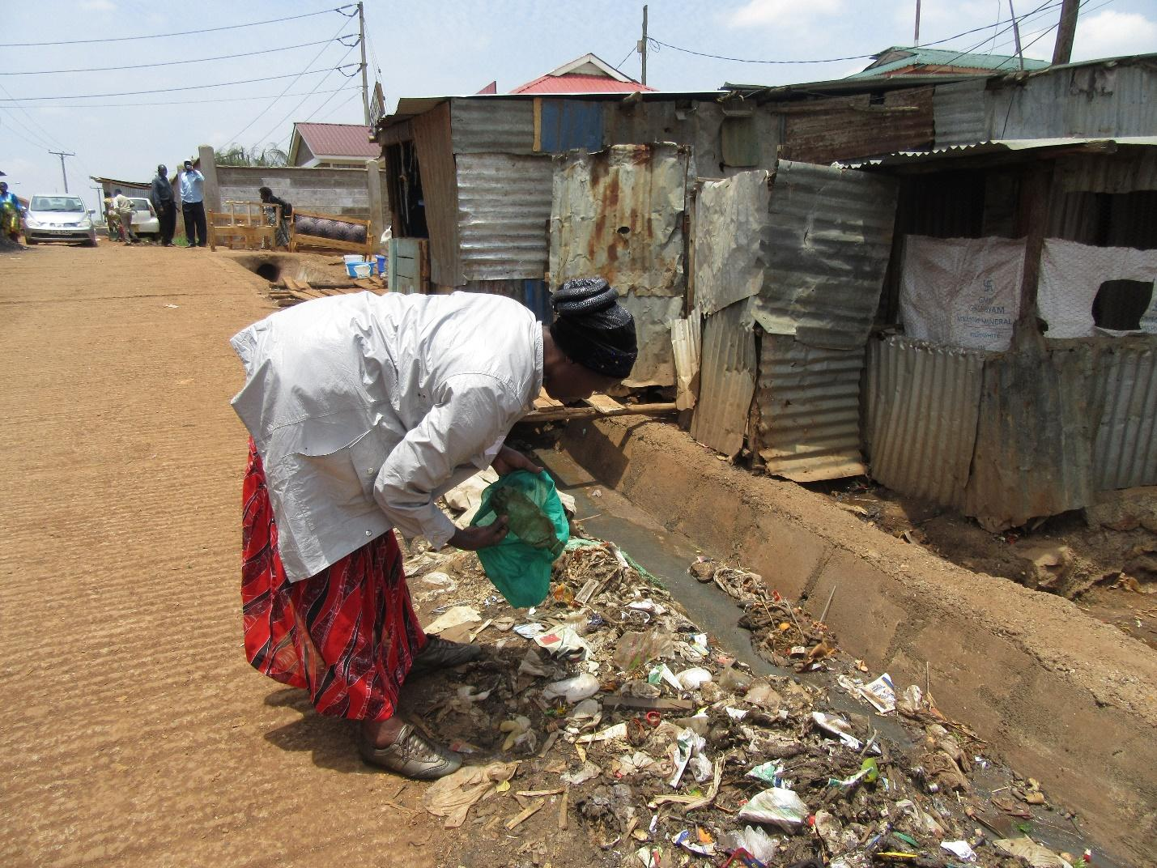

R10: From what I can see from the photo when people have problems and they fail to find something to give the children they would rather go to the trash. As you can see from the picture there is a paper of milk and I will take it and go and cook for the kids.

M: So when the people take the milk from the trash and go and cook for the kids what issues can arise from that?

R10: I saw as though they may have lacked something to give the kids so they would rather pick the milk up go and feed the children. That is what I think.

M: Thank you. Allow me to expand this discussion. Is this a reality here in Kibera? Does it happen?

ALL R: Yes!

M: So if people pick food from an area like that to give their children is there an effect to the children?

R9: Yes, children get sick. You will pick the milk and find it is bad but still end up giving the child which will cause illness in her house.

M: So when you take food from such a situation you end up getting sick?

ALL R: Yes.

M: Alright. Thank you very much. We had discussed at length issues to do with sicknesses and food so let us give her flowers. Thank you very much. Photo number two group 2

PHOTO 2, GROUP TWO
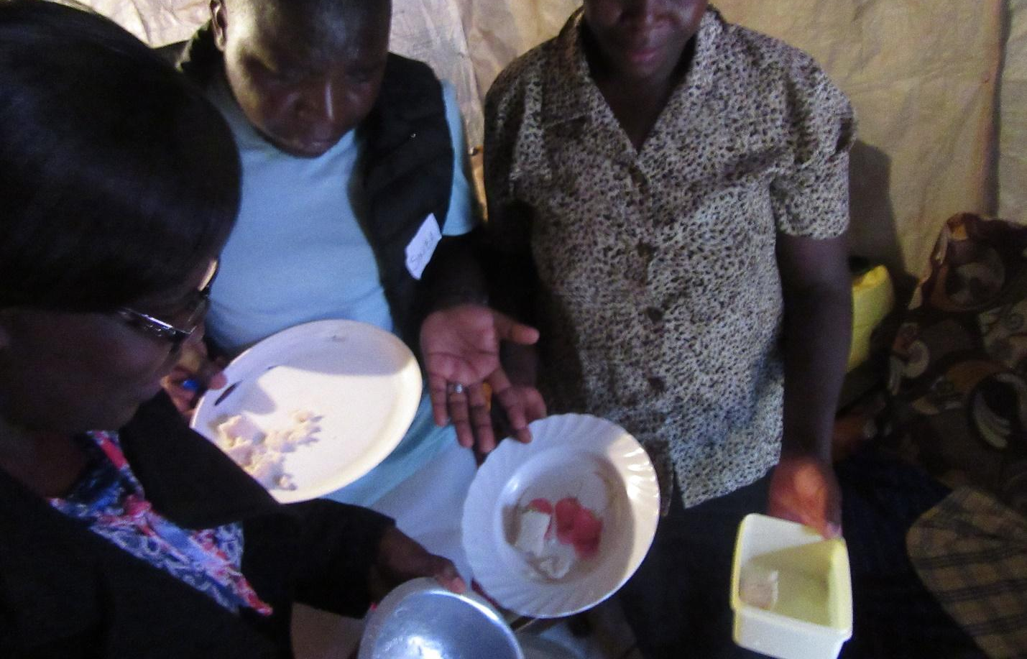

R(?): That picture I took for me I saw that the family may have many children and you don’t have enough food so you try to divide and it’s looks like they have found only ugali . So she divides for the kids giving less to the children and the food is expensive but it’s not enough for the big family.

M: She has discussed the issue of food and money. This is a topic we had already discussed in detail earlier. So let us give her flowers. Thank you so much. Next is photo number five group 3.
PHOTO 5, GROUP 3.
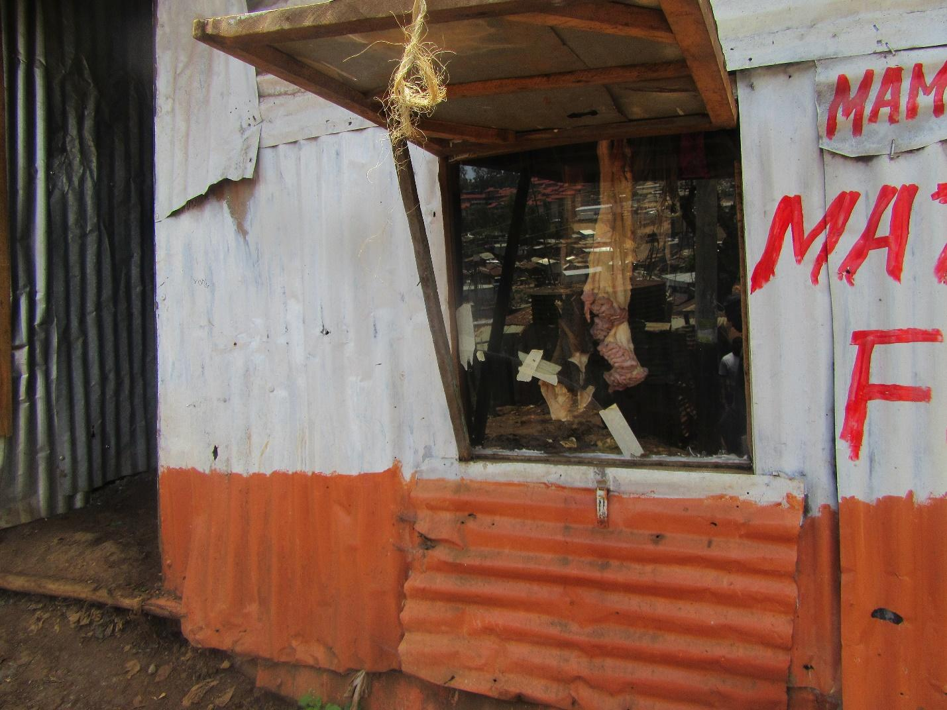

R8: I am R8 and I am taking about photo five of group three this picture here shows issues of low income. In this butchery we found intestine. In little portions as you can see but I think that it’s because the owner lack finances to be able to stock more meat so it’s not that the meat is not available. He did not have finances so he brought only little meat for sale. If the owner of the butchery is not able to sell his product or get more than his family will also lack. Also for those that buy from the shop if he is not able to keep bring the meat then even his customers will not have the protein in their homes either.

M: Thank you very much R8. She has touch on the topic of the economy. Can we please give her some flowers? Thank you. Photo six group three.
GROUP 3, PHOTO 6.
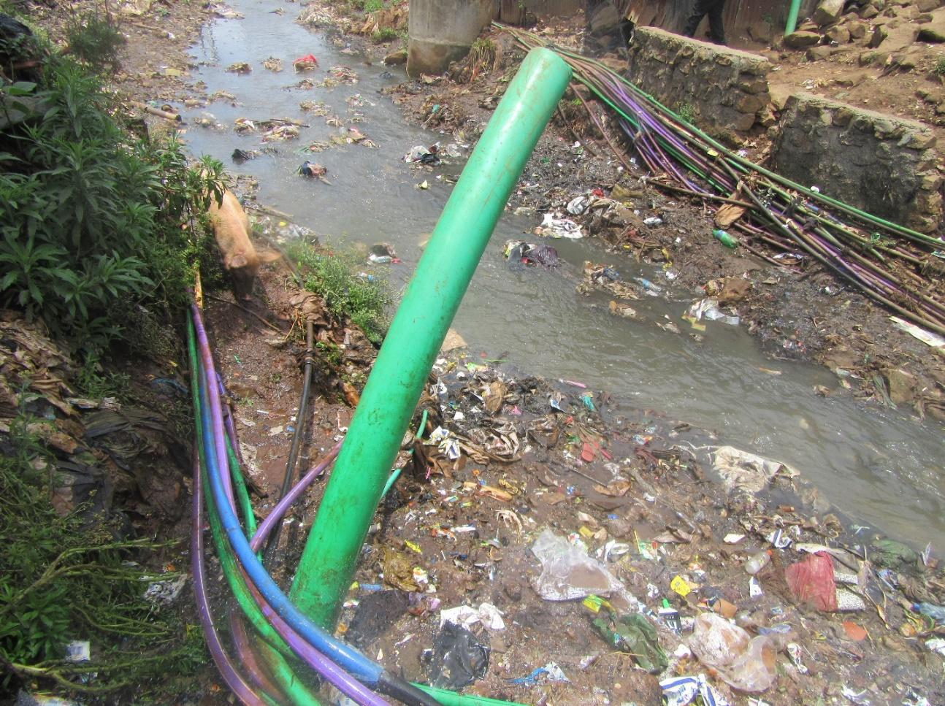
R7: I am R7 and I am discussing photo six from group three. From this picture you can see that clean water pipes are passing alongside sewer line. What I wanted to show here is that water is very important for every person living in Kibera so it needs to be clean. So from the picture there are sewer lines and the clean water pipes are licking. When they come in contact with the sewer water and that can cause illnesses such as diarrhoea, typhoid. Some people also dispose of chemicals that can have negative effects on the people. So because of this expose the water that gets to the taps can end up being contaminated and can put their life at risk especially for the hound children if the water they are drinking has chemicals you find that their intelligence can also be affected.

M: Thank you very much R7: R7 has touched on the issue of health again but we had discussed it so let’s us give him some flowers. Photo number seven group one.

PHOTO 7, GROUP 1.
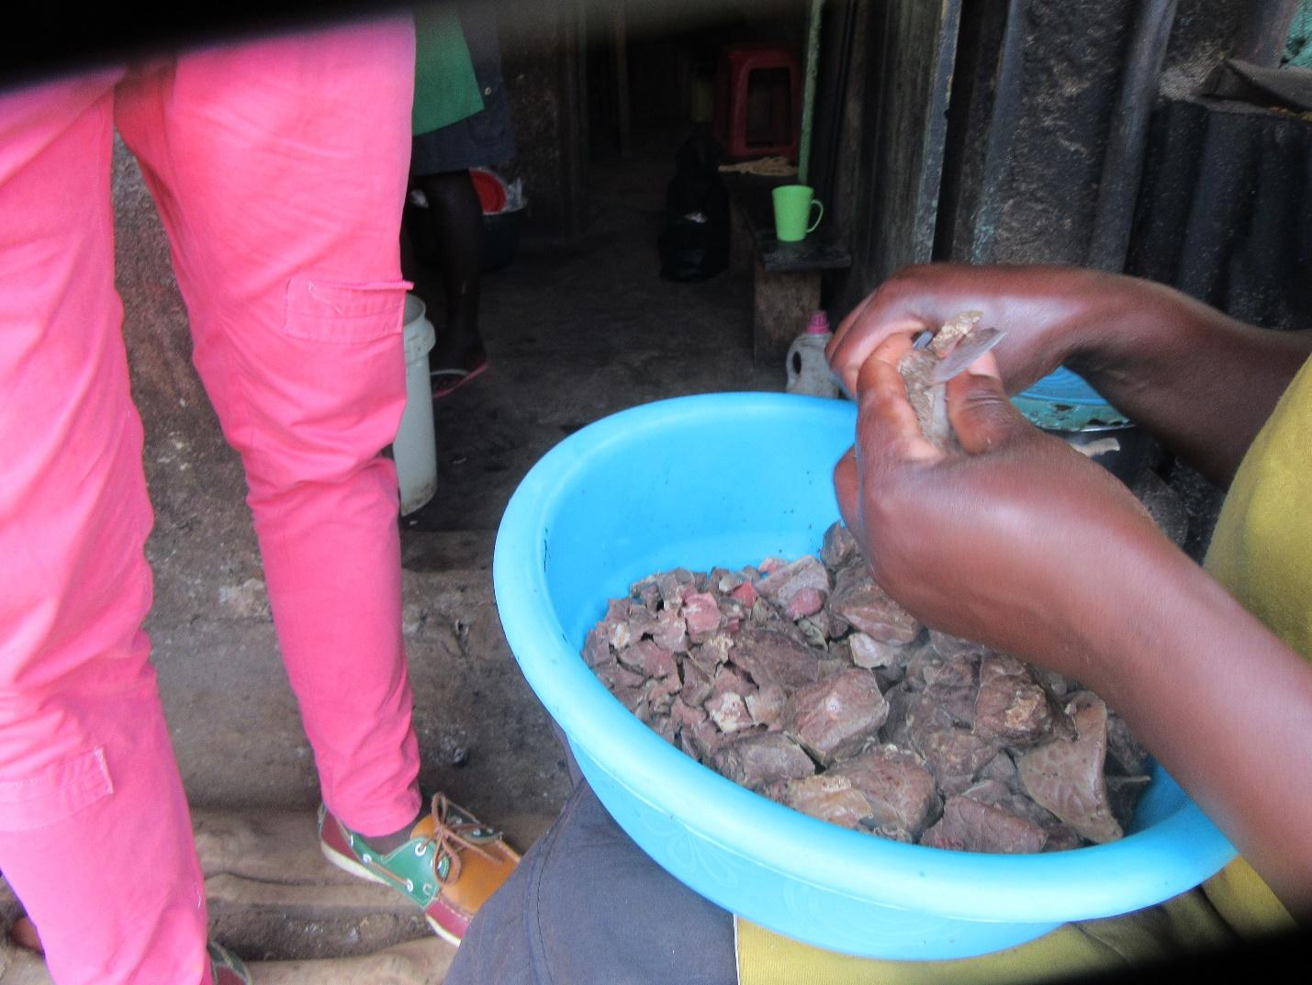
R2: I am R2, I will talking about photo seven from group one. The picture shows about hygiene preservation. If you look at the picture you can see someone is cutting lungs for sale. If we look at cleanliness we can’t be sure how the vendor has handles the meat. Did he wash his hands? And even if you look at the environment where the food is being cooked it’s not very clean. What can make us go to place like this to buy food is if you can’t afford to make your own food you will go to the food that is ready made and the readymade one you can’t be sure how it has been made and the person who has made it, are they clean. So low income is what makes us will to buy food from such place.

M: Thank you very much R2. R2 has highlighted again the issue of contamination and sickness. Please let us give her flowers. Thank you so much. I can see we are progressing well. Let us go to photo 8 group one.

PHOTO 8, GROUP 1.
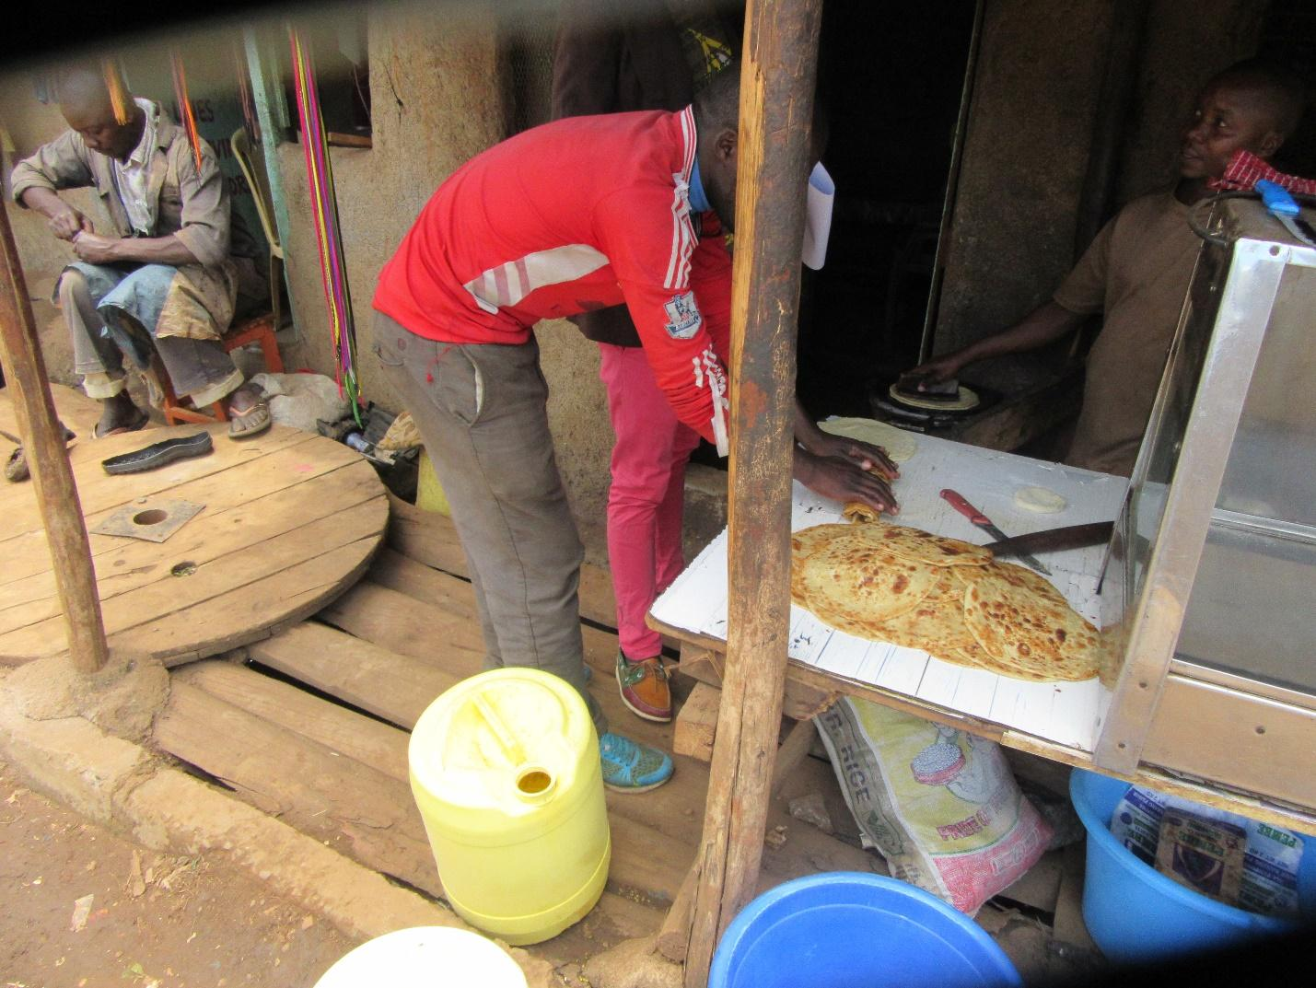
R1: I am R1 talking about photo eight of group two. Here I was highlighting about limited resources. If you look at where they are cooking there are terraces passing underneath so they have tried just to use the space that is available.

M: Thank you very much. He has touched on the same theme. Let us give him some flowers. Photo five group two

PHOTO 5, GROUP 2.
PHOTO NOT AVAILABE

R11: I am R11. Poor food regulation in the slums. You will find that milk is brought to Kibera and it’s like they have planned something against us. This milk has usually been put for bad preservatives. Here in Kibera what is used to preserve meat? We all know the sting that they use don’t we? It’s the medicine used in the mortuary, sorry to say that but that is the medicine that is really used. If you go to Olympic there is a butchery there that a kilogram of meat is two hundred and sixty yet other people sell meat at four hundred shillings a kilogram. You can wonder. Has this person started a “Red Cross” service in Kibera and we can’t be sure who his donors are. So many of these butcheries you may find that the animals sold may be animals that died in accidents or because butchers don’t want to their meat to go to waste they will use that mortuary drugs to preserve it. When you cook this meat it has some foam that is almost soap like. Then when it comes to the milk when you put it in a cup it starts to turn yellow and other people are also adding flour so that it can be thick. When you cook tea with that milk it taste almost like yoghurt. So food regulations here are poor because no one is following up on it.

M: Thank you R11. I would like to ask one question. R11 has highlighted issues of quality and of standard. Is that the reality for the people in Kibera? All in agreement say “I”.

ALL R: Aye.

M: Thank you. Please let us go straight to recommendations. What can be done to ensure that the food that comes to Kibera is of standard and of good quality and whose responsibility is it to handle that?

R12: When it comes to health matters because this is health touching on food this the responsibility of county government and national government. Because if you talk about something like food before it is sold it’s should ideally go through approvals by the veterinary to ensure that the meat is good for human consumption. We can fail to know because if you ask me as a consumer I will looked at the food from outside and feel like the meat is clean but maybe that meat has been affected. So the county government and the national government have a wing of inspectors that should be sent here to investigate whether the food we are consuming are up to standard.

M: Thank you. Any other recommendations? Can we get one or two? Other than the one of the government? R13.

R13: Also is as residents may you know that someone is adding things to for example milk before they sell we can try and prevent them from doing that .

M: Thank you very much. R8

R8: We should also be keen because always cheap is expensive. You can buy a cheap product but what is the story behind it? Like that meat that is two hundred and sixty a kilogram if it is truly cow meat is it safe for human consumption because if it was three hundred and sixty shillings it would make a little more sense because others are selling at four hundred shillings and another vendor is selling at three hundred and sixty. But two hundred and sixty. A difference of one hundred and forty shillings is a bit much. We ourselves should not go for the cheaper thing just because it’s cheaper but we should focus a bit more on if it is good for us.

M: Thank you. Let’s give R1 flowers. I can see we are moving well through the photos. We only have three more photos. Let us move up photo six of group two.

PHOTO 6, GROUP 2.
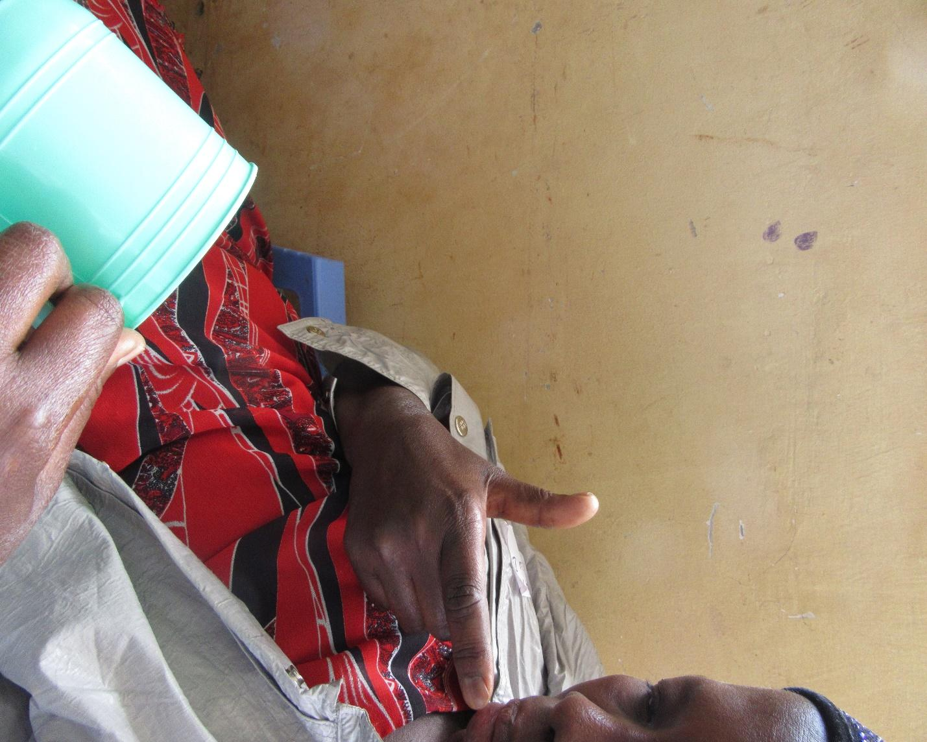

R10: I am talking about photo six of group two. Here I had seen like it was during a time of great hunger. Someone has cooked porridge and put in a cup so that at least they can get full. So that is why I am taking about this photo in regards to problems.

M: Thank you. We are still touching on the issue of the food not being enough, a bad economy. Let us give her flowers please. Thank you. Let us go to photo seven of group three.

PHOTO 7, GROUP 3.
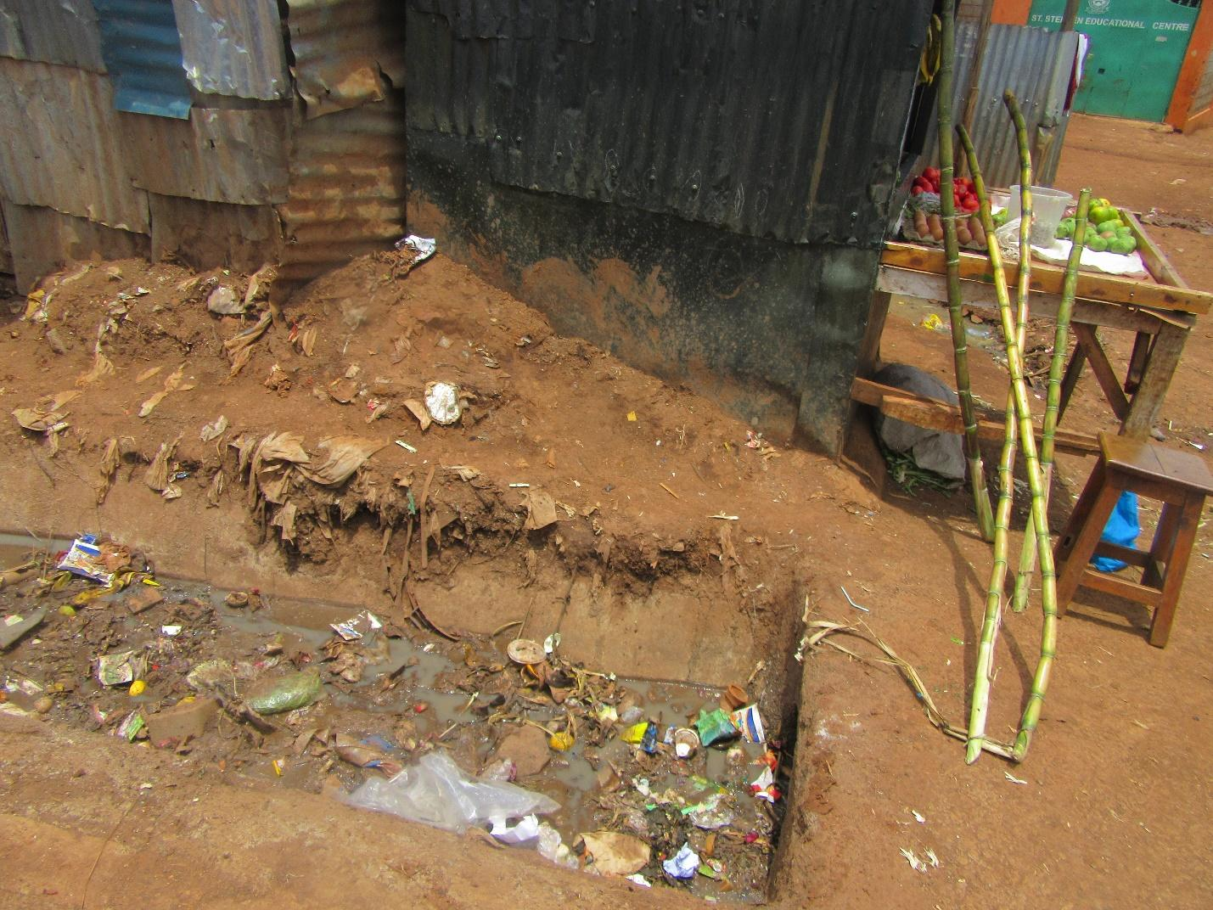

R8: I am R8. Talking about photo seven of group three. In the photo of you look at it you can see food that is kept near terraces that has dirty water. So here in my opinion there is no cleanliness because the food will get flies and the flies move from the terraces to the food and if you look at the photo closely there is sugar cane that will not be washed before eating. There are fruits that consumers may not wash well before eating. Especially when it comes to sugar cane people usually eat it directly without washing it.

M: Thank you very much R8. She has touched on hygiene and sickness again. Please let us give her flowers. Thank you. Let us move to the last picture photo eight of group three
PHOTO 8, GROUP 3.
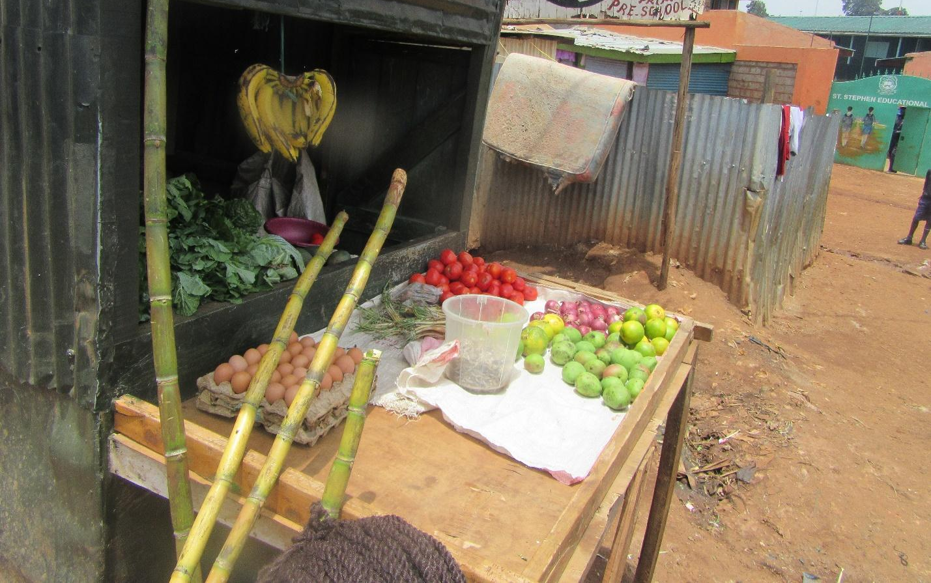

R7: I am R7 talking about photo eight of group three. When I was looking at this picture I saw that even if this person has little income he wanted to help his neighbour. If you look at the sugar cane it provides starch, there are eggs that provide proteins, and there are tomatoes that provide vitamins, so out of good networking we can have access to a balanced diet. As in with the little resources you have you can afford something. Let’s say you have fifty shillings at this shop you would not have failed to get a balanced diet.

M: Okay, thank you R7. He has highlighted topics that we have already looked into. But there is one things he has mentioned that I would like to follow up a bit. About availability of food. I know we had discussed it but there is one angle I would like us to look at it from. We had said that there is food in the market so my question is every time there is food in the market does it means that there is food in our homes? R8.

R8: There can be food in the market but there is no food in the house mainly because you may not have the money to buy the food. So you then cannot access the food much as it is available.

M: Okay, so for the situation of Kibera residents when we say that there is food in the market but we don’t have it in our homes. What is the reason? R12?

R12: When you find there is food in the market you can find that there is not food in people’s homes because in order for food to leave the market and get to our homes we need money. So even if there is a lot of food in the market but we don’t have money at home then we can get that food. And it ends up getting spoilt in the market.

M: Thank you very much. My last question on this is in the seasons where there is a lot of food in the market what season is it? Which months of the year? But I guess food is also seasonal so it depend on the season.

ALL R: Yes.

M: For example in December when food is most available is it true to say that in December people in Kibera eat well? Cause I. December there is a lot of food in the market. Is that statement true?

R8: Yes the food might be a lot but the cost doesn’t become less so because we may not have enough money still to be able to buy the produce. So the food can a lot but you still can’t afford it.

M: Okay, thank you. I want us to move to the last section and then I will hand over to my fellow moderator M1 to take us through our experiences in this process of Photovoice. So for me I want us to finish with recommendations. M2 has highlighted for us quite a number of recommendations. I would like us to look at them and can we please give M2 flowers. Thank you. So as we have been discussing from the beginning we have highlighted several recommendations depending on what we are discussing and as you can see we have filled two Manila papers so we have highlighted many recommendations about what should be done to improve our food situation. They are quite a number and I won’t go through them all because we are the ones who have highlighted them my only question is these recommendations we have said that they should to, we have mentioned, government. So I want us to be a bit specific. So that something can be done about these recommendations who should receive these recommendations? If you say government can be please try to be specific. Who are the stakeholders that should get these recommendations? R12.

R12: These recommendations should be sorted out into two. One, there are recommendations that should reach the community because there are very many things we have mentioned that the people themselves that live here can implement even without waiting for government to in. Two, we should give them to government as policy makers so that they can make policies that will give us a better life.

M: Thank you R12. Who else should they reach?

M3: Maybe these things can be discussed in the family. When we are in the house and we remember how we have lacked food we can discuss the issues raised so that we see how to implement some of the recommendations and how we can find solutions. So if we tell our parents and our siblings maybe when they go out they will also encounter policy makers that they can also share with.

M: Thank you. Is there anyone with another recommendation that we have not mentioned? R6.

R6: Sometimes I see like when the government wants to relay information they can use churches, mosques, they can teach church leaders and mosques workers so that these people then give the information to the community.
M: My last question because of time. We have put our recommendations while looking at our experiences. My question is those people that we want to reach with these recommendations what channels can we use to reach them? Which is the best means to communicate to them these recommendations? Because remember that we want by the end of the day for the recommendations to be implemented so that our lives become different. So which are the best channels?

R13: I think since this session has been recorded we can give it to the media so that it’s can reach the citizens of the nation and it can also get to the government and policy makers.

M: Thank you very much. R1.

R1: We can also use small groups like community based organizations to help the information reach many people.

M: Okay, R12.

R12: We can use workshops and seminars. So seminars can be planned and then church leaders and community leaders can be invited to be part of them and they can be taken through food security and its effects.

M: Thank you. Any last one? Yes R2.

R2: I think we can also use social media.

M: Okay. Any other before I wind up? R6.

R6: I think for example like here we can use “radio pamoja”. If the recommendations are shared on the station many people will be able to hear about it.

M: Okay, thank you so much. That is the end of my bit. M1 will come up. As she comes because I may not get a chance to speak again allow me to say thank you very much. We have had a very good session and you have all been very cooperative and active. We have spoken about very important things. So from me I just want to say thank you.

M1: Thank you very much M. And also thank you very much to all of you. Now, I just want to get your feedback. It’s not For Photovoice or food security bit I want to get your feedback about your experience in the process of the two days. Yesterday when you ca did you know what you were coming up do? We came and we started. How was the process for you?

R12: The process has been good and educative but my suggestion would be that we expand it to a bigger gathering. With our few number we are limited as to how many people we can reach. But if we had been more we would have captured a lot more and maybe there is a lot that could have been brought on board. So if next time it can be bigger it would be better

M1: Thank you. Anyone else on this side? You can also expound. You can take about the whole process. Handling a camera. Going to take photos on the community.

R8: Okay, to me it has been very educative. I have learnt a lot and I have interacted with and met new people. It has also taught me how to use a camera. You know I just used to see it but at least now I have made a step in life.

M1: Thank you. R8 has said she has learnt a lot. Is there anyone else who has learnt? R2 what have you learnt?

R2: I have learnt a lot to do with happenings here in Kibera and how I can we can help each other in the community.

M1: Thank you very much. On this other side. Has anyone learnt something they would want to share? R13?

R13: I have also learnt how to take a photo and also when I look at a photo there is something I can say about it. I can learn something from a photo.

M1: Okay, thank you. I want to touch on what R13 has said about learning from photos but before I eat there. We learnt to use a camera and we went to the community to take photos. How did you feel? Were you feeling afraid, or were you ok? How were you feeling? Let us start with R1.

R1: I had some fears but when we went out and befriended the people it became less scary.

M1: R6.

R6: I was worried about why kind of photo I would take and where would I find the photo. So you worry that you will not find a photo.

M1: But when you reached there?

R6: You then take a photo. When you have taken the photo and then you look at it that is when it begins to speak to you.

M1: Thank you. These photos that you took and also you have explained to us that when you see a photo there is the voice you want to give it and you have also told us that there are many people who you would like to see these photos. Are there people you would not like to see them?

R13: Yes, you see when you are a resident of Kibera you have a village where you come from so I would not want my people from the rural area to see where I live because they will not understand and will think it may have been better for me to stay in bye village. Because much the place can be dirty we still have hope. It’s not that we stay here without dream of different.

M1: Okay, thank you. Anyone else?

R12: Yes, people who don’t have good intentions. Those who will take this photos for their own selfish gain. You know there are people who come here to Kibera, they take a photo and then they show the plight of the people for their own gain. They profit from the pictures.

M1: Okay, so the people who are meant to see these pictures are those people who a positive put look and not those people who want to use them in order to gain personally, Ok. Thank you very much. Now from the time this process started, I don’t want to ask many questions because we have had a long session. But, from the time we started yesterday to today if we came again to do Photovoice with this group or another group what can we do it make it a better experience? For example you can say if they came and did this or if they had told as “this” before they came or if we had done the Photovoice in “this way” it would have been better? R13.

R13: If we had been given advance notice about taking photos maybe o would have been able to think a bit more about what photo I would like to take.

M1: So what you are saying that more time would have worked better. Like I come today and train you. Then you go and take a photo and then we meet another day or something like that? R10?

R10: As a woman of feel like the process has taught me many things. I can also put in more effort to do something that will be helpful to me.

M1: Thank you. How have you found the process? What could we as a team have done to make this process easier for you?

R9: I am very happy. If we can find other groups the next time. We can be a bigger group. At least we can see where we can expand it. What we have learnt can be very helpful for our children in the future not only us. It’s been a short while but we have really learnt a lot.

M1: So you would want us to take other groups through the process because they may have different insights?
R9: Yes.

M1; Okay, thank you very much. R8.

R8: For me if I had known earlier what we were coming to do I would have had time to process many more ideas. Maybe there is a picture I would have wanted to take but I could not get to it today. I would have been more prepared and I would have present even better photos.

M1: Thank you very much. R7? Is there anything they have not mentioned?

R7: I think the only thing that I can say that has not been mentioned is maybe punctuality.

M1: So we should try our best to start on time as well as to finish on time? Thank you very much. R6.

R6: I wonder for example if we could avoid the camera because when someone sees a camera they feel like their photo is being taken but if I have a phone I can take a photo without someone know what I am doing. Cause they can’t come to ask to see my phone. But when they see a camera you have to first speak to them and they can just become difficult for no reason.

M1: so you feel you would have been more comfortable using a phone as opposed to a camera?

R6: Yes, because 1 don’t have to show them I am taking a picture.

M1: Thank you. R5?

R5: I wanted to say something about R6 comment. It would be wrong to take a picture of someone without their knowledge. So we should avoid situations that would be bring us issues.

R6: What I meant is, I know we had been taught about not taking someone photo without their permission. What I meant is for example if I am taking a picture of a terrace then just random people come to ask “why are you taking a picture”. The terraces don’t belong to anyone but they just want to be difficult but if I have my phone it’s my business what I do with it.

M1: Thank you.

R5: It may be better for us to start taking photos earlier so that we can cover a bigger area so that we get different issues.

M1: Thank you. Is there something we could have done R1 and R12 to make the process better?

R1: On my side I feel everything has been okay.

M1: Okay, R12 I hope I have not cut you out?

R12: No.

M1: Okay, thank you very much. I want to give back the room to R11.
END OF AUDIO

RECOMMENDATIONS

- Train the food bender on ways to store food/ preserve county government together with ministry of education to assist in trainings.
- Projects on how to do good gardening
- Locals to put more effort in implementing their own projects e.g. sack farming.
- Youth in Kibera should work as a team.
- Embrace each other and live as a community.
- Politicians to help in curbing tribalism.
- Government bodies like “Kenya Bureau of Standards” should send inspectors to the area to check produce.
- Community Based Organizations to be empowered on techniques for food preservation.
- Put up banners with food preservation processes that will act as a good reminder to the community members.
- Community members should find clean food from clean vendors to avoid illnesses.

