AFRICAN POPULATION AND HEALTH RESEARCH CENTER
RIGHT TO FOOD PROJECT
ARCHIVAL NUMBER: 181108_1259
CONTACT TYPE & DESCRIPTION: PHOTOVOICE–KOROGOCHO(OLDER WOMEN)
DATE: 08/11/2018
START TIME: 1:00PM
END TIME: 2:00PM

M: Thank you very much and we’re going to start with the owner of photo number 1.
Photo 1
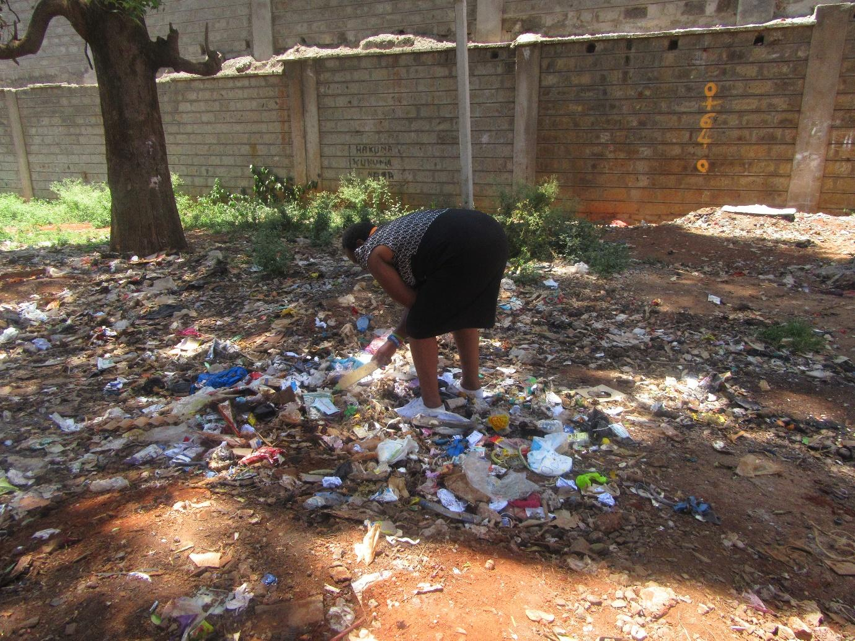
R1: As the person who took photo number 1, I would give my history and say that we spend our days in the dumpsite where when rubbish is collected from the estates, when they’re brought and dumped, we go through them, separate bones, separate plastic bags- there are bags that are bought we select those ones- and then we go and have the weight measured. The challenge comes in when we go and get them weighed and find that the person who you’re selling to also doesn’t have money and so you end up going home with nothing because it means you don’t find food for that day. So on that day you find that there’s a decline in health and if you’re someone who is on medication, and yet you haven’t found food, you find that the body suffers and gets worse. So we work at the dumpsite because we have no other option for work. We are very many, we are many women, and you can even find that someone has contracted a disease from there because they’re working in the rubbish. It’s not a place where you can say you’re going to do a good job. It’s work in rubbish, when rubbish is collected from wherever, some is collected from mortuaries, wherever it comes from, all things, things that have died, all of them are dumped there. So we sift through the garbage looking for those bones, pieces of carton, pieces of iron sheet, so that we can get those weighed. So we find this to be a major problem because people contract all kinds of diseases from there. And yet we’re take care of each other among ourselves, we don’t have options of where we can take each other to hospital, when you go to hospital and you’re asked for money you have none, so many people die from home due to starvation and lack of treatment.
M: Okay, thank you very much number 1. The question I would ask is this, also to everyone here. What number 1 has said, is it a common occurrence here in Korogocho? Are old women forced to go and sift through garbage?
R?: Yes they’re very many.
M: Okay, thank you very much number 1. Let’s all give number 1 some flowers. We shall then move from there and move to the person who took photo number 2 to give us her story just the way number 1 has given us hers.
Photo number 2
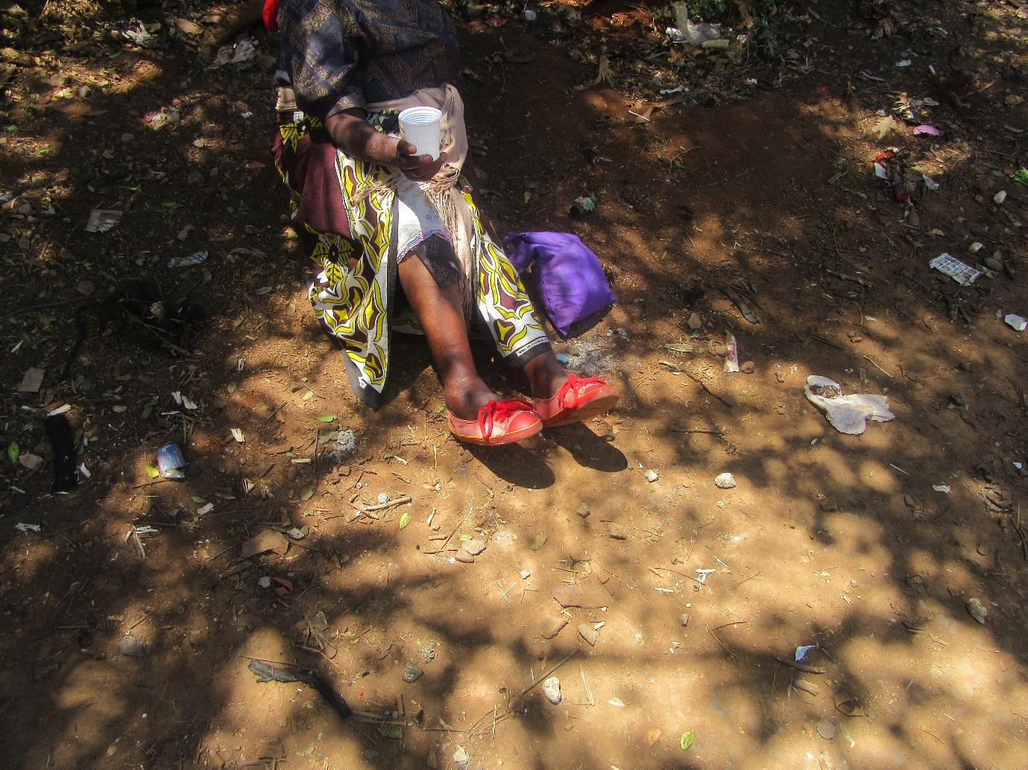
R2: Number 2, what I have seen is number 2 was going to scavenge in the garbage and while doing that after going to scavenge, after some time number 2 was unable to do it and when that happened they looked for something else to do in order to find something to eat. So what I did is I went and became a beggar because I became unable to walk due to problems with my legs. So I have been begging since then, there’s nothing else I do. When I get however much I will get, I come home, warm some porridge and drink.
M: Are there ever times when you beg and received nothing?
R?: There are times when I beg and get nothing and so I sleep hungry. I sleep having eaten nothing and then in the morning I get back at it. I go and beg and God provides and I drink at that time, I eat and drink.
M: And is this a common occurrence in Korogocho or is it just grandmother here?
R?: It is a common occurrence, they’re very many. There are many beggars from here.
R?: Like now if we say that a woman like this one could walk and is now unable, why wouldn’t she end up sleeping hungry? Then I who am able to move a little bit, you see the shilling I have even if I think about giving her, I am unable. So we have some huge challenges here.
M: And this issue of women or even men your age going hungry, is it a common occurrence in this community?
All R: Yes.
R?: To the point that some are unable to leave the house until someone notices they haven’t seen them and go to search for them.
R?: Like when there was an organisation that used to supply us with porridge, you would find long queues of people queueing to get some to drink, if they cook some githeri they would go to collect some with bowls so they can get something to eat. Going without food in Korogocho is a normal thing. And there are many who are unable to leave the house because maybe they haven’t eaten for several days.
M: So here someone can go for 3 days without food?
All R: Yes.
M: I have a question I would like to ask the person who took photo number 2 as well as the rest of you and then I will ask another question. In order for women your age in Korogocho to stop having to go out to beg, and in order for them to have food and stop going to bed hungry, what would you like to happen and who would make it happen? Have you understood my question?
All R: Yes.
M: Okay.
R2: What could happen, it’s only if there is another option that they can find for them to have a little food, somewhere they can be going to get something to eat. At that point they might stop begging because they have obtained what they needed to drink and eat because there’s no other option.
M: So R2 if I can ask you concerning what you have said, that place where they can go to get some food, who in your opinion ought to create that place where men and women can be going to get food?
R1: Let’s say in terms of food, it would take maybe an NGO that can create a place where food is cooked for them to collect and eat. Because let’s say once you eat and are full, even if you’re old, if you’re not in any pain, won’t your mind be able to work? But now if you go hungry and you’re old, you even lose your mind.
M: Okay, R1 has told us that an NGO can start a place where people can go and collect food. Does anyone have a different opinion other than an NGO?
R?: The government.
M: And the government? So the government and an NGO can come together and make sure there is a place where old people can go and access food. Thank you very much. I we go back to number 1, she told us many things, isn’t it? And she told us that that place where she goes scavenging for things to sell in order to get food, she can contract diseases as well as other things. How can women such as number 1 and other women in Korogocho be assisted in order for them to not need to do that? Let’s start with number 1 and then move to someone else.
R1: Women from Korogocho like number 1, if someone isn’t unwell they would be able to work. But now the work you could be able to do, when you go to look for work, nothing comes through. Because that is the same place you’re getting your food from, you don’t own farmland, you don’t have any property, if you went and bought kales for 100 shillings, if you sell them for a profit and get 150 shillings, you will use 100 shillings to buy oil, flour and what is left over that you buy vegetables. Isn’t the money finished? So tomorrow you won’t go to work. So first and foremost if people could access capital to work with, they would be willing to work.
M: Okay so you’re saying capital would be helpful? Okay, someone else. Who else has another way through which we can help women such as number 1? Number 4 do you have something to say?
R4: I have seen that it will be good (unclear) because like for me, I go to Burma, when I go to Burma, maybe I didn’t make anything. Say I had 200 or 300 shillings. I spend maybe 100 on food that night. Will I manage to go back tomorrow? I won’t be able to go because I don’t have bus fare. You find that to go in the morning will cost me 40 shillings. Where I will buy I need to get on a car that will charge me 20 shillings. Now can I go to work if my only capital to spend is 100 shillings? You can’t make that work. If there’s nowhere else you’re getting help from, it doesn’t work. But if we were assisted so that you’re getting 10 shillings here, and with your effort you earn another 10 shillings, they come together and at the end you have something to work with.
M: Okay, thank you very much. Let’s give number 2 some flowers for the great information she has given us. Let’s move to number 3, number 3, tell us your story.
Photo 3
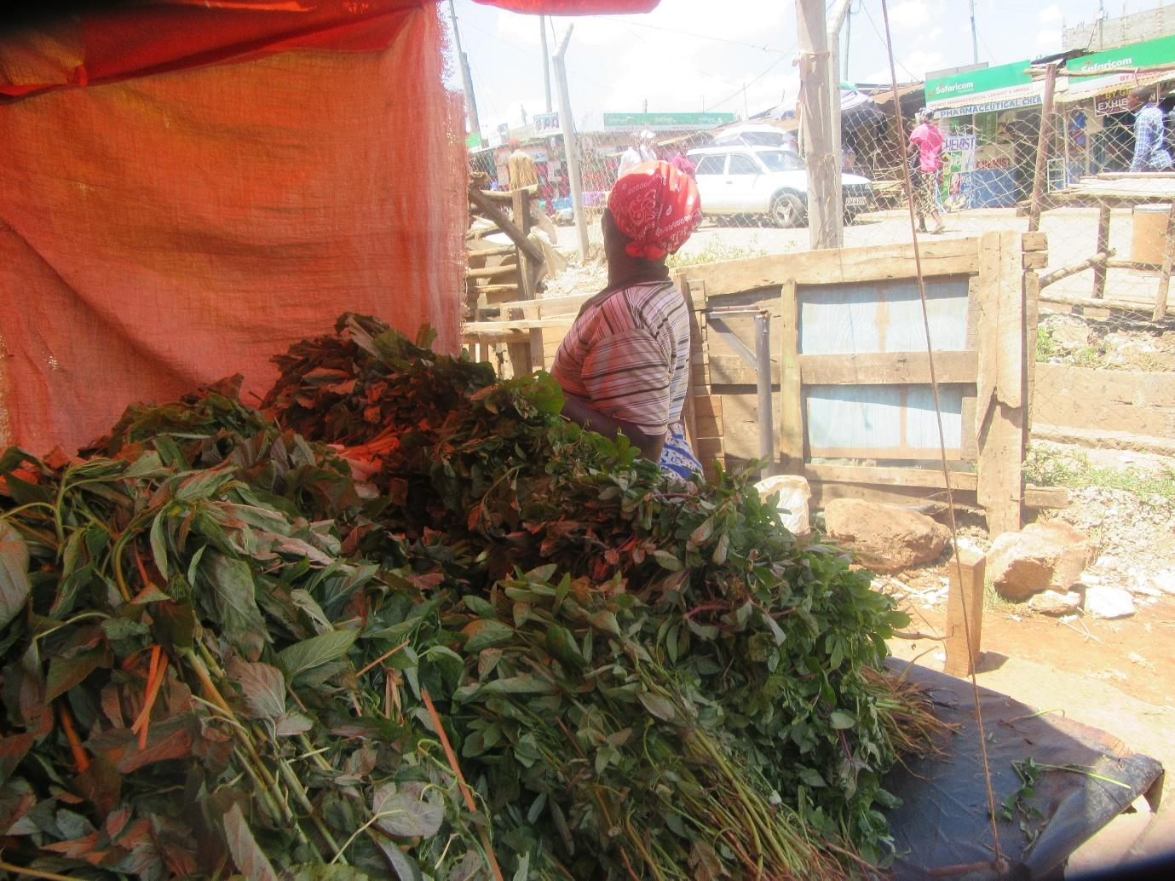
R?: It’s you [Name], come and give your story of how you get food to eat. What you experience. You tell us whether people buy from you or they don’t.
R3: People don’t buy from me. Even when someone comes along they ask me to sell to them on credit, and no one is buying from me. So when I come to restock, the few things I have kept aside aren’t enough and there isn’t enough money because people just bought the other stock on credit and when I go to ask someone to pay me, they insult me and then like in one instance one woman took my vegetables and threw them at me and said take your vegetables, they aren’t good quality, they’re bad, because I’m not able to sell good quality products, I sell cheap things that I can sell for 20 shillings each, so that person says to me that because I don’t have strength (unclear) so I decide that rather than get into a fight I take my vegetables and go and wash them since I’m not getting money to replace my stock, I chop them up and cook even without cooking oil because I don’t even have money to buy the cooking oil. Even when it comes to flour, sometimes when I go to the shop to buy on credit, the shop owner even kicks me out because I don’t have money to buy the flour and this little stock of mine I was setting out to sell so that I can get food to eat and be able to assist my children. So now there’s no work really, it’s just suffering. Sometimes I sleep hungry having eaten nothing because when I go to someone else’s house, they look at me badly because I have nothing. So even when I am helped, I get whatever I have through much suffering, but while earning through suffering, I pray a lot to God, and when I pray fervently to God, He has mercy on me, I go to my neighbour, the one who lives next door to me and I find that they have some few things so I beg from them and they also insult me and say to me since you have hands why don’t you pick up a bowl, go to the road and beg so you can get something with which to buy those few things? So I do that, I get a bowl and go to the road to beg but people aren’t giving to me, they’re just looking at me and hitting my bowl. Then they kick me out of that place. So I go back to my house and ask God if He has forgotten me. Then I find someone who has mercy on me, and after they have mercy on me I restart the business after which I find that there’s no help for me, it’s just suffering. I stay like that selling nothing. I leave there and go to Mukuru and start collecting the bad ugali that has been thrown out, I come and cut it into small pieces after which I boil it. Then I peel potatoes that are rotting and after peeling these rotting potatoes I put them on the fire with cooking fat like the one that is thrown out by companies, I scrape off the cooking fat left on cooking fat container covers and I put it in the pot, not knowing whether it has worms or soil or sand. I put it in the pot and by the time I go to hospital, I am told that my sickness cannot even be treated because I have a serious disease. So I say to God “you’re the one who will heal me.” God heals me and once I’m healed I leave it at that. Even getting meat is a problem. I just pick whichever is there in Mukuru, which I can't even tell if it's human meat or what it is, I fill my stomach with it.
M: Thank you very much number 3. Number 3 has told us very many things and I would like to ask a few questions. Is it common place to find that when someone has a kiosk, people come to buy on credit?
All R: Yes.
M: Here's the second question, she has told us that when she goes to buy flour on credit, it is denied her, right? So is it denied her because she is old or what is the reason for her being denied credit?
R: It's because the seller is wondering “if I sell to you on credit, what will you pay me with?”
M: Okay, that was the second issue. The third issue is this. She has told us that when she's totally unable to access food and when people have bought so much on credit from her kiosk that her business is extremely low, she goes out in search of food that she comes and cooks at home, right? Is it normal for people to be forced to go out scavenging for food? For old people, is it common or is it a one off occurrence?
R?: It is a one off occurrence. There are some who you will hear when they fail to find food they go out scavenging. Because when you have failed to access food, why won't you do it because you'll just be waiting to die.
R?: But I don't think it's a one off occurrence because if the Catholic Sisters hadn't come, wasn’t everyone going to Mukuru? Isn't it the Sisters' place that has helped things? Everyone would go to Mukuru but now they find that the little vegetables from the Sisters' are at least helping people so that now they don't go but it is also that they can't manage to go.
M: When you say the little vegetables from the Sisters' what do you mean?
R?: What she's saying is this: you see the Sisters' place, they give people some French beans.
M: So there's a Sisters' place where they give old people food?
R?: Yes, but they just give you a small bunch of French beans, but you can't complain.
R?: Because the people in need are many. But majority of the people end up going out to scavenge. If you're not the one who's going to go out to scavenge, because like this lady used to go to scavenge but she's now unable, the child who she was going with knows how to scavenge. They will go scavenge and bring what they get. So that valley helps old people.
R?: In fact many people have been raised off that.
M: When you say “mukuru” (valley) what do you mean?
R?: [Name].
M: So [Name]?
R?: Yes.
M: Okay thank you very much. Let's give number 3 some flowers she as given a lot of information. And then we move to number 4 to give us her story. Please give us the story behind your photo.
Photo number 4
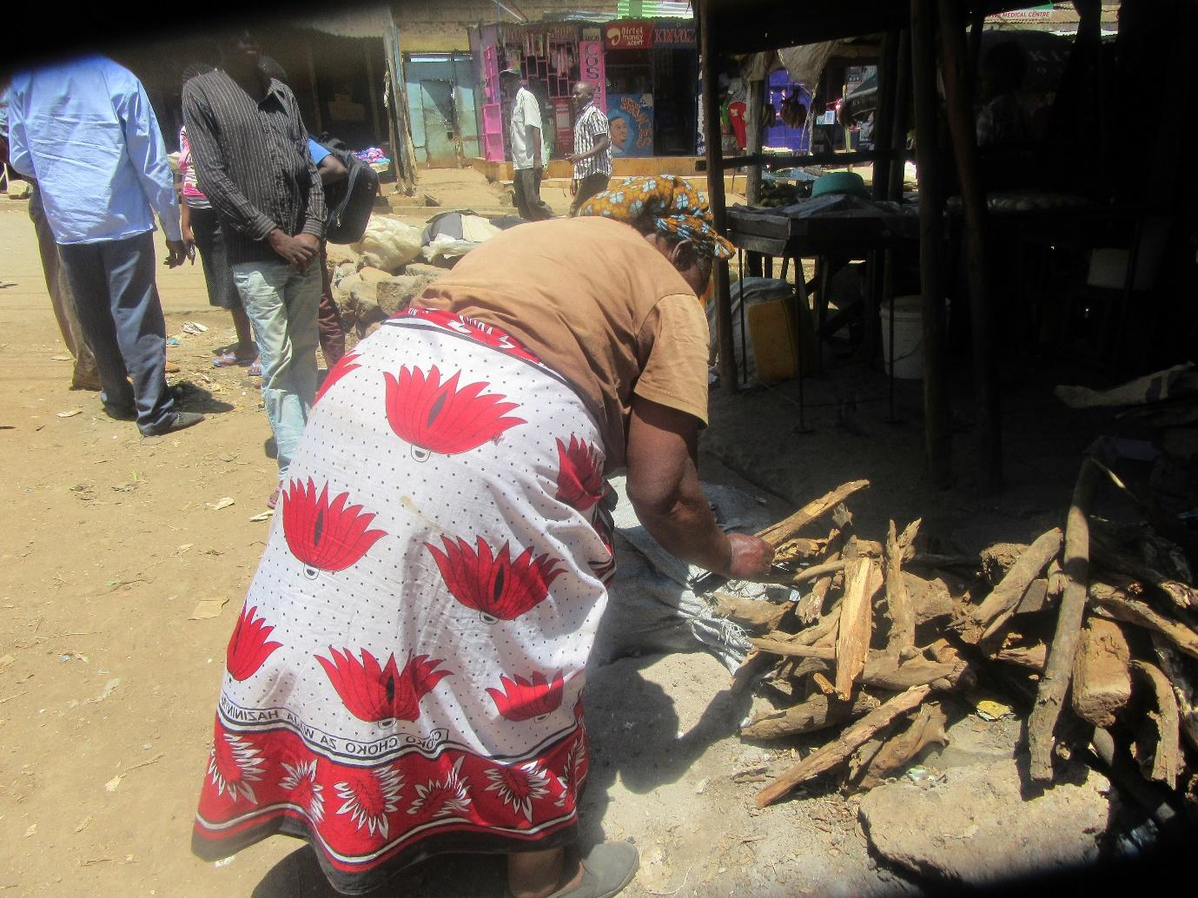
R4: My story is a long one because I wake up in the morning and go all the way to Burma where I am asked for 500 shillings. And because I know that I will be able to make that 500 shillings, (unclear). Sometimes I fail to make that money. So I come back and tell you I didn't manage to make it, you see. So I say “take this 300 shillings as yours, when I make the other 200 shillings I will look for you.” Then you go for maybe 3 days without being able to make the money. So maybe you go to Nairobi on foot and you walk back. Haven't I slept hungry at that point?
M: You've said that you wake up early to go to Burma. How early do you wake up?
R4: 3 in the morning. I leave at 3:20.
M: And is it common for women your age to have to wake up that early in the morning when it is still night to out in search of food for the day?
R4: Let's just say if it wasn't for other challenges, they would go. You see this leg, it is often painful. But because I have no one providing for me, I am forced to exert myself so that I can go there and come back.
R?: Let me say it is not a common occurrence but it is common because even if it's the person who will go to the vegetable market, they will go at that time when it's still dark in order for them to get vegetables to buy. So the challenge is that at that time you will come across rapists, you will come across thieves who will rob you and take the money you were going to buy with.
R4: Yes, sometimes I am robbed.
M: You're robbed of your money on your way to buy stock?
R4: When you come across a young man, they say they want your phone and your money. So you say “here's the money, you can have it” to protect your life because you don't want him to stab you. Since he has then taken the money, I go back to the house to sleep and the result is that I sleep hungry and spend the day like that.
R?: And when you meet worse ones, they also rape you. So you start hearing so and so was on her way to work when she was raped so she's now in the house. So the help we're seeing now is the vehicle for rape victims (inaudible- group chatter) it has started helping them.
M: So you're saying that as old women go out in search of food, they suffer bad things such as being robbed and raped?
All R: Yes.
R4: Once you've boarded the bus is when you thank God. Once you've gotten there. But before you leave this side, you go all the way with a troubled heart wondering if you might encounter them at which point they will rob you or stab you or rape you.
M: So for you, what do you think needs to happen in order for these things that you're facing stop taking place? The things that happen to you but also to other women who like you go out in search of their living at night.
R4: In my opinion if for example there was a place for someone to establish their small business, somewhere where you don't need to leave too early in the morning that would help us.
M: Okay. By the way I forgot to ask number 3, number 3 told us many things and she told us about scavenging for food in the dumpsite, isn't it? She also talked about being denied access to food on credit because she is old and cannot earn money to pay back. What things, or in what way can we help these women?
R?: Elderly women, if the government can think about elderly women, so for example there are times when they are given 4000 shillings by the government. 2000 shillings per month. If you look at the money that they receive, 2000 shillings per month, it's not enough for them. Because if she goes to the shop, the problem with Kenya is that shops don't differentiate between the rich and the poor. You who don't have purchasing power and the one who does, you buy things at the same price. If the government can look after these women, they would be greatly helped.
M: So the first thing you're saying is that they should be given that money from government?
R?: They should be given and the amount should be increased. If say an old woman is given 10000 shillings for their consumption by the end of the month they won't have finished that money because they'll just buy their few things for those 2 months. They'll buy their food and store it in the house and they'll continue to eat. But as it is, this woman is leaving the house because they don't have an option. Because if she doesn't leave, she'll die in the house, if they don't leave they'll die in the house. So you find that there's no one who can help her. Because maybe her child didn't get educated so they're in the valley. The child who would help them is in the valley at the dumpsite, they went to eat that food. And if they lack an alternative and can't find help, they end up sniffing glue and smoking bhang in an attempt to find contentment.
M: So you're saying that these women can have their stipends from the government increased. What else can be done in order for them to stop eating food from the dumpsite?
R?: So like for me I don't eat.
M: You don't eat food?
R?: No. I don't eat.
M: And what can be done in order for you to eat? You're saying you don't eat?
R?: No I mean I don't get that old people's stipend, I have never received it. In fact for me it sounds like you're just telling a story. I've never even heard about it.
R?: There's some money that is given out but to old people whose names were taken down.
20:00
M: So what you guys are saying is that when it comes to stipend for old people it should be accessible to all old women, so the stipends should all the women and that the amount should be increased. What else have you recommended?
R?: When it comes to hospitals, they have to stop asking for 500 shillings because that amount is what they use to get food so they should have their hospital bills paid by the government.
R2: What would help is that if these women are to be helped then they ought to be given those cards for using at the hospital. Because you can fall ill at night and you go to hospital and end up being admitted for 2 days at which point you will be asked to pay the bill, where will the money come from?
M: So on top of receiving a stipend for food, you also need to not be charged for your medical bills?
All R: Yes.
M: So first you need to get the medical cards so that you can manage to spend the stipend on food?
All R: Yes.
M: Okay. Thank you very much number 2. Do we have something to add to the information that number 4 has given us or do we give her flowers? Okay, let's give her flowers. So next we're going to grandma. Grandma all the information you were giving me about your legs, now it's your turn to give us all the information and how it is connected to food.
Photo 5
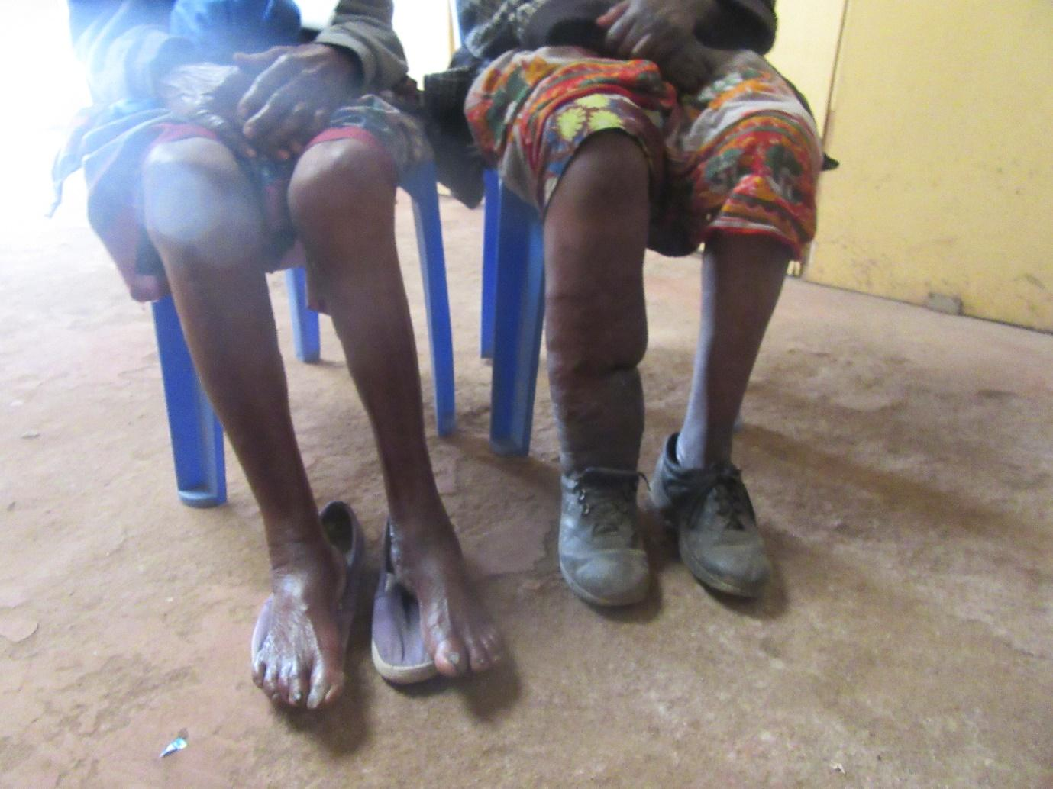
R5: Now I suffer from hunger a lot because I'm not able to walk around by myself, you saw that I was almost unable to even get here today. Now you know that if someone isn't able to move around, I may go out and come across you and tell you that I haven't had tea or I haven't had something to eat. If you're kind you give me something. So all I can do is get out of the house and sit outside my house. So even if you find me there and offer me something, what I will say to you is go and buy for me such and such a thing. So if I found someone who said to me “I'm helping you with this 50 shillings or 100 shillings” I say to them “go and buy me some flour, or something else for the house so I divide it because even if you give me some money I won't be able to take myself to buy. So my greatest challenge at this point is in the fact that I can't go out. I can even lack drinking water. Because when it comes to water, there are some children who I pay to fetch it for me. I buy the water and pay for it to be brought, you understand? Now even my mind, there are times I go to hospital and I'm told my mind is not right when I remember how I used to move around by myself. Before my legs got too bad, if I got 50 shillings, I would go to the market and buy some traditional foods and come home and they would take me through the week. But now without traditional things, I just have things from the shop. That is where things become extremely difficult for me. But if I found someone who is willing to give me something who can bring it there for me, I am able to cook. But since I'm unable to leave, that is the point from which my hunger becomes extreme. And when it comes to begging, you can beg from someone and they insult you.
M: Thank you very much number 5. Now number 5 has told us very many things. She has told us that even if you have money you can end up sleeping hungry. You can even lack drinking water. She has also told us that when she was able to move by herself, she was able to go out and buy food for herself so the question I would ask number 5 is whether it is normal for old women here in Korogocho to be unable to leave where they are to go out in search of food for themselves? And due to those challenges they end up not eating sometimes, is this normal?
R?: Yes it is.
M: So now for women like number 5, how can they be helped and who can help them? Yes number 7.
R7: They can be assisted through this stipend that the government gives to the elderly.
M: But let me remind you that number 5 has said that even if she were to be given that money by the government it might still not be of assistance to her because she is unable to go out in search of food for herself, isn't it?
R5: The money will help me because if I send you, you will go and bring me the food.
R?: If she sends you, you will go and bring her everything she needs. She'll list for you bring me this and this and this and you will bring it to her.
R5: But then if I have nothing, what can I send you to buy for me?
M: Okay, so the first thing is the stipends for the elderly. What is another way in which women like number 5 can be assisted?
R?: The government has very many things going on and they're saying they want development, they're saying they want to deliver people from enslaving poverty. People such as her who aren't even able to walk, the government ought to think about how they can even open up a home because it won't cost them many millions. So if you have someone who is unknown like how they were saying that disabled people should be brought out from their homes so that the government can know them, isn't it? Even those who are disabled due to old age, who have become unable to leave their homes due to old age, the government also ought to know about them. They could then maybe set up a home, so that someone like that who maybe doesn't have family members who are able enough to feed her, is then sent to the home where they can stay without problems. Because now sometimes she's forced to wait until someone is passing where she is and she calls them to send them. Maybe she ends up giving the money to a thief who then disappears with her money. You see the challenges they go through? Because when she's hungry she'll just send whoever is close by. “You, come. Take this 100 shillings and go to the shop and buy for me this and that. Then that person disappears. So you see if all she had was that 100 shillings it means she ends up sleeping hungry that night? So now even the government ought to look and consider. This kind of people, since they aren't so many that the government would be unable to handle them, the government should when they get to the place where they can no longer fend for themselves, pick them up and place them in homes.
M: So is it a common occurrence for example to give someone money as you send them to buy something for you and they disappear with the money?
All R: Yes.
R?: Now since you're hungry, the problem is that there's no difference between adults and children. So you can even send a child and you find that the child has gone away with your money.
M: So number 5 because you have faced this challenge, have you ever given someone money and they went away with it and failed to bring you whatever you were trying to send them for?
R5: It hasn't happened once by the way, it is a common occurrence. So now the only person you can send is the person who is well known to you. You can't just give a stranger. But now if the person who is well known to you isn't passing through, you see a child and maybe you can't differentiate the child from another child whose mother you know. You think that because it's a child they can't steal from you only to find out that the child is even worse. Then she ends up sleeping hungry.
M: Okay, thank you very much. Let's give number 5 some flowers. Or was there someone who had something to add to that? Let's move to number 6. Number 6, give us the story you gave us earlier, the story about disease and how it affects your lack of food. So your story as it is connected to food. Like you were saying how sickness causes old women to go without food or to fail to access the foods they would like to eat.
Photo 6
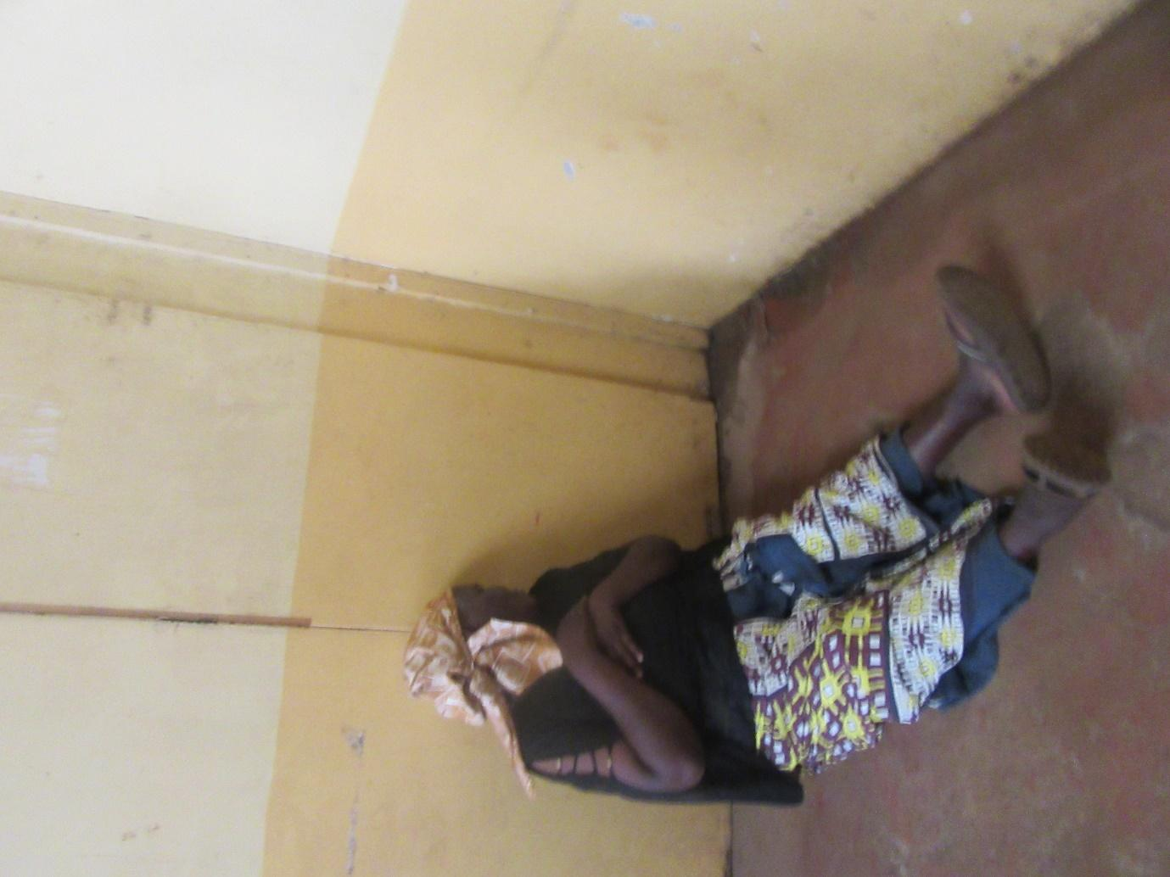
R6: My leg is often sick which results in me spending my time at home. But near my house there's a path and no one passes there without calling out to me “[Name] how are you?” And then they get in and see how I am. Then they leave with a prayer, prayers can change people.
M: So apart from your leg, have you ever been suffered a sickness that made it impossible for you to fend for yourself or get food to eat?
R6: I am often extremely sick (unclear).
M: How is that sickness connected to you lacking food?
R6: I was told I am diabetic.
M: You were told it's diabetes. Okay, so to the other women here, when someone falls sick, does this disease in any way impact their ability to find food or lack food?
R1: Like that one is really bad because once you're diabetic, you can't just mix kales and eat because you're hungry, you can't just mix whatever is available and eat because you're hungry, this disease limits you so that there are specific foods that you ought to eat. So now you find that you don't have the money to buy those foods. You're told to go and buy brown flour (sorghum or millet flour). Since not many people eat this brown flour, there's no shop you can go to and ask for brown flour unless you go and get your own flour milled, so you source maize and you go and get it milled. Many things concerning the diseases that are currently there result in oppression and they result in people lacking food. The medicine you need to buy if you have 200 shillings it can only get you a prescription for that day alone and then the medication runs out. You don't have a source of income because you're bedridden. So starvation there is a real problem, people really go hungry.
M: Number 6 is there something you would like to add concerning the connection between sicknesses and food? Is there something you would like to add about how you get food when you fall sick? That is how you access food when you fall sick?
R6: Now, when you fall sick, only God can help you. If you don't have a relative close by. Much as you love me you're still not able to come and fetch water for me, buy me food and help me in other ways. So I only call on God because I don't have any of my people close by. But they were there, one of my in-laws who passed on recently.
30:42
M: So what do you do? When you fall sick and you don't have any of your people close by, what do you do? In order for you to get some food to eat?
R6: God just comes through because my house is close to the road.
R?: They're also given by neighbours. When you find that they have nothing, you go to the house and given her what you may have.
M: Okay. There's something else that you guys said. You said that when someone infirm and has to stay in the house, someone can come and give them some food. Is it other women your age who will come and give you or who is it who will come and give you something? Let's hear number 1 and then move to number 2.
R1: The person who can give you food, let's say for example this lady learns that this other lady is sick. Then she comes and tells me that she's sick. Then as we're talking there about the one who is sick another neighbour might wonder “why are people going into this woman's house? Is she unwell?” Then she also walks in to the home. If say you have flour, you will bring some. But now you can hear the challenges of food that are there because the food that you're eating in your house is what you will collect from and give. The sugar in your house is what you will divide and give her some. So you see such challenges. So this challenges are the ones weighing heavily on elderly people because most of the time the reports that are often received have to do with diabetes and high blood pressure. Those illnesses require different types of foods. So you find that there are many of them who are dying due to lack of food.
M: Okay, are the rest of you in agreement with what number 1 has told us?
All R: Yes.
M: Would anyone like to add something or are you satisfied with that contribution?
R?: We're satisfied.
M: Okay, let's give number 3 some flowers. Then there's one thing that I forgot to say. You said that old people, when they're alone in the house, most of them don't have relatives close by and they can stay hungry in the house for many days, isn't it? In order for this issue to stop being a common occurrence, what needs to happen and who would need to make it happen? What can you say needs to happen?
R1: There's what we were saying that if the government can give them stipends that will suffice for each elderly person who is older than 60 years to get enough support it would be good. Because if the son works in the valley, when they come home with flour, they will eat theirs they won't need to eat what their mother or grandmother has saved up. This will mean that the elderly person still has their food which will push them along. But if that person leaves so that now this elderly person has no other person they can depend on, if that person goes and comes home with that flour or sugar after work, the elderly person can't consume it because the disease they're suffering from requires that they don't consume some foods since their blood sugar levels will rise too high, you understand? So what we can say is that we often see elderly people dying in that area due to hunger and dietary issues.
M: So now number 1 has told us, and she had told us that before, that if elderly people can be given enough money for their needs through the government's stipend for the elderly program, it would be good. But then number 5 told us that you can even have that money but fail to find someone to send or have the person you send run off with your money.
R5: That means people who like me are unable to move by themselves but it's not necessarily everyone. But now when I have some money, I'll be willing to send you isn't it? So you bring me something or I send someone else. But if I don't have the money what would I use to send someone? But once you deliver those foods for me, I will manage to cook.
R?: If someone brings her water and food and charcoal or even maize cobs, someone goes out looking for them and they bring to her, she will be able to cook for herself.
M: Thank you very much. Other than the stipend for the elderly, how else can these people be assisted in order for them to stop sleeping hungry?
R1: So maybe an NGO to open up and give to them.
M: Give what to them?
R1: Food.
R2: So it would be known that there's an elderly person in this home, they need to be given food.
M: So number 1 and 2 are saying that there could be a group somewhere that cooks food and gives to the elderly.
R1: So for example it may not even be necessary to cook for them because when the food is cooked for them it will mean only one type of food is cooked. But you see if for example an NGO got a group like this one you guys have here today of 10 people, and they said they're able to help those women, you see everyone has their own medical history, one suffers from diabetes, one is HIV positive, the other one suffers from whatever other disease. Now what someone eats, when you go to buy from the supermarket, they can know that brown flour for ugali is for 4 people who are given that flour so not necessarily that you come with ready cooked food.
M: thank you very much number 1. Number 7.
R7: Let them be given food.
M: Number 7 says they should be given food. Is there someone we have left out? Number 3. None. Okay.
M1: Maybe also let me ask, is there something you can do for yourselves? Or had you already discussed that before I came?
R1: Yes we had said that someone can do some work. The one who is not sick. So someone who is not sick if they were to find some capital, they would be able to work.
M1: Okay, so what kinds of work do old people do?
M: Number 4 can give you her example. Let number 4 give her the example of the work she does just the way you had told us.
R4: You see if someone has money, and you're healthy, not in any pain, you're able to leave the house and when you leave, whatever you get you bring home and cook it and sell for some shillings. Once you have sold, you will have managed to help yourself isn't it? Then God comes through in other ways. But when you have no money, you have no options in terms of what to do. So like now I came here which means I didn't go.
M1: You didn't go to work?
R4: I didn't go. So like now unless something happens and I figure out a way to get food, what shall I eat?
M1: So you don't know what you will eat today?
R4: Yes.
M1: But now like when you talked about having some money with which to run a business, are there many people who have money to run businesses here or how does it work?
R4: You see like now if, like you have work that you're doing. I can come to you and ask you to lend me 500 shillings. And then you ask me what I'm borrowing the 500 shillings for. And then I say to you I want to do such and such a thing like all the other women are doing. Would you refuse me? You wouldn't. And now because you have given me the money on loan, I will only work with it for 2 days and then pay you back.
M1: So now for old people, say that money that you're saying you would like to have in order to start a business, about how much would that be? About how much do people need in order for them to start a business like the one you're talking about?
R4: Even 2000 shillings would be enough to start that business.
R?: It will also depend on the type of business you're starting.
M1: Yes it will also depend on what work that is that you go and engage in.
R?: Yes so like her, she sells “moshothi.”
M1: What is that?
R1: She buys chicken's heads at Burma market, when chickens are slaughtered she buys the heads and takes them home where she prepares. After that she sets them up on a table outside her house on the road. So if she considers her capital perhaps 2000 shillings will be enough for her to grow her business. There could be someone else like number 3 sells kales. If she were able to buy high quality kales and was able to store them properly, you might find that 2000 shillings can be enough, depending on the work that someone is going to begin, right? So depending on what business someone is interested in, you may be able to assist them. So that is what we were saying that anyone who is able to walk by themselves would be able to work. The challenge comes in with people like her who aren't even able to walk, those who are unwell. And then you hear that she has never even received the stipends that are paid out to elderly people.
M1: So the cash stipends being paid out to the elderly aren't getting to everyone?
R1: No they aren't getting to everyone. Which is why I'm saying I had heard the chief calling for people to present themselves. So what I'm saying is that these people can be helped by government because like now the government is talking about millions and hundreds of millions having gotten finished. These people who are too old to cater for themselves would not reach a million in total. So if say we were to build for them a centre, those who are totally unable to care for themselves like this one who is even unable to send people should be taken to that centre. So for example both she and I work in the valley, scavenging in the dumpsite. If I am unable to go where will the old woman go to? To the dumpsite. So when I'm unable to support myself, she will be bringing ugali that she has collected at Mukuru and bring it. I am diabetic so I'm supposed to eat brown flour and yet at the dumpsite she didn't find ugali made from brown flour but only white, so I end up sleeping hungry. Don't you now see where the hunger comes in?
39:51
M1: So this centre that you're talking about, it's a place for the elderly people to live?
R1: Yes. They can live there because even now that she's not in the centre she's suffering. When you give her that money, maybe she can't even find someone to send, the only person passing is a small child so she decides that is a small child so they can't steal from her. “Come. Go to the shop and buy me some milk so I can make some tea.” Then the child runs away and all she had was that 100 shillings. She doesn't have anyone else she can get help from because that is Korogocho there's nothing. She cooks with firewood and maize cobs and there's nothing else she can do. You see? What we need is for you guys to first come to the field and go door to door and see things for yourselves so you can see that it is true. Poverty doesn't hide, isn't it? So for you to see for yourself what we're saying about cooking with maize cobs, “rondorondo,” and firewood, it is a normal thing. But if there was someone to offer them assistance, they can be assisted effectively. Because for example if you take say that NGO that was taking 10 people and it starts to help them set up businesses, then they go to maybe to the city and they're bought for plastic products like sandak shoes and so on and then they find a spot to display them and they're told what the prices are for the various items. After you have made your sales we'll come and do the calculations later and your commission from this business is such and such an amount- they would do that work. They live like this because there's nothing they can do. There's no one you can go to and ask them to give to you for free.
M: Now I want us to go to this photo, photo number 7. Thank you very much number 1. Once we have discussed it I'm going to do a summary of all the photos so that those who were not there can hear. So that anyone who has a question can ask, right, then someone who has something to add can add. Isn't that a good plan? Okay photo number 7.
Photo 7
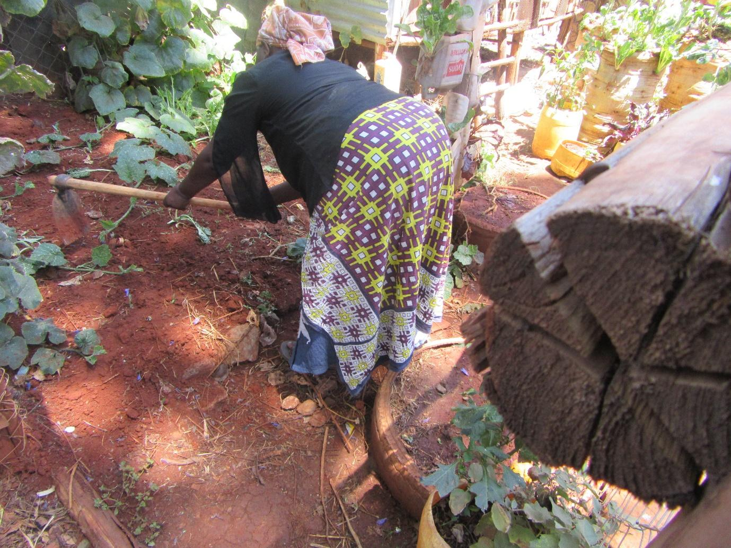
R7: Photo number 7 is at the time when I was still strong. I wasn't very sick. But when I got sick I was no longer able to go out to farm. What can you do? Now I have to be given and my medication has to be bought for me by whoever may have pity on me. If no one has pity on me I have to wait until when some money comes in in order for me to buy some medication.
M: You're saying this is when you were still strong enough for you to fend for yourself. So right now what are you doing and how are you getting your food?
R7: I am able to get some food because I have some grandchildren who come and share with me what they have. When they don't manage to earn anything, then we all sleep hungry.
M: How old are your grandchildren and where do they earn from?
R7: They just go to the dumpsite to scavenge. Whatever they find they bring to me. Whatever is brought, they know for example that I take very little sugar, so they put for me a teaspoon of sugar. They know that. In my house they know what type of flour I eat due to blood pressure issues.
M: You have said that they scavenge in the valley in the dumpsite. Is it food they bring from the dumpsite or what is it they get from there?
R7: In regards to food you could go and find some bones and some pieces of metal which they go and sell and come home with the money. But when they're told “place what you've collected for the day there, the business owner will come tomorrow,” then they just put down whatever they have and they come home. So at that point we can only beg for some food from the neighbours.
M: So is that normal? What number 7 is telling us, is it a common occurrence here in Korogocho, where you find old women who are unable to fend for themselves and are forced to rely on their grandchildren to go out and work and whatever they earn they then use to buy for the grandparents some food?
R7: Yes, they're there. In fact they're many.
R?: Yes we're there.
M: And are there times when the grandchildren fail to earn anything and when you seek help from your neighbours they're unable to help you?
All R: Yes.
M: Because you women have told me that they aren't given when they try to borrow because they're told that after borrowing they won't be able to repay.
R7: Yes, you may be unable to repay.
M: So it is a common occurrence? Number 4.
R5: Because if you lend to me, how will I pay you back and yet I have no income generating activity?
R7: In fact they will tell you plainly right there. “If I lend to you, how will you pay me back? Because when your children get back, whatever money they will have earned won't be enough for you to pay that money back so I won't lend to you.”
M: So let me ask, in your opinion, when you say, number 3 spoke to us and told us that when she sets up her vegetables business, sometimes too many people buy on credit to the extent that she is forced to close down her business because the people fail to pay her, right? When you consider your neighbourhoods, do people refuse to lend to you because you're old people so you might be unable to repay or are the other people denied credit as well?
45:01
R?: Even the other people are denied credit because I told you for example if I work in the valley in the dumpsite, my child will also go to work there and when they get a child that child will also work in the valley. So you find a generation going to work in the dumpsite. So there's no money because you can't make good money from the dumpsite. Before there was money working in the dumpsite but now there's no money because all the garbage trucks are divided among some people so that each person has theirs and you aren't allowed to scavenge from rubbish that came from someone else's truck so even such issues have brought problems.
M: And what do you mean when you say that all the garbage trucks are divided among people?
R?: You see the garbage they carry, when a truck comes from Westlands, that truck- that is the rubbish in it- belongs to Nyambura, it can't be touched by someone else. So even where you would go and find a piece of carton to go and sell that doesn't happen anymore. The trucks are unloaded, then the “owner” sifts through, removing the cartons and whatever else they want to resell, and then leave the rubbish that is of no value. So even where before many people would benefit from the dumpsite that is no longer the case. So even as you hear us talking about earning from the valley, that's not really there. If say a truck is coming from Baba Dogo and takes garbage to the valley, it belongs to a specific person. So they first get all the things they want- plastics, and so on- whatever is forgotten, that is what you will find the old people scavenging through, those who are still energetic as well as their children. So there isn't much there.
M: Thank you. Let's give number 7 some flowers. And then what I want to do now is to go through all the photos, so that those who weren't there can hear and you can tell me whether that is what you have said and then if someone would like to add something that will also be fine. Number 1 told us that old women in Korogocho are forced to go to the valley- by which we mean the Dandora dumpsite – to scavenge for things like bones, plastics and pieces of metal which they can sell in order for them to get food.
R?: It's not just old women, it's all kinds of people. You can find everyone there.
M: So it's all kinds of people. And then she also told us that there are many times when they leave that place with diseases and other issues. Number 2 told us that a long time ago she used to be able to go to the valley in search of a living but that now she got sick and is now forced to go out begging. And sometimes she's treated with contempt, people kick around her collection bowl, she can fail to get something and end up sleeping hungry. Number 3 told us that she tries to run a business selling vegetables. But then people come and keep buying on credit and not paying her and sometimes young people come and disrupt her business and she goes hungry, so much so that she is forced to go to the valley to scavenge for food which is what she then eats. This food doesn't go down well with her because it makes her sick and sometimes when she goes to hospital they even tell her they can't tell what the sickness is. Because she went and collected food which she ate. Number 4 told us she wakes up before 3 in the morning and goes to Burma market to look for animal meat pieces which she comes and sells. She also told us that since they leave in the night, many bad things happen to old women. They get raped, they're robbed and stabbed and also sometimes they can go and fail to earn something. When that happens, then they come back home and sleep hungry. Number 5 then told us that as an elderly woman, her legs are sick and painful. She said that there are times when women are unable to move by themselves so they can't move from wherever they are. So at that point if you don't get someone who will come to give you something, you end up sleeping hungry. Sometimes you could even have money but fail to find someone who you can send and you could even fail to find someone to fetch water for you and you end up sleeping hungry. Those you send to the shop also sometimes run away with your money so you can go hungry and lack food or even water. Number 6 told us that elderly women in Korogocho when they fall sick they can go without food for many days because they are unable to go out in search of food and they don't have relatives in Nairobi who can help them so sometimes they lack food. And number 7 said to us that before she got sick she worked as a farmer and would earn some income. But right now she is unable to do that and can go without food. Have I covered your stories well?
All R: Yes.
M: Is there something you would like to add on? Or might there be some questions from the other moderators? Anyone with a question? Okay, from these photos and the stories you have told us concerning these photos, there are people who you have told us you would like to see them. You said it would be good if some NGOs were able to bring food for the old people. You said that those responsible for disbursing stipends to elderly people need to get information that not all elderly women in Korogocho are getting those stipends. So they need to see to it that the money reaches those women. Apart from those people, who else would you like these photos to reach? Who would you like to receive all that information that you have given us?
R1: Anyone who may be able to assist.
M: Like who for example?
R1: Like you who are asking us these questions.
M: For me you have given me this information. Who would you like me to get this information to? Other than the NGOs you have mentioned?
R?: Uhuru.
M: Uhuru? (President Uhuru Kenyatta)
50:06
R?: Uhuru is the one you can take this information to because he is the one who takes care of orphans, he's the one who takes care of elderly people and he's the one who takes care of the disabled. That is the person who normally needs to receive this information.
R1: But if you found whichever avenue through which you can get food to us, we're not choosing that we only want to receive from certain places. Even if they're going to come from Uganda or wherever they will come from, if they can bring women in Korogocho something that can be of assistance, it's okay.
M: And who would you not like to see these photos? Or to be reached by this information? Are there people who you would prefer not receive these photos?
R?: There aren't.
M: Number 5 are there people you would prefer not see these photos?
R5: No.
M: These photos, when we said we're going to take them, many people said they have challenges with their feet, isn't it? So we didn't go too far to take them. If you had the ability to go to your neighbourhood to take photos, what kinds of photos would you have taken that you weren't able to take? Number 5.
R5: I would still have taken the ones I took.
M: So the ones you took are the ones you would've taken. What about number 4?
R4: I would have taken the same ones.
M: Okay, so the same ones. Grandma, if you had been able to go all the way to your neighbourhood, are there other photos you might have taken instead of these ones or something you would've liked to portray that you weren't able to because you couldn't go far to take your photos?
R?: No.
M: So you're fine?
R?: Yes.
R1: I would like for you guys to even come to my place where I live and stop looking at my appearance only. Where I live where I cook with maize cobs, I would've liked for you to come all the way there to see what it is that I do. Because now here they might see a photo of me in the dumpsite and think that these people are clean and it's because I was told get up to go for a meeting some place. For you to see me where I live, where I go to when I'm done scavenging in the dumpsite.
R?: You should tell her about where I live where she will find a place full of maize cobs.
R1: I would've liked that photo of the place where I live.
R?: I would also have liked it.
M: Is there anything else that you would like to tell us? Would anyone like to add something among the moderators? Okay, so all I can say is thank you very much, yes?
M1: And these things you have told us about, since you're all women, do the men go through the same kinds of issues or are their challenges different?
R?: Let me respond to you. My problem, unless I share it with you, you would never know, isn't it? So you might come across a man and unless he shares what his challenges are with you would you be able to know? You wouldn't. Isn't it? You wouldn't know. Even a woman like this one if I meet her, unless she shares her problems with me I wouldn't know.
M: So the issues you've shared with us are women's issues, not men's issues?
R1: Well, you will find that they're almost similar. But now you know with a man, let me start with men, from the beginning, men were expected to help these people. So when he is in the house even if I am the one who has some money, (unclear) if he is not the one who is earning, you understand? So it is very good for you to reach that man in order for him to also give you his challenges because we're not the same. When a woman has children they may take better care of her than they do their father. So this man, you need to sit down with him so that you can hear what his problems are.
M: Okay, thank you very much. We're very grateful for the time you have given us. I know that there are those who would like to go and open their businesses so we will release you but before we release you please the lady at the back her name is …..
End of Audio
Recommendations
- Government to give enough money to old people. Old people die a lot due to hunger.
- As an old person who cannot walk the only way I v=can get food is by sending people to the shop. There needs to be a solution for us.
- NGO’s to start feeding programs.
- We can work hard for ourselves to get food.

