AFRICAN POPULATION AND HEALTH RESEARCH CENTER
RIGHT TO FOOD PROJECT
ARCHIVAL NUMBER: 181025_0211, 181025_0921
CONTACT TYPE & DESCRIPTION: PHOTOVOICE–KOROGOCHO WOMEN
DATE: 25/10/2018
START TIME: 2:00PM
END TIME: 4:30PM

M: Alright, I can see that we’re ready. Let me say once again welcome and thank you for also welcoming us here and for your time. As I had informed you, we’ll start our conversations and we’ll follow the procedure I had told you about earlier. So I would like to welcome the person who took this photo. The floor is yours. This is photo number 1, group 1.
Photo 1, group 1
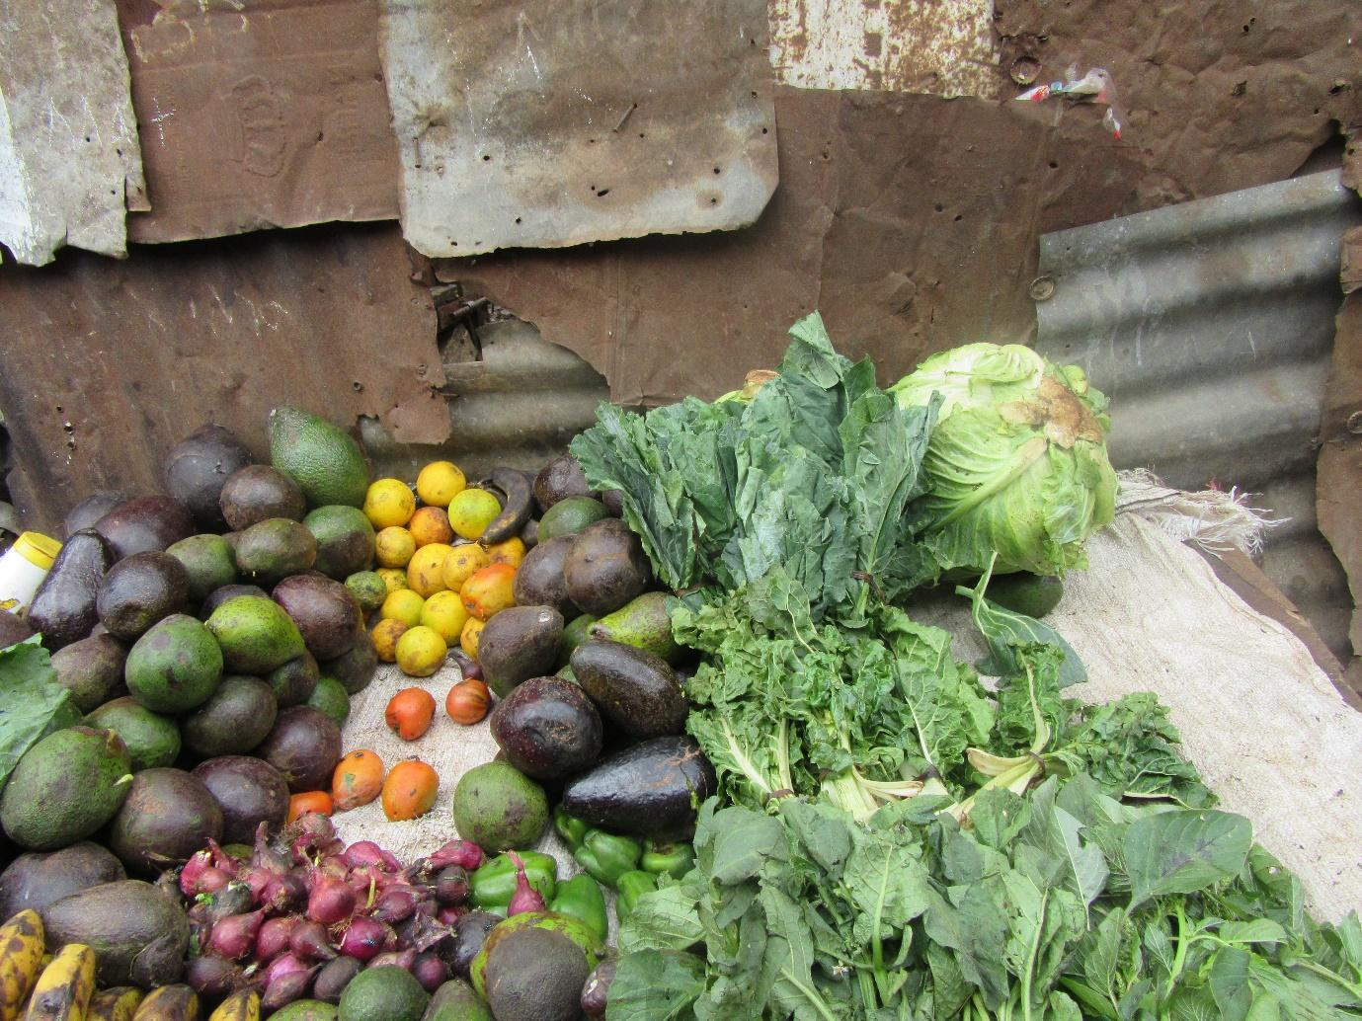
R3: How are you? This photo number 1, good access. These are the foods that are accessible in our neighbourhood. This is along a pathway. So if you want something cheap, you can find it there along that pathway, it’s called Mama Lisi’s place. We go there to buy things. Employment, these young guys, a while back they were criminals and then they reformed and were given these motorbikes to start a project.
M: A small interruption: which is your photo? Is it photo number 1, group 1? If that’s the case, you will only speak concerning that one. The other photo, the one who took it will have their turn. So for now we only discuss photo 1 group 1 taken by R3.
R3: Okay, I was saying that these are the foods that are available in our area, so we go there to buy. This is what we see as fitting for us. You can’t afford the expensive ones so you go to the cheap seller.
M: Okay, I would like to ask the first question: which foods are these?
R3: You can see some avocadoes, but not the very fresh ones, they’re the ones- they’re fresh but not very fresh at the same time. Cabbage, kales, spinach, bell peppers, onions, oranges, tomatoes, and African night shade.
M: Okay, thank you. I want to stay with you. You said that it is fresh and it’s not fresh, how?
R3: Because these are the ones which after the very fresh ones have been selected, the ones that are left are the low quality ones which are sold cheap.
M: I would like to ask a question but first, I want to speak to all of us. You can just have a seat. These foods that she has spoken about, this situation- is it what you find here or not? Is this situation there?
All R: Yes.
M: So now let’s talk. First let me ask. She said “fresh, not fresh.” She said that there are the one that have already been selected and these are the ones that are left. My first question and this goes to everyone. Who has selected the other ones and where did they take them? In order for you to be left with these ones that you are saying?
R1: So depending on the life of the owner of this business, they don’t have a high income. So when they go there to the market, they can only pick these ones that they get for a low price. Because, since they’re being sold at different prices, he wants these ones that are cheap. Because when you go there to their place, you can even go with 5 shillings and he takes out two avocadoes because he has to first cut the avocado to confirm whether it is good, you see? Because he doesn’t have the income to allow him to get these other ones.
M: So R1 let me ask you this: you mean that this seller when they go to the market to buy their avocadoes, he is the one who selects these ones?
R1: Yes.
R7: Let me speak there. You know in the market there are things like avocadoes that get to the market when they have slight dents. There will be tomatoes that have been squashed. There will be kales that aren’t very fresh. So you see, this person goes to select those ones and they are sold to him at a price that is very low such that even if you go there, he will sell those to you at 2 for 5 shillings. And one usually goes for 10 shillings, the very fresh one- one is 10 shillings. But these are sold to him at that discounted rate and he is able to come and sell to people in the neighbourhood at that low price. Because it is dented. Because as you have heard it has to be cut before it is sold. Maybe it was squeezed during shipping and is spoilt on the side so they will cut that side before selling it to you.
M: I have many questions concerning this. But let me first start there concerning the “faulty” food because you have touched on that. Number one, what is the fault? Let’s hear from R10.
R10: they are faulty because they have been dented and also they are slightly spoilt. Also, the ones that were fresh, maybe they were bought by someone else and these are the ones that were left. So that is the “fault” they have.
M: Okay, let me stick to the issue of “fault” a little bit. When you consume this faulty food- does it cause any harm?
R8: It doesn’t cause any harm because that place that is spoilt we will cut it off and you actually find that these ones that are getting spoilt are the ones that are oily nicely. So once you cut the part that is spoilt, you eat something that’s very good and that you bought at a low price.
M: Okay, so it doesn’t cause any harm? I don’t know if there is someone with a different opinion? Do they cause any harm or are they just fine? R6.
R6: They don’t cause any harm. They have come from the same place, from the same farm, and they were delivered in the same vehicle. But now the way they have been delivered, there are some that were ripe while others were not ripe. So the ones that weren’t ripe are placed aside, they are selected and placed aside, and these other ones that were ripe are the ones that got dented during shipping. So due to that they get damaged.
R?: They aren’t expired.
R6: Yes, they’re just damaged due to getting dented during shipping.
R?: Also, the place they are selling from, the customers are used to that price.
M: So you are trying to say that this person has a market?
R?: Yes they do. Many are bought because even me I will send my child and say go to mama Lisi and buy an avocado for 5 shillings. Sometimes the child will be given 2, they’re just cut a little bit, the part that was damaged.
M: Okay, so let me ask this. There in the market where this person gets their supply, are there others that are better there at the market?
All R: Yes.
M: So why don’t they pick those good ones? Let’s contribute one person at a time. R2.
R2: So this person prefers this one depending on their purchasing power. So he sees that yes there are better ones, but the price at which they are sold, it is beyond their reach, you see? So they buy these ones because they can see that when they go and sell, they will make some profit and tomorrow they can go back to the market. But if he bought the more costly ones, he knows that he will stay with his stock for long, it won’t move as fast.
M: Okay, on that point I have understood. Let me ask this, a follow up question. In the neighbourhood, now let’s move from this woman, in the neighbourhood we already understand that in the market there are better avocadoes. Here in our neighbourhood, are there people who sell those better ones? The ones we were speaking about, the ones this seller didn’t choose. The ones you said would cost more, are there people selling those ones in the neighbourhood or do the sellers sell only these ones? Let’s start with R8.
R8: There are vendors selling the good ones because even here in Korogocho, there are people who place themselves in a high class. So they will go and buy that one for 10 shillings while I will go and buy this one. There are also those who sell both- the good ones, they will place a label indicating the price is 10 shillings and these others they will place a label indicating the price is 5 shillings. So you simply go and choose the one you want as per your class.
M: Okay, R4.
R4: Let’s say it depends on how you earn your money. You might find that your job pays you 200 shillings so you have to do the math for that 200 shillings. You see where you will buy those kales, tomatoes, will the 200 be enough? Plus to pay for your savings group contributions- it will be enough. The other person, maybe their income is 500 shillings per day. So they will choose the fresh supply while you will choose the cheaper supply so that your money can be enough. So it depends on how much you earn.
M: Okay, R3.
R3: But also at the end of the day, all of you… you’re saying “bora chakula” (just food), not “chakula bora” (quality food).
M: There where she says “bora chakula” not necessarily “chakula bora” that was actually going to be my next question. I now want us to look at these two situations. R4 has explained to us. There are those who depending on their purchasing power, have gotten what we have called here the better food, and then this one is also not bad, it’s good food but this is what is normal, what has some “faults,” my question is this. This person who is consuming the ones we’re calling very good that cost more, and the person who buys these ones that we see here in the photo, when it comes to health, is there a difference? In terms of their physical health, is there an effect? Because you said that there is no harm that is caused, but is there a difference? R6.
R6: you’re asking is there is a difference between the one who eats the better ones and the one who eats the ones that are dented? For me, like those ones that are being sold at 4 for 5 shillings or 6 for 5 shillings, I will go and buy for my kids those ones and if you look at my kids, they are completely fine. Even if you just take a look at them you can tell they are kids who are well taken care of. Because it’s something that I take, I come and prepare it and feed them. Even those ones that they’re saying are for high class people, you can go and buy them and feed your children but if you compare these children, you find that mine are healthier than those one.
10:13
M: So you’re saying that the ones who eat avocadoes from this bunch that is dented are healthier than the others? Okay, who has another view concerning this story? R10.
R10: They are all the same.
M: Why?
R10: Because if it is avocado they have eaten, they have all eaten the same avocadoes, the faulty ones only had small problems- they are slightly dented and these other ones are not. But they are all avocadoes.
M: Okay, let me hear from R8.
R8: You know those people who go to select the good ones, their thinking is that it might have an insect. Now you see with that kind of thinking, you will even lose weight. Because by the time you have wondered whether there is an insect in the fruit, your brain is already processing a lot. But those of us who don’t choose the good ones, we eat everything and the bodies are healthy.
M: Thank you very much. That was going to be my next point and she has put it very well. Where you mentioned insects for example. Let me ask this, these ones we have said that they have dents. The first question: how did they get dented and where did that happen normally? R8.
R8: There’s a way, as they come from the trees, there are the ones that fall to the ground and get slightly dented. So when they ripen, they ripen that way with that dent. But also when it comes to being dented, those who carry the ripe ones, they carry them and toss them into the vehicles because they’re already tired of carrying them so they simply toss them into the vehicles. But the unripe ones can’t be dented. An unripe one can’t be dented.
M: Thank you. And this brings me to my main question. The question is this, when the fruit has an accident as you have called it, whether it has fallen from the tree and cracked a bit, or whether how it was carried during shipping to the market they get dented, my question is this in this entire process, including in the market, the handling in the market, as well as where the avocado may have fallen originally from the tree, when these things happen, is there a possibility of the food getting contaminated? Is there a possibility of this food getting dirt, or as you said insects, is there a possibility of contamination with germs or any kind of dirt? Is that possibility there?
Group: Yes.
M: R5.
R5: Yes, that is possible.
M: It is possible?
R5: Yes.
M: Okay, R2.
R2: It is possible because even that process for it to get to the market, you see it has gone through many processes. When it gets here, the vehicle simply drops the food onto the ground. It then leaves here and goes to that kiosk. This person then moves it from here to deliver in their kiosk. Oftentimes you will find that even the way they have placed them at the kiosk, they didn’t wash them, they simply placed them there. So the process that they come and use is the knife, you see?
M: Okay, thank you very much. R3.
R3: Down there in that kiosk, there is a ditch passing under the kiosk and it isn’t a clean ditch.
M: Okay, thank you. I want to come there to the ditch. Let us move back a little bit. Have you all agreed that in that process you find those dents and the slightly dented fruits for example it might get dirty. Is that what we have said?
All R: Yes.
M: Normally, because these may have that dirt, might they harm us? Are there some health effects? Might they cause us to get sick because of that dirt? What is the situation normally? So what I want is for you guys to tell me what has been happening, not what might happen. I want to get the experience, because people have been eating these, and we have said they have a chance of getting germs there, do you normally see diseases which you can say might have been caused by this situation? I don’t know who to start with, R10.
R10: When it comes to diseases, there are times when we get them because you can find that there is a cholera outbreak in our neighbourhood and if we investigate closely we find that it is due to the things we were consuming.
M: Okay, who would like to add to that?
R2: As I add onto that, sometimes you find that especially with these younger children, say I have given the child 5 shillings, you see they don’t know, they just go and buy and eat. If it was me who bought, maybe I would have come home and first washed the food. For the child they just buy and eat. You find that diarrhoea is sometimes highly prevalent
M: Okay, thank you very much R2. Now let me ask this. We have said that in the market, there are the ones that are good and then there are these dented ones and I know that one reason she has given is the level of income. Apart from low income, if you move income levels from your mind for a bit, what is it that might cause someone to decide to buy these ones, and not buy the other better ones if both are available in the market. If you move away from the issue of money and income levels, the money is there, you have money. What would still make you buy these ones that are in this photo and not buy the ones that we can say are good? What would be other possible factors?
R4: Distance.
M: R4 says distance. Please explain that to us.
R4: You find that those ones in the photo are available close by. Those other ones are far away. So you just decide to buy the ones that are available close to you.
M: Okay, R8.
R8: Also, what you’re accustomed to contributes. Since you’re used to going there, even when you have money, you will still go there. You don’t want to lose your status as a customer, you want to be identified as a loyal customer especially if you need to buy on credit. Because if I buy somewhere else, I won’t be allowed to buy on credit.
M: Okay, thank you. R3.
R3: That’s why I’m saying you have to be well known to the person from whom you’re going to buy and you make friends so that if tomorrow you lack money, they will allow you to borrow. It’s not that today you buy from here, then when you have money you go to the other person, then when you don’t have you come back to this person, this would cause problems.
M: R2.
R2: When I have money, you will find that I have gone and bought the avocadoes for 10 shillings and maybe I have 5 children. That 10 shillings has only bought me 1 avocado which I see won’t be enough for the family. So I prefer to buy the other ones so that I get enough for all my children.
M: Okay, thank you very much. And because we have spoken at length about money, even as R3 was presenting about that photo, they said that these are available at low prices. I would like to ask: generally in our community here in Korogocho, what is the situation with the cost of food? And here is how I would like us to look at it: is food available at prices we can afford? What is the situation? How would we describe the situation when it comes to the cost of food? Yes R3.
R3: I would say when it comes to the cost of food, it is cheap. Because there’s no other place I think where the food is as cheap as it is in Korogocho.
M: Okay, good. Does anyone have a contrary opinion? So we are agreeing that in our community here, food is cheap? We can access food at cheap prices?
All R: Yes.
M: Why is it that food is available here at very low prices? That is my question. R7.
R7: Food is found at low prices because this area is a slum and many people are living in lowly conditions. They aren’t employed, their only work is their different hustles, so you find that even the food that people bring, the food they sell, and buy is very cheap.
M: Okay, thank you very much. Another contribution. Yes R3.
R3: Let’s say for example when you go to a hotel, someone is selling their food at 50 shillings which is githeri and for me the same githeri I am selling for 20 shillings. You see I will have more customers that they will because everyone will rush to where I am selling at 20 shillings and the one going for 50 shillings will be left there. So the consequence is that those in higher living conditions are the only ones who can go there but the people in lowly conditions, and these are the majority, will come to my selling point.
M: Okay, thank you. I see R10 followed by R7.
R10: The fact that the market is close by also contributes to availability of food at low prices.
M: Okay, thank you. R7.
R7: the other thing is competition. You find that that person is selling, this person is selling, so they are many. If you price your food high, you won’t find someone to buy from you which is why food is cheap.
M: Thank you very much. I would also like to ask this. This food of ours that we eat here that we have said is easily available and cheap, where does it come from? So like these vegetables, where do they come from, if it’s the fruits, where do they come from, those in the market, where do they come from? R5.
R5: It could be they come from Marikiti or others come from the rural areas. There are times when the suppliers from the rural areas bring their foods here to the market.
M: Okay, thank you. Someone else? R8.
R8: There are others who have planted for themselves.
M: People have planted here?
R8: Yes, people have planted and then they see that the food is ready, they harvest and deliver it to the market and sell at good prices.
M: Okay, let me stick to that point you have said about those who have planted their own food. Where have they planted their crops? Are there farms here?
R2: If let’s say it’s here in Kasarani, on this side near the river, there are some farms there, here in lucky summer, also in Korogocho if you to the side of the river there are some farms.
M: So R2 is telling us that they are planted alongside rivers or streams?
All R: Yes.
M: Okay, are there other places where people plant crops? But let me first ask concerning these rivers- which rivers are these that we’re speaking of? These rivers where they plant, how are they in regards to hygiene? What is the state of the water in regards to hygiene? R8.
R8: I would say they are not clean. They aren’t clean because those rivers pass through, I would say here in Korogocho, many latrines are drained into that river. And as that water flows, it also reaches the vegetables, the water flows to the kales, which is why you find that this person has bought these kales and they have seen that they look very fresh even insects haven’t eaten them, the insects haven’t attacked them, the vegetables are very good, people see that these are the good vegetables and they buy them and when they eat they have serious diarrhoea.
20:30
M: Okay, it affects people?
R8: It affects in a major way.
M: So these vegetables that you say are found here at low prices, they have an effect? Do they have health effects in terms of causing diseases?
R8: There are some that do. Let me tell you, when you go to the market, look for the kales that have been eaten by insects. Insects like what is good. If you find the one that hasn’t been attacked by insects that is the end of you.
M: Some good lessons we have been taught there, thank you R8. Let me ask this. You yourselves have told me that vegetables have been planted there in those places that you have described and you have said yourselves that those are not appropriate places to grow vegetables from as R8 has explained. And we know very well that the vegetables have come from there. Now, have we taken any steps as members of this community?
R?: Let’s say not everyone who has planted in those areas delivers their produce to the market. Those who plant there, many of them sell by the roadside. You find that they have come here to the road, this main road, they arrange them there and sell from there. Because often times the vegetables in the market come from other farming communities.
M: Okay, for my point, I want us to go back right there. We ourselves know that there are places where the vegetables are grown poorly and it goes to be sold, even if not in the market for this community. Us as the members of this community, have we taken any steps? R2.
R2: There aren’t any steps you can take against someone because there if you look, that is their business, it is the place from where they feed their children that is where they educate their children from. You see like now if I come to buy, I won’t be buying knowing where it was grown. I will simply come and buy it because I have seen that it is fresh. Then now you say let me just go to mama Lisi’s because she is the one with whom we have an understanding.
M: Who would like to add something about this story? Is there a step we have taken so far? Is there something you yourself have done to assist in this situation? R8.
R8: We haven’t taken any steps because here in the neighbourhoods if you want to take any action you’re branded a spoiler. If you go and say you want to speak about something they just say “get away from here you spoiler.” So there’s no way to help the situation.
M: Thank you very much. Let me ask this. We have said that so far we haven’t taken any steps for a good reason which you have explained. So, if we were to brainstorm here right now, what can be done, in order for people to stop planting vegetables in those areas or in order for us to make sure people from the community don’t eat vegetables that come from those places? Where is the solution and who ought to look into these issues? Give us a solution, we said that today we want to speak about finding solutions. R2.
R2: Right now, at least right now I have seen that we’re starting to see some changes because people are being educated about things like a kitchen garden, you see. I think that kitchen gardens, you can even plant here at your home right at the door, a place that will be safe. If you compare that with what is grown there along the riverbank, sometimes you find that the vegetables are being watered because the farmers are directing the water to those vegetables.
M: Okay, so you are telling us that the solution is for people to adopt these kitchen gardens in the way people are being taught? Maybe very briefly, are you able to tell us who is undertaking teaching the community about kitchen gardens?
R?: Mostly, there are some projects that involve educating people about these kitchen gardens. The NYS also educated people, yes.
M: That is a good contribution. And people, after they have been educated, have they started forming these kitchen gardens? R10- have people started implementing or are they just speaking about it?
R?: There are those who have started.
M: There are those who have started and those who haven’t? Let me then ask this. For those who have yet to start, how come they haven’t started yet?
R2: sometimes people, even if you come and educate them, they will tell you that getting the seeds is a challenge, they might say getting the seeds, or getting the insecticides they will need for the vegetables they may also say that is a problem getting them.
M: So before I move to R3, R2 you are saying that finding say insecticides and seeds is hard- are they hard to get access to or is the challenge the cost of buying them?
R2: Let’s say it is me. You have come and educated me and I have seen that that is good knowledge, but according to my situation, I feel that it is difficult because I won’t be able to get those things.
M: So you’re saying that the challenge is you might be unable to get the money for these things, not to find a place to buy them from. Okay, R3.
R3: I will say that many of us haven’t been able to start farming because first and foremost of the space challenges. You see our houses are corridors, even if you look at them from outside you can see they are the size of a corridor. So you wonder this space, this is where I walk in through the door to enter into the house, for the neighbour to walk past and go to their house. It is where the neighbour hangs their clothes. That is the same space where the child uses the pottie, so you see the space challenge. Most people don’t have that space because the houses in Korogocho are corridors.
25:12
M: Okay, R10.
R10: Something else that stops people from starting is water. Because you will need to be watering those vegetables and yet the water we use here we have to buy. So if you buy 2 or 3 jerry cans of water, you have to decide will you use it to cook or to grow vegetables? So now you end up deciding you’re better off not starting a kitchen garden.
M: Okay, so my last question in this story about the kitchen gardens. For those you have seen doing it, have you seen any benefits in their lives which you can say, like a testimony of how you have seen their lives change in their standard of living? Or in regards to health, anything you may have seen. R4, have you seen someone doing this kitchen garden?
R4: I haven’t seen anyone yet.
M: Okay, R8.
R8: They’re doing well because they can sell those vegetables and get an income from which they can buy what they don’t have in the house. If for example we say I lack a table and have those kales that I’m growing there, I will simply pick and go sell to people a fresh product that is good and then buy myself a table.
M: Okay, which table is that?
R8: Just a regular table for the furnishing the house.
M: Okay, R3.
R3: Those with kitchen gardens are doing well because the money they were going to buy vegetables with, they’re no longer spending. Maybe they’re saving, you see. And they have those kales that they can mix with amaranth. So they can come to me and sell me vegetables for 20 shillings and then with that 20 shillings they can buy amaranth and at the same time supplied me with vegetables at which point we will have helped one another.
M: Okay, thank you very much. That discussion on kitchen gardens we got there as a recommendation of what can be done to resolve the issue of vegetables that have been grown in sewage. Let’s go back there to the recommendations. What else can be done to make sure people don’t eat these vegetables or plant these vegetables and who ought to take these measures? R9.
R9: We can educate people (unclear). So people should look for ways how they shall grow even if it’s finding a sack and they start growing the food in sacks, where they can plant them properly and place it there to grow.
M: Okay, thank you. Another idea? R3?
R3: Okay, what she has said is good but also people from Korogocho are difficult. You could be explaining to them, they’re just listening but they won’t implement, you see? At the same time you can’t be going to find out other people’s business and yet you haven’t sorted out your own. You mind your business and leave me alone.
M: So these difficult people, what causes these people, what can be done to resolve this being difficult?
R?: Perhaps you bring them money. Korogocho is all about money.
M: Okay, that’s a good contribution. What else can be done? Because R8 told us that if you speak concerning these things you are told that you are a spoiler. So, is there another channel we can use to get this information to them in a way that you won’t be branded a spoiler but the people will gain from it? What can we do? Okay, R7 is saying something about the government. Yes.
R7: The government could bring that directive that people ought to stop growing food close to sewage and sewer lines because often times they farm in the places where sewage is leaking- those are the places where they farm. So the government needs to issue a directive that people are not to farm close to the drainages through which sewage water flows.
M: Wow, a very good contribution. I would like us to move forward. In this photo as we started, we have spoken about where people source food from and in speaking about sewage, it was one of the areas from where our foods are sourced, isn’t it? So we have been told that there’s the food that comes from near sewer lines and there are the foods that we’ve been told come from the rural areas. Are there other sources of the food we eat here? What are some other sources? Let’s not limit ourselves to vegetables only. Let us consider all types of foods. Where do they come from?
R7: They come from Mukuru.
M: R7 says they come from Mukuru. Where in Mukuru?
R7: There at the dumpsite- it’s on the other side across the river. There are sweets that come from there, they’re washed, kids are given and biscuits, there is also bread, the loaves that come from the factories where they’re produced, there are those that get spoilt or deformed, say a loaf fell and was walked on by people, they are usually packed in sacks and delivered there. And people eat them, they are cheap, people buy them they are very many and in the morning people have them with tea for breakfast. And I think it’s not a good thing because you see the people who sell, when they’re caught, they get arrested and that thing is eaten so even the government knows that it isn’t a good thing that is being brought to the people.
30:19
M: R10 has something to add.
R10: There are also leftovers from bakeries. When they’re leaving the bakeries they say these leftovers are for use as pig feed or chicken feed but once they get here they are sold to us.
M: Okay, R10 take me a bit slowly so I can understand clearly.
R10: These loaves, when they are leaving the bakery, it is said that they are going to be chicken feeds.
M: Okay, I understand now- so when they get here, they are sold to people for their consumption? Okay, I understand. R6.
R6: Even chicken is there. There is a place from where chickens are slaughtered, the ones that are cooked in town there are the parts that are chopped off. When they’re chopped off they say they’re going to dispose of them there in boma, in Mukuru, but they’re brought here to Korogocho in the evening you’ll find them in plenty, they’ve been arrayed for sale. So we buy, we go and cook ugali and eat with them.
M: Okay, those are very good contributions. Someone says fish as well. Yes R7.
R7: Fish as well, here, there is fish that is available close by, there is the fish that is considered waste, the ones that are rejected. So people go and buy and they bring them here to our neighbourhood and we buy them.
M: Okay, let me ask this. These foods that we have spoken about just now, starting with those that come from the dumpsite, coming to these ones that come from town, and the ones that come from industries like you have said, when we eat them, because we have been eating them, do they have any negative effects on our health? Do they have any effect on our bodies? R2.
R2: They do cause some harm.
M: What harm?
R2: Sometimes you will find that someone is eating, after 2 or 3 days, you hear them saying I’m having some stomach issues or they say they’re having diarrhoea. If you ask them what they ate, they say I bought such and such a thing from there and I suspect that is what is causing me this problem.
M: Okay, would anyone like to add to that? R6.
R6: They are completely harmful. Say for example when the children are coming from school. The child will be in that group of theirs, how they walk together. They pass by these foods displayed for sale because they’re usually displayed around 4 p.m. The child has their 2 shillings the other one has their 5 shillings, so you find each child buys something and starts to eat on the way home. By the time they get home, they have stomach aches through the night. So tomorrow first thing in the morning is to take them to hospital as you wonder what the child ate and then you remember it must be the things that they bought on the way home. So yes, they do cause us harm.
M: My question is this what can we do, or what can be done, in order to get people not to eat those foods? Because we have seen they have negative effects, what can be done? What is the solution? R9.
R9: The government needs to intervene in this issue.
M: Okay, what specifically does the government need to do and is it the county government or the national government?
R9: The county government.
M: Okay, I can see R3 wants to assist as well.
R3: I would say the government ought to intervene, the county government, because it is the one that is close to us. Because if they start, say like that “moshothi” (chicken remains) comes from Kariakor, where those chickens are slaughtered. So you see for me, I go with my money, I go to buy “mushuthi” and they add for me some intestines and feet, those that are added for free. I then come and boil them and sell to people. Haven’t I made a profit? Haven’t my children gone to school? The one who gets a stomach ache, that’s their problem, do I care? All I need is for my life to go on.
M: Okay, let me get a contribution from R7 and then R8.
R7: Okay I would say the government ought to intervene because often times when there’s a cholera outbreak, I hear the outbreak starts in Korogocho, most of the times. And the times when they say that those businesses should be closed, when the doctors from Mathare who are the ones in charge of our area come and say so, you find that all those things are not available, they aren’t being sold, when they come. So they have more power than we do. For us, sometimes we go as we’re teaching them about hygiene and so on, but they ignore. So I think if the government intervenes this goal can be achieved. They only come when there’s a cholera outbreak and you find that at that time not even a single kiosk is in operation. But once they leave, everything returns to normal.
M: Okay, we have spoken at length about the government. Before I pick R10, let me ask. We ourselves who are here, what can we do to improve this situation? Where is the solution? R8.
R8: I would say this. I see people writing, you see how we have taken those photos, we can write on some papers and go posting them that we want cleanliness, we don’t want to eat dirty food, and we have decided. And those of us who are buying these dirty things and we know they’re dirty, we need to decide that we won’t be eating them. If you’re longing for chicken, wait for the day your pocket will be more full.
M: Okay, a good contribution. Let me take a final contribution. What can we do ourselves? My neighbours, R5, what can we do?
R5: What we need is to cooperate all of us together, we unite. If we unite, we can resolve that issue. Even those ones who are selling we can speak to them.
M: Okay, thank you very much. I want, maybe one last question regarding this photo and then we can move forward. You have told me many times here that there’s plenty of food here in the market, isn’t it? The food is in the market, right? But in our homes, is there food? So I’m asking this, because there is food in the market, does it mean that in the homes as well there is plenty of food? That is the question, who should I start with? R3.
R3: In our homes, there isn’t plenty of food. Because if we say for example looking at me right now, (inaudible). Because right now, maybe I would’ve gone to look for that casual work washing clothes, so that I can start and buy flour for 20 shillings, vegetables and whatever else, you see? Once that money runs out, I then have to look for more tomorrow and so on. So you see there’s really no stock to store. There’s nothing you’re stocking up there. So you get, you eat, you get, you eat, there’s no day you will save and say I don’t know what. Because even right now if the child got sick, maybe I would say “I see so and so can help me,” so I run to their place. Then I am begging them for that 100 shillings of theirs, and then they say to me here it is, I don’t even have.
M: Okay, thank you very much. Let me add something to that question on order for R8 to respond. So we’re saying that there is food in the market, isn’t it? In our homes, is there also food? Not even speaking of keeping some stock but in your house do you have enough food simply because there is food at the market? R8.
R8: I will say that in our homes, we don’t have a fridge in which to store food. If we find we can keep, we can get the ones that are broken and we store in them. But right now there’s no fridge and even the money someone earns is very low, so it still doesn’t allow you to store some stock. Yes.
M: Okay, thank you. Now in our homes normally, why are we not keeping any stock? Are people eating enough food, do they have all the food they need? Speaking about the home now, because we have established that there is food in the market. Is this reflected in the house?
R8: It depends.
M: R8 says it depends. How?
R8: It depends on your work. If my work allows me to get 100 shillings a day, that 100 shillings is what I will use. We’ll just eat and deceive the worms in the stomach. We’re better off just eating a little and being grateful for that day. Then I go and get another job doing laundry and earn 200 shillings, on that day we’ll add a little more food and so we’ll be a little more full even if not too much. And on and on just like that.
M: I don’t know if I should have one more contribution as we wind up. Yes R3.
R3: I wanted to add something briefly. You see that 100 shillings she’s talking about, from it you still want to save maybe for school fees, in the morning the child might want to eat a mandazi and so on, so you can see it becomes difficult to have any stock of food.
M: Okay, my final question is this. Because in Korogocho there’s lots of food, and we have been told that there are many varieties of foods, isn’t it? What is the health situation for the people living in Korogocho? Because we’re speaking about nutrition and how people are faring physically, what is the situation generally? Are people in good health? The fact that there is food in the market, does this reflect in our bodies? Do we look healthy because we have many foods and good foods? What is the situation? Let me first hear from R10?
R10: The situation is not good. The health situation is not good.
M: So why is the situation not good and yet there are lots of foods?
R10: The situation isn’t good because also getting access to that food is a challenge.
M: Why is it a challenge and yet the foods are right here in the market?
R10: Due to income levels.
M: Okay so due to money issues, I get you. Anyone else want to add onto that? R6.
R6: There is plenty of food in the market but then it depends on the money you earn. Perhaps I wait and receive money once per week, you see. So it will be difficult even if foods are available in plenty in the market for me to have them in my house due to the income I am earning.
M: Okay, R8 and then we move on.
R8: I would say our health isn’t too bad. We’re better off than people in places like Marsabit, we’re better off. If we travel, in places like Marsabit people are very skinny.
R?: I wanted to add: even you when you look at us, us who are from Korogocho, how do you differentiate us from the others?
R10: I would like to add to that. Yes it may be true that here we’re slightly better off but if you walk deeper into the slum you will find some homes where health is truly low. So yes food is plentiful in the market but like that bread that we were telling you about, that “anyona” is what children eat with black tea in the morning. That is what they will live on all day and maybe all they will have in the evening is a cup of porridge. So you see maybe for us here we’re fine but if you go deeper into the slum, you will discover the situation is really not good.
M: Thank you very much R10 for a good contribution. R3 you took a good photo that has brought us some very good discussions as we have seen. We have discussed many things, haven’t we? Before I release you, as you were taking this photo, as you were trying to communicate to us the good message you have communicated to us, might there have been other photos you would have wanted to take communicating the same message but were not able to take? Explain to us please.
R3: We wanted to take many photos but some people didn’t want us to take their photos. Others would ask you “are you paying me something? If you aren’t paying me anything, don’t take photos of me. You have found work nowadays!” So such things which would make you afraid because in Korogocho when you walk with something like a camera or when you’re seen with a stranger because in Korogocho we all know each other, so if they see me with someone like you they assume today Magda will have so much money today no one can touch her.
M: Okay, thank you very much. I want us to appreciate guys but we won’t clap due to the recorder, so we’ll give flowers, you guys know how we give flowers right? Drop. Thank you so much. So far we’re doing well. Are the issues coming out and are we having good discussions?
All R: Yes.
M: Let’s move to photo number 2. And let me say this. You see like in photo number 1 as you have seen we have spoken about many things, isn’t it? So once we go to another photo you might find that the issues that arise from it are issues we have already discussed so we won’t dwell on them so much. So if it is something we have already spoken about we’ll simply move along. So don’t worry if we dwell on one photo for a long time. If an issue comes up it is important for us to discuss it, isn’t it women? Let’s move on to the person who took photo number 2 group 1. Welcome R2.
Photo 2, Group 1
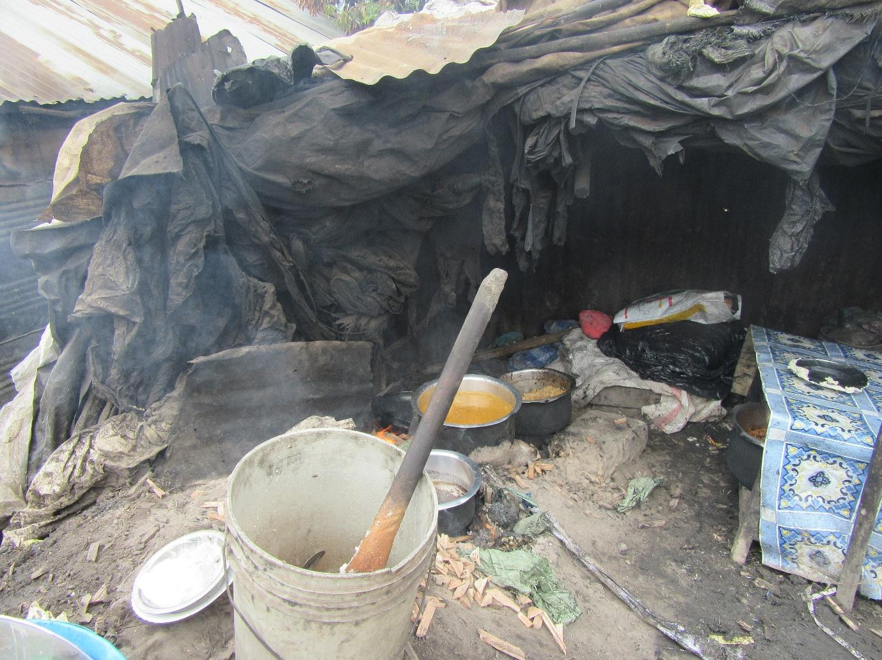
R2: how are you? I am R2 from group 1 and I took photo number 2. It was speaking concerning contamination. This is a business premises and they’re cooking food for sale. If you look at this surrounding environment, you will see how it looks. Also, there’s a ditch on this side. A ditch that serves as a drainage there and this is where they’re cooking food for people from.
M: Wow, thank you very much R2. You may have your seat because I now want us to speak and let me ask this first. This photo, does it portray a situation that is found here or it doesn’t happen? Is it something that happens?
All R: Yes.
M: So we find people cooking in places where there’s dirt, there are drainages, there’s sewage?
All R: Yes.
R?: Even right now if you went you would find people having lunch and enjoying themselves.
M: Okay. So I have many questions here. My first question is this. On account of this situation with these foods, are we affected in any way when we eat that food? Does it cause any of these diseases we have spoken about or it doesn’t have any effect? R8.
R8: It has an effect because those flies- do we call them flies? It will go into that ditch, get into contact with that dirty water and then come and get into contact with the food and there are some negative effects there.
M: Okay, before I pick R3, let me ask this. The places where we buy food from, might there be people who sell the same food? By the way R2, what food was that?
R2: They cook rice, chapati, githeri and ugali.
M: Okay, let’s take the chapati for example. They’re cooking chapati in this environment. Are there others who cook chapati in an environment that is different from this one? A cleaner environment? Are there such places? R8 says there are. So let me now ask this question. Why would you buy chapati here and yet there is another place that is clean where chapatis are being sold? R3.
R3: If I respond to that, that place most of the time is a base for drunkards. So drunkards are the ones you will find tackling that food there according to how I know that place, it is in my neighbourhood. You wouldn’t find someone like me going to buy food there and I can see how the place looks.
M: Why drunkards?
R3: Because drunkards in Korogocho are “don’t cares” provided someone will get full, even if they will sleep there it’s fine. Also, that place is cheap, you see? If all they have is 20 shillings, they can buy something. They will go there and buy on credit, because that woman knows them, she will give them food and they will pay later or whatever agreement they will come to. So there are different options.
M: Okay, thank you. Would anyone like to add something? Why would someone- other than a drunkard- why would a regular person buy something there and the same thing is available at another place that is cleaner? What would cause that? R10 says that this place is close by.
R10: I might decide that instead of going far I’d rather buy here.
M: Okay, another reason? R6.
R6: You see for drunkards depending on where they enter and drink, it happens to be close to where this food is being cooked. So once they come to eat, they’ll only need to go round one corner, enter their house and sleep.
M: Okay, thank you very much. In photo number one we spoke at length concerning contamination, isn’t it? And we spoke a great deal about diseases so I won’t speak at length here about that. So my last question is this. When someone eats food from this environment, and they get sick, so maybe they get cholera like you mentioned earlier, I want us to brainstorm a little and ask this: when this person gets sick, how does this affect the food security situation in the house? The availability of food in the home? What is the impact? So think about it for yourself- you have eaten there, you have gotten sick, maybe contracted cholera or typhoid, the fact that you are sick, how does it affect the food situation in the home? Who do we take first? R10.
R10: It has an impact because if I’m taken ill, and maybe I’m the breadwinner, it will mean that even the rest of the family will go hungry. If I’m sick, I’m bedridden, I won’t be able to provide for the children.
M: Thank you very much, that is first angle, that you’re the breadwinner in that house so you won’t be able to bring in an income. Is there another way sickness would have an impact other than in that sense? R7.
R7: The food that would have been spent on buying food, will be spent on that sickness.
M: Okay, thank you very much. So we have seen that apart from you being sick, there are other impacts on other people in your family, right? So the final question is this. Where is the solution? What needs to be done and who should do it? In order for us to not have this kind of situation, for us to not have that contamination? Yes R3.
R3: The solution is for people from health to come and inspect and if they’re going to shut down that hotel, they show that woman the way forward in terms of how she will earn. Because now if you tell her to shut down, and this business is where she is feeding her children from, paying her rent, what is she going to do? It is a must that you show her the way forward.
M: Thank you very much, that’s a very good idea. R4, what can be done?
R4: What can be done is that if these people from NEMA (National Environment Management Authority) can come and assist here if say it’s to (unclear). They can put up a kiosk for her which will be raised and that ditch should be fenced off and that place made clean.
M: Thank you very much. R5 is there something that we can do?
R5: I would just agree with what she has said, the solution is for that person to be assisted, rather than simply shutting down her kiosk which is where she earns, she needs to be assisted.
M: Okay, thank you very much. I would like us to proceed to photo number 3, group 1. Let’s kindly give R2 some flowers. Receive them. Photo number 3 group 1, this is by R3 right?
Photo 3, group 1
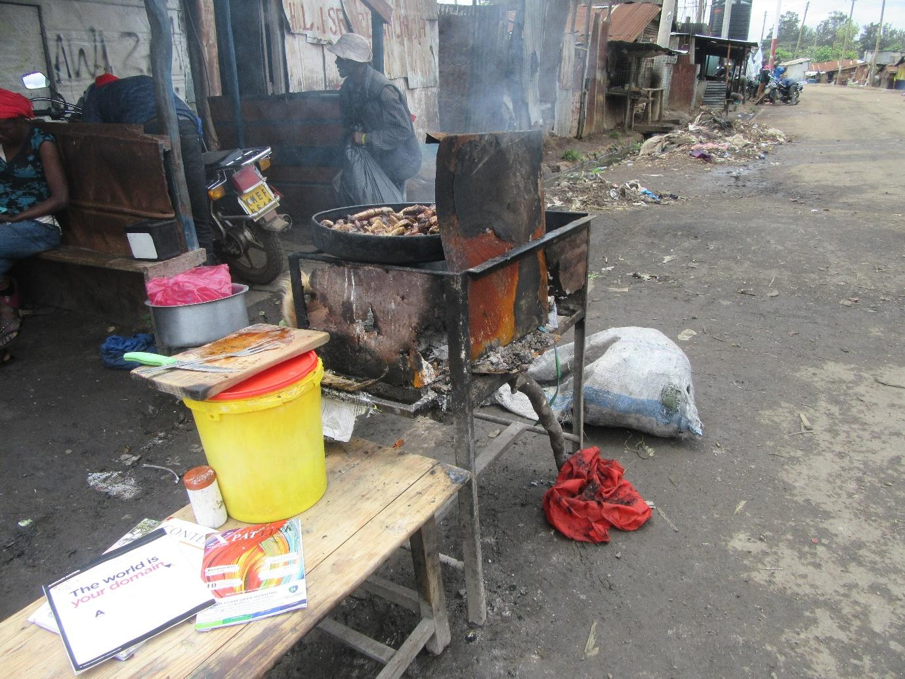
R3: Good afternoon. Affordable. The foods that are affordable are these ones. This meat I don’t even know what type of meat it is but it is quite delicious. What are they called? These are those ones. And then now when you find them being cooked, you wouldn’t even like to look at them. But they are so delicious, we eat them with ugali. But also this place where they’re being cooked from, is so extremely dirty, maybe these guys can explain to you.
M: Okay, I have been told that you guys should explain it to me and support me there. The first thing I would like you guys to explain is what she has said- she doesn’t know how to describe them, she has given them a name, “mukamo” and other names, what types of meats are these? Describe for me, give me an image of those meats. How do they look? R10.
R10: They’re the ones from the insides of the animal. So liver, intestines and so on.
M: So the internal organs?
R?: The meat that a long time ago people would say are for feeding to the cats. This meat would be specifically set aside for cats. Those are the ones.
R?: They can come from cows or goats.
M: Okay, and they’re cooked nicely and they become delicious?
R?: They’re boiled in their fat then people go, you go and get for 10 shillings, and ugali for 10 shillings there and they add you some salad, it’s awesome.
M: So it’s very delicious? Okay, thank you very much. The second question is this. You have said that it is affordable and you have said that starting from 10 shillings you can buy something there. So, when we eat this food because we have been eating it, does it have a health effect? Does it affect our health in any way? What normally happens? R8. The people who eat this food, do they suffer any negative consequences to their health, is their health impacted? Do they cause any diseases or are they just fine?
R8: To some people it is fine. But to others, it affects them.
M: Okay.
R3: By the way I have eaten it many times, and it has never affected me.
M: R3 says it’s fine for her. R4.
R4: For other people it might affect them because you might go when you’re in a hurry to eat and you eat before it is properly cooked, won’t you get worms? Because it isn’t properly cooked.
R?: At the same time there is some meat which I hear these guys saying they’re internal parts, but there is meat which even if you ask the vendor themselves “what part is this?” they just tell you “just eat the meat if it is meat you came to eat.” Even they don’t know what that is. They don’t know what it is.
M: SO, because I can see the discussion is becoming hot, we had spoken about affordability in discussing photo number 1 so I won’t dwell on that much. Then I can also hear the issue of contamination has come in which we have also spoken about so I won’t dwell there much. The one thing I will ask, also concerning affordability, normally here in Korogocho, let’s look at the budget for one person first, as a single person, how much money do you need to have, in order for you to eat food for a day and say you have eaten well that day. Because for these foods that we find here in our community, because we have said that our food is cheap, it means that how much money do you need per day in order for you to eat well? R6. Come up with a budget.
52:30
52: 33
R6: For you to have eaten good food? If say for example me, let's say I want to cook supper right now. The supper that will be adequate for me and my 4 children. I'll buy kales for 20 shillings, say on that day I earned 200 shillings, and I'm craving meat so I go up the road, I leave this other food that's for when I am low, I only have 20 shillings and it's just for me so I buy ugali and beef for 20 shillings. So when I can afford it I’ll go buy beef- there's some meat that goes for 50 shillings. So I will buy that meat for 50 shillings, kales for 20 shillings and flour for 20 shillings. And that will be enough.
M: So if you have 100 shillings...
R6: I can buy meat for 50 shillings, flour for 20 shillings and kales for 20 shillings. You see at that point I’ve spent all the money. I'll maybe use cooking oil that I already have in the house or I buy for 20 shillings, or even for 10 shillings, you can even find for 5 shillings.
M: Okay, R8 please wind that up for us.
R8: I will say 100 shillings isn't enough for me. Right now it can be enough because the cost of maize meal has come down. But when the cost was much higher, 100 shillings wouldn't suffice. Because I will buy meat for 100 shillings which is a quarter of a kilogram. So you see the 100 shillings is already finished. I have to find for maize flour. We eat three quarters in my house, me and my children. Three quarters of a kilo we were buying for 50 shillings previously. So we're now at 150 shillings. Then I need to buy onions, I need coriander, I need garlic for the food to have a good aroma so I can know I have eaten well. Yes.
M: Okay, I want us to move forward. Please let's give R3 some more flowers. Let's not be selfish guys, flowers, give them, okay. Thank you very much. I would like for us to move forward and look at this photo, photo number 4 group 1. Thank you mum, if you would prefer to speak from right there it is fine. If you want to come to the front it's fine, if you want to be a teacher, it's also okay. Welcome.
Photo 4, group 1
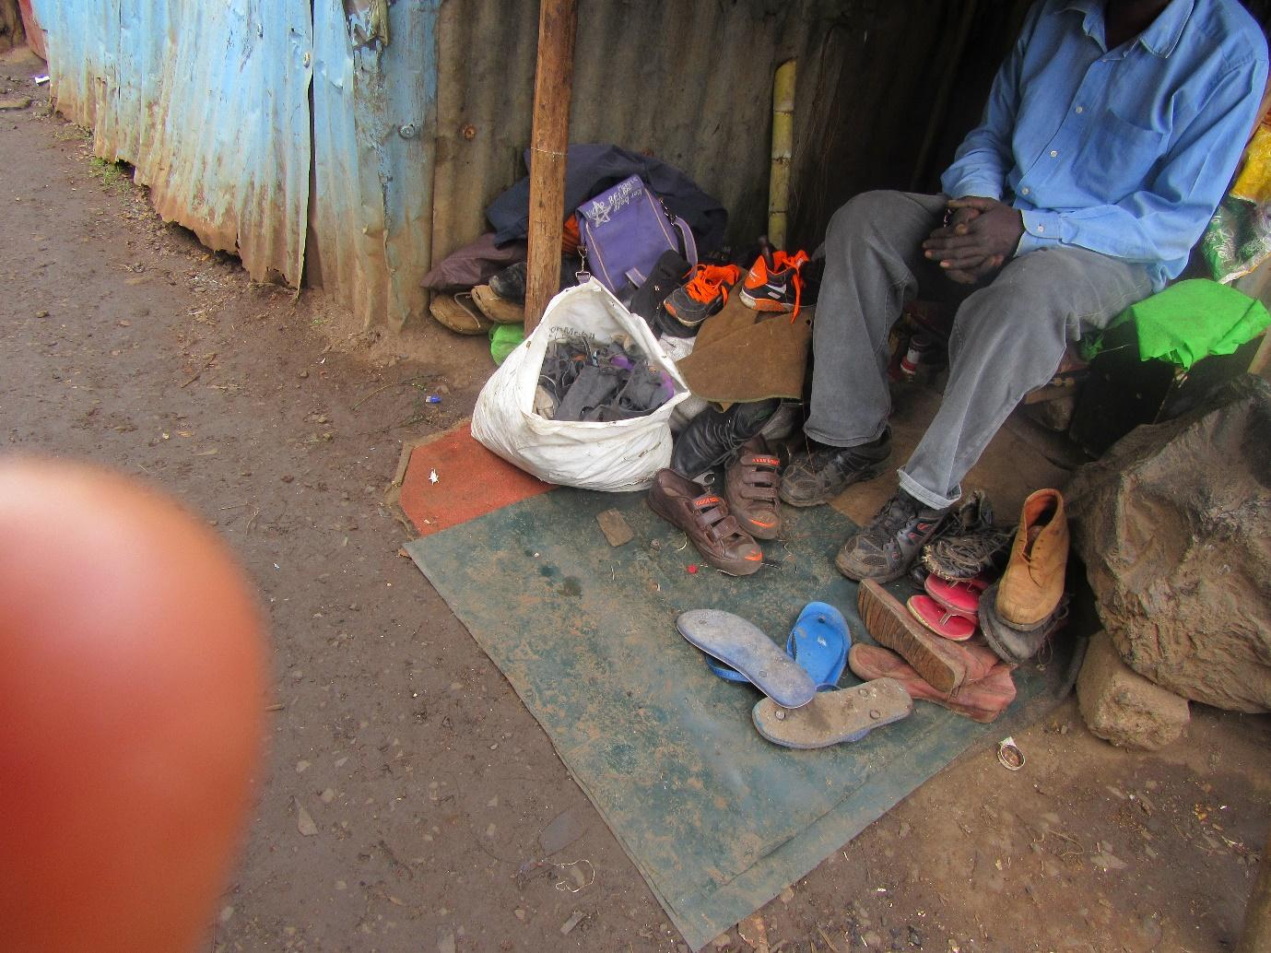
R?: How are you? I would like to explain here. Here there is a cobbler and this is his work he wakes up every morning and goes out in search of an income. So this is his work and this is where he gets his income from in order to feed his family. So he has his work that he goes to daily and gets customers.
M: Okay, so he has work. Let me open up the discussion and ask since she has mentioned work and a place where we earn in order to feed the family, here in our community, what is the situation? When it comes to income, what is the situation? Is there work? Are people earning? Are the opportunities there for people to earn? What is the situation, give me a description, paint for me a picture, R8.
R8: The income here is very poor. For me my shoe will get spoilt. When I go there I’ll start telling that person “accept 5 shillings, just accept 5 shillings.” So you see that income isn't good? 5 shillings, if he gets 4 customers to pay him 5 shillings that is 20 shillings. 20 shillings won't help him in his home. So income levels here in our community are extremely low.
M: Okay, thank you. Someone else. Here in our community, the kind of jobs that we do, what would you say about our income levels? Does money come in or it doesn't? R3.
R3: Let's say for example my shoe is spoilt and I've taken it to him to fix for me but I won't pick it today, I may even stay for a month before I go and pick it and that 10 shillings that I would've paid is what he was relying on. So you see I haven't been helpful to him. In real sense, he hasn't made any money. So maybe he has a large stock of shoes there and it appears to people that he has a lot of work but in reality there's nothing.
M: Okay, thank you very much. So now as we move from this cobbler specifically, we consider all the types of jobs that we do, that people in the community do because we're a representation of the entire community, what is the situation? In regards to income. R2.
R2: I would say in terms of income we aren't doing well. Like for us sometimes you go out and get that casual job washing clothes, you find that someone has a big load of laundry. What you had negotiated isn't what they give you and especially these Muslims. They will tell you here are the clothes go and wash, maybe you had agreed they will pay you 200 shillings and at the last moment when you have finished the work they will give you 50 shillings. They tell you if you're not willing to settle for this, you can leave it and yet you have already finished their work. So there is also mistreatment.
M: Okay thank you very much. R8.
R8: Adding to that, especially when it comes to these Muslims, their work isn't good. After you have washed, you've strained yourself and have washed, they will pretend that they’re going to the clothesline to inspect even the stains that never come off and say “for this stain I'm deducting 20 shillings” they look some more, and say “for this one I'm deducting 10 shillings.” They go round until the money is finished. You're left with no money.
M: Okay, thank you very much for some good contributions. Let me ask this. The jobs that we do, it could be on account of the income or the work itself, are we together? Are we together ladies? The jobs that we do, it could be we ourselves or generally members of this community, consider that work in terms of the work itself or the income you earn from that work. How does it harm the availability of food in the house? How does it affect the food situation in the home? I want us to relate our jobs to the food situation in the home there. R3.
R3: It harms us in this sense. You see now this person is selling their vegetables. And then I’ve gone and worked for those Muslims who have deducted my pay the way they deduct it, you see now I will be forced to go back to Mama Lisi's place and ask her to sell to me on credit and I will pay her in the evening. You can't even say you will pay tomorrow because she won't sell to you because that is what they are dependent on. So you say “I will give you in the evening, just give me so that the children can be eating.” You see? Due to her sympathy and the fact that I am a regular customer, she agrees to give me the vegetables. You think she will see me there again? So now tomorrow when I earn something won't I go to another vendor? Only when I finally get money to pay her will I see her. Or maybe I pass near her place and say to her “mama Lisi I will see you.” I pretend to be in a hurry so that she doesn't ask me concerning that debt. We might even end up having conflict because we have been unable to pay that debt. Because you see if I have some money you see I won't go to buy there because she will demand that I pay what I owe. And now in Korogocho if you owe some money and you come to buy, they first deduct the money you owe so that you're paid up. So you see you have to come with enough money to buy for the day as well as pay what you owe.
M: Okay, thank you very much. Let me ask this. Because we have spoken at length concerning money and we have spoken about how money affects the availability of food there in the home, now let's look at work. Not along the lines of how much money we earn from it, we who do the work, consider your energy, consider the time you spend there, does it have an effect on the situation at home in regards to availability of food? Does it have an effect on how we raise our kids? Does it have an effect on how we feed our children? Paint for me that picture. R7.
R7: Okay for me responding to that, I think we spend a lot of time on work whose income is not very good. And it harms us because you find that when you leave and come back to the house you realise that how you had hoped to feed your family won't come to pass. So you start calculating that the money you have is what you will use. So in that sense I feel that we suffer some harm.
M: Okay, thank you very much. She has said that we use a great amount of time on our work, we spend a lot of time working, I want us to add on to that point, when we spend a lot of time working, does it have an impact on how we feed children at home? How we are caring for our kids at home? Does it cause any harm to how we feed our kids at home? Okay, R10.
1:00:34
R10: Yes it causes some harm because maybe you wanted to cook some good food for them but because you spent so much time working you will come and cook the foods that are easy to cook quickly.
M: Give me an example. For example I would like to cook this but due to time I will cook this.
R10: For example I would like to cook my githeri myself in the house in a hygienic way. But now because I am in a hurry I have come from work, I'll buy my githeri from that place where it is already cooked and that place isn't very clean so that all I have to do is fry it for the children quickly.
M: Okay, thank you. R3.
R3: As I add onto that, maybe I had planned that I will be done with my work at noon so that in that 45 minutes I have boiled some rice, I have boiled some beans stew for us to mix. So you see now I won't manage to do that and I will end up giving them that 10 shillings for them to go and eat anything they choose, provided they're full so they can go back to class. And often times the money we give our kids for lunch is 10 shillings, you can't give them more, so whether they're satisfied or not, provided they have eaten we're fine.
M: Okay, I would like to pick up from where R3 has left off. From this thing where we give our kids to go and buy food because there at home sometimes we don't have time to cook, what impact has this had on the health of the children? R8.
R8: The children won't be in good health.
M: Why?
R8: Because they get so used to eating one type of food and this causes kwashiorkor. You just find that the child's tummy is swollen and you wonder why it is swollen, only to find that you only feed the child one type of food, one dish, you don't give them a balanced diet.
M: Yes, I see you have read my mind because my next question was in regards to a balanced diet and she as mentioned it there. Here in our Korogocho community, do people eat a balanced diet? What is the situation, among children as well as adults, do we eat a balanced diet? R10.
R10: No.
M: Why don't we eat a balanced diet and yet we said that there are plenty of foods out here in the market?
R10: The time needed to balance the diet....
M: Okay, R10 I have a question that I will ask you. But first let us hear from R4.
R4: That balanced diet we eat it at night. For lunch, we eat one type of food because we don't even have time to cook lunch. But at night you can cook a little ugali, some kales, a little meat for 50 shillings, because here in our neighbourhood you can find meat for 50 shillings, you put that in the pot and get add some avocado so you see at least you have tried to balance a little.
M: So at least at night. Okay, would anyone like to add to that story? R6, you're okay? Who would like to add to this story of having a balanced diet? Are we eating or are we not? And what are we eating? R8.
R8: I would say we eat.
M: R8 says we eat.
R8: Because we have said whatever we find, we eat. Even the deformed loaves of bread, we eat, we eat bananas and oranges, and we eat a few fruits here and there. And there are times when you can come across grapes and you have 20 shillings you buy, if someone is passing by with a bucket selling water melon slices if you have 10 shillings you buy, you see?
R?: If you have it.
R8: Well you just deduct a little from the money for supper.
M: Okay, thank you very much.
R10: But in reality there's no time you will find that you can place all those foods on the table at the same time and say this is such and such a food, this is such and such a food.
M: That is the question I was going to ask, what R10 I speaking about and ask this, when we speak of a balanced diet, based on how we understand it, how should it be? Meaning is it the food you have eaten through the day, how do you look at a balanced diet for you to now say “this is a balanced diet?” How do we look at it? R2.
R2: Let's say even if it's that rice, maybe you buy for the child that rice for 10 shillings and add in it some avocado. I think by then they will have had a balanced diet. Also not to eat all the time, that at lunch time they have eaten rice then in the evening they are eating the same rice, you need to mix different foods.
M: Okay, let me ask this. When we speak of a balanced diet, are we speaking concerning all the meals you have eaten in a day or are we talking about what you eat when you seat down to have a full meal? This balanced diet, what is our understanding of it? R10.
R10: It is one meal.
M: R10 says it is one meal. Who has a different view? Do we look at one meal, or do we consider all that we have eaten the whole day?
R?: Let's say that it's one meal because let's say in the morning you have eaten that bread for 10 shillings and strong tea. For lunch you have had rice without an avocado. So don't you see now that supper is when you have ugali, kales and avocado?
M: Okay, thank you very much. We have moved from there. So perhaps my final question for this photo is this. Ladies are we together? My final question regarding this photo is this, and I want us to consider children, because I love children a lot, for women who are breastfeeding, because you have to carry on working, - the photo is speaking of employment, right? - so for breastfeeding mothers who are also working, since they have to report to work, does it harm the child in any way? R8.
R8: I would say it doesn't harm the child because we were taught that there is a way to express milk. So you express the breast milk and the caregiver you leave your child with is the one you live with that little milk. That's what they will drink during the day and they will drink through the day and by the time you're coming home, you then breastfeed. So I think it doesn't harm the child.
M: Okay, thank you very much. And you have also brought in a new issue. Okay R3.
R3: It harms the child. When you have denied them time, say for example this one here, the way we're here with her, her child is outside, you see. All that time that we have spent going round, she doesn't have her child. She only breastfed when we came here at lunch time. So in my opinion, it causes some harm to the child because they haven't gotten satisfied, they haven't gotten full. I haven't seen what they have breastfed, because the mother is in a hurry, she wants to get back to work and you see she can't carry them to work.
R?: They can't be satisfied because they're the child of a hustler.
M: Okay, yes R10.
R10: Also for others, you find that many mothers don't know how to express milk and then store it hygienically. It results in the babies suffering from diarrhoea which has resulted in many mothers when they try to express that milk, that baby when they drink that milk they get serious diarrhoea.
M: I have 2 questions. R10 has answered the first one, thank you. The second one now. We have been taught how to express breast milk as you have said. The question is, have most mothers accepted this solution of expressing milk? How is the acceptability, have mothers accepted this idea of expressing?
Group: Not many.
M: Not many? Why are people rejecting the idea and we've been taught that it is a good thing? R2.
R2: Many people are rejecting this idea based on their circumstances. Maybe they're careless. You're taught to express in a certain way, put the milk in a clean bottle, and cover it. You will find that this mother just left the milk, you see. Once they have left it and they've gone, when the person who has been left to mind the child comes, they'll simply pick the milk and feed it to the baby. Afterwards it will harm the child.
M: Thank you very much. Another issue? Yes R10.
R10: You might find that the child has been taken to a day-care and there are many children there. So each mother brings their expressed milk and maybe they won't be stored in a hygienic way.
M: Thank you very much. Another reason why mothers are refusing to express in spite of having been taught. R4.
R4: Lack of time.
R?: We don't have refrigerators.
M: So lack of time and the fact that we don't have refrigerators. Might there be another reason? R8.
R8: Some others say that (unclear).
R?: I wanted to add that even that milk for expressing, where is it? Once they breastfeed it's finished.
R?: I just say they will breastfeed when I get home. They will just have to get used to it.
M: Okay, thank you very much. I think that we can spend a lot of time there but due to time I would like to move us forward. Okay, thank you very much, that photo was taken by R5, thank you very much R5. Let's give them flowers. Drop. Thank you so much. We get into photo number 5, group 1. Photo number 5 group 1. You're very welcome R4.
Photo number 5, Group 1
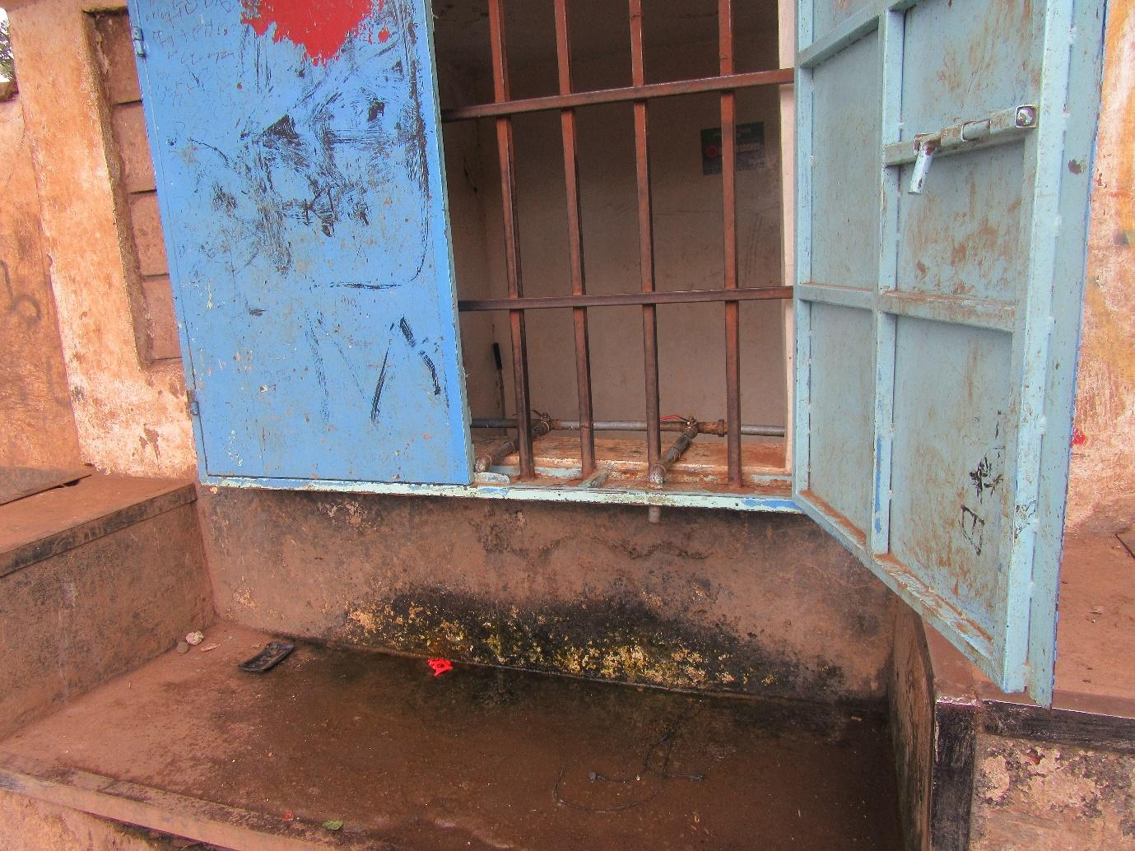
R4: How are you all? This is close by to a school where we fetch water. And this is a borehole where we can get cheap water for 3 shillings. But that water we ought to boil it before drinking because it isn't clean, that's the challenge. You can see how that place looks and down there as well it's very dirty.
M: Thank you very much R4. Is the situation like that?
All R: Yes.
M: And if we drink this water, normally does it harm us or not?
All R: It harms us.
M: Because we spoke about sanitation there, and this is now about water sanitation, I will only ask one question. What can be done, or what needs to be done for this situation to change? For this type of situation not to arise, where is the solution? Ladies, where is the solution? Okay, R3.
R3: I was thinking if there was say a trench of some sort there where the water stagnates, because this is the water that drips as you collect it into your jerry can, or like now because it has rained is why you see the water all over that place, so in my view the problem is that there’s no path for the water to drain away because there’s no trench or drainage there. If the people who constructed that place could dig that trench so that that water doesn’t stagnate there, at least it would have a little more hygiene.
M: Thank you very much. R4.
R4: Also on that photo, that school has a small field. If it was bigger they could have dug a trench and then planted a small farm and then directed the runoff water to that farm and then you see the vegetables would grow and would also be useful to them. But the challenge is the space is small and the school as you see is also small.
M: Thank you very much, I want us to move away from that school because we’re discussing contamination of water in general, think about all those situations, the different ways in which water is contaminated, all the different types of water contamination. What can be done so that we no longer have this situation of water contamination? R8 and then R7.
R8: I will say this. This borehole water, that is where people should be taught how to treat water so that it can be safe for us to drink it. Because the supply from the tap water is inconsistent. So we end up using the borehole water which we also drink. So they also ought to be treating the water. Thank you very much. R7.
R7: I think she has said it because it was that same issue about treating water. I think we can be taught on how to boil water.
M: Thank you R7. And you will also add this for me. Where does the responsibility lie? When it comes to educating people, and so on?
R7: It is just on us within the community to educate one another on how to boil water.
M: Okay, thank you very much. I would like for us to move forward. Let’s give R4 some flowers. And ladies next time when we give flowers let’s give the big flowers. Don’t be selfish! Okay, thank you very much. Moving ahead, photo number 6 group 1, no I don’t want to take that one. Let me take this one photo number 1 group 2 so we can move in that direction. So photo number 1 group 2, welcome R8.
Photo number 1, group 2
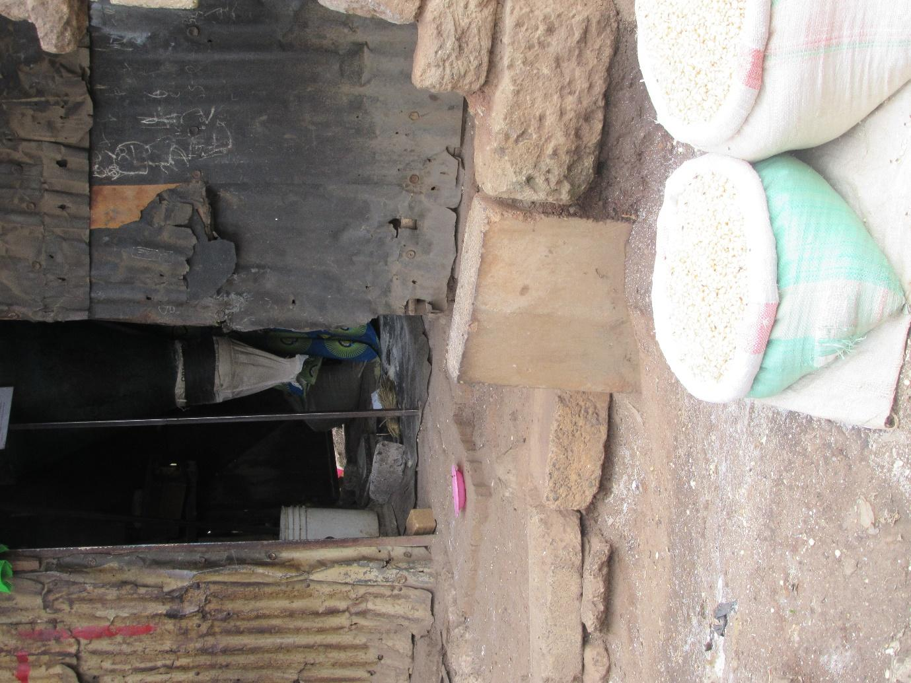
R8: For us Luhyas, getting up from here…. Praise the Lord. Praise the Lord again. I am Pastor Faith. Here, we’re seeing that getting maize and milling it is easy. And that maize flour, that one that you take to the mill, is good if you just cook a little ugali it stays in the stomach for long. But then when you buy the processed flour in a packet, it all goes into the water. Also, in here it is clean. We saw how this lady sweeps, it is clean, and she is grinding maize meal in a clean place. Yes.
M: Thank you very much R8. She has brought us a different perspective. The question has come up: is this photo from Korogocho? The question is here, you need to answer: is this situation found here? Is this a situation we see here in our community?
All R: Yes.
M: My first question is this. We have said that for you, this maize flour from the mill is very good, and she has said it lasts in the stomach. Is it true? Does it go for longer in the stomach?
All R: Yes.
M: In what way? R4, help us understand, how does it hold the stomach for longer? For someone who may not understand what we mean when we say it holds the stomach for longer?
R4: So you cook it over charcoal until it is properly cooked. If you just eat a small piece of it, you’re satisfied. You see this other white maize flour you have to eat a lot. This one you only need to eat a little and you’re full.
M: Okay, thank you very much, let me ask this: apart from holding the stomach for longer so that someone doesn’t feel hungry fast, this flour that we get from the miller, I want us to now compare the flour we get from the miller and this other one. This one that is from the miller we can give it a name, what do we call it and what do we call the other one?
R?: “Arega” and “special.”
M: So we shall call it arega and special. Arega is the one from the miller and special is the one we buy processed in a packet, when you compare arega and special, apart from which one makes you more full, what other differences are there? Or, what would be the benefit of consuming one over the other? R3.
R3: This one that is from the miller has not had anything removed from it. It has all the nutrients. Even my aunt says to me if you want to get full, leave this flour from the shops alone. Feed your kids with the flour from the millers, it’s the proper flour. It has more nutrients, so someone gets more full like she said. But this other flour like the one we have eaten for lunch, you feel like you’ve just drunk some water.
M: Okay, thank you. She has said that this arega, nothing has been removed, isn’t it? So is there any benefit it has to the body because nothing has been extracted that you wouldn’t find in the packet flour? In terms of health that is, is there a difference? And what’s that difference R6?
R6: This one gives me energy. It increases the energy levels in my body but the other one, the special one, it just like drinking water.
M: Okay, so you’re speaking about energy. Thank you very much. Is there any health benefit apart from energy? A benefit that arega brings that isn’t available from the other type? R8.
R8: It also brings health to the pocket because it is cheaper than the other packed one.
M: Wow, okay so it is good I terms of economy. Thank you. In terms of health, is there a difference health wise?
R10: Because it hasn’t had the anything removed, it has all the parts of the maize kernel.
M: Okay, thank you R10. And I would also like to ask does it in any way benefit the body, the fact that nothing has been extracted from it, does it in any way benefit the body apart from energy? R3.
R3: It has higher health levels.
M: It is healthy? Okay, fine let’s leave it there. Thank you very much. We’re still comparing. We have compared in terms of energy, now we’ve comparing in terms of health it’s good, and that it is good for economy. Is there any other benefit? Comparing arega and the packed maize meal. Or are there benefits that the packed one has that arega doesn’t have?
R?: All are flour.
M: They’re the same? Okay, fine, my next question will be as follows. These maize mills, or this arega, let’s call it that, if you compare arega and the packet flour, which one do people use more? R3 says the packet flour. Who would have a different thought?
R?: Arega is also used. You see like Luhyas, Luos, they don’t go for the packet flour. You find that they’re the ones who use this maize from the mills mostly in Korogocho.
M: So they’re 50-50? You yourselves have told me the many benefits of arega, so why would someone use the packet flour, and yet you know the benefits of arega and arega is also available? R8.
R8: Because that one is brown and the other one is white. So now they don’t want brown flour, they just want white flour.
M: Okay, the colour, thank you. R3.
R3: Because, many people don’t know how to cook ugali with the miller flour on a kerosene stove or a gas burner and they don’t have the time to light a charcoal burner. So you see if someone cooks that one, there will be complaints that it isn’t properly cooked, and yet they’re the ones who haven’t cooked it properly. This one with the other flour, you just put the flour in the water, mix it and then the ugali is ready, and then life goes on.
M: Okay, thank you very much. My second last question. Which flour do we normally feed our children in this community? So now I’m speaking about flour in general including porridge flour, not just maize flour for ugali. What flour do we normally use? Flour from the millers, or packed flour? Most times, what flour do we use? R9.
R9: Packet.
M: You’re saying packed flour? Okay, R8.
R8: For me I would say flour ground at the millers.
M: So for you it’s flour from the millers? So it’s 50-50? Okay, because we have already spoken about the benefits, let me ask this, normally, our children, these foods- whether porridge or other foods, and we have said that we’re mothers who go out for work- normally, at what age do we start to give our children food? At how many months normally? I want you to be honest with me and tell me what people here in our community usually do.
R?: 6.
M: We wait until 6months before we start weaning them?
R8: Nowadays, women have been trained that children ought to start having food at 6 months. Previously they would start being fed porridge even at 2 months.
M: Okay, thank you very much. So mothers have been educated. Have we been educated?
All R: Yes.
M: So are people following what they have been taught? You see being taught is one thing, but there is also implementation. We go to church, isn’t it? We’re taught lessons from the bible but do we follow those teachings? That one we will answer in heaven. R4.
R4: Not all mothers. Some mothers will, in secret, start giving their babies food at 2 months.
M: Okay, thank you very much R4. Who supports R4, are there people who don’t implement what you have been taught? You all support her?
All R: Yes.
M: So the question is, what would cause a mother, after having received the training, to wean their child and start them off on food before 6 months here in our community?
R2: Sometimes the supply of breastmilk reduces if the food she is eating is not adequate so she wonders “how am I to breastfeed this baby with no milk?” So she decides that since the child isn’t getting satisfied, I had rather give the baby some food. So they feed on whatever little breastmilk there is and then they have some food.
M: Thank you very much. Another reason R7?
R7: Work.
M: Work, okay.
R7: Sometimes they go for work, and they decide that the person they’re leaving to care for the baby they’re better off telling them to start them off on food.
M: Okay, thank you very much. Is there another reason? Let’s hear them quickly. That’s all? Okay then, I know that this photo has shown us some good things, isn’t it? It hasn’t been a poor photo, so now I want to ask this. Since you have said this arega has many benefits, and you have also said that some people don’t use it and you have given the reasons, what can be done in order for many people to eat this food and get those benefits that you have spoken about? R3, tell us.
R3: They could bring us this maize for free so we can be taking it to the mills.
R?: Yes, we start eating it ourselves so we can go to teach the others because you can tell me to eat something that you yourself are not eating. So you you’re eating white ugali but you’re asking me to eat the brown one. So we start with those of us who are here who have known those benefits so that we can teach the others how to cook the maize flour from millers.
M: Okay, thank you very much. I want us to continue. And before we move forward, let’s first give R8 some flowers, the big ones please. When she passes there we drop them, okay? So she can pass with swag. Okay, drop. Thank you very much. Before we proceed, are we moving along well? Are we all okay?
All R: Yes.
M: before we move on, because we’re almost done, because I can see that this hand here is tired, I want us to give here a few minutes to do this, isn’t it? And for us as well we can rise up and go to stretch so I will hand over to Julia briefly, so she can instruct us on how we shall take our break, briefly for maybe 2 minutes after which we can proceed. But I would prefer that people don’t leave the room due to time.
M1: I would like us to stand up briefly.
{Audio paused}
M: Okay, welcome back. So we’re going to photo number 2 from group number 2. Welcome R9.
Photo 2, group 2
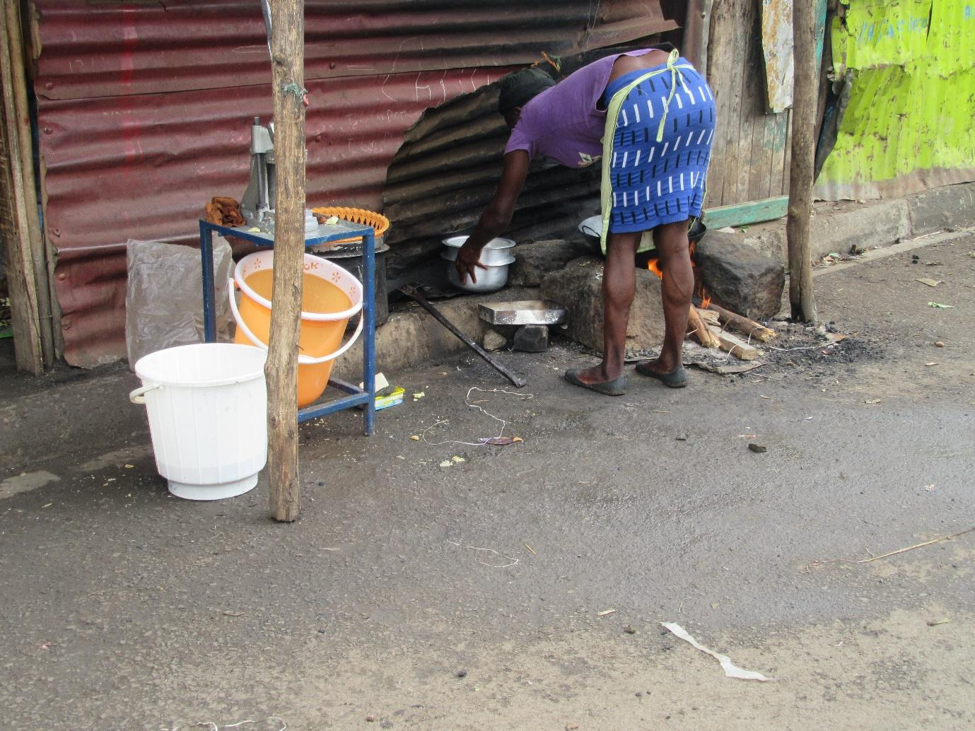
R9: How are you? I am R9. This photo, I thought that this is what is easy to find and that people enjoy. Because even me as I’m walking, if I come across this, I am happy. Because before I take githeri and cook, this will already have made me full. This is chips.
M: So you’re saying that chips makes you very happy and you can get it easily?
R9: Yes, and also it is fast, it cooks quickly. At the same time it is available in plenty in Korogocho.
M: Is it true that chips is available in plenty in Korogocho?
All R: Yes.
M: And in terms of cost, how is it?
R?: It is cheap because even with 10 shillings, sometime last year you could even buy for 5 shillings.
M: Okay, thank you very much R9, please have your seat. I want us to speak about this chips because they have said that chips is plentiful here in Korogocho. So do many of us eat chips? Ladies, do people eat chips here? In plenty?
All R: Yes.
M: Who are the people who eat chips mostly?
R?: Women and children.
M: Women? R4, what do you say?
R4: Girls. That would include us isn’t it?
All R: Yes.
M: So as ladies we eat chips, right? Okay, so I’ll ask this. Normally, these chips, do we eat them right there along the road as a snack as we go about our business or do we eat them as the main meal? And when I say main meal I mean do we eat these chips for supper or breakfast or lunch or do we only eat them in between meals?
R2: Many eat it as their lunch.
M: R4.
R4: Along the road on the move.
M: Along the road as we move?
R4: As a snack.
M: As a snack. Okay but R2 is saying something different.
R2: As lunch.
M: R2 says people eat them as their lunch.
R2: You find that someone didn’t have lunch in the house, they have come there, bought those chips to be their lunch.
R?: Let me add a little to that. You see this can’t be lunch, it’s bought as a snack because the quantity is very small.
R2: But then children buy it as lunch?
All R: Yes.
M: Okay, why is it that children are the ones who eat it as their lunch?
R?: Because now the child has cried that they want to eat chips. So you wonder, now chips, you even ask them “is chips really food?” But they say “I want chips.” “Here you go!” Alternatively you go with the child and buy for them. That’s their lunch because there was no other money with which to buy lunch. So they have preferred chips and you had wanted to buy for them maybe githeri, or rice.
M: Okay.
R?: Sometimes it also happens that you aren’t close by so you left them with lunch money. So for they will choose the chips. They won’t consider something like rice or githeri. They will just go to the chips.
M: Okay, thank you very much. So these chips, in our opinion, do we think that chips is good for our health? What is our opinion? R10.
R10: In terms of health, it is not an ideal meal.
M: Why not?
R10: Because when you consider it you can see that that is one type of food. There’s nothing it adds to your body.
M: She has said that it is one type of food and there’s nothing it adds to the body, thank you. Who can add onto that? In our opinion, these chips, R8, does it have any benefit to the body, does it benefit the body?
R8: We will say it doesn’t benefit the body because there are some people who cook with that the fat that dries up, what is it called? The yellow cooking fat and there are others who cook with salad. The yellow cooking fat is harmful because it just goes and sticks in the stomach. So that one doesn’t help us.
M: Okay, thank you very much. Is there someone who would like to add something? R3.
R3: I would say that in that instance it is helpful because they get full. But later on it will harm them because of that cooking fat, it causes diarrhoea, you see. It brings some problems.
M: My second last question in this conversation about chips, apart from chips, because here we have said that chips works as a snack, here in the community, what other snacks are available in plenty that people really enjoy, other than chips? R4.
R4: Bhajia.
M: Bhajia, okay another one. R3.
R3: Sausage for 10 shillings.
M: Sausage, okay, R4/
R4: Samosa.
M: Samosas, yes, which ones?
R4: Those that have green grams and potatoes.
M: Is there another snack that is common here? So here in our community food is available? Even along the road there’s food available? Okay, thank you very much I would like for us to move along, maybe let’s here from R9. R9 as you took this photo might there have been another one that you didn’t manage to take? Which one?
R9: There was another one of chicken.
M: You wanted to show chicken? What were the chicken doing?
R9: As in chicken meat.
M: Okay, what information did you want to give us with that? If you had taken that one of chicken?
R9: You know in town, there are chicken which are sold so now the ones that have expired are brought and cut up for people.
M: So that is what they sell to people here? Is it true? Are things sold to people here that have become rejects in town?
All R: Yes.
M: So do they affect us when we eat them?
R?: It affects some but some others are fine.
M: So some are affected and others are not?
R?: So it depends on your health. It depends on your stomach. Because like now I hear people saying how they get stomach aches and I eat those ones and I have never had trouble.
M: Okay, what do you want to say R4?
R4: The challenge is to get used because once you’re stomach is used to something, that’s it. If someone who’s new comes and eats, they will have diarrhoea but once you’re used to it, it won’t make you sick.
M: So it’s just about getting used?
All R: Yes.
M: Okay, thank you very much R9 let’s kindly give her some flowers. Thank you so much.
R3: Okay, I wanted to add something small there. So this food, don’t eat it as you are thinking about it processing what was done to it, you just eat it as though you are eating this other food because if you say “these chicken of this and the other…” you won’t manage. You eat knowing that this is the food that is available.
M: Thank you so much R3 for a good contribution. Let’s give R9 flowers, drop. Okay, we’re moving along well. We’re at photo number 3 group 2, number 3 group 2. Welcome R7.
Photo 3, group 2
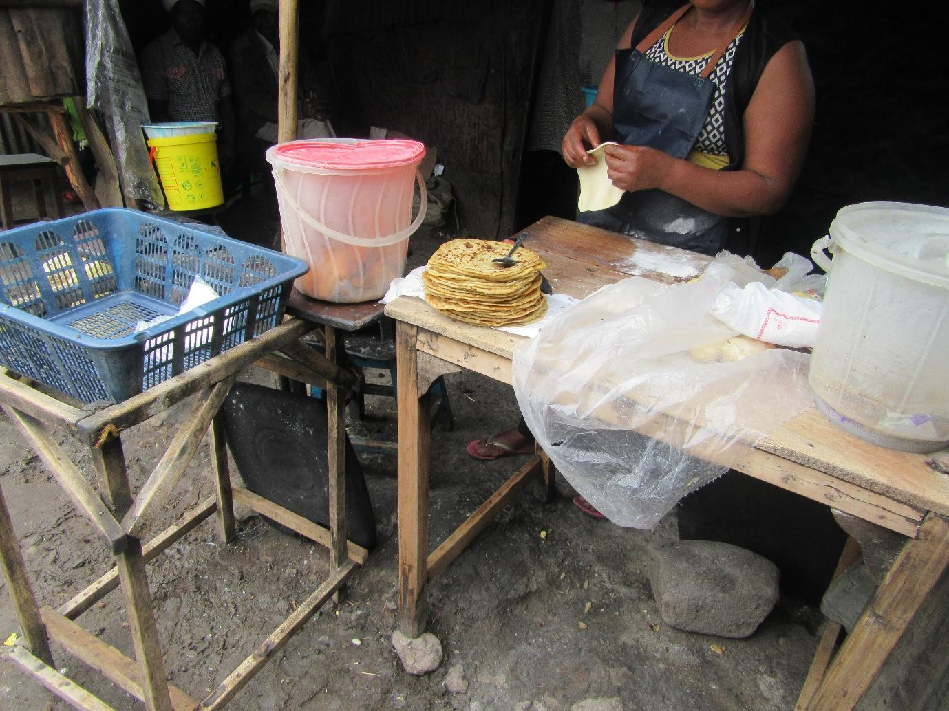
R7: I am R7 from group 2. This photo has to do with employment. This woman has made chapatis so she can sell them, get the money so that she can sustain her life even in the issue of food security. I also wanted to speak concerning hygiene, because the place she is selling from has a road passing nearby and vehicles pass, motorbikes, so as you can see these chapatis aren’t covered. So I saw that they may be harmful to people in the community. Yes.
M: Thank you very much R7. R7 has highlighted 2 issues that are very important. She has mentioned the issue of the hustle, that this woman is at work there, and we had spoken about the hustle, isn’t it? She has also spoken about contamination because the food is exposed and by the roadside and we had also spoken about issues of sanitation and contamination, isn’t it? So we’ll just give her flowers, big flowers please then let’s give her. Okay, thank you very much. Let’s move to photo number 4, group 2. Photo number 4, group 2. Welcome R10.
Photo 4, group 2
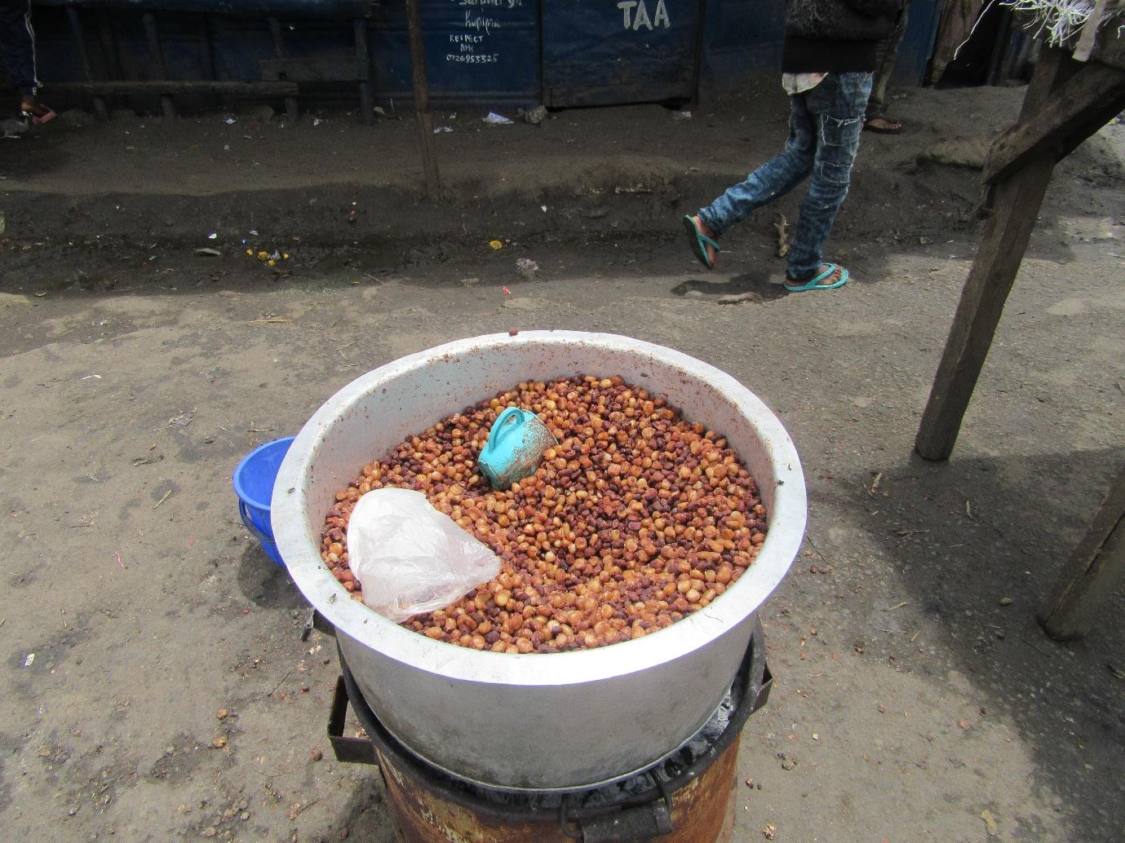
1:29:57
R10: This photo of mine also is close to the other one, it’s almost the same as this one but mine is speaking about food hygiene. You find that this is food being cooked somewhere by the roadside and it isn’t covered, that’s by the road and there’s a drainage nearby so there are flies there, and this food is totally exposed so you find that it will also contribute to the things we were speaking about concerning cholera, diarrhoea and so on. But you find that we ourselves are chasing that food because it is cheap and it is ready.
M: Okay, thank you very much. Good, she has spoken concerning issues we have already discussed so we’ll just give her flowers, some good flowers please, receive them, thank you so much. Okay, let’s move to photo number 5 group 2. Number 5 group 2. Welcome R6.
Photo number 5, group 2
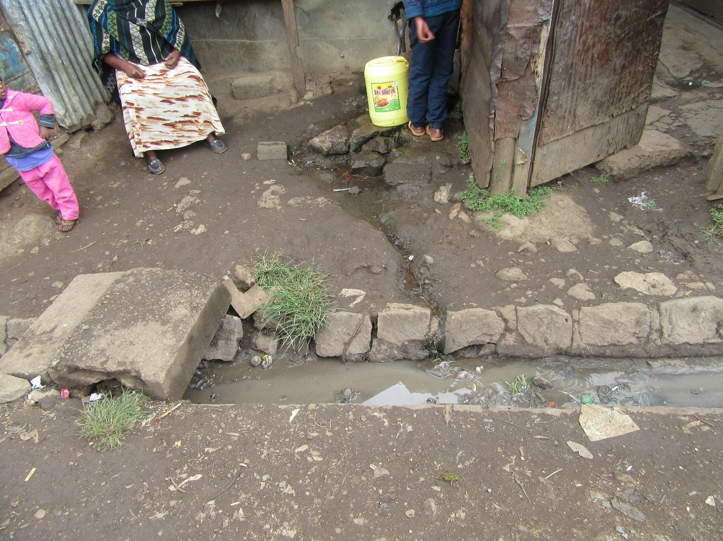
R6: Praise the Lord. I am R6. Okay, this photo of mine, speaking of sanitation, this woman is selling water and she has sold water for a very long time. And then if you look there is a ditch there and there are several toilets close to each other. All those latrines, they don’t call people to come with exhausters, they just move a stone and all the waste flows out. And you can see there is water that is sold here. So this is the water that comes out, they get contaminated by the waste from the toilets. There is a tank that is up here and that tank has been there for more than 20 years. It is never washed and there are things that end up in the tank and that tank is where the water is dispensed from.
M: Okay, thank you very much, she has highlighted once again issues of sanitation and hygiene and we had already discussed that, isn’t it? So we can give her flowers, big ones like we said, isn’t it? Okay, receive your flowers R6. Okay, I want us to move forward and come here, to photo number 6 group 2. Photo number 6 group 2. R8.
Photo 6, group 2
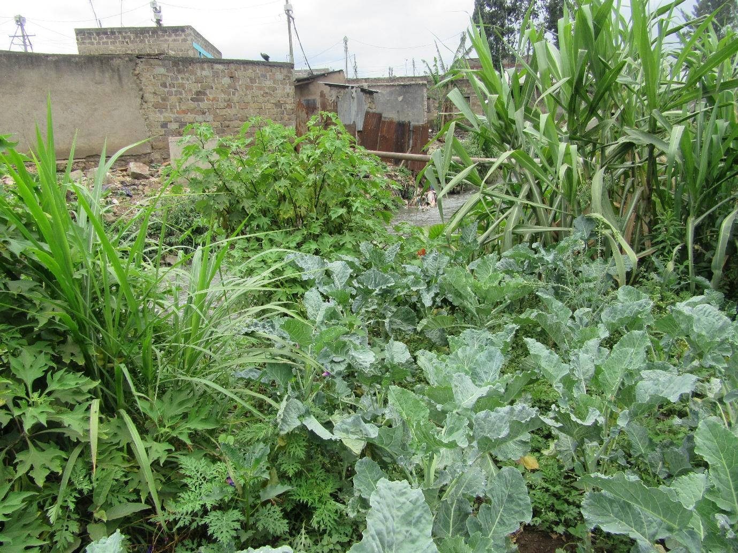
R8: Once again how are you? We have already spoken concerning this we can see these are the vegetables planted close to the river. Let me show you a little bit. These are kales here, and this is sugar cane, this is Napier grass and there are also some traditional vegetables here, and then right here, is a stream as you can see there.
M: Okay, thank you very much. We spoke concerning that when we discussed photo number 1 isn’t it? Flowers please. Alright, get your flowers. Photo number 7 group 2. Welcome R9.
Photo 7, group 2
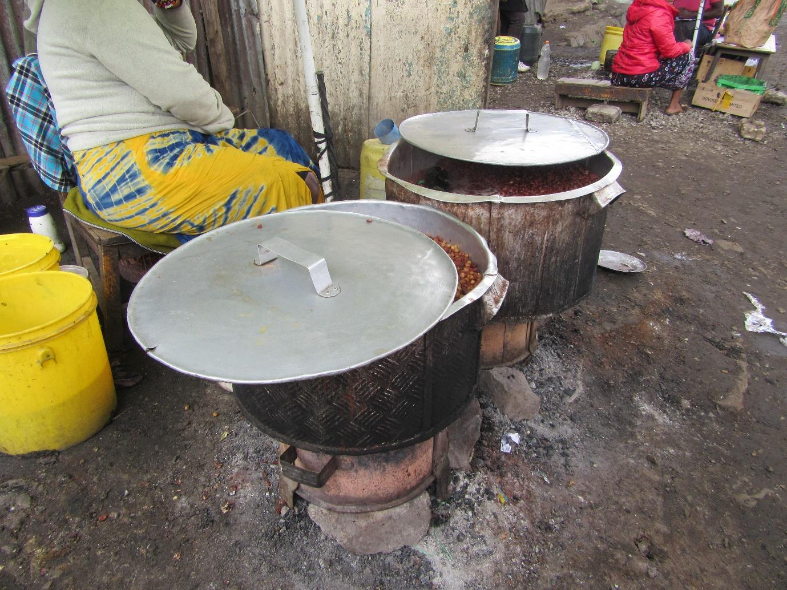
R9: Once again how are you? We have already spoken concerning this because it has to do with issues of hygiene.
M: Okay tell us a bit about this photo. What does it show?
R9: This is the food that is popular with people here. Because this is already cooked, it is ready, so when someone comes along they just order- pack for me githeri for 10 shillings- and they have their meal.
M: Okay, thank you very much I can see that R8 would also like to make a contribution.
R8: We saw that the other one wasn’t covered. But we can see that this woman is a little bit cleaner, she has covered her pots. So when you go to buy, she will uncover it and measure out your order.
M: Okay, R3.
R3: I wanted to add something small to that. Those cooking pots have been covered but there is no hygiene because it’s near a ditch, you see. That is near a ditch.
M: So we’re going back to that conversation about hygiene. There are those who cover and those who don’t. There are vendors who cover their food but the environment is still not clean. So we have gone back to the same problems caused, right? Okay, thank you very much. Let’s give her flowers please. Flowers, flowers, receive. Thank you. Okay, photo number 8 group 2.
Photo 8, group 2
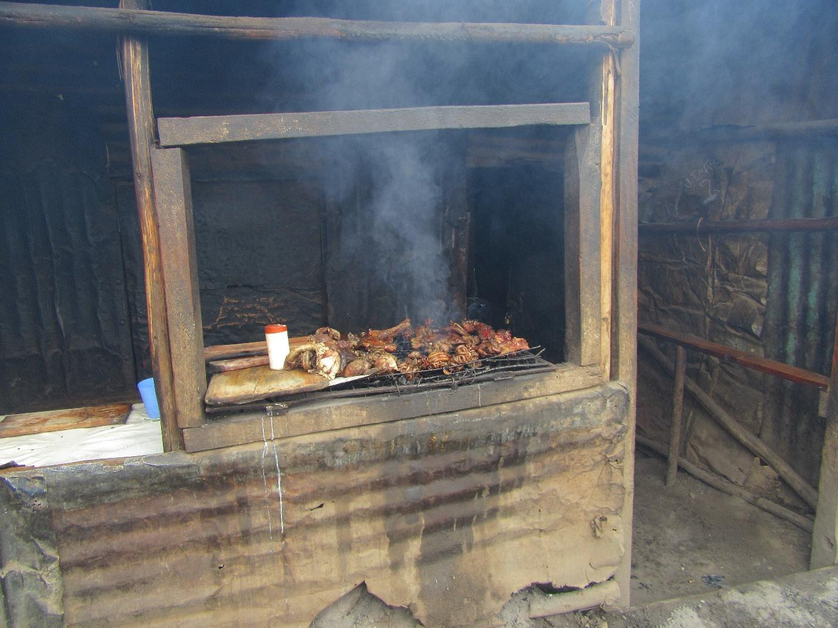
R7: Photo number 8 was taken by R7, group 2. I was trying to portray the types of meat that people can afford in Korogocho and they have been discussed. They are the internal organs.
M: So these ones we spoke about when discussing photo 3 group 1?
R7: It’s just the same. There is some “mutura” (African sausage) there, in fact they were asking me to buy for them but I didn’t have money, there are other meats I don’t even know what parts or organs they are. We asked and they were unable to describe them. There are intestines, liver, gizzards, and other organs. They’re all there. At the same time the hygiene there is poor, the road passes right there, and the meats are exposed.
M: Okay, thanks, let’s give her flowers please. Okay, receive your flowers. Thank you very much. I can see that we’re moving on well, right? Are we okay? Fine, let’s move to photo number 9 group 2. Welcome R10.
Photo 9, group 2
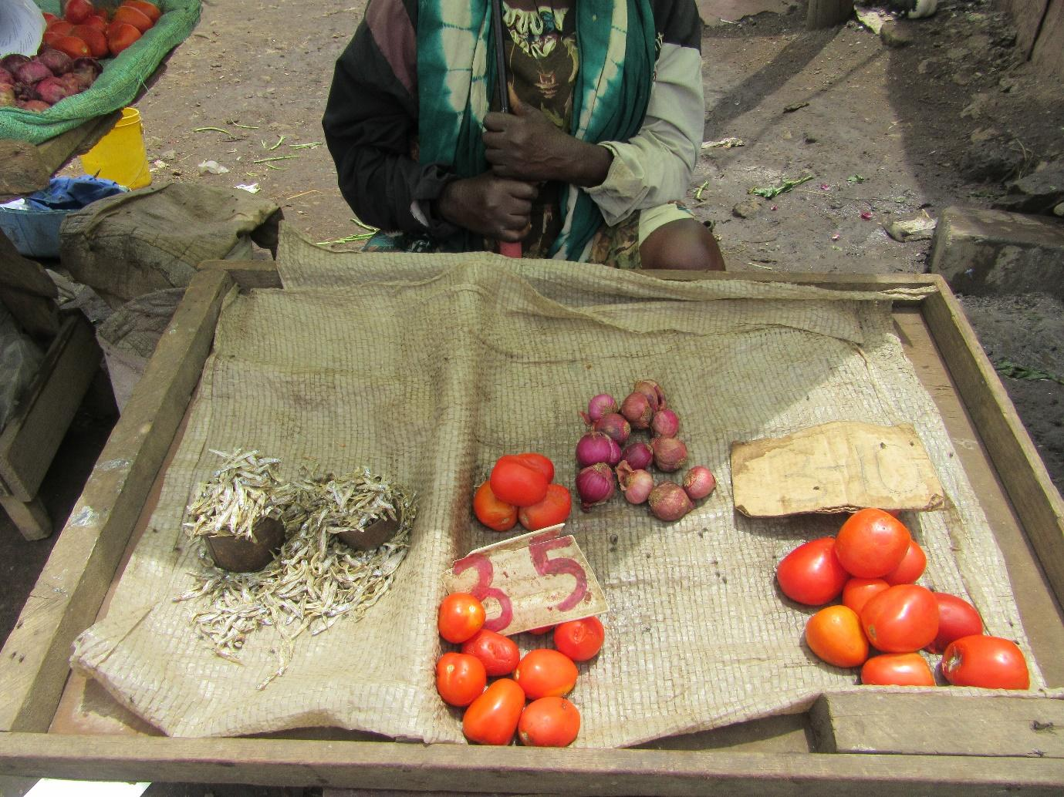
R10: Here, it’s a little different because there are tomatoes and there are some “omena” (Silver cyprinid). Here in our community in Korogocho, because the people who live here don’t have very good incomes, you will find that the fish that is very high-quality are not easy to find. This cyprinid is what moves fast, we a lot of it. You find that this is the fish that is cheap.
M: This is what is cheap? Okay, yes R8.
R8: There where the cyprinid is we can see that woman only has a little stock, so her capital isn’t very high. You see like right now, tomato supply is very high, you can buy 3 for 10 shillings. So this woman has only a few but she is selling at 3 for 5 shillings. So hers will move faster. You see the other one is full of stock, her stock is low because it’s moving. It is moving faster because her price is low.
M: So these are the low prices we were talking about?
All R: Yes.
M: Okay.
R?: Also you will find that she has, this business you can see is very small, but the other one has more stock, but then she is selling her tomatoes at 3 tomatoes for 5 shillings while the other one is selling at 3 for 10 shillings. So you see this one is cheap and it still has everything. It has onions, tomatoes and cyprinid.
M: Thank you very much, let me ask this. We are saying that this person who owns this business, their selling their goods cheaply and I want to ask this, this person, why is her cyprinid cheap? Where does she get them that others haven’t sourced theirs from? Why can’t others sell their cyprinid for that same price? R3.
R3: It’s because these ones that she’s selling are the ones that were rejected when the expensive one picked the best ones and went with the high quality ones. And then the quality that is left after the best have been picked, this one who will be selling them cheap comes because they also have customers who can only afford the cheap ones.
M: So this is the same story we spoke about in photo 1? The same story is coming out but now it’s coming out with cyprinid?
Group: Yes.
R?: And also for this person you can see some cans which they use to measure portions of that cyprinid. There’s a container for 20 shillings, there’s one for 20 shillings and so on.
R?: If you need to buy on credit, they will also sell for you on credit. They’re not too driven by profit.
M: So this photo shares with us the same story as before?
All R: Yes.
M: Okay then let’s give her flowers. Okay, thank you. Let’s move to photo number 10 group 2. Photo number 10 group 2, welcome R6.
Photo 10, group 2
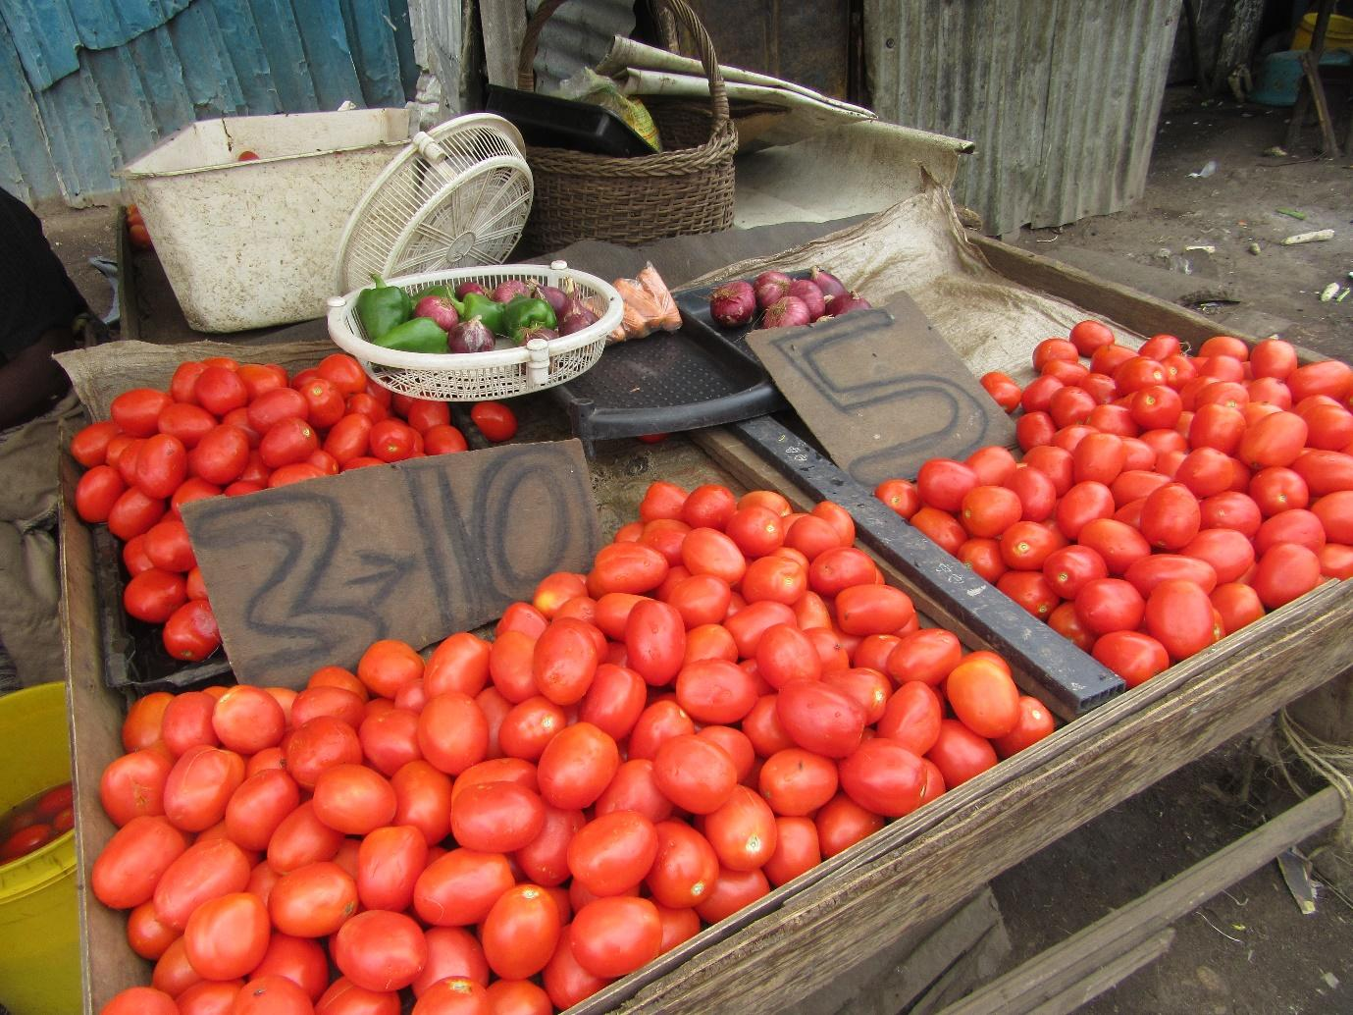
R6: I’m R6. This is the one we have been speaking about for those people who pretend they are high class. They don’t want the foods that have been squashed and the ones that have dents even if they’re just fine it’s just that the better ones have already been selected. And that is why they are selling theirs at a high price, there are those for 3 tomatoes for 10 shillings and there are those going for 5 shillings per tomato. So the people who need cheap things often times will go to this woman but they’re all together, they (unclear). So you can see the expensive one and the one who serves the lower classes who we were speaking about.
M: So in other words, here we have gone back to the same discussion?
All R: Yes.
M: In that case, flowers please. Let’s give her. Thank you. Before we move from here, because these photos almost speak about the same thing, and there is something else I have remembered that we hadn’t spoken about here- we are saying that and we had said earlier that there is plenty of food in the market, isn’t it? - my first question is this: is there food in the market every day? Or are there days when there is no food in the market? Are they there or not? What is the situation? Do you have food in the market all year round or are there seasons when there is no food in the market or the supplies are low?
R?: Let’s say for example that Korogocho market is relied on by many people not just people from Korogocho. People from Dandora, Buruburu, and other places, so let’s just say many people come even rich people with their cars come to that market, you see? But you see now they will select those high quality ones and then we come to select these ones that are left over, so it is relied on by many people. Which is why that market runs every day.
M: So it doesn’t have seasons?
R?: But there are official market days which are Wednesday and Saturday.
M: So there are “market days?”
All R: Yes.
M: So and the day that isn’t a market day there is no food there?
R?: No, the foods are still there.
M: They’re still there? Okay, thank you. Now let me ask this. Are there seasons when we can say in such and such a season a certain type of food is not available in the market?
All R: Yes.
M: It is there? And are there seasons when specific foods or vegetables are available in plenty?
All R: Yes.
M: So that is where my question comes from and this is the question. At that time when there is food in plenty, give me an example of a vegetable that is in very high supply at times and at other times it isn’t available, give me an example. Does that happen with kales? I want a practical example, a food that is in high supply in some seasons and very low supply at others.
R10: Right now, there is a very high supply of tomatoes in the market.
M: Okay, R10 says tomatoes, so let’s speak about tomatoes. During those seasons when there are plenty of tomatoes in the market, are there any leftovers that aren’t sold?
All R: Yes.
M: Okay, those ones that are left over, what happens to them? R8, what happens to them?
R8: They might throw them away.
M: So they throw them away.
R8: If they have already tried selling them at throw away prices and there are still some left over, they throw away what is left over and even gets spoilt.
M: So it goes to waste? So here is my question.
R3: Let me first add to that. When they pour them out it’s not that they are throwing them away, they pour them out to sell to the people who have piggeries. It’s not that you can come to collect from where they pour them out, you will still have to go and buy from them. So it may be dirty but they still sell for you because they know that you’re getting them to go and feed your pigs.
R?: There are also times when they will sell to us very large portions for only 5 shillings for the ones that are broken.
M: Okay, thank you very much. My question there is this. We’re seeing that there are seasons when a certain food is available and there are season when it isn’t, isn’t it? And in that season when they’re in oversupply, there is much that goes to waste. So what can be done so that at those times when food is available in plenty, it doesn’t get spoilt? So we don’t then end up lacking that food afterwards. What can be done and who can do something, in order for us to get to the place where if say it is tomatoes, we have a supply of tomatoes all year round. So we don’t have these issues of tomatoes going to waste, that sometimes we don’t have tomatoes available in the market, what can be done? R3.
R3: I would say that, okay farmers, ought to plant these things- okay, they plant in seasons right? But now that means that when they grow they grow all at once. Because there are times when in places like Laikipia, a crate of tomatoes was being sold for 300 shillings and here in Nairobi, they were being sold for 1000 shillings for a crate. That time you see, the people from Laikipia were complaining because they can see that there is a lot of waste and at the same time getting their products to Nairobi so they can sell at the better prices becomes a challenge, you see. So that is why foods go to waste.
M: Okay, thank you. Another contribution?
What can be done in order for us to stop having this problem? R10.
R10: The government should also intervene because if they were to facilitate a way in which these tomatoes can be preserved for a long time and then they reduce the pressure during the low seasons.
M: Okay.
R?: Transportation- this transportation also contributes. Okay, some good contributions, thank you very much. I think we’re proceeding well, we’re almost done. As you can see we’re done with this section and this section and only left with the middle section. Is that right, or is there a photo I have not spotted? That is right?
All R: Yes.
M: Okay, photo number 6 group 1. 6 group 1.
Photo 6, group 1
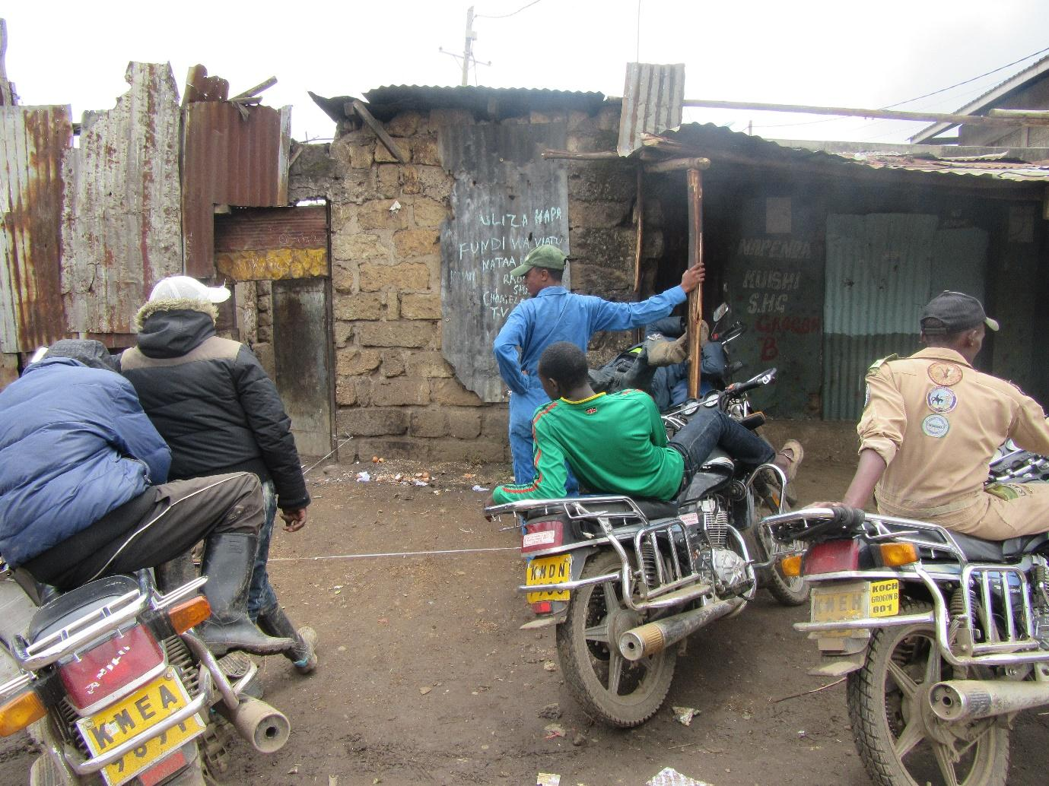
R3: Photo 6 group 1, as you can see there it is employment like I had started before. These young men of ours are the ones who used to rob people in the neighbourhood. And then they were spoken to, they were given motorcycles and they started an income generating project so they could stop bothering people. So employment has been created for them. So now they are no longer robbing people, they are eating off their own sweat.
M: Thank you very much. There’s an idea you have brought there. The issue of employment and the issue of insecurity. We had already spoken about employment. Now let’s speak of insecurity just briefly. When the neighbourhood is not safe, when people are getting robbed and there are many issues of insecurity, how does this affect our food issue? How does this affect the issue of food security? R9. As R9 gathers her thoughts, yes R8.
R8: I would say there is a problem there. When someone is robbed, obviously there will be some commotion and as people are running about they will trample on tomatoes and kales because here in our community people like to display their goods on the ground. Oranges, and so on, the goods get trampled on which leaves people at zero.
M: Okay, thank you very much. Another way in which insecurity contributes negatively to our food security and the status of food in our homes?
R3: So if you consider now that you have opened that kiosk, you have sold all day since morning till evening, and I’m waiting for you. You just sell. You sell and sell and then I come. “Bring all the money you have sold today.” You see now I will have left with the money. So now how do you help yourself?
M: Thank you very much R3. Okay, another way? R7.
R7: So also the person who had gone out in search of an income and they have now gotten to this road on their way home and have gotten robbed and left with nothing, you see now in the house you won’t have anything left to buy food for that day? It affects people because you then won’t be able to go and buy from the kiosk so that even the person selling to you at the kiosk will have lost their income which they would’ve used to provide for their family.
R7: Okay, thank you very much R7. Another way, R10.
R10: Maybe they have been stabbed and they die leaving a family and children.
M: So if they die it affects food, because they were the breadwinner? Thank you very much R10. Another way in which insecurity affects the issue of food? Is there something we have left out? Okay thank you so much. As we wind up on the issue of insecurity, these means of employment, R3 has told us there is one means that was used which has helped in a way. So, has insecurity come to an end? Did it come to a complete stop or not yet?
R?: It’s there a bit.
M: It’s still there to some extent?
All R: Yes.
M: So what else can be done, another way like this one which worked, what other way can be used in order for insecurity to continue to reduce? R8.
R8: So like in my neighbourhood there are some young people. But then they were called together and offered to be bought for the big super drum so they can start a car wash where they can be washing motorcycles. So it keeps them busy and makes them hardworking and they can’t even think of robbing people.
M: Okay, thank you very much. Are there other ways we can use, R10?
R10: There is also the option where they, they plant trees by the riverside like in my neighbourhood. They plant trees and are paid. There are some organisations that bring the young people together and get them to plant trees, grass, and then they’re paid. Yes.
M: Okay, thank you very much. I would like us to move forward due to time. We’re done with this one, so let’s please give her some flowers. Receive them. Okay, photo number 7 group 2. Our fourth last photo, photo number 7, group 1 sorry, number 7 group 1. Who took it? Yes R2
Photo 7, group 1
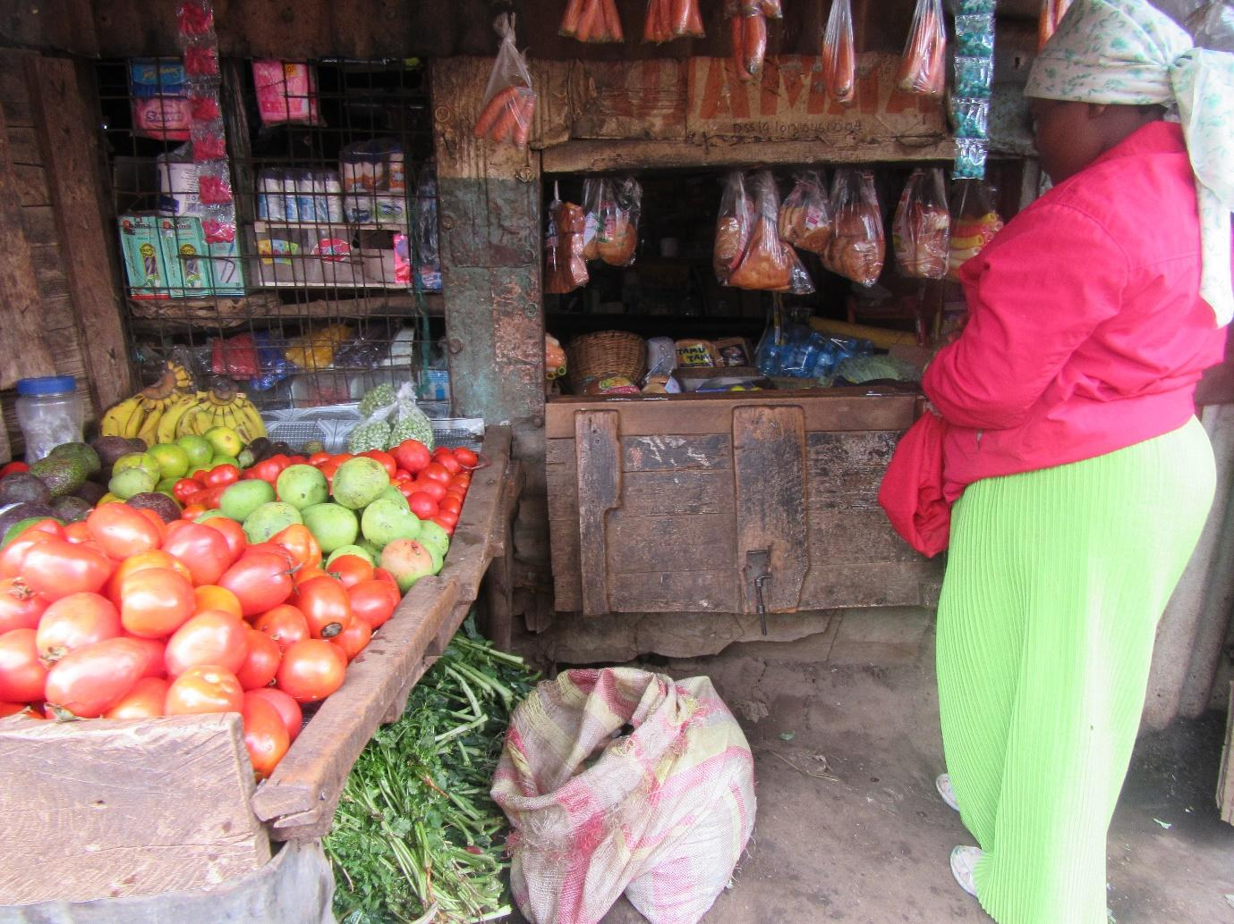
R2: This is insecurity, the same issue we have spoken about. This business is operating there at the centre, down there. So you find that that place has no security. So you see the business may be going on well but many customers won’t get there because they’re afraid. Yes.
M: Thank you so much. We have spoken about that, so let’s give her some flowers please. Give them. Thank you. Let’s go to our third last photo, photo number 8 group 1. Yes R3.
Photo number 8, group 1
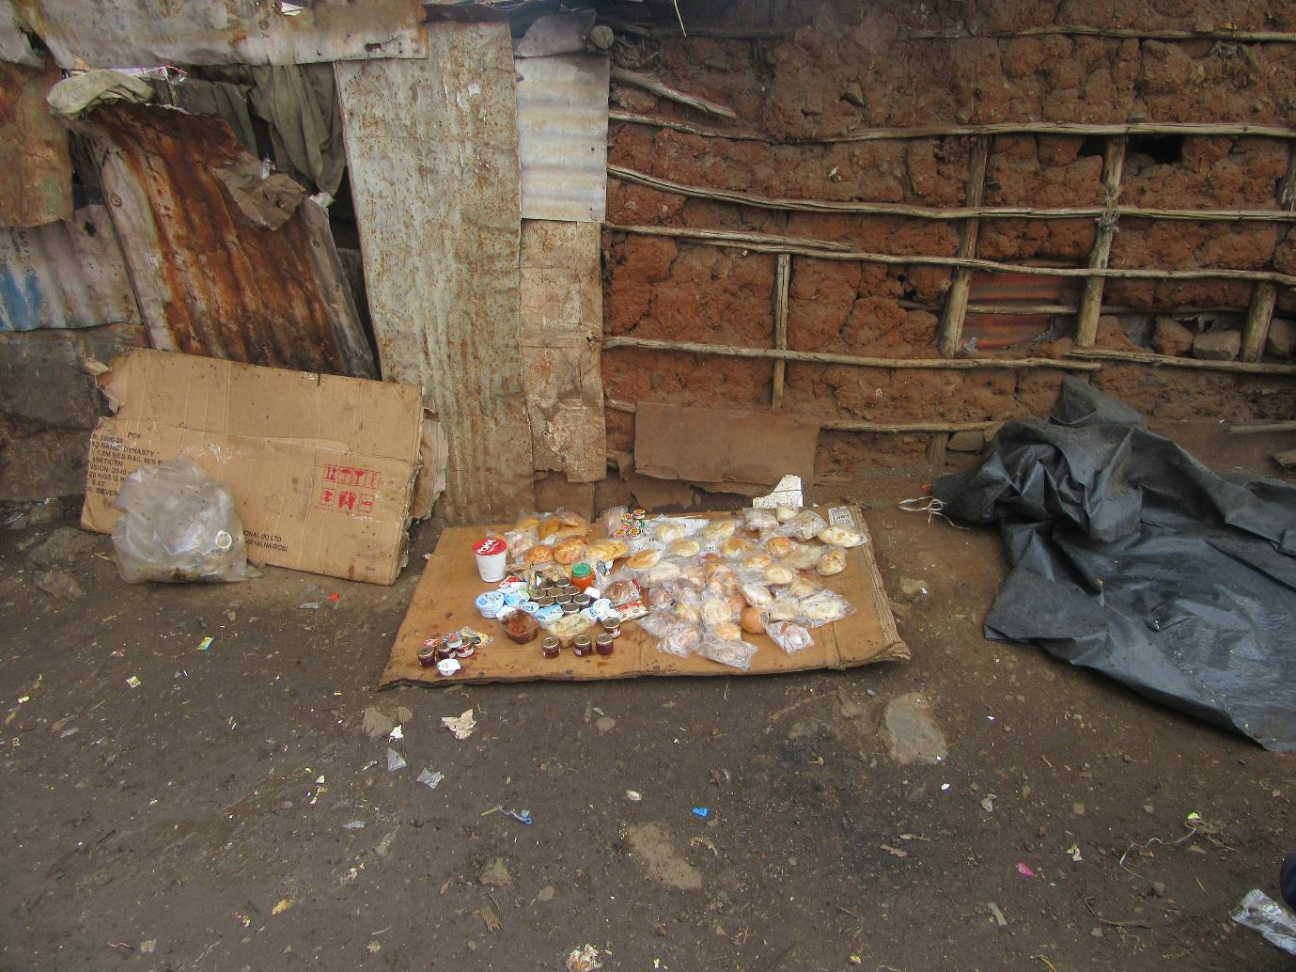
R3: Photo number 8 group 1 those the foods that are- is it exported? - they come by plane, they are called “chombo.” This chombo will consist of cake, nuts, yoghurt, jam, and these are affordable because there if I have 10 shillings, I can get 4 cakes or I can get a yoghurt.
M: So you’re speaking about those foods that are collected from the dumpsite? It’s what we had spoken about? Flowers, let’s give her. Thank you so much. Our second last photo, photo number 9 group 1. Welcome R5.
Photo 9, group 1
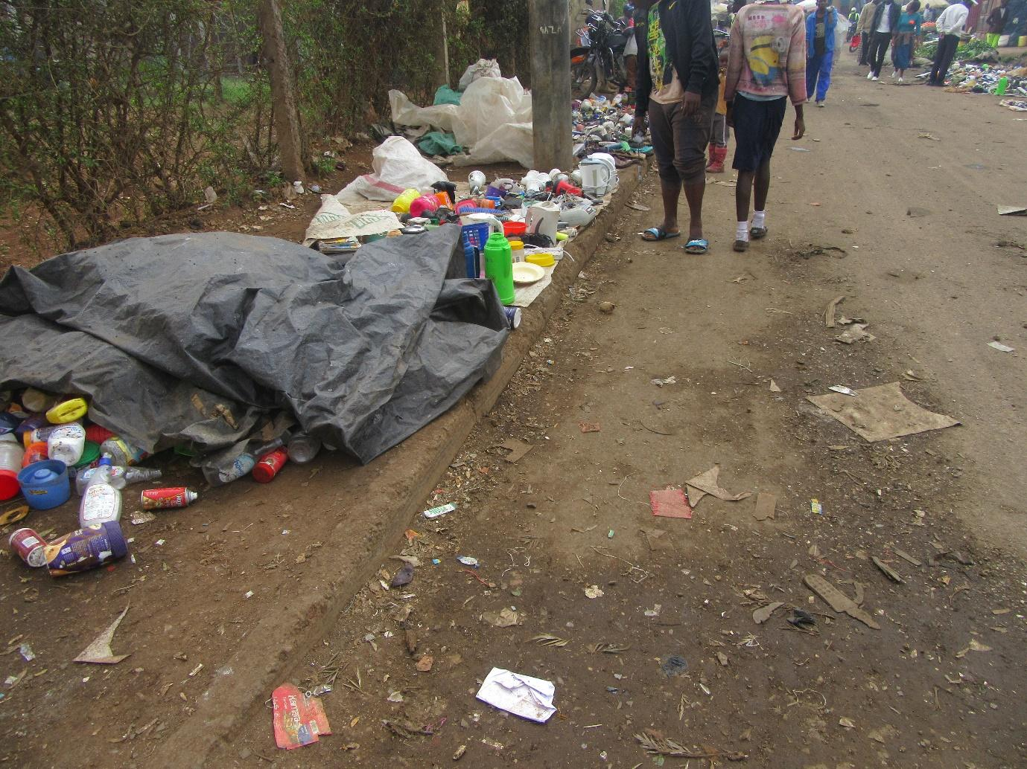
R5: This is a woman who we passed as she was washing shoes to sell, so she can earn an income. So she was still washing so that she can display them to sell.
M: So she is washing these so that she can then go to sell them? So it’s about looking for an income? It’s the hustle?
R2: And these ones also come from the dumpsite in Dandora, if I can contribute, they’re the ones that are disposed of there, things like iron boxes that are thrown there when they get spoilt, you come and fix it and because it wasn’t completely spoilt it can be used again.
M: Thank you R2, R3 I can see you also want to contribute.
R3: I wanted to say that, say for example how your clothes become small, or you don’t like them, you toss them in the trash and then the garbage collectors come and collect them, they come and sell to someone who is now this woman. She’ll buy those ones and come to sell them.
M: So it is also what we had spoken about right? Let’s kindly give flowers to R5. Let’s give her. Thank you.
R?: So I wanted to say, when your stuff gets spoilt, don’t throw them away, bring them to us. You know that one day Magda will come to use them.
M: Okay, thank you so much. Let’s move to photo number 10, group 1, our last photo. Photo number 10 group 1. Yes R4.
Photo 10, group 1
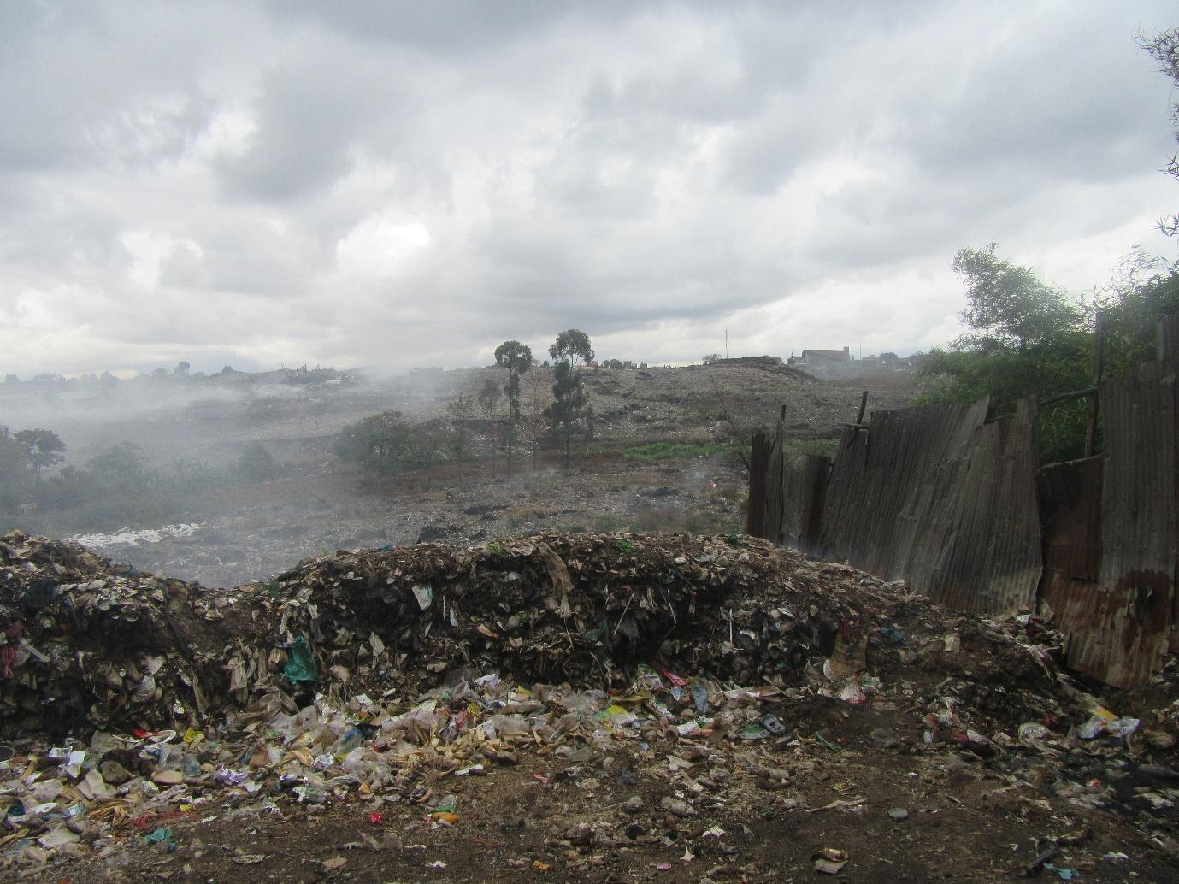
R4: This is at the dumpsite.
M: The place we have spoken about?
R4: Yes, that is where things come from. So the place you can see where there seems to be smoke, things like chombo come from there, and the plastics, all that, it comes from there. So I thought I should take that photo so that you guys can see it.
M: So this is the source of those things we have spoken about? When we spoke about the issue of the hustle there?
All R: Yes.
R7: If I can add there, that smoke often affects children in the neighbourhood. Oftentimes you find that they’re coughing, because that smoke comes from there and the things that are burning are harmful. There will be waste from hospitals, waste from the industries, and so on.
M: So R7 you are saying to us that this area still affects your health?
All R: Yes.
M: So this now brings me to my question. What can be done in order for this situation to get better, so that people stop contracting diseases from that place? R4.
R4: What can be done, because those who are usually in that place are our husbands, our brothers, they’re the ones who are usually there. If they found somewhere else to work, you see they can stop working there. Because many of them maybe they didn’t even get a good education so they’re forced to go there to earn their living. So if they could be given other forms of employment, it could enable them to move from there.
M: Okay, thank you. Yes R7.
R7: If I can add to that, closing down that dumpsite has been a big challenge. They had even crossed over to this side, but then the police have tried plus the chief, because it was here in Ngomongo, not too far, so all the smoke was harmful. But now the community plus the government, everyone has tried and they have vacated that place now. But it was a huge battle before they would agree to move. So the site has moved back to the other side now.
M: Okay, thank you. Is there anything that someone would like to add? Before I ask the next question? Okay, fine. If there is no question, I would like to say this. We have spoken concerning all our photos. Is there anyone who has a photo we didn’t discuss here? We have considered all our photos, isn’t it?
All R: Yes.
M: But why have we no joy? So now we’re winding up. We are done with the photos. So now we’re at the conclusion, we’re winding up now. And let me first ask this. We have discussed very many things. Many things, and thank you very much for giving us some very good contributions. And for every issue that we discussed here, we would get from that issue some recommendations. We were giving some solutions- this should be done, that should be done, so and so ought to do this, right? And they were very good contributions. My question is this. These ideas that we have shared, for those they ought to reach, because we were saying maybe the government ought to do this, the community ought to do this, those to who we need this information to get them, what means can be used in order to get this information to them? R8.
R8: Let’s look for someone in the media, give all our issues, so that even the leaders can see the issues.
M: Okay, thank you very much. Another way, R4.
R4: I would say coming together, the government and we the people coming together.
M: Thank you. R3.
R3: In churches, when the services have come to an end, they can then be informed. Something like that, in the churches.
M: Thank you very much. Are there other ways for us to communicate this information?
R10: Also, such photos, they could even be published in the newspapers so that they can explain that story.
M: Okay, thank you very much R10. Is there another way? R7?
R7: Okay we can also speak and maybe create awareness. We could talk even at neighbourhood gatherings, when we’re speaking about food hygiene, we just move slowly and we’ll change. You know change can’t come immediately, it will happen slowly.
M: Thank you very much. R4 would like to add to that.
R4: We could go to ghetto radio and Korogocho fm.
M: So our local radio stations?
All R: Yes.
M: Thank you very much. I am grateful because we have had a very good discussion and we have gained some good points. So now I would like to move us from this discussion, we move completely from this discussion, for two final minutes, we move our minds from there, and I would like to ask this, let’s go back to the experience we had while we were taking these photos, okay? Let’s move from the discussion to the process of taking the photos, and look at the process starting from, let’s look at the photography first, as you went to take these photos out there, how was the experience? What’s your feeling concerning that process? How was it taking photos out there?
R?: I was feeling bad when you go talk to someone and they refuse to allow you to take it and yet you know one another, you see. They say that you’re working and so you will get money and they will be left with nothing. So I was feeling bad. In fact I have felt very bad with another woman who is a friend of mine.
M: Okay, thank you very much. Another person? How has the experience been? R6?
R6: It was difficult because some would say to you that you have to first give them some money because you’re going to eat off their business, you might go to get praise for yourself off that business and leave them with nothing.
M: Okay, thank very much. R2.
R2: Another person says to you “I am helping you build your work so you can earn off my efforts. So don’t take a photo. In fact we have created some enmity in the neighbourhood to be honest.
M: Okay, R8.
R8: I would say that I am very happy because God was with us, where we went, the people who refused- were they many or just a single person?- someone was asked if a photo of their fish could be taken and they just shouted “I don’t want that.” We went to where they were selling bread and they said “we don’t want!” But we thank God that we took the photos we were interested in.
M: Okay, thank you very much. I want us to get one final contribution. R10.
R10: Some of us have also seen that when we’re in there in the neighbourhoods, we don’t see some things like that dirt, we don’t see it as a big issue but then when we were going there, you would see that surely, this ditch shouldn’t be here because that thought was in our minds. But when we’re there, we usually don’t even think about it.
M: Okay, thank you very much, let me take one final contribution. R2.
R2: There’s something else I saw. When you go to speak to someone so they can allow you to take a photo, you would find that now like these guys selling that bread, selling that chewing gum, you find that they also understand that they’re doing something wrong. Because they’re afraid, they ask you “this photo once you take it, where will you take the photo? What is it for?” You see they’re afraid? They even tell you “my business should not be photographed.” Because you try to tell them I am not taking a photo of you let me take a photo of the business. Their response is “no, where will you take the photo?” You see they also understand that they’re engaging in an inappropriate business?
R?: But then the key was here in the money. Give me something small so I can allow you.
M: Okay, thank you very much. My very last question. This entire experience of what we have been doing, this thing called Photovoice, maybe for some of us we have heard of it for the first time, some of us may have done it before, this entire experience starting from the training, we went and took the photos, we came and discussed the issues that came up, this process that we’re now winding up for today, this Photovoice process, say we wanted to do it again maybe in this place, or perhaps we want to do it in a different place, what would you advise us to do differently or what would you recommend we adjust in order for our outcomes to be much better? How can we improve this process of Photovoice? R4.
R4: For me, I would say that if you’re able to give us even if it’s 100 shillings so we can give the vegetables vendor so they can agree for you to take the photo. Because once they see money, they will agree very quickly.
M: Okay, thank you. Another way? This process- how can we make it much better? R8.
R8: When we’re done, a group photo of us should be taken so you can go back and say “these are the women we were with.”
M: Okay, thank you very much, Julia has heard that one. Is there any other way for us to improve this process of ours? Yes R2.
R2: Also, you see like now we’ve gone around and were just showing up so even if someone knows you they wonder “why didn’t you tell me in advance?” We could be telling them in advance. Because someone wonders even if we know each other, I won’t agree because you’ve come to me very suddenly.
R7: I would say, I’m just adding on. We can identify the person, we go and explain to them first that “tomorrow I will come at this time, please expect me” so that at least you don’t just show up to them suddenly and then they wonder what is happening.
M: Okay, R4.
R4: I would add, is it possible to have a hidden camera? These cameras are what they’re afraid of, the fact that you’re taking their photo. If we had some hidden cameras, you would already have taken a photo and they don’t even know.
M: Okay, let me say this, first allow me to say thank you before we switch off the recorders so we can speak as ladies, isn’t it? Thank you very much for being available for today’s process. So let’s just clap for ourselves as she switches of these recorders. Thank you so much.
End of audio
Recommendations
- Urban farming: establishment of kitchen gardens ought to be encouraged.’
- Resolve issues surrounding cost of seedlings and pesticides as well as water availability.
- Embark on training to encourage people to undertake the practice and know how to do it properly.
- Water vendors can be trained on how to use runoff for farming.

- Sanitation and hygiene
- Government should ban farming close by or along sewer lines.
- The community can be challenged to take initiative when it comes to stop the sale of food products from the dumpsite.
- Train food vendors on hygiene so they can manage their business places better in terms of cleanliness and storage.
- The places from where water is sold should have proper drainage facilities.
- The water vendors should be trained on how to treat the water while the community members ought to be trained about boiling water to sanitise it.
- Food availability
- Government should help come up with a solution for food to be stored during the bumper harvests so it’s available during the low supply seasons.
- Dumpsite challenges
- If the community had better employment opportunities, they would not need to engage in income generating activities revolving around the dumpsite.
Photovoice recommendations
- Give the participants tokens to give to the people whose places they want to photograph.
- Take a group photo to mark the experience.
- Give the participants advance notice so they can also communicate in advance to those whose photos they would like to take.
- Have hidden cameras to make it easier to take photos.

