AFRICAN POPULATION AND HEALTH RESEARCH CENTER
RIGHT TO FOOD PROJECT
ARCHIVAL NUMBER: 181108_0752
CONTACT TYPE & DESCRIPTION: PHOTOVOICE–KOROGOCHO (OLDER WOMEN)
DATE: 08/11/2018
START TIME: 1:00PM
END TIME: 1:30PM

M: Let me put the recorder here near us. Now we want to talk a little about these pictures. So R1 let us start with your picture that is up here. You have said you want to talk about the shop.

Photo One
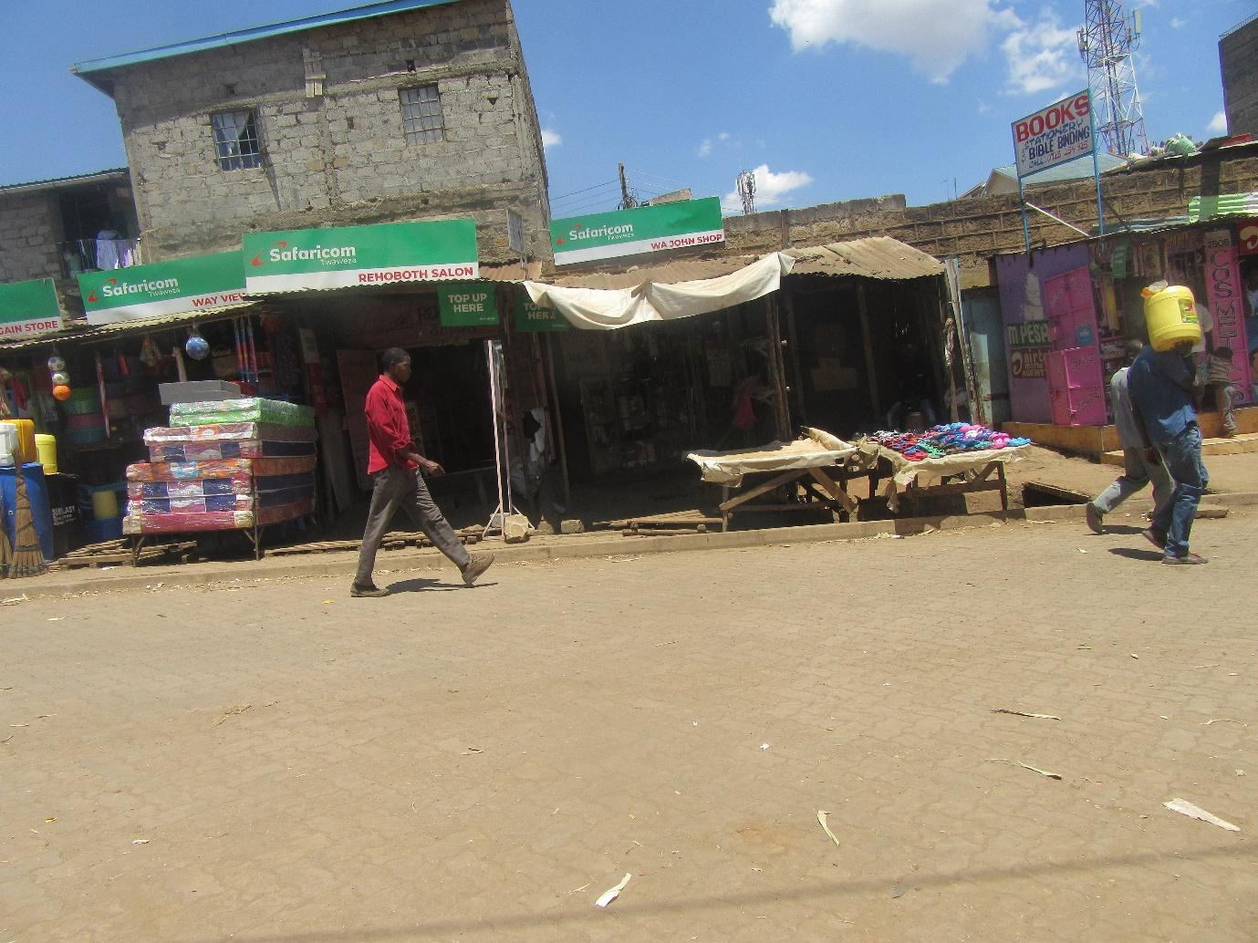

R1: Yes, I would like to talk about the shop. The cost of the things in the shop are expensive. Like sugar, flour..
M: Flour is expensive?
R1: Yes
M: So how much is flour right now?
R1: People send the flour at different prices.
M: So at this shop how much is flour sold at?
R1: One hundred shillings
M: That is flour that is two kilograms?
R1: yes
M: Ok, so this flour at what price would it need to be sold so that it is less expensive?
R1: Even if it is expensive it should be sold at seventy shillings.
M: So at seventy shillings that would be affordable. R2 do you agree? R2 what is your opinion about the flour price?
R2: for me I agree. Seventy shillings is at least fair for us because the money is hard to come by.
M: What else to do feel is costly that should reduce?
R1: Cooking oil.
M: Things that are eaten.
R2: Cooking oil, vegetables, even tomatoes are very expensive. Like at the moment that small tomato that you can see is five shillings and the other small one is ten shillings and some at fifteen shillings. The price of things are so expensive even when you go to the market and I go to the market often.
M: Now tell me…
R2: Vegetables you can find that they are tied in very small bunches and are sold at ten shillings and a bunch that is slightly bigger is sold at twenty shillings or even twenty five shillings. Even cabbage and kale are very little.
M: now tell me about the pricing. In the past what was the pricing of things? Let’s talk about flour first. In the past how much was flour
R1: It was fifty five shillings.
M: How long ago was that?
R1: During president Moi’s time
M: So when President Moi was still working?
R1: From 1984 to 1990.
M: When did things get spoilt? In regard to the price of flour?
R1: Things go spoilt in during President Kibaki’s time.
M: So R2, let me ask you, what spoilt the price of the flour? Where did the problem start?
R2: what brought about issues is where the leaders are that is what has brought about the price of flour. Because they cannot make the price of flour for us properly because they want to increase the price of things at once upwards. But for them they want to make money and for us there is no work that we are doing. For us we are poor so there is nothing we can do. For them they have money that is why they increase the price of things, them they eat well but for us we have no means.
M: So what can we do here in Kenya so that the prices of things like the flour can be cheaper?
R1: For us there is nothing we can do, only the government can reduce the price. If government doesn’t reduce the price, there is nothing we can do.
M: so government should reduce the price?
R1: yes. Let them reduce the price of flour at least and that is when a solution can be found.
M: So now these government. For you who have problems if we want to find these government so that we can share our challenges. How and where would we find them?
R2: for me I feel that the leaders like Uhuru should help us because hunger is killing us. Us we are walking in the dump sites so that we can eat. We are picking shopping bags in the trash so that we can eat. He needs to see how to help us by reducing the price of food so that we can eat. Because there is nothing er can do and we have grandchildren whose parent have died and we have no way of feeding them. So when you walk around and find those shopping bags we come and wash them, then you take them to the market to resell them. But still that money is not enough because the price of things is still high. Sugar is high, flour is high, everything is expensive and our children die of hunger.
M: Okay, that is good feedback. Let us move to the second photo that has jerry cans. You were trying to tell me earlier about something to do with oil. Now tell me about it properly.

Photo two:
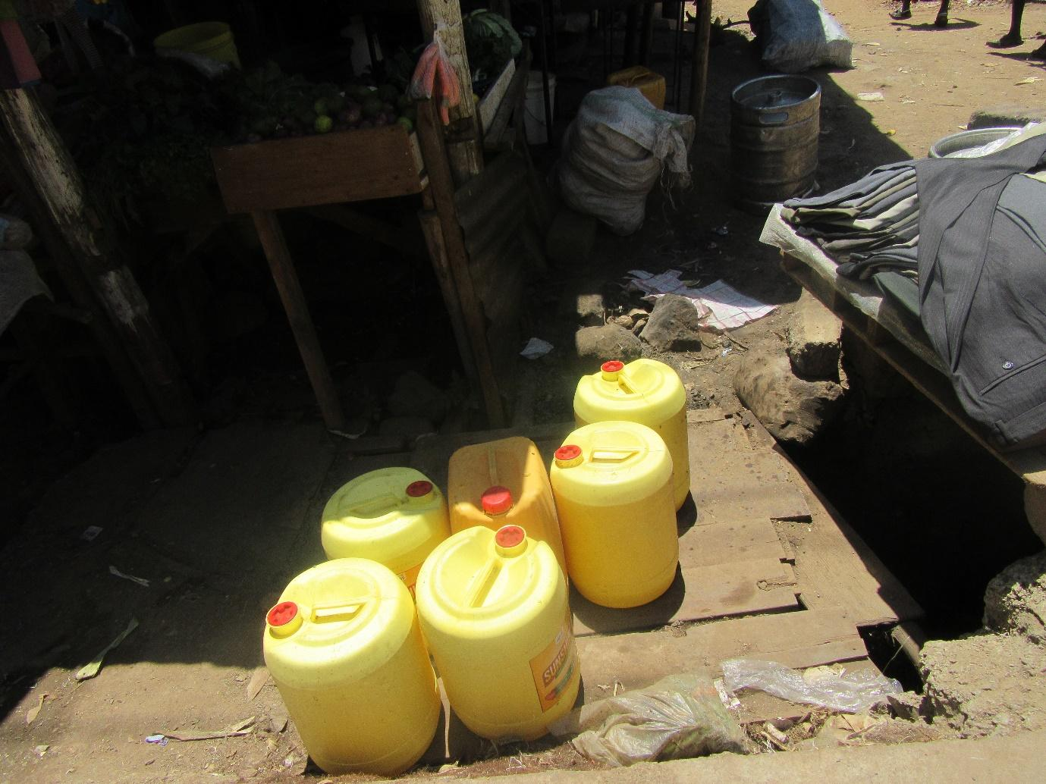

R1: Paraffin is quite expensive. Cooking oil when you buy at twenty shillings. You may have little money but decide to buy the oil for twenty shillings but that oil cannot be enough to cook both vegetables and Ugali. If you want to cook tea with oil of that amount you will only be able to cook the tea.
M: So here where we live. Do many people cook with paraffin?
R1: yes many people cook with paraffin.
M: So why do many people cook with paraffin as opposed to other things like charcoal?
R2: It is because the price of charcoal has been increased. A small tin of charcoal now is one hundred shillings. So sometimes when you have that one hundred shillings you think. From that one hundred I need vegetables, tomatoes and paraffin. So you are forced to just get twenty shillings to buy the paraffin so that you can buy tomatoes and whatever else you might need. From just that one hundred shillings. Our leaders need to help us.
M: so charcoal is too expensive?
R2: Very.
R1: these days charcoal for fifty shillings can’t cook anything. The medium tin cost eighty shillings.
M: There food cooked on the street do people buy that?
R2: yes for food that is sold on the street, sometimes you only have fifty shillings and the children may sleep hungry and you don’t have money. You will go and buy “githeri” for twenty shillings and sugar for thirty shillings. You come and warm for them the tea and that is what they eat. That is how we live.
M: so when you budget for buying things to cook in the house verses buying the food that is ready cooked which one is cheaper? Buying food to cook at home or buying ready food?
R1: You see you left that you were going to buy food and you know that you have one hundred shillings. For this one hundred shillings I have already done my budget for things that I would want to buy but I have three children. That one hundred shillings will not be enough so it seems better to by the ready “githeri” so that after I have bought the “githeri”, I can buy paraffin for twenty shillings so that I can warm it for the children with black tea. Sometimes if I have some money, I will buy a kilogram of porridge flour. Mix for the children and that is what they will eat. If I have two hundred shillings then I will buy more but if I don’t have I will buy what is available.
M: Are there people who eat from the food kiosks? If you have little money and you do the budget of going to eat at the kiosk instead of going home to cook are there people who prefer to just eat at the kiosk?
R1: if you eat at the kiosk it means the people you have left at home may not eat.
R2: you know eating at the food kiosk is not good because just to get intestines they give you a very small portion for fifty shillings and a very small piece of “ugali” together it comes to sixty shillings. If you go with this sixty shillings home you may be able to buy more with it and the whole family can eat.
M: so cooking at home is cheaper?
R1: Because also if you have children you can’t eat at the kiosks and they have not eaten.
M: Alight, I have understood. Let us talk about the next picture. This picture of yours that shows tomatoes. Let us hear the story behind the tomatoes. What did you want to tell us with this picture?

Photo Three:
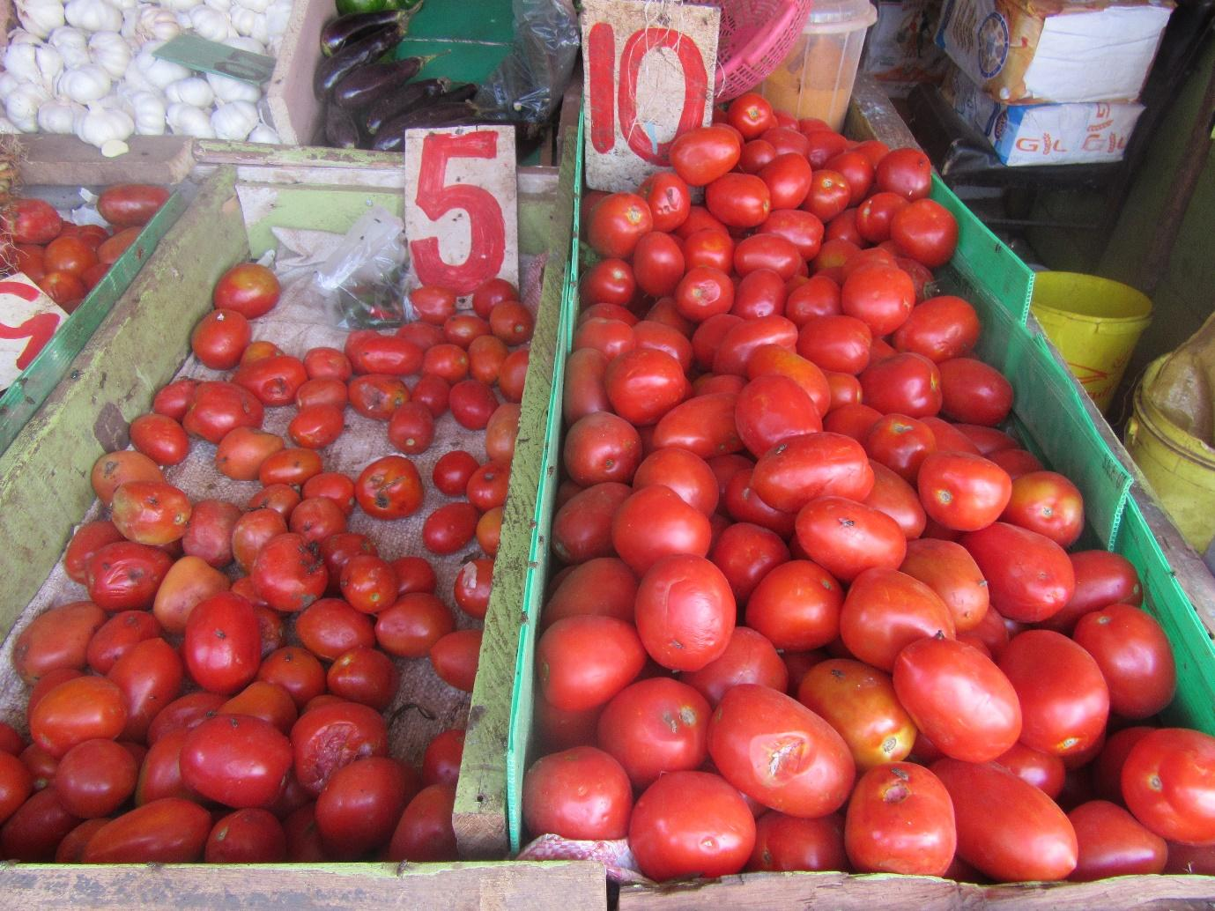

R2: These tomatoes if I go to the market I am given two tomatoes at ten shillings. It means when I come to sell them, I have to sell one at ten shillings so that I can make some money. So now this five shillings I get three tomatoes which means that I have to sell the tomatoes each at five shillings. It’s the only way I can make some money so I can feed my family. These vegetables you see it’s tied in such little bundles and when I come from the market I have to divide it again and then sell it at the same price in order to make some money. If I don’t do that then I have no money for food.
M: Thank you. If you look at the people who sell vegetables and tomatoes around here what is the price range. Do the people who live here feel like the price is too expensive or they don’t mind it?
R1: They are ok with it because it depends on how you tie it. You have to tie it in such a way as to attract customers. Even if they will feel the pinch of the price, you still have to find a way to attract the customer. So you put the portions in such a way that you don’t talk advantage of your customers too much. So you look for things in the market that your neighbours can eat.
M: These vegetables in this area what do they enjoy to eat?

Photo Four:
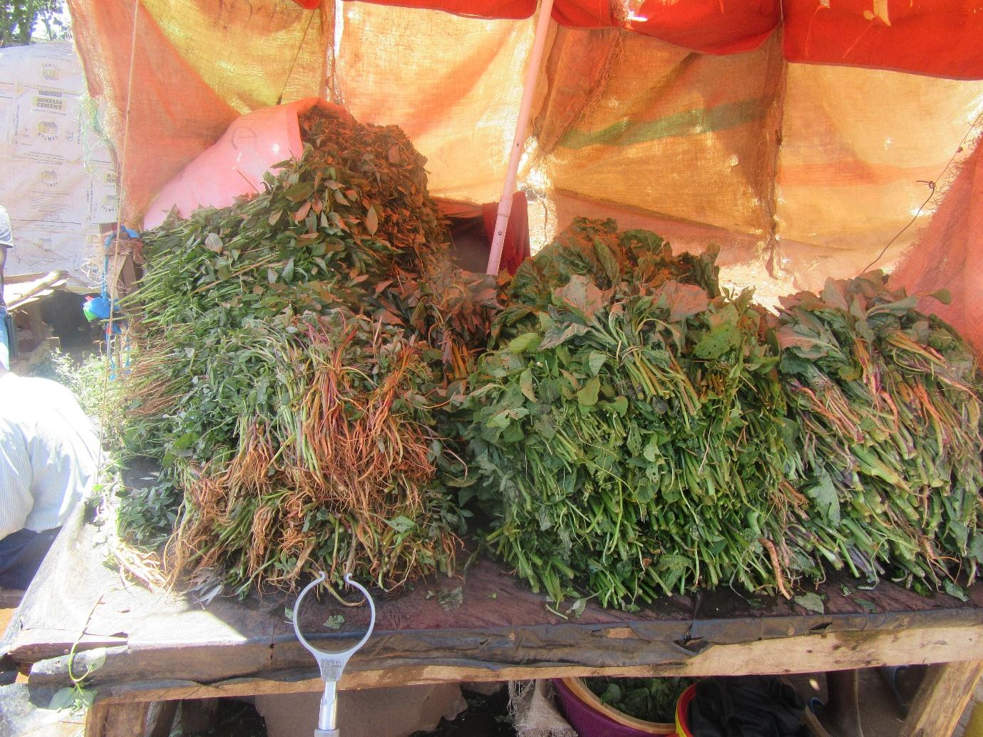

R2: The vegetables that people are enjoying to eat are the traditional vegetables. Because many people have ulcers so they prefer the traditional vegetables.
M: So the traditional vegetables help with ulcers?
R2: yes they help.
M: So at the moment people are not buying a lot of Kale?
R1: If they buy kale they have to buy a traditional vegetable, some spinach to mix it with. They will rarely cook it on its own.
M: If you compare the price of traditional vegetables and kale or spinach. Which of them is more affordable?
R2: Traditional vegetables are quite expensive.
M: So when people choose to eat the traditional vegetables they are spending a lot of money?
R1: Like the “African nightshade” you can be tied for three brunches.
M: How much would that be?
R1: Twenty Shillings or ten shillings.
M: where are these vegetables sourced from?
R1: From the market.
M: Which market?
R1: the local market in the area or Gikomba in town.
R2: Gikomba market or the vegetables brought by kikuyus.
R1: the portions are different depending on where you go so people buy where they will get more.
R2: So depending where you buy from you have to come back and divide it again for sale so you can make some money.
M: So those who buy these vegetables and tomatoes here in Korogocho because people are many, they must make a lot of money? What is the profit?
R2: There is no real profit. You make just a little to be able to eat.
R1: you know it better than seating at home. At the end of the day you have rent to pay and you also have to eat so you do what you can, the little you get you can plan with it. So you can look for money pay half the rent and then tell the landlord you are still looking for more rather than just seating in the house.
M: Why is the profit not good yet many people buy the vegetables?
R1: Some people say the portions are little and sometimes they have many children so they would rather just go the market themselves.
M: So they just pass the local vendors and go to the market themselves? What else can people eat apart from the vegetables? What else is available if they decide they don’t want the vegetables?
R2: “Orenge” (hoofs of cows and chicken) is found on the road. Örenge of the chicken is also something a lot of us eat. If you buy three “Orenge” for twenty shillings that is what you will boil and eat.
R1: (laughing) that you boil it.
R2: isn’t that the truth, I am not lying. Here in Korogocho that is what we buy plus chicken head and eat.
M: So finding “Örenge” is easy? So people will buy that and leave vegetables?
R2: Three chicken heads is ten shillings and three “orenge” is twenty shillings. If you go and boil and then fry them nicely with tomatoes the children eat well and enjoy it.
M: This “orange” and chicken heads where do you buy them from?
R1: we get them from industrial area.
R2: the chicken heads come from chicken farmers. There are places where chickens are farmed so people go and buy and come and sell them to us.
M: So the people selling them and roasting them are they doing it well and in a hygienic way?
R2: Now that we can’t really be sure because for us we find them there ready for sale. So for as since its roasted we believe it must be clean.
R1: the fire has burnt the dirt. What the fire has burnt now has no risk.
M: What has experienced heat is just good enough to eat? For those of you who have eaten the “orenge” have not experienced any challenges like running stomach?
R1: It hasn’t killed anyone.
M: so it’s just fine? Okay, so what else can people by that is not the “orenge”? Something that people buy a lot?
R1: It’s just the vegetables.
R2: or the “githeri” although sometimes you can also buy eggs, or even meat someone can buy on occasion. What people also enjoy is the head of “mbuta” (Nile patch) or “orenge” that is what people enjoy.
M: is “omena” (Silver cyprinid) easily found?
R2: yes “omena” is easy to find.
M: So what is the price of “ömena”?
R2: Small tin is fifty shillings.
M: Is that a good price or it expensive?
R1: 1ts expensive
R2: That is expensive
M: It’s expensive?
R2: It’s a very small tin.
M: what are the different prices?
R1: If you want two kilograms that is in a large tin its three hundred shillings.
M: Three hundred shillings for two kilograms?
R2: Yes, three hundred even if you go to industrial area.
M: Where does the “omena” come from?
R2: It come from Yimbo in Nyanza and Moka, Seme. It depends. Even Mombasa.
M: Here in Korogocho are there many people who like “omena”?
R2: Yes. If we can afford it we buy. Many people buy it when its less expensive.
M: What is the price of fish?
R1: One fish can go for about two hundred shillings.
M: One fish? That is what size? Big or small?
R2: A small one.
M: As small as the size of my palm?
R2: Yes, the size can be very small.
R1: so are seventy shillings, others are sixty shillings. Then there are those that the meat is taken out and is just head and bone. (mgongo wazi)that can go for twenty shillings or thirty shillings.
M: Okay, so in that case do people eat fish a lot?
R1: “orenge” is what people mostly eat. Sometimes that two hundred shillings is what you have for a full meal so you can’t buy fish only.
M: Okay, let’s go back to the discussion on “ugali” briefly. If someone decided they don’t want to eat ugali what else can they eat?
R1: They can eat githeri, children also really enjoy rice so sometimes you can buy rice.
M: So rice is easy to find? What price does it go for?
R2: Yes it is. It can be twenty shillings for a quarter of a kilogram. Forty shillings for half a kilogram.
M: But that is not a bad price?
R1: Yes, that price is ok.
M: What about like chapati?
R1: Chapati is like ten shilling.
M: So do people buy them from the road and kiosks ready cooked or they cook them at home?
R2: People will usually buy what is on the road because by the time you buy oil and the other things needed to cook them and spend time cooking them it’s easier to just go and buy what is already ready to eat.
M: What about fruits do people eat them?
R2: yes they do like mangoes, oranges.
M: So the mangoes and oranges found on the street.
R1: yes also avocado.
M: So fruits can be found. What is the price range?
R1: A very small one around five shillings and a bigger one ten shillings.
M: so what you are saying is the price is not too expensive. Things like tomatoes are what are expensive?
R1: Even oranges one can get. There is for five shillings and three for ten shillings.
M: So that is to say that food is readily available here in Korogocho? Even when you go to the market you will find food.
R2: Yes it is available.
M: Now that the food is found easily at the market does it mean that people have enough food in their homes?
R1: No, not if you don’t have money.
R2: Right now money talks. If you have money then you have food.
R1: If you don’t have money you can’t eat.
R2: sometimes people set up food right next to you but you don’t have money so you can really eat.
M: Is there something else that make someone not have food in the house other than money?
R2: It’s mainly money.
M: Its only money! Okay, when you are home and you find that you don’t have money what is your plan b? What do you do to be able to get food? I know women usually can make a plan.
R2: You know sometimes you can leave, you can go look for tomatoes or you can go to the dump site and pick waste to go and be weighed like tins. The tins are counted and then you can make some money. You can also pick the used shopping bags, wash them then take them to be resold at the market and you get some money for food.
M: So when you don’t have food in your house and a neighbour has do you help each other?
R2: Like a season like this? Right now it’s hard to help each other.
R1: neighbours don’t help each other. There is no one who can help each other right now
M: Why?
R2: How can you be helped if even you can’t find something to help a neighbour with?
M: But sometimes your neighbour can have extra?
R1: They can’t give you. Even if you are crying at your neighbours door or your child is starving they can’t help you. Everyone finds for themselves.
M: Why? What has happened to hospitality? Why are people to being helpful?
R2: I don’t know what has happened now. I used to witness in the past. If you see your neighbour’s child hungry, you would call that child to come and eat with you or you give them something to eat. I still do that to this day. I am telling you the truth. Because if I see a child that is hungry I know that they will go and steal. Even if they find something of mine they will take it because he is hungry so it’s better to give them something to eat.
R1: you see for a child even if you give them something small they will go and tell everyone that they were given food.
M: Okay, and do you have merry go rounds or associations here?
R2: I used to be in one but I left it. I felt like they started going round and round and talking about government issues so I saw like there was division.
M: Are there and merry go rounds where people come together to try and help each other when it comes to food. Like buying food together like sugar?
R2: There are people who are in those associations but I don’t belong to one. I don’t join them.
M: Why don’t you enter them?
R2: I have many bills that I split. Every other day I am paying for something. The associations to do with food especially have defeated me. I don’t enter them.
M: For the people that are in this group. What do they buy as a group?
R2: There are the kitchen ones where they buy for example, one person can by flour and another can by sugar and each person buys something different so even if you are many you divide what has been bought. But for us in our current state you don’t have to be able to buy so you don’t join.
M: I have heard the health ministry say that someone should eat a balanced diet. Do people look at whether the food is balanced or they eat what is available?
R1: We don’t really. You buy what you are able to buy with money you have. Some days you will buy vegetables, other day you will buy “githeri”. For ugali you won’t just eat it plain.
M: So for example now its lunch time. Will you look for a way to buy food that has different nutritional value or do you always just by little food?
R1: you will eat what you find. Someday all you can afford is vegetables so you may not have for protein but you just eat that and sleep. So then sometimes you will see you have eaten a lot of vegetables to you will buy “githeri” and eat.
M: The meat you talked about where do you get from around here?
R1: You just buy at the butchery.
R2: It is brought from a place called “kiabiyo”.
M: Okay, and its good meat. There are some cases in other areas where we have found that meat is put for unhealthy chemicals.
R1: I have not heard about that.
M: Okay.
R1: But where people buy meat varies. Some people buy from “Kariobangi”. So it is sourced from different places. Sometimes back it may even be a donkey that has been slaughtered but I have not heard that happen in a while.
M: So these days it’s not a case that is heard of?
R2: Yes they used to bring donkey’s meat.
R1: But that meat when you put it to boil it is very hard and it looks like paper.
M: So you can tell the difference?
R2: Yes.
M: But now we were in another group and they talked about traditional vegetables and how some of them are grown next to the sewage. Is this true?
R1: That is true. In fact it happens a lot.
R2: A lot. We eat vegetable from the sewage.
M: If you eat those vegetables does it affect a person’s stomach?
R1: Yes it does.
M: When you go to the market are you able to tell the difference between the one grown we and the one that is grown near the sewage?
R1: Yes the one that is from the village you know it.
M: And people still buy it?
R1: Yes people still buy it.
M: So why would someone leave the one grown well and buy the one grown near the sewage?
R1: When you go to the market it is the one that looks the healthiest and most appealing.
M: So it just pull your eyes?
R1: It just looks more attractive than the one that has come from the village. So you just find yourself buying it.
M: Okay, so because it attracts your eyes you just buy it?
R1: There is a day I went to the market and saw banana. Those bananas were so attractive. I bought them but I was defeated to eat them. I put them to cook and they just turned black.
M: For the vegetables do you know where they are grown?
R2: I don’t know where they are farmed here.
M: So they come from far?
R2: Yes.
M: These days are there people who do farming in sacks or in tins?
R2: There are none. People have not planted.
R1: I have not seen.
M: There are no even groups you have seen doing it?
R1: there was a group sometime back but in a place called “Kayongomongo” are the ones I saw doing the sack farming. Near the bridge.
M: What about animals like goats and chicken? Do people keep them?
R2: That I have seen people keeping. Even I kept chicken for awhile but they died.
M: What killed them? Illness?
R2: No not illness. They were poisoned.
M: Someone killed them?
R1: Yes someone was angry and poisoned them.
R2: I had kept the chicken and now I was just seating and gaining and someone go jealous.
M: So someone was just jealous? So you mean to tell me jealousy can make someone do such a thing or even prevent people from doing farming?
R1: But jealously can make someone even burn another person’s house down.
R2: Even till now people still ask me about the chicken. Kikuyus will come to me and tell me how sad it was that I lost my chicken and I just respond and say God will give me more or something else. I had really kept those chicken.
M: Are there people that have cows and goat?
R2: Yes there are?
R1: There are.
M: Cows that give them milk and other things?
R1: the kikuyu’s are the ones who mainly keep them.
M: So if someone wanted to start a project to do with sack farming, what would need to be done for you to also take part in it?
R2: if it is near the house there is no point because of thieves.
M: you mean to tell me that thieves can make it so that your efforts with the sack farming can be wasted?
R2: especially for those that are kept near the house you can find them picked and picked till there is nothing.
R1: You can go to sleep and when you wake up you find that nothing was left.
M: From what I can see these are really slowing down the progress of the community. What can be done to get rid of them? What can be done about these thieves?
R2: there is nothing we can do because they are our children. We can’t hand them over to the pole.
M: So you just see them and keep quiet?
R2: You also can’t go to the police and tell them about the child because when they come to look for them they will say that I am the one who told them. So it’s like you are agreeing to be killed.
M: That is hard. That is a difficult situation. But now I feel like we have finished. We have debated about different things. Now I want to hear your last thoughts about the things we have discussed about food.
R2: For us we are saying that you just help us because there is little that we can do. For me the way I am now, I am limp, I only have one functional hand and one leg so it is challenging to find work so I am asking for the government to help those of us who are disabled so that we can access food. Because for us we have grandchildren left in our care and we don’t how to feed them because for even chapati I would not be able to mix and cook. So for me that is my plea, that government should assist us. The leaders can see how to reduce the cost of things. That is input.
M: Thank you very much. But the money that is for the elderly given out by government do you get some?
R2: I don’t get.
M: Okay, R1 give me your last comments. How do we finish or you don’t have anything to say?
R1: Yes.
M: If you have nothing to say then it is well. I would just like to say thank you. We have has a good discussion and I just want to say thank you. Let us continue to pray that things will be come better.

