Figure 2: PRISMA 2020 flow diagram
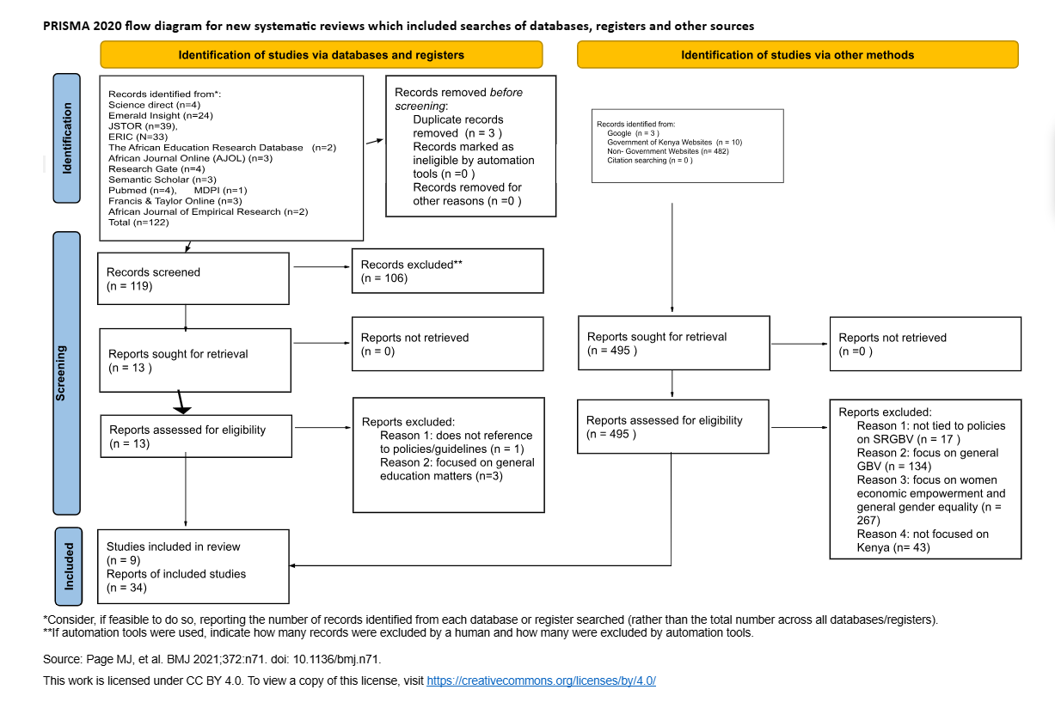
Note: PRISMA 2020 flow diagram showing the desk review documents screening process.

